PREMIER-WATCHES

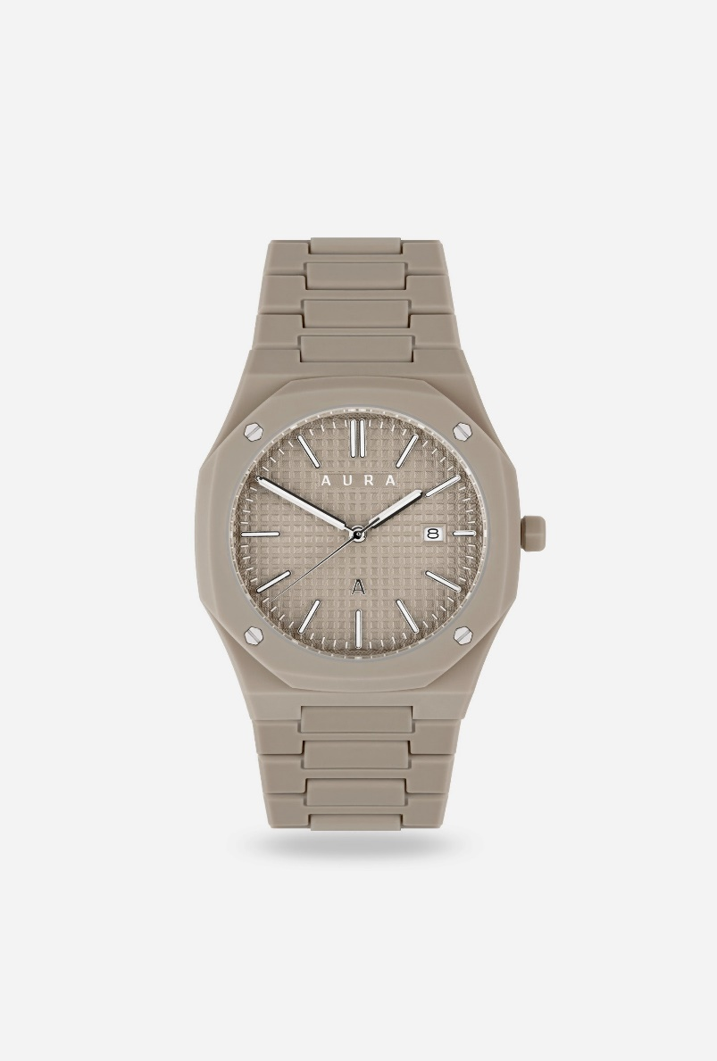
1. Audemars Piguet Royal Oak Offshore Chronograph
- Type: Luxury Chronograph Watch
- Key Features:
  - Display: 42mm stainless steel case with a signature octagonal bezel, featuring a “Tapisserie” pattern dial, typically in blue, black, or other vibrant hues. The dial has subdials for the chronograph function and a date window.
  - Movement: Equipped with the Caliber 3126/3840, an automatic chronograph movement with a power reserve of 50 hours.
  - Water Resistance: Water-resistant up to 100 meters (328 feet), making it suitable for swimming and shallow diving.
  - Chronograph Features: The Royal Oak Offshore is equipped with a chronograph function, including a central chronograph seconds hand and two subdials for minutes and hours, ideal for timing events.
  - Design: Known for its bold and distinctive design, the Royal Oak Offshore features a large case and rubber or leather strap options, enhancing its sporty and luxurious aesthetic.
  - Durability: The case and bracelet are crafted from high-quality stainless steel or precious metals, providing exceptional resistance to wear.
  - Price: Around $25,000 to $40,000 depending on model and material choices.

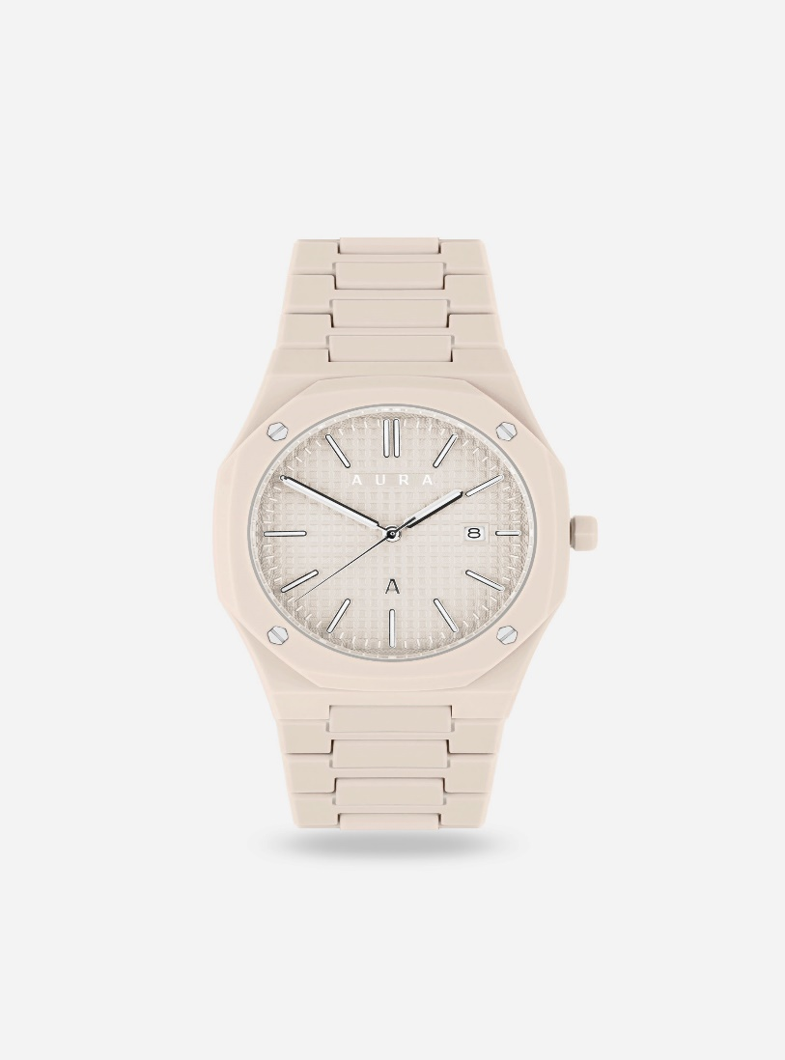

2. Patek Philippe Nautilus 5711/1A
- Type: Luxury Sports Watch
- Key Features:
  - Display: 40mm stainless steel case with an iconic rounded octagonal bezel. The dial is a rich blue with horizontal embossing, which has become a hallmark of the Nautilus collection.
  - Movement: Powered by the in-house Caliber 324 S C automatic movement, offering a 45-hour power reserve.
  - Water Resistance: Water-resistant up to 120 meters (394 feet), making it suitable for light swimming and other aquatic activities.
  - Design: The Nautilus combines elegance with sportiness, featuring a bracelet that seamlessly integrates into the case, offering a comfortable and refined fit.
  - Durability: The stainless steel case is highly durable and resistant to scratches, with a polished finish and refined detailing.
  - Specialty: Known for its luxury appeal and timeless design, the Nautilus is a status symbol and a highly sought-after collector's piece.
  - Price: Around $30,000 to $40,000, but can go higher due to demand and rarity.

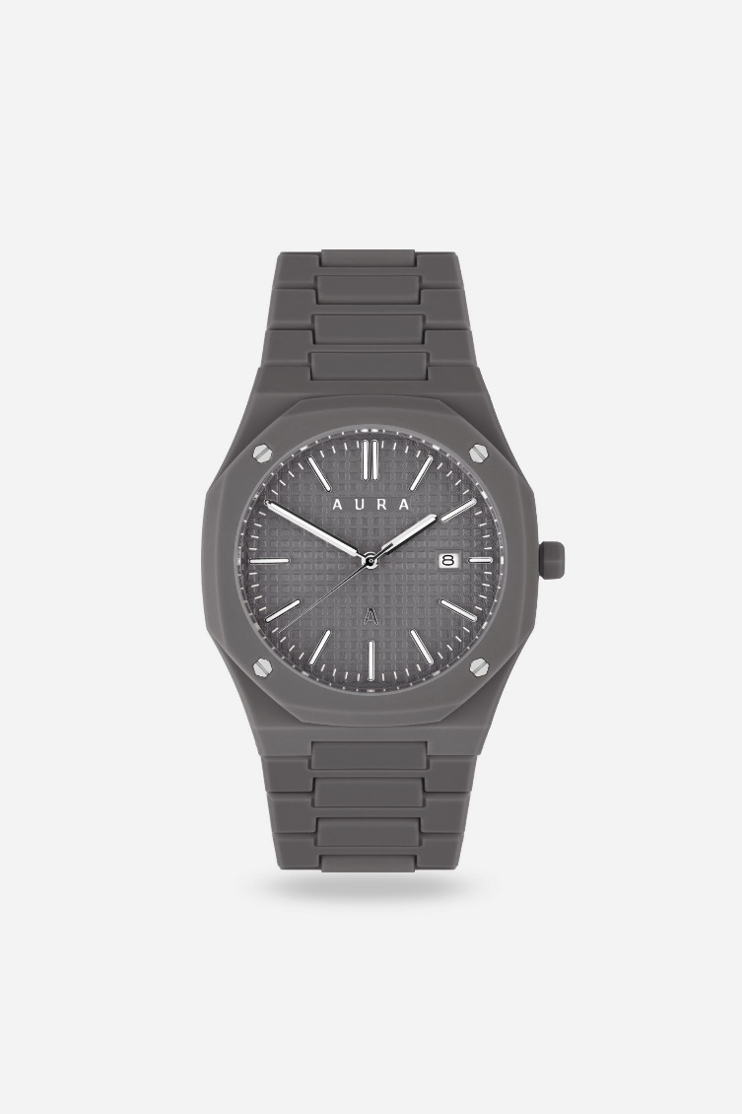
2. Audemars Piguet Royal Oak Offshore Chronograph
- Type: Luxury Chronograph Watch
- Key Features:
  - Display: 42mm stainless steel case with a signature octagonal bezel, featuring a “Tapisserie” pattern dial, typically in blue, black, or other vibrant hues. The dial has subdials for the chronograph function and a date window.
  - Movement: Equipped with the Caliber 3126/3840, an automatic chronograph movement with a power reserve of 50 hours.
  - Water Resistance: Water-resistant up to 100 meters (328 feet), making it suitable for swimming and shallow diving.
  - Chronograph Features: The Royal Oak Offshore is equipped with a chronograph function, including a central chronograph seconds hand and two subdials for minutes and hours, ideal for timing events.
  - Design: Known for its bold and distinctive design, the Royal Oak Offshore features a large case and rubber or leather strap options, enhancing its sporty and luxurious aesthetic.
  - Durability: The case and bracelet are crafted from high-quality stainless steel or precious metals, providing exceptional resistance to wear.
  - Price: Around $25,000 to $40,000 depending on model and material choices.

