SPORTS-WATCHES

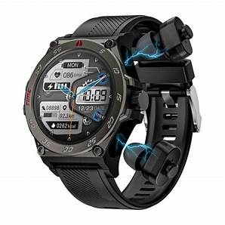

1. Garmin Fenix 7X Solar
- Type: Multisport GPS Watch
- Key Features:
  - Display: 1.4-inch solar-powered touchscreen with a 280 x 280 resolution.
  - Battery Life: Up to 28 days in smartwatch mode, 37 hours in GPS mode, and unlimited solar charging when exposed to sunlight.
  - GPS and Sensors: Supports multiple satellite systems (GPS, GLONASS, and Galileo) for precise tracking. Features a barometric altimeter, compass, and thermometer.
  - Sports Modes: Supports over 30 sports modes including running, cycling, swimming, hiking, skiing, and golf.
  - Health Monitoring: Includes heart rate monitoring, Pulse Ox sensor, sleep tracking, and Body Battery energy monitoring.
  - Durability: MIL-STD-810G military standard for thermal, shock, and water resistance (up to 100 meters).
  - Smart Features: Notifications, music storage, Garmin Pay, and smart connectivity with phone apps.
  - Price: Around $900.

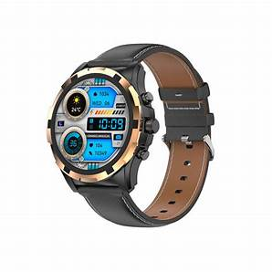
2. Rolex Submariner Date
- Type: Luxury Diver's Watch
- Key Features:
  - Display: 41mm Oystersteel case with a black ceramic bezel and a blue sunburst dial.
  - Water Resistance: Water-resistant up to 300 meters (1000 feet), making it perfect for diving.
  - Movement: Powered by Rolex's in-house Caliber 3235 self-winding movement with a 70-hour power reserve.
  - Durability: Known for its robust build, scratch-resistant sapphire crystal, and anti-magnetic properties.
  - Design: Classic and timeless design with a rotating bezel for tracking dive times. The date is displayed at 3 o'clock.
  - Comfort: Adjustable Oysterlock bracelet with Glidelock extension system, which allows for easy adjustments even when wearing over a wetsuit.
  - Specialty: A luxury piece that is just as much a high-performance tool as it is an iconic status symbol.
  - Price: Approximately $10,000.

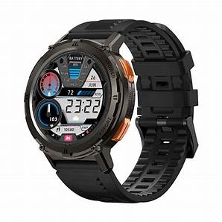

3. Apple Watch Ultra
- Type: Smart Sports Watch
- Key Features:
  - Display: 49mm titanium case with an always-on Retina display, 2000 nits brightness (bright enough to read in direct sunlight).
  - Battery Life: Up to 36 hours in regular use and up to 60 hours with Low Power Mode.
  - GPS and Sensors: Dual-frequency GPS, compass, altimeter, heart rate sensor, blood oxygen sensor, and temperature sensor.
  - Sports Modes: Specifically designed for extreme sports, including mountaineering, diving (100 meters water resistance), trail running, cycling, and swimming.
  - Health Features: Advanced health tracking with ECG, blood oxygen, and sleep monitoring. Additionally, features fall detection and emergency SOS for safety.
  - Durability: Built with a rugged titanium body, sapphire crystal front, and WR100 water resistance, it's engineered for extreme conditions.
  - Smart Features: Full integration with the Apple ecosystem, allowing for notifications, calls, and app management directly from the watch.
  - Price: Approximately $799.

