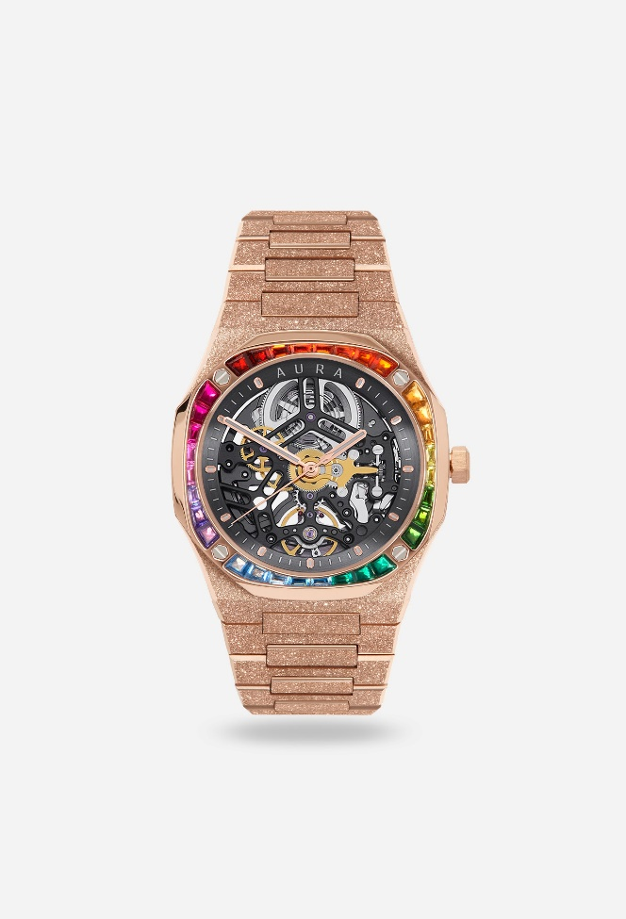

LIMITED-EDITION-WATCHES

1. JADES Piguet Royal Oak Offshore Chronograph
- Type: Luxury Chronograph Watch
- Key Features:
  - Display: 42mm stainless steel case with a signature octagonal bezel, featuring a “Tapisserie” pattern dial, typically in blue, black, or other vibrant hues. The dial has subdials for the chronograph function and a date window.
  - Movement: Equipped with the Caliber 3126/3840, an automatic chronograph movement with a power reserve of 50 hours.
  - Water Resistance: Water-resistant up to 100 meters (328 feet), making it suitable for swimming and shallow diving.
  - Chronograph Features: The Royal Oak Offshore is equipped with a chronograph function, including a central chronograph seconds hand and two subdials for minutes and hours, ideal for timing events.
  - Design: Known for its bold and distinctive design, the Royal Oak Offshore features a large case and rubber or leather strap options, enhancing its sporty and luxurious aesthetic.
  - Durability: The case and bracelet are crafted from high-quality stainless steel or precious metals, providing exceptional resistance to wear.
  - Price: Around $25,000 to $40,000 depending on model and material choices.

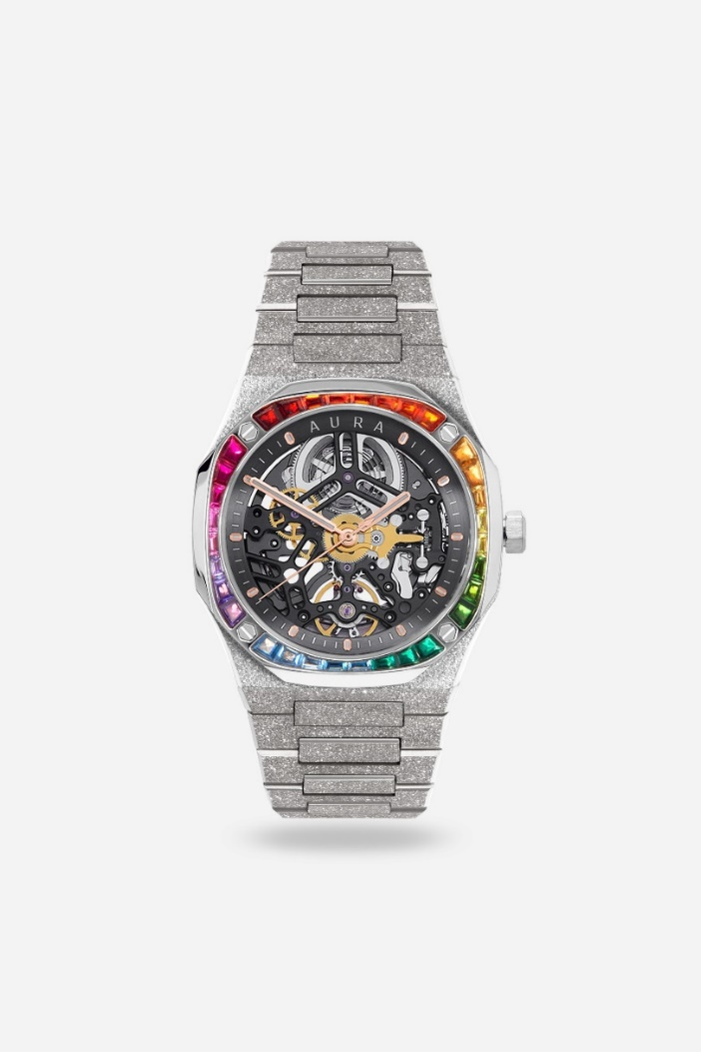
2. Audemars Piguet Royal Oak Offshore Chronograph
- Type: Luxury Chronograph Watch
- Key Features:
  - Display: 42mm stainless steel case with a signature octagonal bezel, featuring a “Tapisserie” pattern dial, typically in blue, black, or other vibrant hues. The dial has subdials for the chronograph function and a date window.
  - Movement: Equipped with the Caliber 3126/3840, an automatic chronograph movement with a power reserve of 50 hours.
  - Water Resistance: Water-resistant up to 100 meters (328 feet), making it suitable for swimming and shallow diving.
  - Chronograph Features: The Royal Oak Offshore is equipped with a chronograph function, including a central chronograph seconds hand and two subdials for minutes and hours, ideal for timing events.
  - Design: Known for its bold and distinctive design, the Royal Oak Offshore features a large case and rubber or leather strap options, enhancing its sporty and luxurious aesthetic.
  - Durability: The case and bracelet are crafted from high-quality stainless steel or precious metals, providing exceptional resistance to wear.
  - Price: Around $25,000 to $40,000 depending on model and material choices.

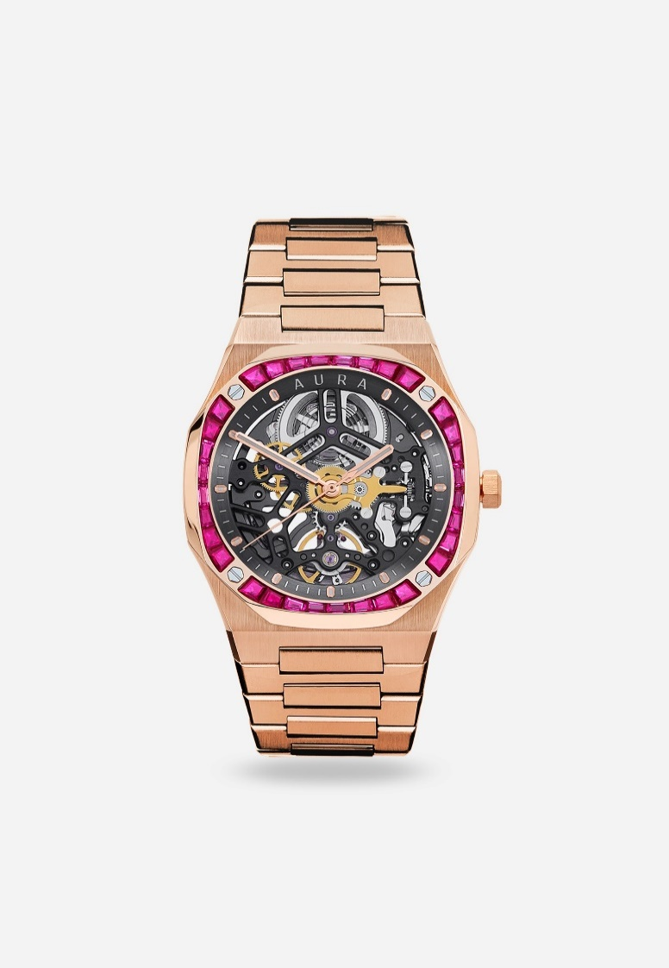
3. Mars Piguet Royal Oak Offshore Chronograph
- Type: Luxury Chronograph Watch
- Key Features:
  - Display: 42mm stainless steel case with a signature octagonal bezel, featuring a “Tapisserie” pattern dial, typically in blue, black, or other vibrant hues. The dial has subdials for the chronograph function and a date window.
  - Movement: Equipped with the Caliber 3126/3840, an automatic chronograph movement with a power reserve of 50 hours.
  - Water Resistance: Water-resistant up to 100 meters (328 feet), making it suitable for swimming and shallow diving.
  - Chronograph Features: The Royal Oak Offshore is equipped with a chronograph function, including a central chronograph seconds hand and two subdials for minutes and hours, ideal for timing events.
  - Design: Known for its bold and distinctive design, the Royal Oak Offshore features a large case and rubber or leather strap options, enhancing its sporty and luxurious aesthetic.
  - Durability: The case and bracelet are crafted from high-quality stainless steel or precious metals, providing exceptional resistance to wear.
  - Price: Around $25,000 to $40,000 depending on model and material choices.

