**BIRLA INSTITUTE OF TECHNOLOGY & SCIENCE, PILANI**

**(APRIL 2023)**



**DERIVATIVES & RISK MANAGEMENT (ECON F354)**

**ASSIGNMENT: EXPECTATIONS AND STRATEGIES FOR THE STOCK**

**i)TATA MOTORS**

**ii)HDFC BANK**

**Report by Group 13**

|  |  |
| --- | --- |
| **Name** | **ID** |
| Krish Mantri | 2021B3A71732H |
| Aditya Dibyadarshan Mohanty | 2021A4PS2419H |
| Gaurav Khurdia | 2021A4PS2552H |
| Gopavarapu Poojitha | 2021A4PS1985H |
| Tanish Gottimukkala | 2021A7PS0047H |
| Sarthak Agarwal | 2021A4PS3087H |
| Nishant Sahoo | 2020AAPS2097H |
| Krishang Shukla | 2021A7PS2168H |

**TABLE OF CONTENTS**

|  |  |
| --- | --- |
| **Topic** | **Page** |
| Overview of HDFC Bank | 3 |
| Expectations for HDFC Bank |  |
| 1. Technical Analysis | 4 |
| 1. Fundamental Analysis | 8 |
| Options strategies for HDFC Bank |  |
| 1. Bull Put Strategy | 10 |
| 1. Butterfly Strategy | 11 |
| 1. Reverse Jaded Lizard | 13 |
| Overview of TATA Motors | 15 |
| Expectations for TATA Motors |  |
| 1. Technical Analysis | 16 |
| 1. Fundamental Analysis | 20 |
| Options strategies for TATA Motors |  |
| 1. Bull Call Spread | 23 |
| 1. Butterfly Strategy | 24 |
| 1. Long Strangle | 26 |
| Sources and References | 27 |

**Overview**

HDFC is India's premier housing finance company and enjoys an impeccable track record in India as well as in international markets. Since its inception in 1977, the Corporation has maintained a consistent and healthy growth in its operations to remain the market leader in mortgages. Its outstanding loan portfolio covers well over a million dwelling units. HDFC has developed significant expertise in retail mortgage loans to different market segments and also has a large corporate client base for its housing related credit facilities. With its experience in the financial markets, strong market reputation, large shareholder base and unique consumer franchise, HDFC was ipositioned to promote a bank in the Indian environment.

**Capital Structure**

As on 31 - December-2020 the authorized share capital of the Bank is Rs. 650 crore. The paid-up share capital of the Bank as on the said date is Rs 550,76,56,932 comprising of 550,76,56,932 equity shares of the face value of Re 1/- each. The HDFC Group holds 21.15 % of the Bank's equity and about 18.67 % of the equity is held by the ADS Depositories (in respect of the Bank's American Depository Shares (ADS) . 32.01 % of the equity is held by Foreign Institutional Investors (FIIs) and the Bank has 13,49,591 shareholders.

The shares are listed on the BSE Limited and The National Stock Exchange of India Limited. The Bank's American Depository Shares (ADS) are listed on the New York Stock Exchange (NYSE) with symbol 'HDB' .

**Stock Expectations for HDFC Bank**

**I]Technical Analysis**

Expectations for the next 1 month - Bullish expectation

To explain the view behind this observation, we will look at the weekly timeframe to form the expectations for the coming 1 month. We can see the SMA 20 ( simple moving average in which the prices of the last 20 days are considered) is most of the times below the closing price on the weekly timeframe, this is also the case when we look at the exponential moving average (EMA) so these two indicators show that we should buy the stock i.e. there is a bullish h expectation. Momentum also indicates that we should buy the stock.

Now, if we look at the MACD, a crossover happened earlier in which the MACD line crossed the MACD Signal line and went above it, since then it has been below the signal line which indicates bullish expectations and confirms our previous view

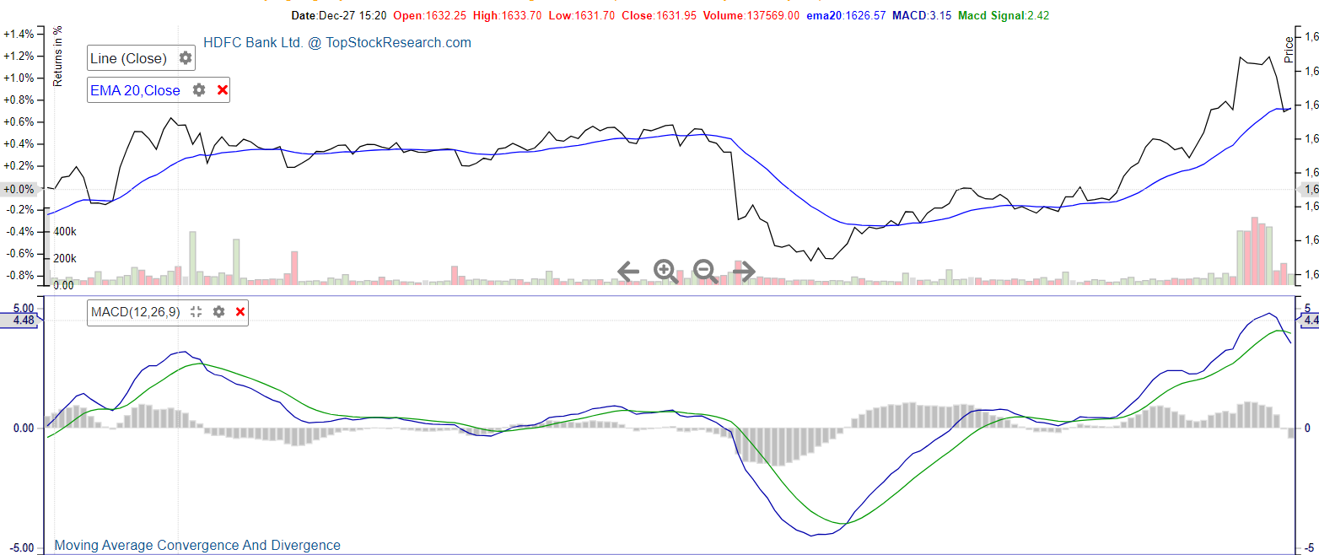

Expectations for the next 2-3 month - Bullish expectation

If we look at the SMA 20 ( simple moving average in which the prices of the last 20 days are considered) indicator we can see that it is much below the closing price on the monthly time frame, this is also the case when we look at the exponential moving average (EMA) so these two indicators show that we should buy the stock i.e there is a bullish expectation.

Now if we look at the MACD (Moving average convergence divergence), the MACD line is above the MACD signal line for a long time which indicates bullish expectations and confirms our view stated above. If we look at the ADX (average directional index), its value is 52 which suggests that the current trend is very strong. So, overall the trend is bullish for the next 2-3 months.

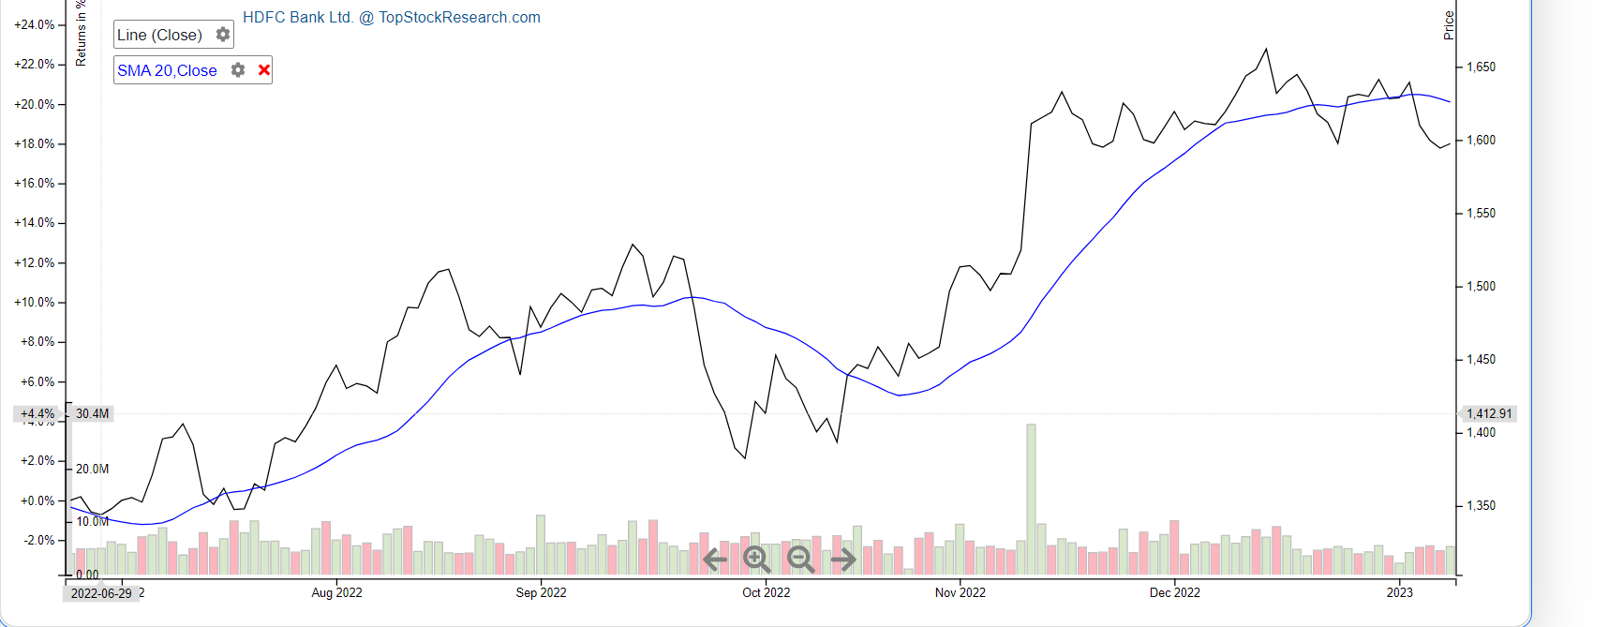

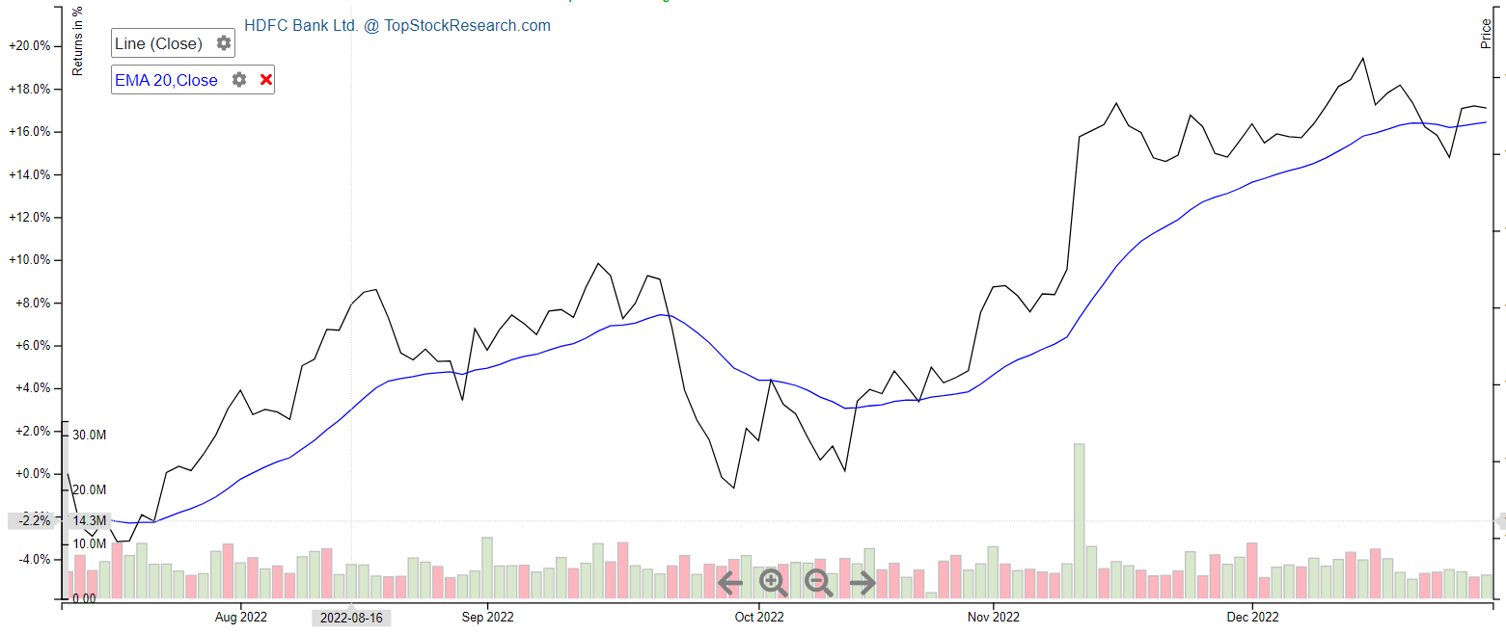

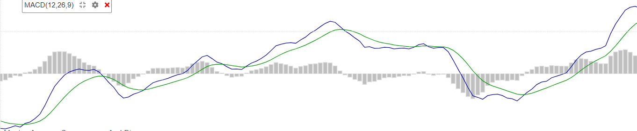

SMA indicator

The SMA (Simple Moving Average) indicator is a popular technical analysis tool used in options trading to analyze trends in stock prices. It calculates the average price of a stock over a set period of time, smoothing out fluctuations in the data and making it easier to identify trends. In the current market analysis of HDFC options trading, the SMA indicator can be particularly useful as it shows a bullish trend. This means that the stock prices are expected to rise in the short term.

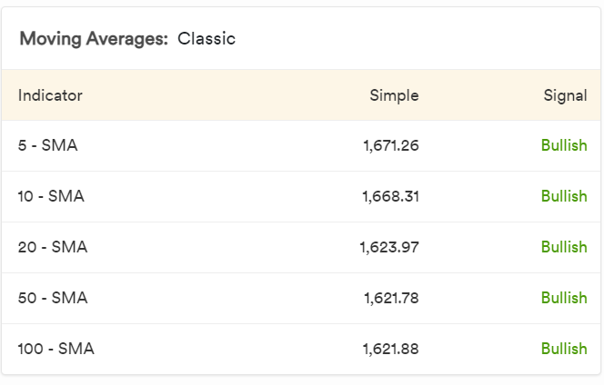

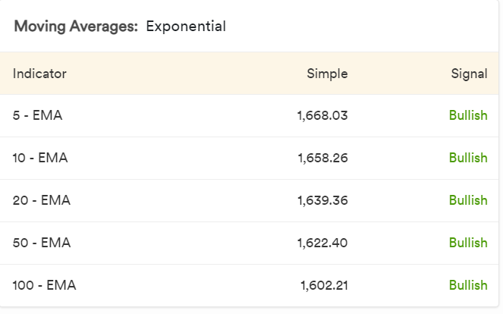

**II]Fundamental Analysis of HDFC Bank**

Net Sales and Profit:

HDFC Bank is a large cap stock with a market cap of approximately 942394 Cr. For the twelve months ending 2021-22, it’s earnings per share(EPS) is 82.4, and PE ratio is 20.5 . The annual sales numbers have increased, and are at 1,70,754 Cr now. 6805 Cr now. Consolidated net profits stand at 46,149 Cr. This signifies that the stock is performing quite well in the market currently.

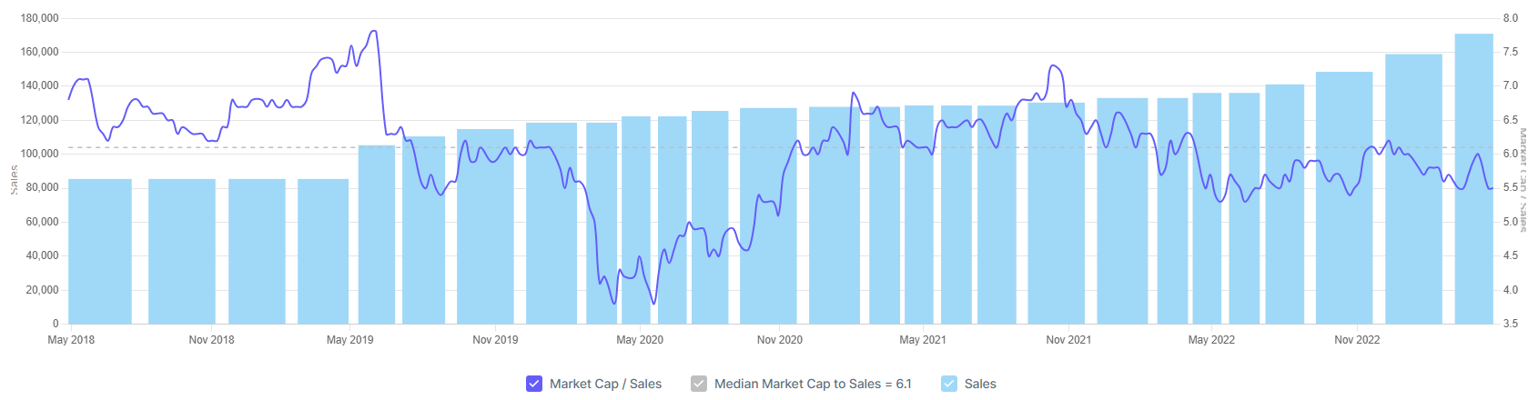

Net Sales

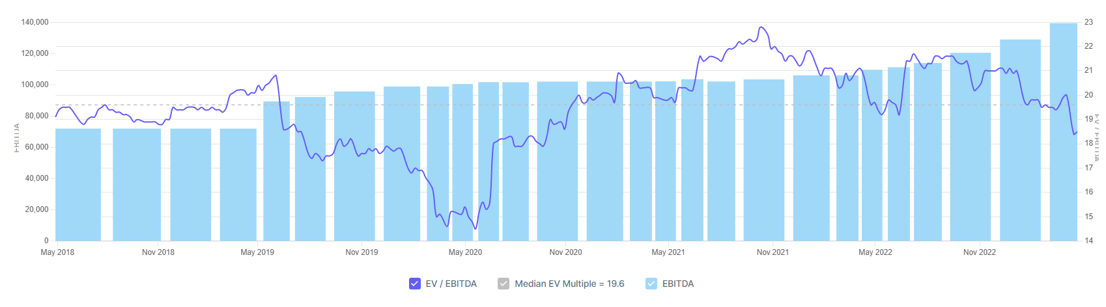  
 EV/EBIDTA

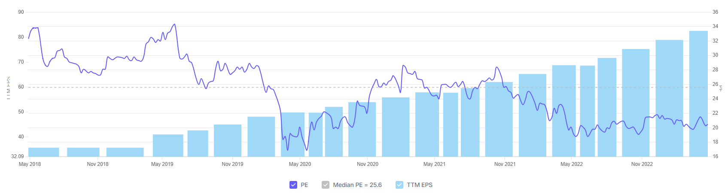  
 PE Ratio  
  
Ratios:  
  
Return Ratios: The return on equity stands at 18.6% while RoA stands at 2.17%.  
  
Growth Ratios: The net sales growth is 25.6% . The rise in EBIDTA is approximately 30,000 Cr.

Valuation Ratios: The price-to-earnings ratio is 20.5 which means the stock is pretty stable and well in demand by the investors.   
  
  
 Peer Comparison

|  |  |  |  |
| --- | --- | --- | --- |
| Company | PE | EV/EBIDTA | PEG Ratio |
| ICICI Bank | 18.59 | 17.41 | 0.54 |
| Kotak Mah. Bank | 26.45 | 21.66 | 1.35 |
| Axis Bank | 13.19 | 17.44 | 0.45 |
| IndusInd Bank | 11.58 | 12.51 | 0.75 |
| IDBI Bank | 17.48 | 20.44 | 0.87 |
| Yes Bank | 61.28 | 16.97 | -2.08 |

From the above table, we can observe that the P.E. ratio for HDFC Bank is lower than Kotak Mahindra Bank,Yes Bank, but higher than ICICI Bank, Axis Bank, IndusInd Bank, and IDBI Bank.   
 Being a trusted brand with a dominant market share in electronic card volumes, it is a good investment for both near and far months alike.

**Option Strategies for HDFC BANK**

**1.Bull Put Spread**

A bull put spread is writing or short selling a put option while concurrently purchasing another put option with the same expiration date but a lower strike price (on the same underlying asset). The bull put spread is one of the four basic forms of vertical spreads, with the bull call spread, bear call spread, and bear put spread being the others.

The premium obtained for the short put leg of a bull put spread is always greater than the premium received for the long put, implying that receiving an upfront payment or credit is required to begin this strategy. As a result, a bull put spread is often referred to as a credit (put) spread or a short put spread.

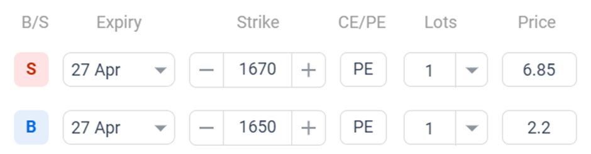

Here we took two positions:

1. Long in a put option with a strike price (K1)=1650 and a premium of(p1)=6.85

2.Short position in a put option with a strike price(K2)=1670 a premium of(p2)=2.2

|  |  |  |  |
| --- | --- | --- | --- |
| Position | ST<1650 | 1650≤ST≤1670 | ST>1670 |
| Long Put(K1) | 1650-ST | 0 | 0 |
| Short Put(K2) | ST-1670 | ST-1670 | 0 |
| Payoffs | K1-K2 | ST-1670 | 0 |
| Profits | K1-K2+p2-p1 =15.35 | ST-1670+p2-p1=ST-1665.3 | p2-p1 =4.65 |

*multiply all results by 550 to get practical values, as lot size is 550.

Max Profit = 2,558 (6%)

Breakeven = 1665.3 (-0.4%)

Probability of Profit = 71%

Margin Required = 40,698

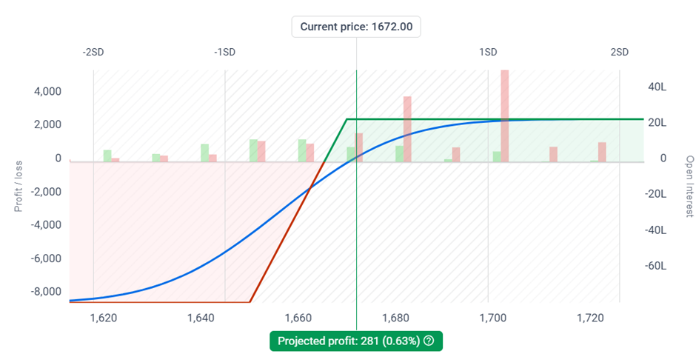

**2. BUTTERFLY STRATEGY:**

The butterfly strategy is a trading strategy that involves buying and selling a combination of options contracts with different strike prices and expiration dates. This creates a limited risk, limited reward trade with a potential profit in a specific range of prices, and a maximum loss outside of that range. The strategy can be used in both bullish and bearish markets, and is often used when the trader expects the underlying asset to move within a certain range, and for volatility to remain relatively stable. Overall, it is a complex options strategy that should only be used by experienced traders.

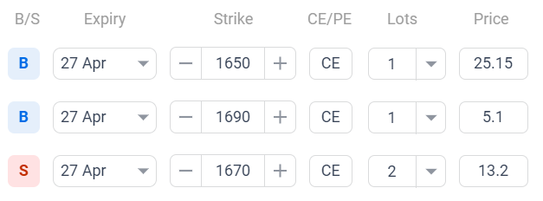

Here we took 3 positions:

1. Long in call option with strike price (K1)=1650 with a premium(p1)=25.15
2. 2 short positions in call option with strike price(K2)=1670 and a premium(p2)=13.2
3. Long position in call option with strike price(K3)=1690 and a premium(p3)=5.

| Position | ST<1650 | 1650≤ST≤1670 | 1670≤ST≤1690 | ST>1690 |
| --- | --- | --- | --- | --- |
| Long Call(K1) | 0 | ST-1650 | ST-1650 | ST-1650 |
| Long call (K3) | 0 | 0 | 0 | ST-1690 |
| 2Short Call(K2) | 0 | 0 | 2(1670-ST) | 2(1670-ST) |
| Payoffs | 0 | ST-1650 | 2(1670)-1650-ST | 2(1670-1690-1650) |
| Profit | -3.85 | ST-1650-3.85 | 1690-3.85-ST | -3.85 |

*multiply all results by 550 to get practical values, as lot size is 550.

Max profit = 8,883 (11%)

Break-even occurs at two points i) 1,653.9 (-1.1%)

ii) 1,686.1 (0.8%)

Probability of Profit = 53%

Margin Required = 69,697

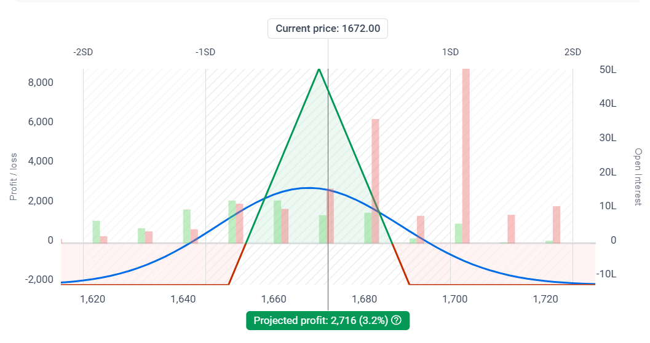

**3.Reverse Jaded Lizard Strategy:**

The strategy itself has three legs. We are selling a deep OTM Call(1690CE)

+ Put(1630PE) and hedging our downside risk with one bought Put(1610PE).

This strategy is suitable as we expect our stock to be range bound. This is an appropriate approach for a moderately bullish trader who expects the stock to be range bound. This strategy also has the perk of eliminating downside risk. It does carry unlimited upside risk.

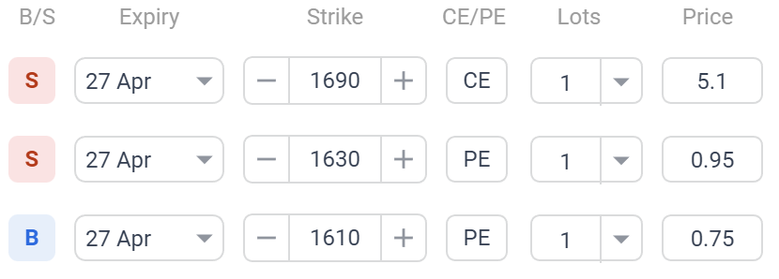

We took 3 positions here:

Long in a put option with a strike price of (K1)=1610 and a premium of (P1)=0.75  
Short in a put option with a strike price of (K2)= 1630 and a premium of (P2)=0.95  
Short in a call option with a strike price of (K3)= 1690 and a premium of (P3)=5.1

| Position | St<1610 | 1610≤St≤1630 | 1630≤St≤1690 | St>1690 |
| --- | --- | --- | --- | --- |
| Long Put(K1) | 1610-St | 0 | 0 | 0 |
| Short Put(K2) | St-1630 | St-1630 | 0 | 0 |
| Short Call(K3) | 0 | 0 | 0 | 1690-ST |
| Payoffs | -20 | ST-1630 | 0 | 1690-St |
| Profit | K1-K2-p1+p2p3=14.7 | ST-1630-p1+p2+p3=ST-1624.7 | St-1630-p1+p2+p3=ST-1624.7 | 1690-St-p1+p2+p3=St-1698.3 |

*multiply all results by 550 to get practical values, as lot size is 550.

Max profit - 2915(1.6%)  
Break-even occurs at two points i)1624.7(-2.8%)

ii)1695.3(1.4%)

Probability of profit - 75%  
Margin required-1.84L

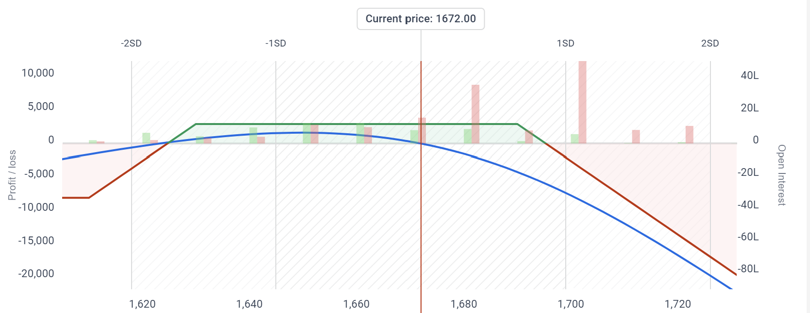

**Overview of TATA Motors**

Tata Motors is a leading global automobile company headquartered in Mumbai, India. The company designs, manufactures, and sells a wide range of vehicles including cars, trucks, buses, and military vehicles. It is a part of the Tata Group, one of India's largest conglomerates.

Tata Motors has a strong presence in India and also operates in various international markets including the United Kingdom, South Africa, Thailand, and Indonesia. The company's key brands include Tata Motors, Jaguar, and Land Rover.

In recent years, Tata Motors has been focused on strengthening its product portfolio, expanding its global footprint, and increasing its market share. The company has also been investing in research and development to develop innovative products and technologies that meet the evolving needs of customers.

Tata Motors has a strong financial performance with a revenue of INR 3,10,397 crore (approximately USD 41.4 billion) in FY 2020-21. The company has a diverse product portfolio that caters to various segments of the automobile industry, which provides it with a competitive advantage.

Overall, Tata Motors has a strong market position and financial performance, and its focus on innovation and global expansion is expected to drive growth in the future. As a result, it is considered a promising investment opportunity for stock exchanges.

**Stock Expectation for TATA MOTORS**

Expectations for the next 1 month - Bullish expectation

To explain the view behind this observation, we will look at the weekly timeframe to form the expectations for the coming 1 month. We can see the SMA 20 ( simple moving average in which the prices of the last 20 days are considered) is most of the times below the closing price on the weekly timeframe, when the stock is bullish and below, when the stock is bearish, this is also the case when we look at the exponential moving average (EMA). Until the closing price and averages don’t intersect, the market sentiment remains same with the average providing resistance and support in respective cases. The latest graph supports buying the stock with visible bullish sentiment.

Now, if we look at the MACD, a crossover happened earlier in which the MACD line crossed the MACD Signal line and went above it, since then it has been below the signal line which indicates bullish expectations and confirms our previous view.

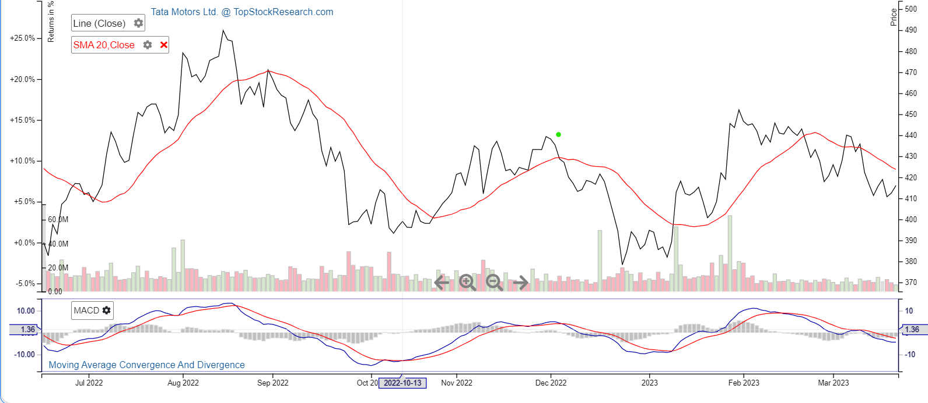

Expectations for the next 2-3 month - Bullish expectation

If we look at the SMA 20 ( simple moving average in which the prices of the last 20 days are considered) indicator we can see that it is much below the closing price on the monthly time frame, this is also the case when we look at the exponential moving average (EMA) so these two indicators show that we should buy the stock i.e there is a bullish expectation.

Now if we look at the MACD (Moving average convergence divergence), the MACD line is above the MACD signal line for a long time which indicates bullish expectations and confirms our view stated above. So, overall the trend is bullish for the next 2-3 months.

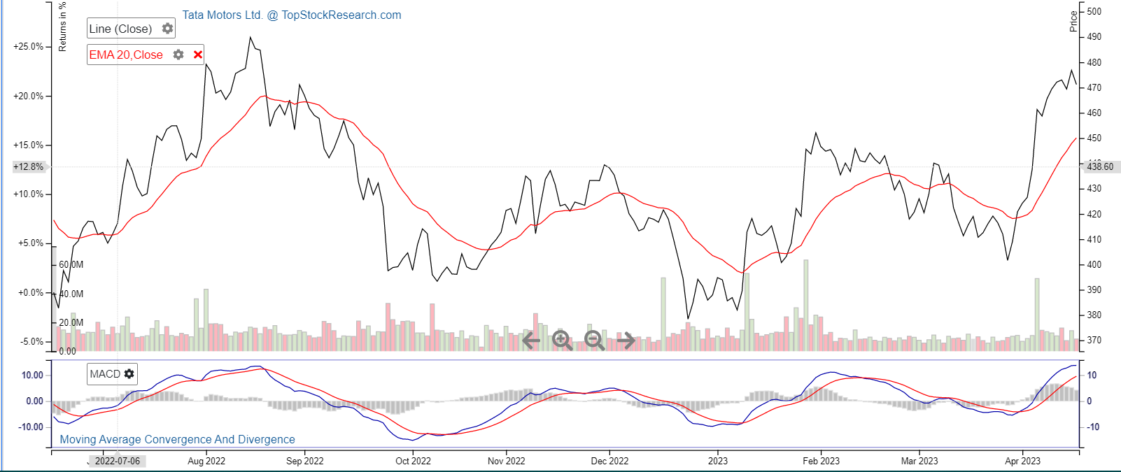

SMA Indicator

Similar to what we did in Hdfc bank, here we can see that.

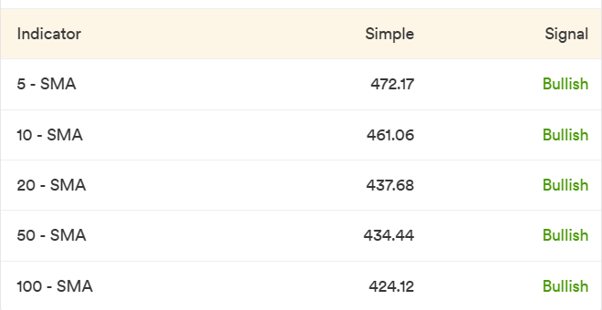

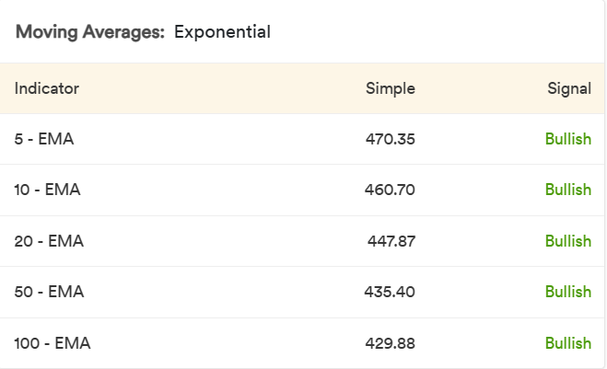

**Fundamental Analysis of TATA Motors**

Net Profit and Sales:

TATA Motors is a large cap stock with a market cap of approximately 170442 Cr. For the twelve months ending 2021-22, its earnings per share(EPS) is -34.5, and PE ratio is 24.2 . The annual sales numbers have increased, and are at 3,18,474 Cr now. 6805 Cr now. Consolidated net profits stand at -3798 Cr. This signifies that the stock is not performing well in the past.   
  
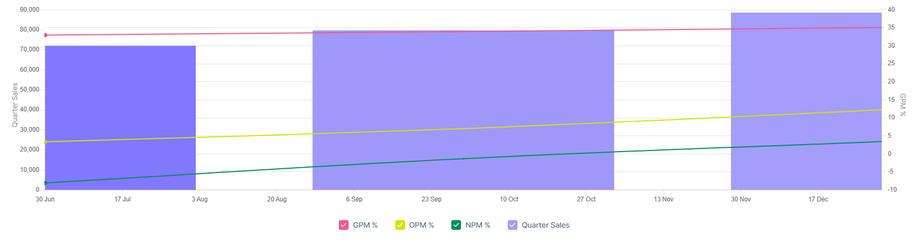  
 Market Sales

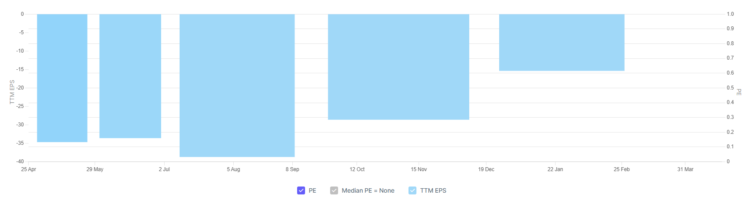  
 PE Ratio

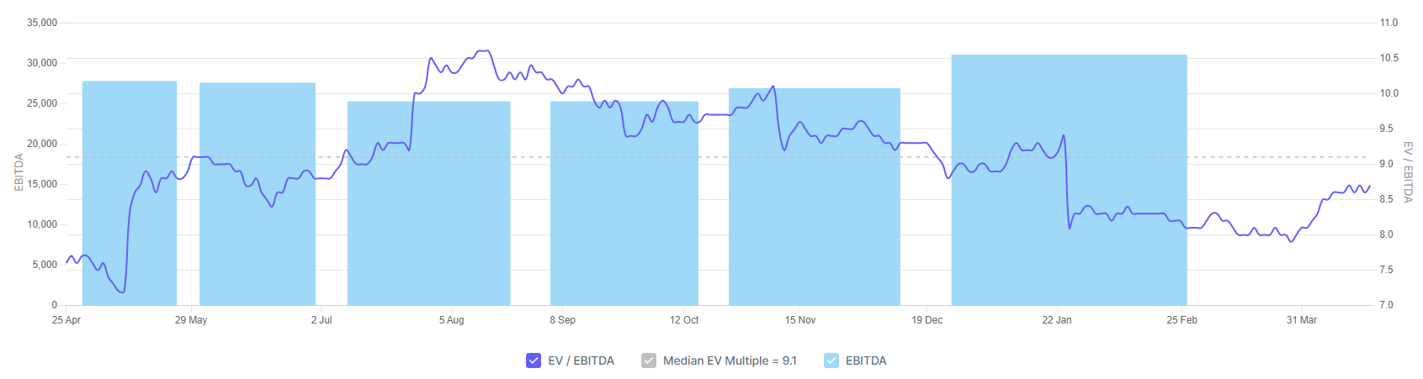  
 EV/EBIDTA

Ratios:

Return Ratios. The return on equity stands at -22.3% while RoA stands at -3.32%.  
  
Growth Ratios: The net sales growth is 22.5% .

Valuation Ratios: The price-to-earnings ratio is -46.17%. This is because of a negative EPS.

Peer Comparison

|  |  |  |  |
| --- | --- | --- | --- |
| Company | PE | EV/EBIDTA | PEG Ratio |
| Bajaj | 21.74 | 15.94 | 3.70 |
| Maruti Suzuki | 34.49 | 20.88 | -4.34 |
| TVS Motocorp | 41.96 | 17.71 | 5.16 |
| Eicher Motors | 33.25 | 21.39 | 221.67 |
| Ashok Leyland | 54.17 | 14.73 | -1.38 |
| Oelectra Greentec | 96.29 | 38.95 | 2.80 |

From the above table, we can observe that the P.E. ratio for TATA Motors is towards the lower side. This can be expected as TATA Motors has a larger industry customer base, as compared to the rest.   
  
The company is one of the most trusted in not only the country, but also the world as a brand, and the crows sentiment is highly positive towards it. It also has a really strong ethic work model. All this makes it a good investment for the near and far months alike.

**Option Strategies for TATA MOTORS**

**1. BUTTERFLY STRATEGY:**

The butterfly strategy is a trading strategy that involves buying and selling a combination of options contracts with different strike prices and expiration dates. This creates a limited risk, limited reward trade with a potential profit in a specific range of prices, and a maximum loss outside of that range. The strategy can be used in both bullish and bearish markets, and is often used when the trader expects the underlying asset to move within a certain range, and for volatility to remain relatively stable. Overall, it is a complex options strategy that should only be used by experienced traders.

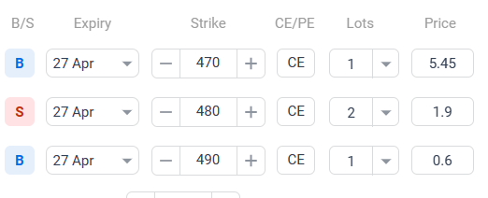

Here we took 3 positions:

1. Long in call option with strike price (K1)=470 with a premium(p1)=5.45
2. 2 short positions in call option with strike price(K2)=480 and a premium(p2)=1.9
3. Long position in call option with strike price(K3)=490 and a premium(p3)=0.6

|  |  |  |  |  |
| --- | --- | --- | --- | --- |
| Position | ST<K1 | 470≤ST≤480 | 480≤ST≤490 | ST>490 |
| Long Call(K1) | 0 | ST-470 | ST-470 | ST-470 |
| Long call (K3) | 0 | 0 | 0 | ST-490 |
| 2Short Call(K2) | 0 | 0 | 2(480-ST) | 2(480-ST) |
| Payoffs | 0 | ST-470 | 2(480)-470-ST | 2(480-490-470) |
| Profit | 2*p2-p1-p3=-2.25 | ST-470-2.6 | 487.75-ST | -2.25 |

*multiply all results by 1425 to get practical values, as lot size is 1425.

Breakeven point-i)472.6

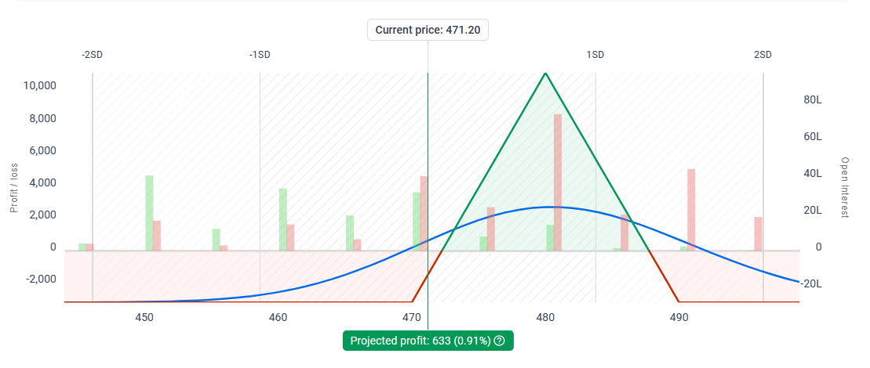

**2. BULL CALL SPREAD:**

This strategy is applicable when there is a moderate bullish expectation for the stock. It has two legs:

One long call that is in the money

One short call that is out of the money

This approach allows for the purchase of a call at a lower cost and limit losses, but it also limits the maximum profit potential of a long call, thus it is best used with the market is acting range-bound but there is a bullish bias as in the case of TATA motors.

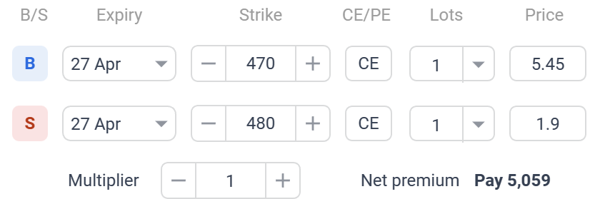

Max profit - 9,191 (21%)

Break-even occurs at one point - 473.6(0.5%)

Probability of profit - 44%  
Margin required-41,681

Lot size - 1425

Premium per contract : 3.55

|  |  |  |  |
| --- | --- | --- | --- |
| Position | St≤470 | 470<St<480 | 480≤St |
| Long Call | 0 | St-470 | St-470 |
| Short Call | 0 | 0 | 480-St |
| Payoff | 0 | St-470 | 10 |
| Profit | -3.55 | St-473.55 | 6.45 |

*multiply all results by 1425 to get practical values, as lot size is 1425.

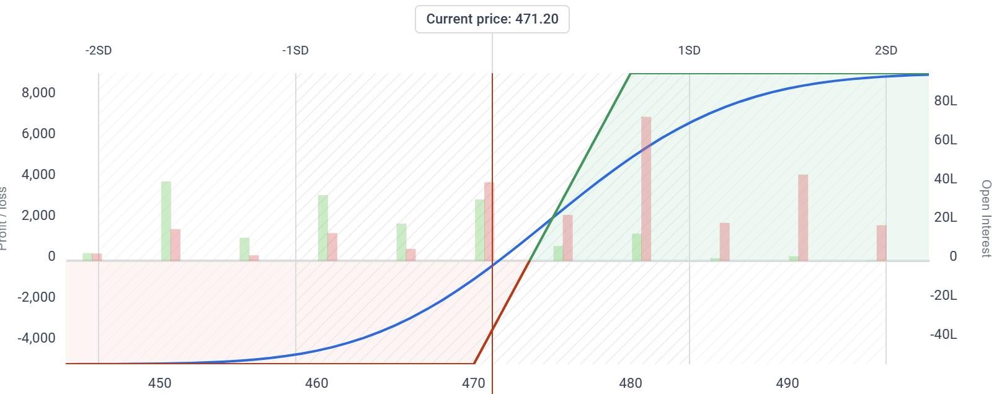

**3.Long Strangle**

The long strangle is an options trading strategy that involves buying both a call option and a put option with the same expiration date, but with different strike prices that are both out-of-the-money. This means that the underlying asset's current price is between the strike prices of the call and put options. The goal of the long strangle is to profit from a significant move in the price of the underlying asset, regardless of which direction the price moves. The risk in this strategy is limited to the premiums paid for the options, while the potential reward is unlimited if the price of the underlying asset moves significantly in either direction. However, if the underlying asset's price remains relatively stable, the long strangle can result in a significant loss. This strategy is considered a higher-risk, higher-reward options trading strategy and is typically used by experienced traders who have a good understanding of options trading and market behavior.

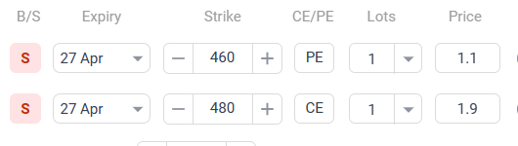

Here we are taking two short positions:

1. A put option with strike price(K1)=460 and will receive a premium (p1)=1.1.

2. A call option with strike price(K2)=480 and will receive a premium (p2)=1.9

|  |  |  |  |
| --- | --- | --- | --- |
| Name | ST<460 | 460≤ST≤480 | ST>480 |
| Short Put(k1) | 460-ST | 0 | 0 |
| Short Call(k2) | 0 | 0 | 480-ST |
| Payoffs | 460-ST | 0 | 480-ST |
| Profits | 460-ST+1.1+1.9=463-ST | p1+p2=3 | 483-ST |

*multiply all results by 1425 to get practical values, as lot size is 1425.

Breakeven Point- i)463

ii)483

Max profit-4275

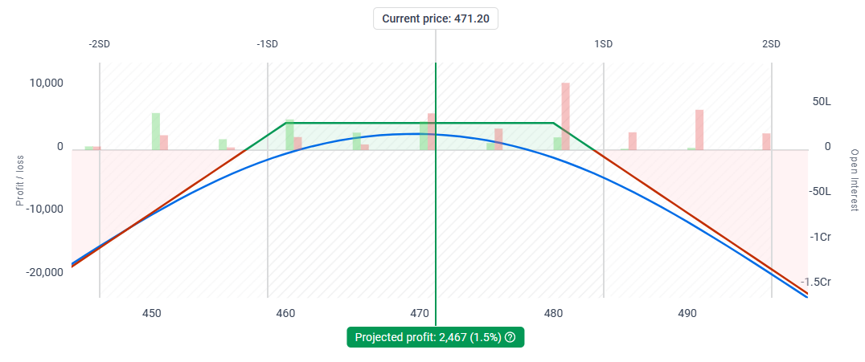

**References and Sources**

1. https://www.screener.in/company/TATAMOTORS/#quarters
2. <https://www.screener.in/company/HDFCBANK/consolidated/>
3. <https://www.hdfcbank.com/personal/about-us/overview/who-we-are#:~:text=HDFC%20is%20India's%20premier%20housing,the%20market%20leader%20in%20mortgages>
4. <https://www.tatamotors.com/about-us/company-profile/>
5. <https://sensibull.com/>
6. https://www.traderscockpit.com/