PORTFOLIO ANALYSIS

ECON F412 & FIN F313 : SECURITY ANALYSIS & PORTFOLIO MANAGEMENT

GROUP: 17



PORTFOLIO ANALYSIS

ECON F412 & FIN F313 : SECURITY ANALYSIS & PORTFOLIO MANAGEMENT

GROUP: 17

| Name | ID |
| --- | --- |
| Aadarsh Labhshetwar | 2021AAPS3023H |
| Aditya Gupta | 2021A3PS2909H |
| Anubhav Mon Baruah | 2021A8PS3198H |
| Khushi Sehgal | 2021A4PS3079H |
| Meet Patel | 2021A7PS2692H |
| Patil Harshith Reddy | 2021A3PS0889H |
| Pavan Viswanandha | 2021A4PS2774H |
| Ritesh Bandaru | 2021A4PS2987H |
| Sarthak Agarwal | 2021A4PS3087H |
| Vanshika Sood | 2021A8PS2910H |

# **ACKNOWLEDGEMENT**

We would like to thank Dr. Shreya Biswas, for providing us this opportunity to work on this project, which helped us in applying the concepts and knowledge learned in the course in real life . We are deeply grateful for her timely guidance throughout the course of this project, which was crucial to the completion of this project. We shall remain indebted to her for her help and guidance throughout the course and this assignment.

We are also thankful to the Economics Department, BITS Pilani Hyderabad Campus, for creating such provisions for students to participate in innovative, useful projects, while also giving us hands-on experience in applying our knowledge to real-world data. This project has certainly developed our skills and has given us the necessary tools to excel further in this field.

# **ABSTRACT**

In the report, detailed analysis and the development of a diversified portfolio of ten securities, including eight different firms, one international security and one cryptocurrency, are shown. The securities are being studied from 1 April 2022 to 31 March 2023.

The firm's raw returns were determined using the fundamental formula (Pt-Pt-1)/Pt-1. To calculate the excess returns on the securities, the risk-free rate was deducted. Using the Nifty50 index as the market benchmark, we conducted a comparable examination of the market.

These variables were used in the portfolio analysis to obtain the minimum variance and tangency portfolios using the Markowitz Model Portfolio. Finally, the same concept was used to generate the efficient frontier.

# **CONTENTS**

**ACKNOWLEDGEMENT 3**

**ABSTRACT 4**

**CONTENTS 5**

**Portfolio Overview 6**

Amara Raja Batteries Limited 6

Adani Energy 6

CESC 7

Cummins India 7

Glaxo 8

Indian Bank 9

Mercedes Benz 9

Tata Chemicals 10

Voltas 10

Ethereum 11

**Markowitz Portfolio 12**

**Domestic Portfolio 13**

Minimum Variance Portfolio 13

Tangency Portfolio 15

Efficient Frontier 17

**International Portfolio 19**

Minimum Variance Portfolio 19

Tangency Portfolio 21

Efficient Frontier 23

**Comparisons 25**

**Conclusions 26**

**References 27**

# 

# **Portfolio Overview**

### **Amara Raja Batteries Limited**

Amara Raja Batteries Limited (ARBL), the flagship company of the Amara Raja Group, is the technological leader and one of the major producers of lead-acid batteries for both industrial and automotive applications in the Indian storage battery market.

Among ARBL's prestigious original equipment manufacturers clients are Maruti Suzuki India Limited, Hyundai Motors India Limited, Ford India Limited, Tata Motors Limited, Mahindra and Mahindra Limited, Honda Cars India Limited, Renault Nissan, Honda Motorcycles & Scooters India Private Ltd, Royal Enfield, Bajaj Auto Ltd, and other well-known automakers. The company manufactures industrial and automobile batteries, which are exported to 32 nations.

Major telecom service providers, telecom equipment manufacturers, the UPS industry (OEM & Replacement), Indian Railways, the electricity, oil and gas industries, among others, have picked Amara Raja as their preferred supplier in India.

**Adani Energy Solutions**

A major force in the energy industry with a focus on clean and sustainable energy solutions is Adani Energy Solutions, a division of the Adani Group. They are actively building and running solar and wind power plants all across India, and they have a significant presence in both conventional and renewable energy sources.

The corporation also provides clean and effective natural gas through a vast pipeline network to homes, businesses, and other industrial and commercial facilities. Adani Energy Solutions, a leader in the sector, places a strong emphasis on technological innovation to increase efficiency and dependability.

The corporation aggressively decreases its carbon footprint and supports environmentally friendly practices in the energy industry as part of its commitment to sustainability. They place a high priority on customer satisfaction by providing energy solutions that are specifically designed to fulfill the demands of residential customers and business partners. Adani Energy Solutions increases its presence abroad, accelerating the transformation of the world to cleaner and more sustainable energy sources while also making a substantial contribution to India's clean energy projects.

### **CESC**

Since 1899, CESC, India's first fully integrated electrical utility company, has been producing and distributing electricity in the cities of Kolkata and Howrah.

With the help of its three generating stations, it is able to supply 88% of the electrical demands of its customers, with electricity from other sources covering the remaining 12%. The coal used in the generating units comes from captive mines in excess of fifty percent.

During the day, they switched to renewable energy sources, and three renewable energy projects were created in three different locations. They have also built two thermal power plants to accommodate the demand for electricity. As part of their continued effort to suit the demands of the consumers and make it simple for them to access all of the benefits from their homes, they have launched value-added online services. The consumer won't need to go to workplaces because work can be done from home. Today, all of the services are available online.

Their goals are to remain loyal, deliver exceptional customer service, and establish a reputation for being morally and environmentally responsible.

### **Cummins India**

The largest operation for Cummins in India is Cummins India Limited, the top producer of diesel and natural gas engines in the nation since its founding in 1962. One of the seven legally recognised branches of the Cummins Group in India, it consists of the business divisions Engine, Power Systems, and Distribution and has a 51% stake in Cummins Inc.

For light, medium, and heavy-duty on-highway commercial vehicle sectors as well as off-highway commercial equipment industries including construction and compressors, engines starting at 60 horsepower are developed.

In addition to power generation systems that include integrated generator and transfer switches, paralleling switchgear, and controls for use in standby, prime, and continuous rated systems, the Power Systems Business develops and produces high-horsepower engines for use in marine, railway, defense, and mining applications. To guarantee equipment uptime, the Distribution Business provides Cummins equipment with products, packages, services, and solutions. The company's nationwide network makes all of its Cummins parts, new and used engines, batteries, services, and customer support available.

**Glaxo**

GlaxoSmithKline (GSK), a significant multinational pharmaceutical and healthcare organization with its headquarters in London, United Kingdom, was created through a merger in 2000. GSK, which specializes in prescription medications, vaccines, and over-the-counter medications, is well known for its dedication to improving human health and wellbeing. Their knowledge covers a wide range of therapeutic fields, including infectious disorders, respiratory health, and vaccines. They play a vital part in international immunization campaigns.

GSK provides consumer healthcare products that support oral health, nutrition, and wellbeing in addition to medications. They invest a lot of money in research and development because they are committed to finding innovative therapies and solutions for healthcare problems.

In order to increase access to healthcare globally, GSK, which operates globally, works with healthcare organizations, governments, and research institutions. GSK's commitment to sustainability and corporate responsibility drives the company to reduce its impact on the environment, uphold ethical business conduct, and improve healthcare access in underprivileged communities. Pharmaceutical and healthcare industry pioneer GlaxoSmithKline is dedicated to enhancing human health through pharmaceuticals, vaccines, and consumer healthcare products, with a focus on research, innovation, and international cooperation.

### **Indian Bank**

Indian Bank is a government-owned banking and financial services company. It was established in 1907 and is headquartered in Chennai, India. The Ministry of Finance of the Indian Government owns it. It is one of India's top-performing public sector banks and services over 100 million customers through its 41,620 employees, 6,004 branches, 5,428 ATMs, and Cash Deposit Machines. The bank's overall revenue as of March 31, 2021, was 930,000 crores ($130 billion).

Unlike most other banks, the bank's information systems and security procedures have received ISO 27001:2013 accreditation. It has offices in Singapore and Colombo as well as Foreign Currency Banking Units in Jaffna and Colombo. There are 227 overseas correspondent banks for it spread across 75 different nations. Since 1978, the bank has been owned by the Indian government. Nirmala Sitharaman, the finance minister for India, announced on August 30 that Allahabad Bank would merge on April 1 to become the seventh-largest bank in the nation.

**Mercedes Benz Group AG**

A well-known German automaker lauded for its luxury and innovation in the automotive sector is Mercedes-Benz Group AG, a division of Daimler AG. Mercedes-Benz has a history of introducing ground-breaking technological innovations, and it continually produces cars with unrivaled comfort, performance, and safety.

The company's presence is felt throughout the world through a sizable network of production facilities and dealerships that cater to a wide range of customers, including both private individuals and business entities. Mercedes-Benz continues to be dedicated to sustainability by making significant investments in electric and hybrid vehicles, helping to protect the environment while providing high-end electric solutions.

Mercedes-Benz Group AG has established itself as a market leader and a global standard-setter thanks to its commitment to innovation, luxury, and sustainability.

### **Tata Chemicals**

The company's story is around harnessing science's advantages for goals other than financial gain. They work in two verticals: introductory chemistry and specialty chemistry. The company's Basic Chemistry product line provides essential ingredients to many of the biggest brands in the glass, detergents, medicine, biscuit manufacturing, bakeries, and other industries around the world.

They also are the third- and sixth-biggest producers of soda ash and sodium bicarbonate in the world, respectively, and also run Asia's largest saltworks.

Due to their Specialty Chemistry discoveries, Tata NQ, India's first and only nutritional science firm, was established. They created the line of wholesome prebiotic products known as Fossence and Gossence, which is sold to B2B clients in Asia, North America, Europe, the Middle East, and India. The company holds a significant foothold in the crop protection sector because to its subsidiary Rallis India Ltd.

### **Voltas**

An international home appliance business with an Indian origin called Voltas Limited focuses on cooling and air conditioning. The business was established on September 6, 1954, in Mumbai as a partnership between Tata Sons and Volkart Brothers. The company's Chairman is Noel Tata, while its Managing Director and Chief Executive Officer is Pradeep Bakshi.

The top air conditioning business in India is called Voltas. In the 1960s, it started making air conditioners with permission from Carrier Corporation. The first window air conditioner in India was created by Voltas employing DC inverter motors with variable speeds. A cutting-edge technology called DC Inverter Technology enhances cooling while reducing how frequently the compressor is turned on and off. This results in a greater reduction in power usage. Additionally, Voltas runs a huge network of repairs. The company is also a sizable manufacturer of evaporative coolers, which are commonly used in dry and semi-arid locations for comfort cooling.

### **Ethereum**

With the help of the Ethereum cryptocurrency transfer mechanism, you can transmit money digitally to other people for a little fee. Additionally, it powers programmes that are accessible to everyone and cannot be turned off.

It builds on Bitcoin's invention by becoming the first programmable blockchain in the world, but with substantial improvements. Both enable the use of digital currency in the absence of banks or payment processors. Ethereum can be used to construct a variety of digital assets, including Bitcoin, as it is programmable.

Additionally, it suggests that Ethereum is not just for making payments. It can be used for many other things, including software, gaming, and financial services, and it won't restrict or steal user information. Everyone can use Ethereum to access digital currency and data-friendly services, regardless of their background or location. The cryptocurrency ether (ETH) and thousands of other current apps are both powered by this technology.

# **Markowitz Portfolio**

Construction problems can be generalized to the case of many risky securities and a risk free asset. As in the two risky assets example, the problem has three parts:

* First, we identify the risk–return combinations available from the set of risky assets.
* Next, we identify the optimal portfolio of risky assets by finding the portfolio weights that result in the steepest CAL by maximizing the Sharpe Ratio of our portfolio.
* Finally, we choose an appropriate complete portfolio by mixing the risk-free asset with the optimal risky portfolio by maximizing the utility function based on the risk aversion of the investor.

• When short selling is allowed

𝑀𝑖𝑛 𝜎𝑃2 = w’𝜮w

Constraint: w’1= 1

𝑤- vector of asset weights

Σ - variance-covariance matrix

**•** When short selling is banned

𝑀𝑖𝑛 𝜎𝑃2 = w’𝜮w

Constraint: w’1= 1, w>0

𝑤- vector of asset weights

Σ - variance-covariance matrix

# **Domestic Portfolio**

## **Minimum Variance Portfolio**

A minimum variance portfolio indicates a well-diversified portfolio that consists of individually risky assets, which are hedged when traded together, resulting in the lowest possible risk for the rate of expected return.

**When short selling is allowed**

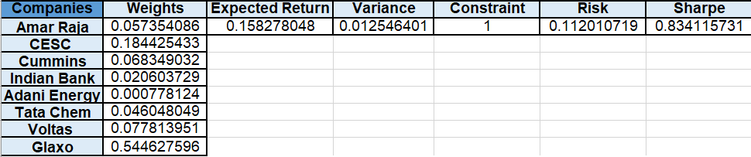

**When short selling is not allowed**

**Interpretation for minimum variance:**

The table for minimum shows the weights required for achieving minimum variance portfolio when short selling is allowed. According to this table, we can see that for minimum variance we have to take a short position in all the stocks except for CESC and Gold as they have low risk comparatively. Also more weight is given to Cesc because of having significantly less risk compared to gold.

When we analyze the table for minimum variance portfolio when short selling is not allowed we see that weights are only given to CESC and Gold for the same reason that CESC and gold have less variance.

## **Tangency Portfolio**

The tangency point is the optimal portfolio of risky assets, known as the market portfolio. It is the portfolios with the best trade-off between expected returns and variance (risk) lie on this line.

**When short selling is allowed**

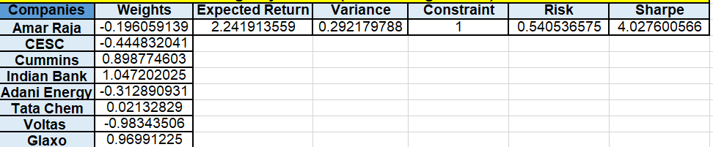

**When short selling is not allowed**

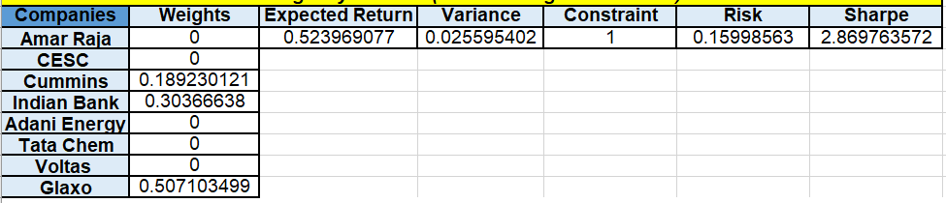

**Interpretation for tangency portfolio:**

In a tangency portfolio our objective is to maximize the risk adjusted return i.e. maximize the sharpe ratio. For that reason when short selling is allowed, the weights are given as such to maximize the sharpe ratio or maximize the slope of CAL. Except for Cummins,Indian Bank and Glaxo, all the weights are negative indicating taking a short position in all these stocks. But in case when short selling is banned all the weight is given to Cummins,Indian Bank and Glaxo as we are not allowed to short sell the other securities to maximize the risk adjusted return and in turn sharpe ratio will be less than that of when short selling is allowed. Also we can compare that although in minimum variance portfolio, risk is comparatively less but sharpe ratio is much less than the tangency portfolio.

## **Efficient Frontier**

The efficient frontier is a collection of optimum portfolios that provide the best anticipated return for a given level of risk or the least risk for a given level of expected return.

Portfolios that are below the efficient frontier are sub-optimal because they do not generate enough return for the amount of risk they carry. Also, portfolios that cluster to the right of the efficient frontier have a greater degree of risk for the stated rate of return, making them sub-optimal.

**When short selling is allowed**

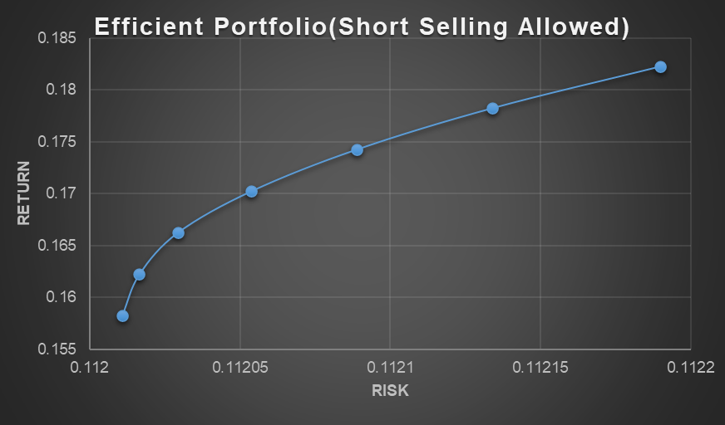

**When short selling isn’t allowed**



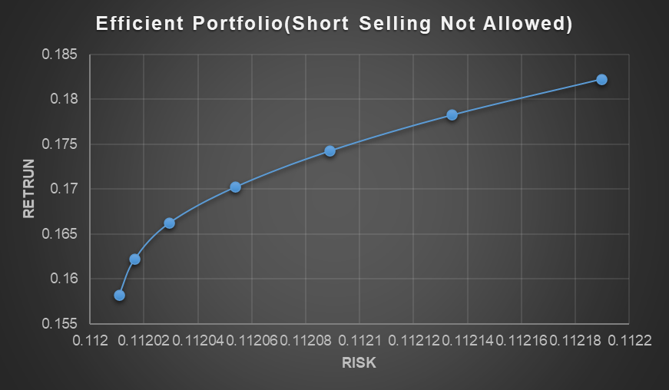

# **International Portfolio**

## **Minimum Variance Portfolio**

**When short selling is allowed**

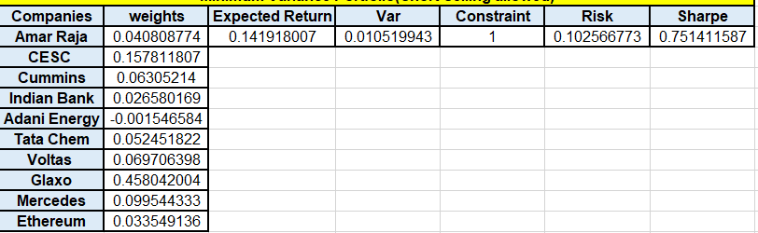

**When short selling is not allowed**

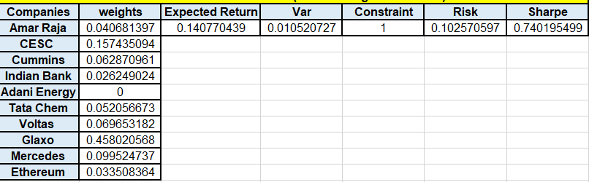

**Interpretation for minimum variance:**

The table for minimum shows the weights required for achieving minimum variance portfolio when short selling is allowed. According to this table, we can see that for minimum variance we have to take a short position in only Adani Energy as it has more risk comparatively.

When we analyze the table for minimum variance portfolio when short selling is not allowed we see that weights are given to all stocks except Adani Energy because all other stocks are comparatively less risky than Adani Energy

## 

## **Tangency Portfolio**

**When short selling is allowed**

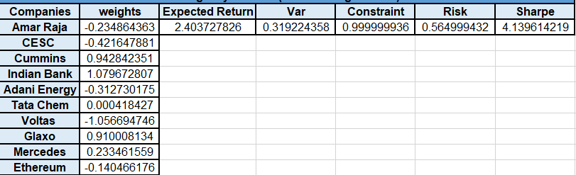

**When short selling is not allowed**

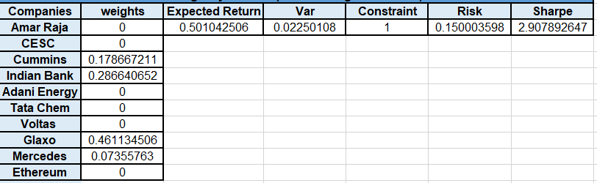

**Interpretation for tangency portfolio:**

In a tangency portfolio our objective is to maximize the risk adjusted return i.e. maximize the sharpe ratio. For that reason when short selling is allowed, the weights are given as such to maximize the sharpe ratio or maximize the slope of CAL. Weights of Amar Raja,CESC,Adani Energy,Voltas and Ethereum are negative indicating taking a short position in all these stocks. But in case when short selling is banned all the weight is given to Cummins,Indian Bank,Glaxo and Mercedes as we are not allowed to short sell the other securities to maximize the risk adjusted return and in turn sharpe ratio will be less than that of when short selling is allowed. Also we can compare that although in minimum variance portfolio, risk is comparatively less but sharpe ratio is much less than the tangency portfolio.

## **Efficient Frontier**

**When short selling is allowed**



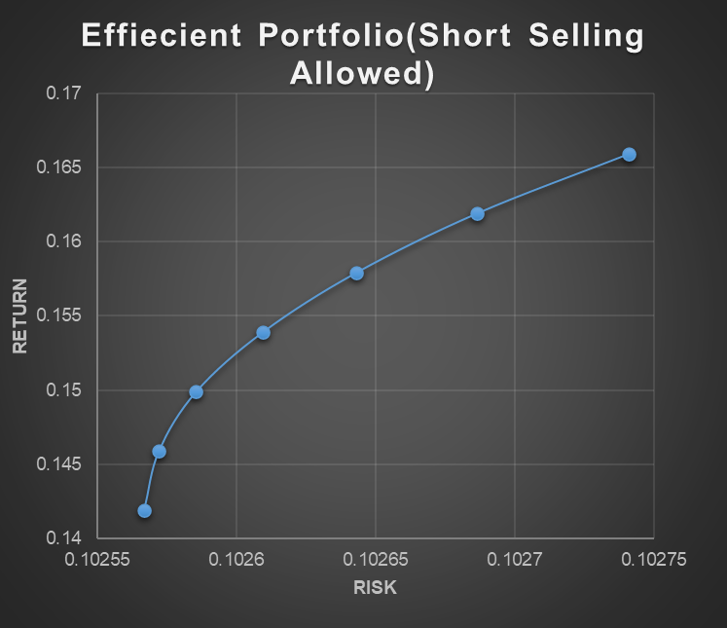

**When short selling is not allowed**

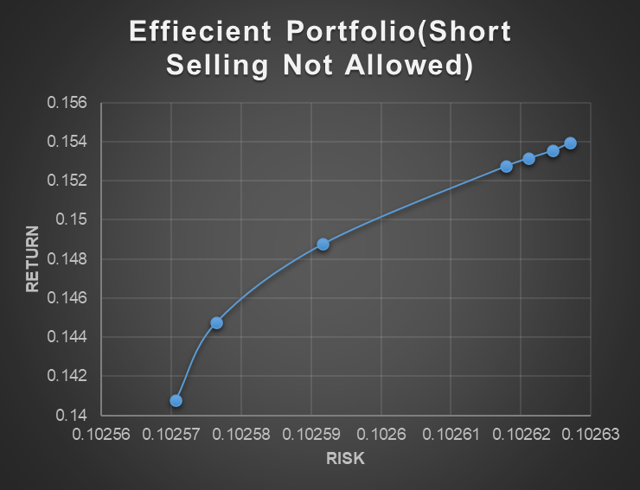

## 

# **Comparisons**

Domestic and International:

Domestic Portfolio had return of 52.39% for 15.998% risk whereas International Portfolio had return of 50.104% for 15.0004% risk which shows that as soon as we added the two securities to domestic portfolio ,risk decreased and therefore return decreased due to risk return trade-off.

Domestic and Index:

Domestic Portfolio had a return of 52.39% for 15.998% risk whereas Index had return of -2.37% for 0.93% which means Domestic Portfolio has superior risk adjusted performance.

International And Index:

International Portfolio had a return of 50.104% for 15.0004% risk whereas Index had return of -2.37% for 0.93% which means International Portfolio has superior risk adjusted performance.

# 

# 

# 

# 

# **Conclusions**

**For Domestic Portfolio**

An investment in the bundle of the equity instruments asset class involves the requirement of a minimum risk of 11.201% for around 15.828% return. Amongst the eight securities, Glaxo had the highest weightage.It has an expected return of 15.828%, which is low for the amount of risk taken, as evident by the Sharpe ratio of 0.834.

An investment in the bundle of the equity instruments asset class involves the requirement of a tangency portfolio, has a risk of 15.998% for around 52.39% return. Amongst the eight securities, Indian Bank had the highest weightage, and again it was a leveraged position.

**For International Portfolio**

An investment in the bundle of the equity instruments asset class involves the requirement of a minimum risk of 10.2567% for around 14.1918% return. Amongst the ten securities, Glaxo had the highest weightage.

An investment in the bundle of the equity instruments asset class involves the requirement of a tangency portfolio, has a risk of 15.0004% for around 50.104% return. Amongst the ten securities, Indian Bank had the highest weightage, and again it was a leveraged position.

For all the portfolios we considered, we observed that as return increased, so did the risk, consistent with the risk-return trade-off concept.

# **References**

* <https://www.cesc.co.in/>
* <https://www.cummins.com/en/in/company/india-companies/cummins-india-limited>
* <https://www.tatachemicals.com/>
* <https://www.amararaja.com/>
* <https://www1.nseindia.com/index_nse.htm>
* <https://finance.yahoo.com/>
* <https://www.moneycontrol.com/india/stockpricequote/banks-public-sector/indianbank/IB04>