

Title:



Seminar Report submitted by

Name:
Reg. Number:
Course code:
Semester/Batch:
Mentor:

B. Tech in Mechanical Engineering
Department of Mechanical and Manufacturing Engineering
Ramaiah University of Applied Sciences
University House, Gnanagangothri Campus, New BEL Road, M S R Nagar, Bangalore, Karnataka, INDIA - 560 054

Declaration Sheet
Student Name
Reg. No
Programme | B. Tech. (Mechanical Engineering) |  |  |  | Batch |  | 2019
Course Code | 19MEP316A
Course Title | Seminar
Course Date |  |  | to
Declaration

The seminar report submitted herewith is a result of my own investigations and that I have conformed to the guidelines against plagiarism as laid out in the Student Handbook. All sections of the text and results, which have been obtained from other sources, are fully referenced. I understand that cheating and plagiarism constitute a breach of University regulations and will be dealt with accordingly.

Signature of the student |  |  |  |  |  |  | Date
 |  | Name |  |  |  | Signature |  |  | Date
First Examiner
Second Examiner
Mentor

Contents
Declaration Sheet i
LIST OF ABBREVIATIONS AND NOMENCLATURE iii
LIST OF TABLES iv
LIST OF FIGURES v
ABSTRACT 1
1. Introduction and scope of work (2 pages) 2
1.1 Introduction should address the following: <Heading-2: Calibri, 12> 2
1.1.1 Sub Heading<Heading-3: Calibri, 12> 2
2. Literature Review (Maximum 5 pages) 3
2.1 Heading 3
2.1.1 Sub Heading 3
3. Details of the Topic 4
3.1 History 4
3.1.1 Sub Heading 4
3.2 Implications on (Society, Environment, business, etc) 4
3.2.1 Sub Heading 4
3.3 Facts and Figures 5
3.4 Data Analysis 5
4. Challenges and Opportunities (2 pages) 6
4.1 Heading 6
4.1.1 Sub Heading 6
6. Conclusion and Suggestions for Future Work (1 page) 7
6.1 Heading 7
REFERENCES (minimum 5) 8
APPENDIX 10

LIST OF ABBREVIATIONS AND NOMENCLATURE

<Symbol1> | <Details>
<Symbol2> | <Details>

LIST OF TABLES
Table 1: Example List of B.Tech. programmes offered by MSRUAS 12

LIST OF FIGURES
Figure 1: Margin setup for the whole document 11
Figure 2: Example Block Diagram of a Single Stage VCR Cycle 12

ABSTRACT
Write the overall summary of the selected topic of the seminar in at least three different paragraphs.
First Paragraph to address the motivation and the need for selecting the topic of seminar.

Second Paragraph to address scope and important highlights of your findings.

Third Paragraph to discuss your views on the topic and conclusion.

Keywords: <Enter any five words that best describe your report>

Note: Length not to exceed one page and Font size: 12

1. Introduction and scope of work (2 pages)

1.1 Introduction

1.1.1 Definition
.

1.2 Scope
.

2. Literature Review (Maximum 5 pages)

2.1 Heading
- This chapter should include survey of literature with respect to the selected topic. The sources for information can be articles from journals, conference proceedings, websites, text books e-sources etc. Suitable in text referencing must be shown.

2.1.1 Sub Heading
- Heading and sub-heading can be highlighted in bold; remaining body to be kept in Normal

3. Details of the Topic

3.1 History

3.2 Implications on (Society, Environment, business, etc)

3.2.1 Sub Heading

3.3 Facts and Figures

3.4 Data Analysis

4. Challenges and Opportunities (2 pages)

4.1 Heading
- Various current challenges and opportunities in the selected topic to be addressed here

4.1.1 Sub Heading

6. Conclusion and Suggestions for Future Work (1 page)

6.1 Heading
- This chapter to discuss critical review of the student about the seminar topic based on the findings
- Conclusions

- Suggestions for future work

REFERENCES (minimum 5)
<References to be included here in Harvard Referencing format. Student may use “References” tab available in Microsoft Word version 2010 and above for referencing the texts and adding Bibliography. All the references need to be listed in alphabetical order (not in the order of occurrence in the text). All the references listed under References need to be cited at least once in the body of the report.>
Example References:
[Referring a Journal Paper]
- L. Shao and T.X. Zhong, “Virtual Manufacturingand Its Application,” J. of Shanghai Jiaotong university. Shanghai, vol. 33, pp. 906-911, July 1999.

[Referring a Book]
- Lee, D. E., and Hahn, H. T., 1997. “Generic modular operations for virtual manufacturing process”. In Proceedings of DETC’97, vol. , ASME Design Engineering Technical Conferences.
[Referring an Edited Book]
3. Applied virtual reality. In SIGGRAPH Course Notes 14. ACM SIGGRAPH,1998

[Referring a Chapters of Edited Book]
4. Dessouky, M. M. et al. Virtual Factory Teaching System in Support of Manufacturing Education. Journal of Engineering Education, Vol. 87, No. 4, pp. 459-467 (1998)

[Referring an E-Book]

[Referring a Dissertation]

[Referring a White Paper]

[Referring Standards]

[Referring a Manual]

[Referring Webpages]

[Referring a Patent]

APPENDIX
Any material, which is important but affects the flow of your writing can be brought under Appendix.

General Guidelines while preparing the Seminar Report:
- This exercise is to assess the students’ performance in written communication
- Use clear and short sentences and write in third person. Avoid using bombastic words or jargons
- All the assumptions and input data should be documented and referenced
- Use British English-spelling
- Units and consistency in the use of units is important. Use only SI Units
- Use A4 white sheet (bond paper) for printing your project report. For the main body of the text, use font size of 12, Calibri, sub-headings can be of same font size but bold
- Margin setup for the whole document to be done as shown in Figure 1
  - Go to Page Layout>Margins>Custom Margins
- A plagiarism report (Similarity<15%) to be attached at the end of this document
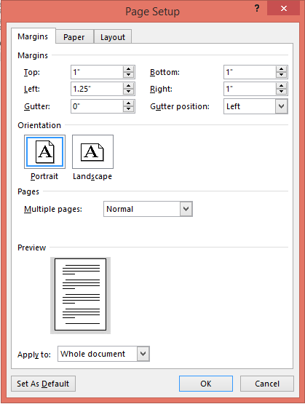
Figure 1: Margin setup for the whole document
<Table to be referenced in the text along with the caption number. Table to include the table caption with number along with table title. Table caption to be given above the table.>
Example:
B. Tech. programmes offered by MSRUAS are listed in Table 1.
Table 1: Example List of B.Tech. programmes offered by MSRUAS
Sl No. | Programme
1 | Aerospace Engineering
2 | Automotive Engineering
3 | Civil Engineering
4 | Computer Science and Engineering
5 | Electrical and Electronics Engineering
6 | Electronics and Communication Engineering
7 | Mechanical Engineering

<Figures used need to be included and cited within the text. Figure caption to include number and description of the figure. Figure caption to be given below the figure>

Example:
Figure 1 shows a block diagram of a Vapour Compression Refrigeration (VCR) cycle. Room air conditioners and Domestic Refrigerators employ VCR cycle.
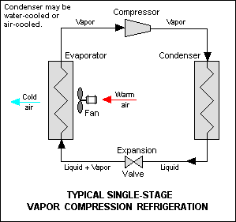
Figure 2: Example Block Diagram of a Single Stage VCR Cycle

