

MODULE: Data Communication & Networking
COURSEWORK: Group Project 1
Network Requirements Analysis & Design
Organisation Modelled: Nigel Law Firm

Group Members

GROUP 3
NO | NAME
1 | Senabulya Elijah
2 | Happy Ategeka Wilfred
3 | Tumusiime Judiya
4 | Mirembe Bathshebah
5 | Tumukundane Ambrose
6 | Kemigisha Chicky Abigail
7 | Naiga Kevin Nana
8 | Katongole Jordan Happy
9 | Mawanda Isaac Newton
10 | Kimbugwe Collin
11 | Lubega Paul
12 | Kharbino Diing Lual

1. Organisation and Network Requirements

1.1 Organisation overview
Nigel Law Firm is a small law practice spread over three floors (ground, first and second) with a dedicated server room. The firm handles confidential client case files, so the network must keep client data private, give staff reliable internet and printing, and support internal phone calls. The network is a wired LAN with wireless coverage for guests and for the Associates' laptops, connected to an ISP for internet access.

1.2 Departments and users
Department | Users | Floor | VLAN | Notes
Front Desk / Reception | 2 | Ground | 10 | Visitor-facing; guest Wi-Fi (AP1) is located here
Partners Chambers | 3 | Ground | 20 | Senior lawyers
Associates / Legal Dept | 7 | First | 30 | Largest department; uses AP2 for laptops
Accounts & Finance | 2 | Second | 40 | Billing and financial records
Managing Partner (Top Management) | 2 | Second | 50 | Highest level of access
IT / Admin / Library | 6 | Server farm | 60 | Also hosts the servers
TOTAL | 22

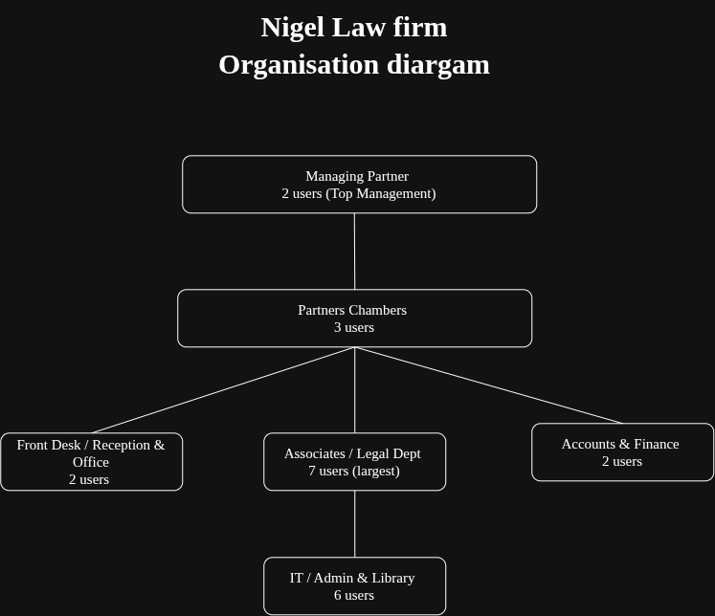Illustration 1: Organisation Diagram

1.3 Users and devices
The firm has 22 users and 30 end devices. Access points are counted separately as network infrastructure.
End device | Qty | Purpose
Desktop PCs | 10 | Fixed workstations (Front Desk, Associates, Accounts, IT/Library)
Laptops | 10 | Partners, Managing Partner, Associates (wireless) and IT
Printers | 3 | One per floor, shared through centralized printing
Servers | 2 | File Server and DHCP/DNS Server
IP Phones | 5 | Internal VoIP calls
TOTAL END DEVICES | 30

1.4 Required services
- Internet access for all staff, through one gateway router using NAT.
- File sharing: a central File Server that stores case files.
- Centralized printing: three network printers reachable from every department.
- DHCP: automatic addressing from the DHCP/DNS server, so staff do not configure IPs by hand.
- DNS: name resolution on the same server, for example fileserver.nigellaw.local.
- VoIP: internal calls between the five IP phones, run by the router (Call Manager Express).

1.5 Security needs
- Client confidentiality: case files must only be reachable by authorised staff.
- ACLs: Front Desk (VLAN10) is denied access to the File Server (192.168.10.86).
- Firewall on the router: only return traffic for connections started inside is allowed in from the internet.
- Encrypted File Server: case files are encrypted at rest.
- Reception VLAN isolation: Front Desk and guest Wi-Fi sit in their own VLAN.
- WPA2-PSK on both wireless access points.
- DHCP Snooping: blocks rogue DHCP servers.

2. Network Topology

2.1 Topology chosen: Extended Star
The network uses an extended star topology. The Router 2811 connects to the ISP and to a central Core Switch 2960. The Core Switch is the centre of the star, and four access switches (one per floor plus the server farm) connect to it, forming smaller stars below. Every end device connects to a switch through its own cable.
Traffic path: ISP (fiber) to Router 2811 (gateway, NAT, firewall, inter-VLAN routing) to Core Switch 2960 → Switch 1 (Ground Floor) | Switch 2 (First Floor) | Switch 3 (Second Floor) | Switch 4 (Server Farm) → end devices.

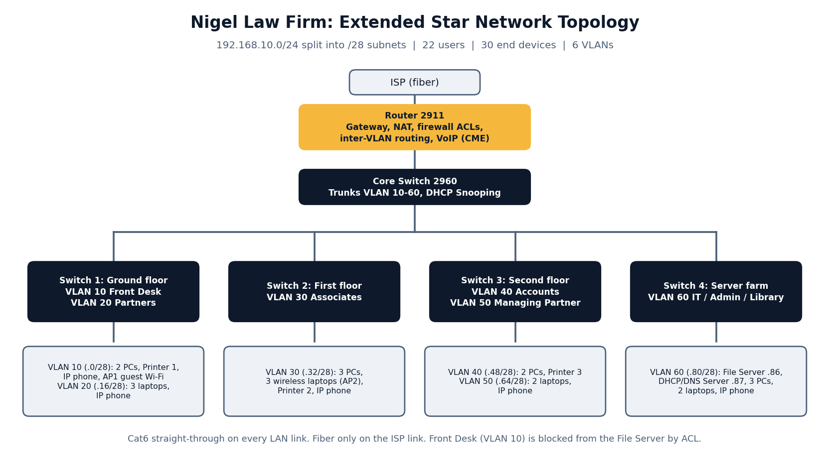

2.2 Link table
From | To | Cable | Carries
ISP cloud | Router 2811 Gi0/0 | Fiber optic | Internet
Router 2811 Gi0/1 | Core Switch Gi0/1 | Cat6 straight-through | Trunk VLAN 10,20,30,40,50,60
Core Switch Fa0/1 | Switch 1 Gi0/1 | Cat6 straight-through | Trunk VLAN 10,20
Core Switch Fa0/2 | Switch 2 Gi0/1 | Cat6 straight-through | Trunk VLAN 30
Core Switch Fa0/3 | Switch 3 Gi0/1 | Cat6 straight-through | Trunk VLAN 40,50
Core Switch Gi0/2 | Switch 4 Gi0/1 | Cat6 straight-through | Trunk VLAN 60
Access switches | PCs, laptops, printers, phones, servers, APs | Cat6 straight-through | Access port in the device's VLAN

2.3 Device placement per switch
Switch | Floor | VLANs | Devices connected
Switch 1 | Ground | 10, 20 | 2 PCs (Front Desk), Printer 1, IP Phone, AP1 (Guest Wi-Fi); 3 laptops (Partners), IP Phone
Switch 2 | First | 30 | 3 PCs, Printer 2, IP Phone, AP2 (3 wireless laptops)
Switch 3 | Second | 40, 50 | 2 PCs (Accounts), Printer 3; 2 laptops (Managing Partner), IP Phone
Switch 4 | Server farm | 60 | File Server, DHCP/DNS Server, 3 PCs, 2 laptops, IP Phone

3. Transmission Media and Devices

3.1 Transmission media
Medium | Where used | Justification
Cat6 UTP (straight-through) | All LAN links: end devices to switch, switch to switch, switch to router | Supports 1000 Mbps up to 100 m, which covers a single office building. Cheap, easy to install and replace. Straight-through is correct because every link joins unlike devices (PC to switch, router to switch), and modern switch ports auto-detect anyway.
Fiber optic | ISP to Router 2811 | Highest speed and lowest signal loss over distance, and immune to electrical interference. The internet link is shared by all 22 users, so it is the one link worth the extra cost.
Wireless (802.11 with WPA2-PSK) | AP1 (guests), AP2 (Associates) | Lets visitors and lawyers with laptops move around without cables. WPA2-PSK encrypts the traffic.

3.2 Network devices
Device | Qty | Role | Justification
Router 2811 | 1 | Gateway to ISP, NAT, firewall ACLs, inter-VLAN routing (router-on-a-stick), DHCP relay, VoIP (CME) | Has Gigabit interfaces and enough throughput for 22 users. It is the only Layer 3 device in the design, so it routes between VLANs.
Core Switch 2960 | 1 | Central aggregation point, VLAN trunking, DHCP Snooping | One central switch keeps the extended star simple and gives a single point to apply DHCP Snooping.
Access Switch 2960 (Switch 1–4) | 4 | Connect end devices; one per floor plus the server farm | Separating floors keeps cable runs short. Separating the server farm lets us give the servers a dedicated uplink.
Wireless AP (AP1, AP2) | 2 | AP1: guest Wi-Fi at Front Desk. AP2: Associates' laptops | Guest access is separated from staff. AP2 covers the largest department on the first floor.
File Server | 1 | Central storage of encrypted case files (192.168.10.86) | One controlled place for case files is easier to secure and back up than files on individual PCs.
DHCP/DNS Server | 1 | Automatic IP addressing and name resolution (192.168.10.87) | Central management of addresses for 30 devices and names that are easier to remember than IPs.
Network Printers | 3 | Centralized printing, one per floor | Staff print from any department without a printer on every desk.
IP Phones | 5 | Internal VoIP calls | No separate phone wiring; calls run over the same LAN.

4. IP Addressing Plan

4.1 Subnetting method
The firm uses the private block 192.168.10.0/24, divided into /28 subnets. A /28 has 4 host bits, so each subnet has 2^4 = 16 addresses in steps of 16. The mask is 255.255.255.240. Each subnet has 13 usable host addresses once the network address, broadcast address and the gateway are accounted for. The largest VLAN (Associates, 7 users plus printer, AP and phone) fits in one /28.

4.2 Subnetting table
VLAN | Department | Network address | Subnet mask | Gateway | Usable range | Broadcast
10 | Front Desk | 192.168.10.0/28 | 255.255.255.240 | 192.168.10.1 | 192.168.10.2 – .14 | 192.168.10.15
20 | Partners Chambers | 192.168.10.16/28 | 255.255.255.240 | 192.168.10.17 | 192.168.10.18 – .30 | 192.168.10.31
30 | Associates / Legal | 192.168.10.32/28 | 255.255.255.240 | 192.168.10.33 | 192.168.10.34 – .46 | 192.168.10.47
40 | Accounts & Finance | 192.168.10.48/28 | 255.255.255.240 | 192.168.10.49 | 192.168.10.50 – .62 | 192.168.10.63
50 | Managing Partner | 192.168.10.64/28 | 255.255.255.240 | 192.168.10.65 | 192.168.10.66 – .78 | 192.168.10.79
60 | IT / Admin / Library + Servers | 192.168.10.80/28 | 255.255.255.240 | 192.168.10.81 | 192.168.10.82 – .94 | 192.168.10.95

4.3 Address allocation inside each VLAN
VLAN | Gateway | Static addresses | DHCP pool (from 192.168.10.87) | Spare
10 | 192.168.10.1 | Printer 1 .13, AP1 .14 | .2 – .12 (11 addresses)
20 | 192.168.10.17 | none | .18 – .30 (13 addresses)
30 | 192.168.10.33 | Printer 2 .45, AP2 .46 | .34 – .43 (10 addresses) | .44
40 | 192.168.10.49 | Printer 3 .61 | .50 – .59 (10 addresses) | .60, .62
50 | 192.168.10.65 | none | .66 – .78 (13 addresses)
60 | 192.168.10.81 | File Server .86, DHCP/DNS .87 | .88 – .94 (7 addresses) | .82 – .85

4.4 Networking table (Device, Interface, IP, Subnet Mask, Default Gateway)
Device | Interface | IP address | Subnet mask | Default gateway
Router 2811 | Gi0/0 (to ISP) | ISP-assigned | ISP-assigned | ISP
Router 2811 | Gi0/1.10 (VLAN10) | 192.168.10.1 | 255.255.255.240 | N/A
Router 2811 | Gi0/1.20 (VLAN20) | 192.168.10.17 | 255.255.255.240 | N/A
Router 2811 | Gi0/1.30 (VLAN30) | 192.168.10.33 | 255.255.255.240 | N/A
Router 2811 | Gi0/1.40 (VLAN40) | 192.168.10.49 | 255.255.255.240 | N/A
Router 2811 | Gi0/1.50 (VLAN50) | 192.168.10.65 | 255.255.255.240 | N/A
Router 2811 | Gi0/1.60 (VLAN60) | 192.168.10.81 | 255.255.255.240 | N/A
Core Switch 2960 | All ports | N/A (Layer 2) | N/A | N/A
Switch 1–4 (2960) | All ports | N/A (Layer 2) | N/A | N/A
File Server | FastEthernet0 | 192.168.10.86 | 255.255.255.240 | 192.168.10.81
DHCP/DNS Server | FastEthernet0 | 192.168.10.87 | 255.255.255.240 | 192.168.10.81
Printer 1 (Ground) | FastEthernet0 | 192.168.10.13 | 255.255.255.240 | 192.168.10.1
Printer 2 (First) | FastEthernet0 | 192.168.10.45 | 255.255.255.240 | 192.168.10.33
Printer 3 (Second) | FastEthernet0 | 192.168.10.61 | 255.255.255.240 | 192.168.10.49
AP1 (Guest Wi-Fi) | Port 0 (management) | 192.168.10.14 | 255.255.255.240 | 192.168.10.1
AP2 (Associates) | Port 0 (management) | 192.168.10.46 | 255.255.255.240 | 192.168.10.33
Front Desk PCs (2) + IP Phone | FastEthernet0 | DHCP: 192.168.10.2 – .12 | 255.255.255.240 | 192.168.10.1
Partners laptops (3) + IP Phone | FastEthernet0 | DHCP: 192.168.10.18 – .30 | 255.255.255.240 | 192.168.10.17
Associates PCs (3), wireless laptops (3), IP Phone | FastEthernet0 / Wireless0 | DHCP: 192.168.10.34 – .43 | 255.255.255.240 | 192.168.10.33
Accounts PCs (2) | FastEthernet0 | DHCP: 192.168.10.50 – .59 | 255.255.255.240 | 192.168.10.49
Managing Partner laptops (2) + IP Phone | FastEthernet0 | DHCP: 192.168.10.66 – .78 | 255.255.255.240 | 192.168.10.65
IT/Admin/Library PCs (3), laptops (2), IP Phone | FastEthernet0 | DHCP: 192.168.10.88 – .94 | 255.255.255.240 | 192.168.10.81

