# Personal Budgeting Application

Requirements:

- Visual Studio 2022

** Description **

The personal budgeting application allows you to plan your finances by allowing you to enter your income,

tax and expenses and then calculate the money left over at the end of the month.

The application will also allow you to plan for the expense of rent or a bond when purchasing a property,

you will be given an indication which is based on the information provided by the

user as to the likelyhood of your bond being approved.

The input may be cleared and the program reused.

** Instructions **

1. Open the application by double clicking the visual studio solution.

2. Press F5 on the keyboard to run the program.

3. Enter your gross monthly income (income before tax or any other deductions).

4. Enter the amount you will be taxed.

5. Enter some basic monthly expenses.

6. Choose if you would like to rent or purchase a property, incorrect input here will display

an error and reprompt for input.

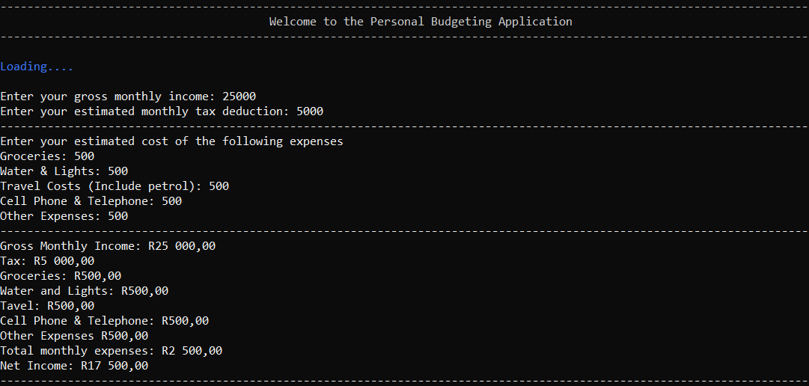

** Rent **

7. When choosing to rent, you will be prompted to enter the monthly rental amount.

8. The application will then calculate the money left over after all deductions (tax, expenses and rent).

9. Decide if you would like to reuse the program or exit.

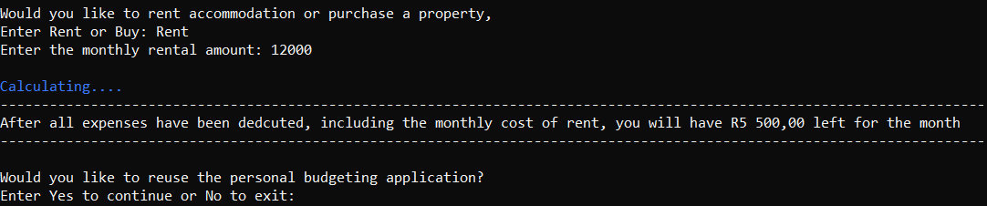

** Purchase **

10. When choosing to purchase, you will be prompted to enter the total cost of the house.

11. Enter the deposit amount.

12. Enter the interest rate.

13. Enter the number of months you want to repay the bond for, incorrect input here will display

an error and reprompt for input.

14. Decide if you would like to reuse the program or exit.

