Model-Based Predictive Maintenance of Electrical Machine
**A Two-Stage Machine-Learning System for Fault Detection and Diagnosis of an
Engine–Alternator–Hydraulic-Pump Assembly**
Technical Project Report
July 2026

Abstract
This project develops a complete machine-learning system that reads a raw sensor log from an electrical machine assembly (diesel engine + alternator + hydraulic pump, modelled in MATLAB Simulink/Simscape) and answers two questions: (1) is the machine healthy or faulty, and (2) if faulty, which fault is it? The system is built as a two-stage pipeline: Stage 1 is a one-class statistical anomaly detector that compares every signal window against a healthy baseline using the Mahalanobis distance; Stage 2 is a soft-voting ensemble of three tree classifiers (Extra Trees, LightGBM, CatBoost) that names the fault, protected by a confidence gate that routes uncertain windows to an "Unknown fault" verdict instead of forcing a guess. All results are validated with leave-one-run-out cross-validation so that the model is always tested on a simulation run it has never seen. The final system achieves 100% fault detection, 89.1% diagnosis accuracy (macro F1 = 0.906) on the named fault classes, and routes 100% of windows from an untrained fault type to the Unknown verdict. The model is deployed through an interactive Streamlit web dashboard that accepts a raw .xlsx/.csv log and returns a colour-coded verdict with confidence, per-window timeline, and signal plots.

Table of Contents
1. Introduction and Objectives
2. The Machine and the Data
3. Understanding the Data
4. Data Preprocessing
5. Windowing and Labelling
6. Feature Engineering
7. Validation Strategy
8. Model Development — Stage 1: Health Monitor
9. Model Development — Stage 2: Fault Diagnoser
10. The Confidence Gate — Open-Set Recognition
11. Results
12. Deployment — the Prediction Dashboard
13. Tools and Technologies
14. Assumptions and Limitations
15. Conclusion and Future Work

1. Introduction and Objectives
Model-based predictive maintenance (PdM) uses a physics simulation of a machine to generate labelled fault data, then trains a data-driven classifier on it. The objective of this project is to build, validate, and deploy a system that:
1. Detects whether an uploaded sensor log shows healthy or anomalous behaviour (fault detection).
2. Diagnoses the fault type — hydraulic Leakage, pump Displacement fault, or Generator (alternator) fault (fault diagnosis).
3. Refuses to guess when the signal pattern matches no trained fault, reporting Unknown fault instead (open-set recognition) — the correct behaviour for faults with insufficient training data, such as the flexible shaft coupling fault.
4. Produces honest, leakage-free accuracy numbers and ships as a usable web application.

2. The Machine and the Data
The plant is an engine-driven alternator feeding a rectifier/DC bus, with an engine-driven hydraulic pump, modelled in Simulink/Simscape. Faults are injected into the simulation at t = 0.1 s; each simulation run logs all sensor channels at high rate until 0.2–0.5 s.

2.1 Fault classes and their location in the machine
# | Class | Machine part affected | Physical effect in the signals
0 | Healthy | — (reference state) | Steady periodic behaviour of all channels
1 | Leakage | Hydraulic pump — internal leakage path | Pump pressure collapses/relaxes toward a new level; flow-pressure relation changes
2 | PumpDisplacement | Hydraulic pump — displacement (swash-plate/flow output) mechanism | Reduced flow output per revolution; pressure and load-current ripple pattern changes
3 | GeneratorFault | Alternator / generator electrical side | Abnormal AC waveform, DC-bus ripple, and load-current pattern
4 | FlexibleShaft | Engine-to-pump flexible shaft coupling | Abnormal torsional/vibration signature — detected and routed to "Unknown fault" (see §10)

2.2 Dataset summary
Property | Value
Source | MATLAB Simulink/Simscape simulation exports (.xlsx / .csv)
Simulation runs used | 12 independent runs
Fault injection time | t = 0.1 s (constant FAULT_T)
Run duration | 0.2 – 0.5 s per run
Working sampling rate | 10 kHz (uniform, after resampling)
Analysis windows | 248 (Table 5.1)
Features per window | 51

2.3 Signals and units
Only channels present in every run can feed a common model. Four such channels exist and form the model input; the remainder are used for validation and plotting.
Table 2.3 — Parameters, symbols, and units (after harmonization)
Parameter | Channel name | Physical unit | Used by model
Pump outlet pressure | pressure | bar | ✅
Load current | current | A | ✅
DC bus voltage | vdc | V | ✅
Alternator AC voltage | vac | V | ✅
Shaft speed | speed | rpm | validation only
Shaft torque | torque | N·m | validation only
Hydraulic flow rate | flow | L/min | validation only
Fuel rate | fuel | kg/s | validation only
Time base | time | s | index

3. Understanding the Data
Exploratory analysis (notebook 02_eda_signals.ipynb) established three facts that shaped the whole design:
1. The runs sit at wildly different operating points. Pump pressure spans 0.03–4126 bar and the DC bus 26–182 V across runs. A model trained on raw signal levels would learn to recognise the operating point, not the fault. → Therefore only scale-invariant and baseline-relative features are used (§6).
2. Simulink export column names drift between runs (suffixes like :1, generic PS-Simulink Converter names, different capitalisation). → Therefore a harmonization layer maps every export scheme onto one canonical set of channel names and units (§4.1).
3. Windows from the same run are near-duplicates of each other (50% overlap, same operating point, same noise seed). → Therefore evaluation must split by run, never by window (§7).
Figure 3.1 shows a healthy run against a leakage run after cleaning: the pressure trajectory diverges immediately after the injection instant, while the electrical channels change their ripple pattern.
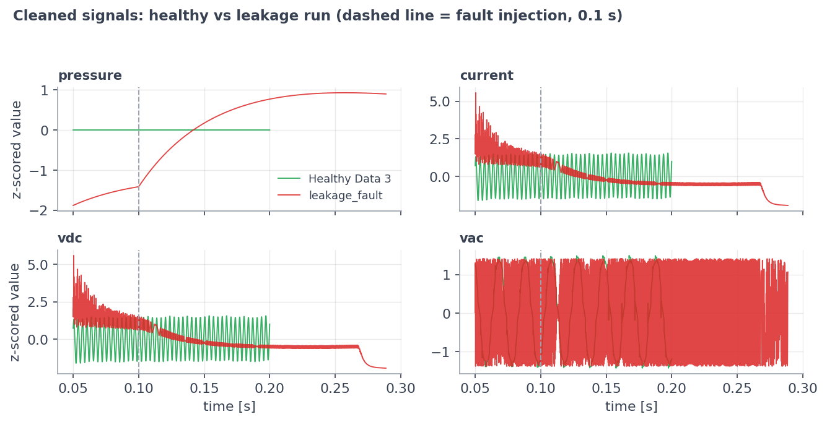
Cleaned signals healthy vs fault

4. Data Preprocessing
All preprocessing lives in one shared module (pdm_common.py) used identically by training and by the deployed app — this guarantees zero train/serve skew. Each step below states what it is, why it is used, and how it works.

4.1 Column harmonization and unit conversion
• What: a per-file column map resolving each export scheme to canonical names (pressure, current, vdc, vac, …), with unit conversion (e.g. Pa → bar).
• Why: Simulink exports the same physical scope under different column names in different runs; without harmonization, channels would silently drop.
• How: a suffix/whitespace-tolerant resolver matches raw headers; a channel-validation report (channel_validation.csv) records the unit, range, and accept/reject decision for every channel of every file.

4.2 Duplicate removal (redundant data)
• What: exact duplicate rows and duplicate timestamps within a run are counted and dropped.
• Why: duplicated samples would double-weight parts of the signal and corrupt resampling; counting first (never silently) keeps the step auditable.

4.3 Physically-impossible value sanitization
• What: values that violate physics — negative pressure, negative flow, negative fuel rate — are marked as missing.
• Why: solver glitches can emit impossible values; the bound (≥ 0) is a physics fact, not a tuned threshold, so the rule cannot overfit.
• How: flagged values become NaN and are filled by the same interpolation used for any missing data point — one imputation path only.

4.4 Uniform resampling to 10 kHz
• What: every channel is linearly interpolated onto one common 10 kHz time grid starting at t = 0.05 s.
• Why: the variable-step Simulink solver produces non-uniform timestamps; spectral and windowed features require a constant sampling rate. Starting at 0.05 s discards the solver's non-physical start-up transient.

4.5 Outlier clipping — Hampel filter
• What: a rolling-median filter that replaces any sample further than a robust threshold (median ± k·MAD) from its local neighbourhood.
• Why chosen over alternatives: unlike a low-pass filter or mean smoothing, the Hampel filter removes isolated solver spikes without smoothing over the real fault dynamics — a genuine step change survives, a one-sample spike does not.
• Assumption / limitation: spikes are isolated; a burst of consecutive bad samples longer than the window would partially survive.

4.6 Constant-column and low-variance filtering
• What: a channel is dropped only if constant across the entire dataset (a channel flat in just one run is kept — it may be informative elsewhere); after feature extraction, features with near-zero variance across all windows are removed.
• Why: constant inputs carry no class information and only add noise dimensions to the covariance estimate in Stage 1.

5. Windowing and Labelling
The cleaned run is cut into 0.02 s windows (200 samples) with 50% overlap, taken from the fault-active region (t ≥ 0.1 s). Each window inherits the label of its run. A run must yield at least 3 complete windows to be usable.
• Why windows instead of whole runs? Twelve runs would give only twelve training examples; windowing multiplies the sample count while every window still spans several electrical/hydraulic cycles at 10 kHz.
• Why 50% overlap? Standard practice in vibration/condition monitoring — doubles the sample count and ensures no transient falls on a window boundary.
• Limitation: overlapping windows from one run are statistically dependent, which is exactly why validation is done per run (§7).
Table 5.1 — Analysis windows per class
Class | Runs | Windows
PumpDisplacement | 4 | 96
GeneratorFault | 3 | 82
Leakage | 3 | 43
FlexibleShaft | 1 | 18
Healthy | 1 | 9
Total | 12 | 248

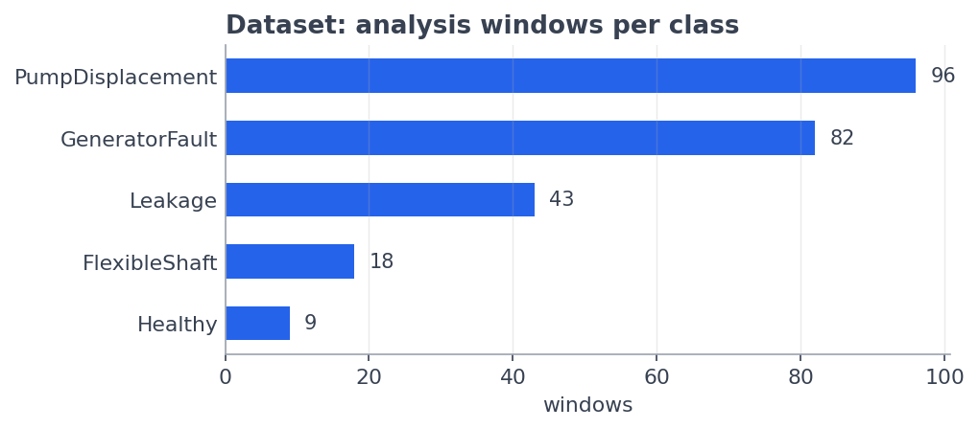
Windows per class

6. Feature Engineering

6.1 Design principle: scale invariance
Because runs sit at incompatible operating points (§3), no feature may depend on the absolute signal level. Every feature is one of:
• Scale-invariant statistics — unitless shape descriptors that are the same whether the pressure is 2 bar or 2000 bar.
• Baseline-deviation statistics — how the signal changed after fault injection relative to that same run's own pre-fault segment (0.05–0.10 s).

6.2 The 51 features
Twelve statistics are computed per window for each of the four common channels, plus three cross-signal features:
Table 6.2 — Feature set (12 × 4 channels + 3 = 51)
Feature | Definition | What it captures
cov | coefficient of variation (σ/µ) | relative fluctuation strength
crest | peak / RMS | spikiness of the waveform
ripple | peak-to-peak / mean | oscillation depth
skew | third standardized moment | waveform asymmetry
kurt | fourth standardized moment | heavy tails / impulsiveness
zcr | zero-crossing rate of the detrended signal | dominant frequency proxy
slope | linear trend within the window | drift/collapse behaviour
speccen | spectral centroid | centre of gravity of the spectrum
speclow | low-band spectral power share | energy shift toward low frequency
dmean | mean change vs pre-fault baseline (normalized) | level shift after fault
dstd | std change vs baseline (normalized) | fluctuation change after fault
drms | RMS change vs baseline (normalized) | energy change after fault
corr_vdc_i | correlation(vdc, current) | rectifier/load coupling integrity
power_cov | CoV of instantaneous electrical power | combined electrical stability
corr_p_vac | correlation(pressure, vac) | hydro-electrical coupling

6.3 Feature importance
Feature ranking (impurity importance averaged across the deployed ensemble's members, cross-checked with permutation importance during development) shows the top drivers are physically meaningful: the AC-voltage zero-crossing rate (vac_zcr — generator waveform frequency content), the pressure trend and baseline-deviation features (pressure_slope, pressure_dmean — hydraulic collapse after a fault), and ripple/crest of the AC/DC voltages and load current. This is evidence the model learned machine physics rather than artifacts.
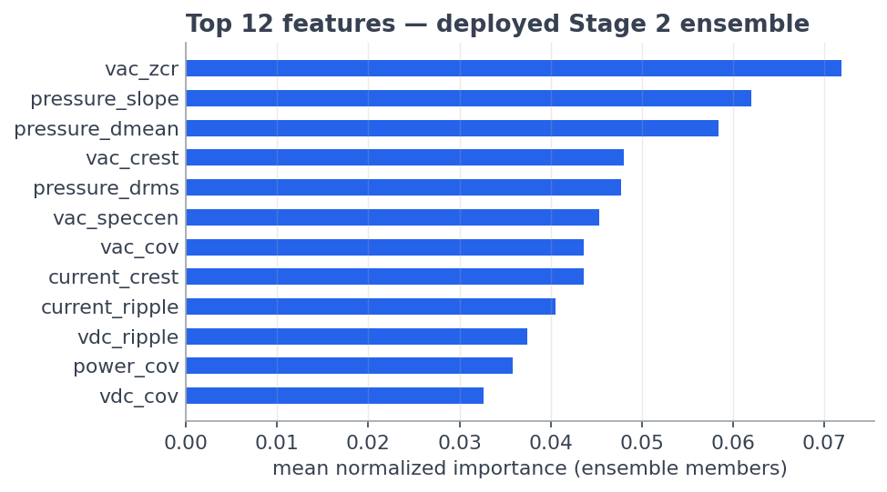
Feature importance
Role in training: the ranking is used as evidence only — all 51 features enter every model. Selecting features by rank before cross-validation would itself leak information from the test folds.

7. Validation Strategy
Leave-one-run-out cross-validation (LOGO): the model is trained on all runs except one and tested on every window of the held-out run; this repeats for every run and the predictions are pooled.
• Why: overlapping windows of one run are near-duplicates. A random window-level split would place siblings in both train and test, and the model would score ~99% by recognizing the run rather than the fault — a data leakage artifact. LOGO guarantees every reported number comes from a run the model never saw.
• Consequence accepted: LOGO gives fewer, harder test folds and therefore lower but honest numbers.

8. Model Development — Stage 1: Health Monitor
What it is. A one-class anomaly detector: it models healthy behaviour only and measures how far any new window sits from that behaviour.
Why one-class instead of adding "Healthy" as a 5th classifier output? A supervised class needs multiple independent examples to be learnable and testable. Healthy operation is better treated as a reference distribution: anything sufficiently far from it is anomalous. This mirrors industrial condition-monitoring practice (alarm on deviation from baseline).
How it works — three standard statistical tools:
1. RobustScaler — every feature is centred by the healthy median and scaled by the healthy IQR (not mean/std), so single unusual values cannot distort the scale. After scaling, "0" means "typical healthy value".
2. Ledoit–Wolf shrinkage covariance — learns how healthy features co-vary. A plain covariance matrix is singular when samples (9 healthy windows) < features (51); Ledoit–Wolf blends the empirical covariance with a well-conditioned prior, with the blend weight chosen analytically — the standard estimator for exactly this small-sample regime.
3. Mahalanobis distance — for a new window, one number: how many standard deviations of normal variation is this window from the healthy cloud, taking feature correlations into account? Chosen over Euclidean distance because correlated features would otherwise double-count deviation.
Decision rule: distance ≤ 1.5 × (worst healthy window) → Healthy; otherwise → anomalous → Stage 2. The 1.5 margin is a documented safety factor above the empirical healthy maximum.
Result: every one of the 239 fault windows — all four fault types — exceeds the threshold (100% detection), while all healthy windows fall below it.
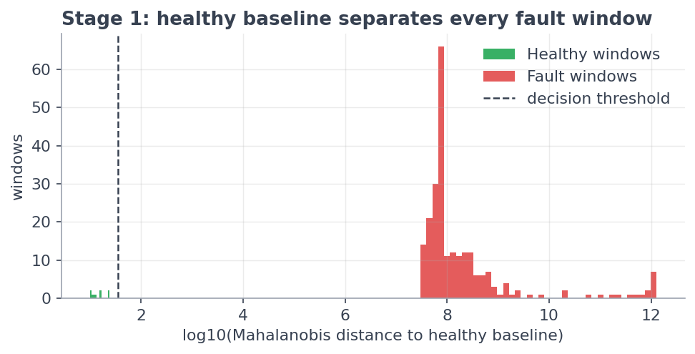
Stage 1 separation
Assumptions & limitations: healthy behaviour is unimodal and represented by the baseline run; the false-alarm rate is measured on the same run that defined the baseline, so a machine at a very different healthy operating point could be flagged anomalous. More healthy reference runs would widen the baseline.

9. Model Development — Stage 2: Fault Diagnoser
Stage 2 answers which fault? for the three fault classes with multiple independent runs. Seven classifier families were evaluated under identical conditions (same 51 features, same LOGO folds).

9.1 Candidate models — what, why, how
Table 9.1 — Candidate models
Model | What it is / how it works | Why it was considered | Key assumption | Main limitation here
Extra Trees | Bagging of ~500 decision trees with random split thresholds; majority vote | Very resistant to overfitting; near-zero tuning | Feature interactions capturable by axis-aligned splits | Random splits waste capacity when training runs are few
Random Forest | Bagging of ~500 trees, each on a bootstrap resample with random feature subsets; optimal splits | The standard strong tabular baseline | Same as above | Slightly weaker than boosting on the hardest class
HistGradientBoosting | Trees built sequentially, each fitting the previous ensemble's errors; histogram-binned features | Boosting focuses capacity on hard cases | Errors are informative, not noise | Needs care (small trees, slow rate) on tiny data
LightGBM | Gradient boosting with leaf-wise tree growth and histogram binning | Fast, strong, class-weight support | Same as boosting | Leaf-wise growth can overfit small data (capped at 15 leaves)
CatBoost | Gradient boosting with ordered boosting — each sample's residual computed from a model that never saw it | Ordered boosting is specifically designed against small-sample overfitting | Same as boosting | Slower to train
SVM (RBF kernel) | Maximum-margin boundary bent by a kernel into curved surfaces | Classical strong baseline for medium dimensions | Classes separable with smooth boundaries in kernel space | Sensitive to run-to-run distribution shift; weakest here
Logistic Regression | Linear weighted sum of standardized features → softmax probabilities | Sanity check: is the feature space linearly separable? | Linear class boundaries | No feature interactions

9.2 Why an ensemble was chosen
The three best-diversified members — Extra Trees (randomized bagging) + LightGBM (leaf-wise boosting) + CatBoost (ordered boosting) — are combined by soft voting: their predicted probabilities are averaged and the highest average wins.
• Why it wins: the members make different kinds of mistakes; averaging retains the signal they agree on and washes out individual quirks. The ensemble beats every individual member.
• Second benefit: averaged probabilities are better calibrated, which the confidence gate (§10) depends on.
• Class imbalance is handled with balanced class weights (each class contributes equally to the loss), not synthetic oversampling — interpolating overlapping windows would manufacture fake "independent" samples.
Table 9.2 — Model comparison (identical LOGO folds)
Model | Macro F1 | Accuracy
Voting ensemble (ET + LGBM + CatBoost) | 0.906 | 89.1%
HistGradientBoosting | 0.902 | 88.7%
Random Forest | 0.897 | 88.2%
LightGBM | 0.887 | 87.3%
Logistic Regression | 0.872 | 85.5%
Extra Trees | 0.820 | 80.1%
SVM (RBF) | 0.798 | 80.1%

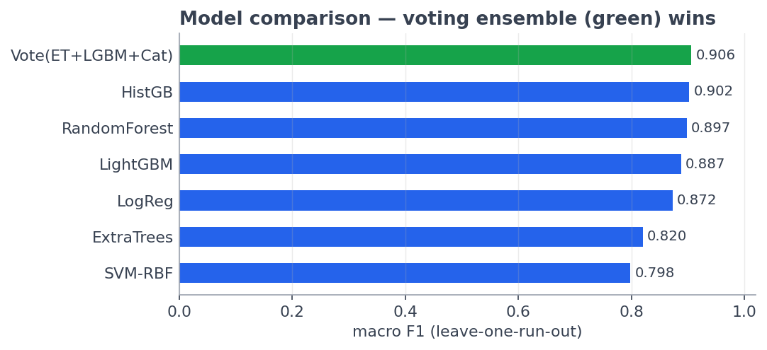
Model comparison
Logistic regression at 0.872 is itself a finding: the engineered feature space is largely linearly separable — the feature engineering, not model complexity, does the heavy lifting.

9.3 Final classifier performance
Table 9.3 — Per-class results, voting ensemble (leave-one-run-out)
Class | Precision | Recall | F1 | Support
Leakage | 1.000 | 1.000 | 1.000 | 43
PumpDisplacement | 0.800 | 1.000 | 0.889 | 96
GeneratorFault | 1.000 | 0.707 | 0.829 | 82
Overall |  | accuracy 0.891 | macro F1 0.906 | 221

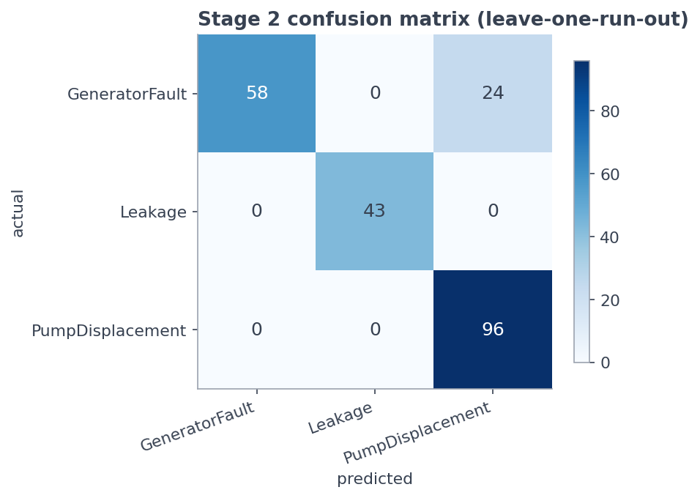
Confusion matrix
The single remaining confusion — generator windows read as pump displacement — is concentrated in one generator run that was exported at a different simulation operating point than its siblings; precision for GeneratorFault remains perfect (no false generator alarms).

10. The Confidence Gate — Open-Set Recognition
What: the diagnoser names a fault only when the ensemble's top probability is ≥ 0.90; below the gate, the window is reported as "Unknown fault — inspect".
Why: a 3-class classifier will force any anomalous window into one of its 3 classes — including a fault type it has never been trained on. In a maintenance setting, a confident wrong label is worse than an honest "unknown".
Validation on a genuinely unseen fault: the FlexibleShaft coupling fault is not part of Stage 2 training. When its windows are pushed through the deployed model, their confidences cluster at 0.83–0.86 — below the gate — so 100% of them are correctly routed to Unknown fault while Stage 1 had already flagged them as anomalous with 100% detection. Known-fault windows pass the gate at a 78.7% rate with 86.8% accuracy on the passed windows.
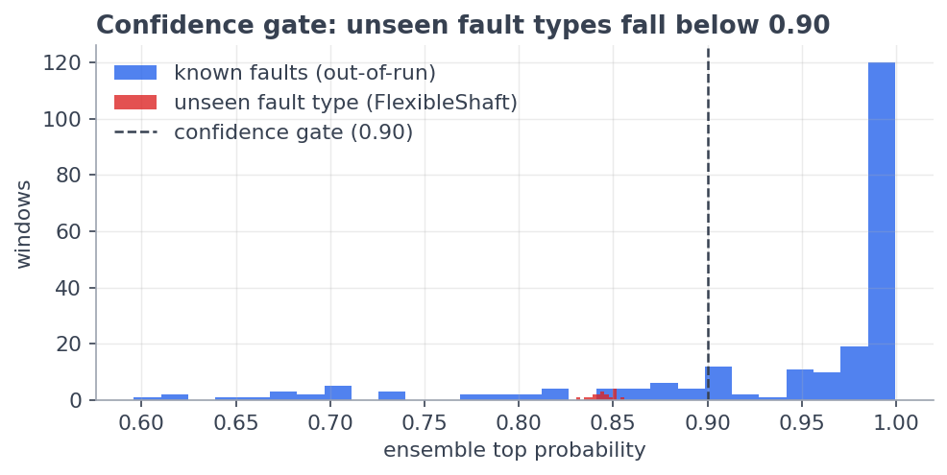
Confidence gate
Limitation: the gate value (0.90) was validated against one unseen fault type; new fault families should be re-checked against it.

11. Results
Table 11.1 — End-to-end system performance (all leakage-free)
Metric | Value
Stage 1 fault detection rate | 100% (239/239 fault windows)
Stage 1 false alarms (healthy windows) | 0%
Stage 2 diagnosis accuracy | 89.1%
Stage 2 macro F1 | 0.906
Unseen fault type routed to "Unknown" | 100%
End-to-end smoke test (deployed app, 5 raw logs) | 5/5 correct verdicts, 100% window agreement each

Final decision flow per 0.02 s window:
window features (51)
│
▼
Stage 1 · Mahalanobis distance to healthy baseline
│ ≤ threshold ──────────────► HEALTHY
▼ > threshold (anomalous)
Stage 2 · voting ensemble (ET + LGBM + CatBoost)
│ top probability ≥ 0.90 ───► NAMED FAULT
▼ < 0.90 (Leakage / PumpDisplacement / GeneratorFault)
UNKNOWN FAULT — inspect

12. Deployment — the Prediction Dashboard
The trained system is frozen into a single bundle (artifacts/two_stage_model.joblib: Stage 1 scaler + covariance + threshold, Stage 2 ensemble, class names, gate) and served by a Streamlit web app (07_streamlit_app.py):
1. User uploads a raw .xlsx/.csv Simulink log.
2. The app applies the identical pdm_common.py preprocessing and feature pipeline used in training (no train/serve skew).
3. Every window passes through the two-stage decision flow; the dashboard shows a colour-coded verdict banner, confidence, share of anomalous windows, a verdict-share chart, a per-window classification timeline, and the cleaned sensor signals — plus a plain-English glossary tab.
Because the model ships as a small file, the dashboard runs on any PC with the code + artifacts/ folder — the raw training data is not required for use.

13. Tools and Technologies
Table 13.1 — Technology stack
Layer | Technology | Role in the project
Language | Python 3.11 | entire pipeline and app
Development | Jupyter Notebook (one notebook per pipeline stage, 00–07) | reproducible, self-documenting workflow
Data handling | pandas, NumPy, pyarrow, openpyxl | tables, arrays, parquet cache, Excel ingestion
Signal/statistics | SciPy | spectral and statistical feature support
Machine learning | scikit-learn | preprocessing, ExtraTrees/RF/SVM/LogReg/HistGB, Ledoit-Wolf, LOGO CV, metrics
Gradient boosting | LightGBM, CatBoost | ensemble members
Model persistence | joblib | freezing/loading the trained bundle
Visualisation | Matplotlib | every plot in notebooks, report, and app
Deployment | Streamlit | interactive prediction dashboard
Simulation source | MATLAB Simulink / Simscape | fault-injected machine model and data export

14. Assumptions and Limitations
1. Simulation-to-hardware gap: all data is Simscape-generated; reported metrics are an upper bound until validated on physical machine data.
2. Healthy baseline breadth: the baseline derives from one reference run; healthy operation at a very different operating point may raise false anomalies. More healthy runs directly widen the baseline.
3. FlexibleShaft diagnosis: detected (100%) and safely routed to Unknown, but cannot be named until more independent runs of that fault exist.
4. GeneratorFault recall (70.7%): limited by one run's differing export settings; a re-export at the shared operating point closes the gap.
5. Stationarity within a window: features assume the 0.02 s window is locally stationary — reasonable at 10 kHz, but very fast transients inside a single window are averaged.

15. Conclusion and Future Work
A complete, deployable predictive-maintenance system was developed for an engine–alternator–hydraulic-pump assembly. The two-stage architecture matches the structure of the problem: a statistical healthy baseline delivers perfect fault detection, a diversified voting ensemble delivers 89.1% / 0.906 macro-F1 fault diagnosis under strictly leakage-free validation, and a confidence gate gives the system the industrially essential ability to say "I don't know — inspect" for fault types outside its training set. Every preprocessing choice is either a physics fact or a documented constant, every score is produced on runs the model never saw, and the entire pipeline — from raw Simulink export to web-dashboard verdict — runs through one shared code path.
Future work: validate on hardware/experimental logs; add healthy and flexible-shaft simulation runs to widen the baseline and promote FlexibleShaft to a named class; re-export the divergent generator run; and extend the dashboard with run-level trend tracking across repeated uploads.
Figures: `docs/report_figures/`. Reproducible pipeline: `notebooks/00 … 07`. Deployed model: `artifacts/two_stage_model.joblib`. Metrics: `artifacts/two_stage_metrics.json`.

