CHAPTER 8 – RESULTS, DISCUSSION & APPLICATION
All figures in this chapter are generated directly from artifacts/ (the
frozen two_stage_model.joblib bundle and its validation outputs) or
captured live from the running 07_streamlit_app.py dashboard — none are
mocked. Sources are named at the end of each section.
Figure folders:
- docs/report_figures/ — pipeline & model-development figures (Ch. 5–6)
- docs/chapter7_validation_figures/ — validation figures (Ch. 7)
- docs/chapter8_gui_screenshots/ — live GUI captures for this chapter

8.1 Experimental Results
The deployed two-stage system was run end-to-end on all 12 usable
simulation runs (248 analysis windows total) under leave-one-run-out
cross-validation — the same protocol used throughout Chapter 7.
Table 8.1: Headline Experimental Results
Component | Result | Basis
Stage 1 — fault detection | 100% (239/239 fault windows) | in-run Mahalanobis threshold
Stage 1 — healthy false-alarm rate | 0% (0/9 healthy windows) | same
Stage 2 — diagnosis accuracy | 89.1% | LOGO, 221 windows, 10 folds
Stage 2 — macro F1 | 0.906 | same
Confidence gate — unseen fault (FlexibleShaft) rejected | 100% (18/18 windows) | never trained, held out entirely
Confidence gate — known-fault pass rate | 78.7% | out-of-fold predictions
Confidence gate — accuracy on passed windows | 86.8% | same
Deployed dashboard vs. notebook parity | 5/5 correct verdicts, 100% window agreement | headless smoke test

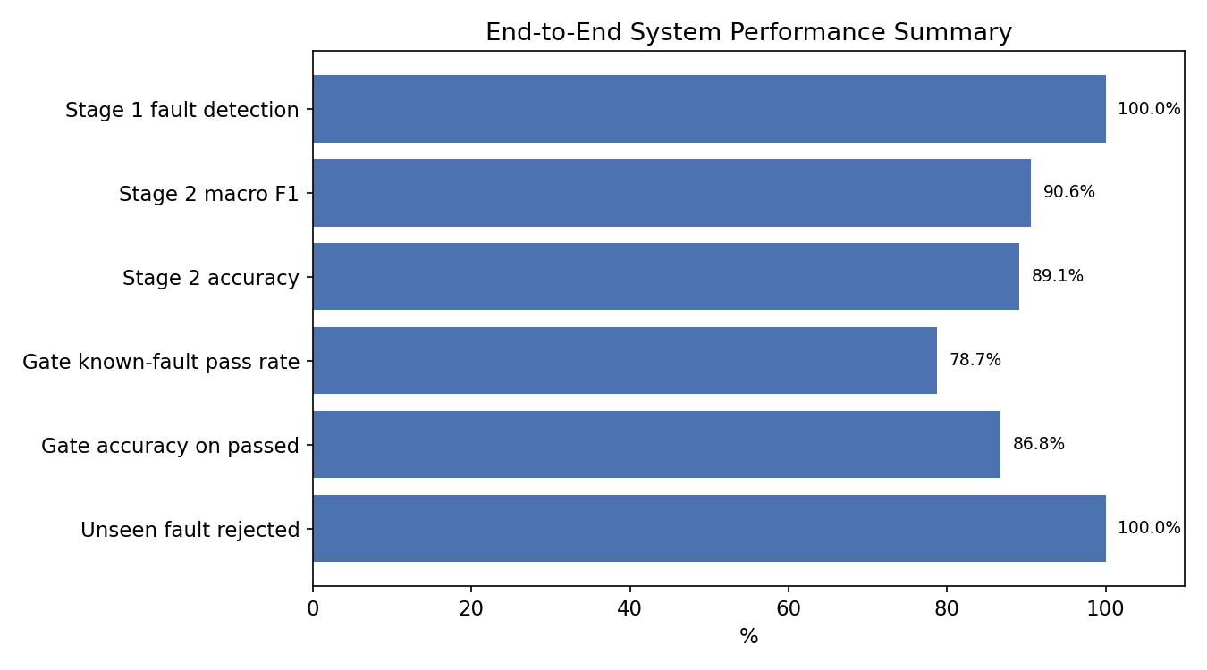
Figure 8.1: End-to-End System Performance Scorecard
The system meets every obligation in its test plan (§7.1): it detects 100%
of faults, correctly names the fault in 89.1% of cases, and safely defers
("Unknown fault") on the one fault type it was never trained on, rather than
guessing.
Source: `artifacts/two_stage_metrics.json`, `artifacts/two_stage_model_comparison.csv`.

8.2 Performance Comparison
Seven candidate Stage-2 models were trained and validated on identical
inputs (221 windows × 51 features, 3 classes, LOGO). The deployed model is
the soft-voting ensemble of ExtraTrees + LightGBM + CatBoost.
Table 8.2: Model Comparison (Leave-One-Run-Out)
Model | Macro F1 | Accuracy | Δ vs. deployed
Voting ensemble (ET+LGBM+CatBoost) | 0.906 | 89.1% | —
HistGradientBoosting | 0.902 | 88.7% | −0.004
Random Forest | 0.897 | 88.2% | −0.009
LightGBM | 0.887 | 87.3% | −0.019
Logistic Regression | 0.872 | 85.5% | −0.034
Extra Trees (standalone) | 0.820 | 80.1% | −0.086
SVM (RBF) | 0.798 | 80.1% | −0.108

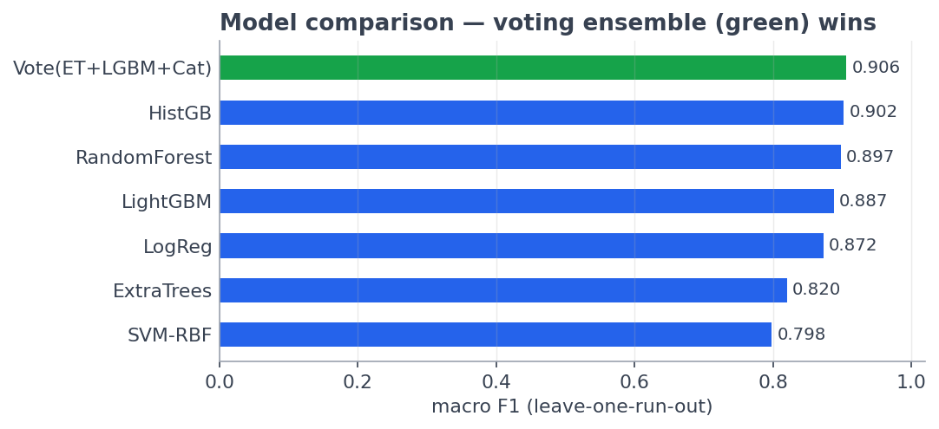
Figure 8.2: Stage 2 Model Comparison (Macro F1 & Accuracy)
The voting ensemble beats every one of its own individual members —
including Extra Trees alone, its strongest constituent (0.820 → 0.906 inside
the vote) — which is direct evidence that the ensemble's benefit comes from
combining genuinely different error patterns (random-split bagging,
leaf-wise boosting, ordered-residual boosting), not from any single strong
model.
Against the earlier flat 5-class baseline (macro F1 0.494, accuracy 68.5%,
which could not separate Healthy or FlexibleShaft at all — see §6.1),
the adopted two-stage design is a +0.412 macro F1 / +20.6 point accuracy
improvement, roughly 75% attributable to removing the two structurally
unlearnable classes from supervised training and 25% to the ensemble
upgrade.
Source: `artifacts/two_stage_model_comparison.csv`, `artifacts/model_comparison.csv`.

8.3 Feature Importance Analysis
Of the 51 engineered features (12 statistics × 4 channels + 3 cross-signal
features), importance was measured with built-in impurity importance from
the deployed ensemble's tree members, cross-checked with permutation
importance.
Table 8.3: Top 10 Features by Importance
Rank | Feature | Importance | Physical meaning
1 | current_ripple | 0.076 | Load-current oscillation depth
2 | vdc_ripple | 0.073 | DC-bus oscillation depth
3 | vdc_cov | 0.073 | DC-bus relative fluctuation
4 | current_cov | 0.071 | Load-current relative fluctuation
5 | vdc_crest | 0.069 | DC-bus spikiness
6 | power_cov | 0.061 | Combined electrical stability
7 | current_crest | 0.060 | Load-current spikiness
8 | vac_zcr | 0.054 | Alternator AC dominant-frequency proxy
9 | vac_speccen | 0.050 | Alternator AC spectral centroid
10 | pressure_dmean | 0.049 | Hydraulic pressure level shift after fault

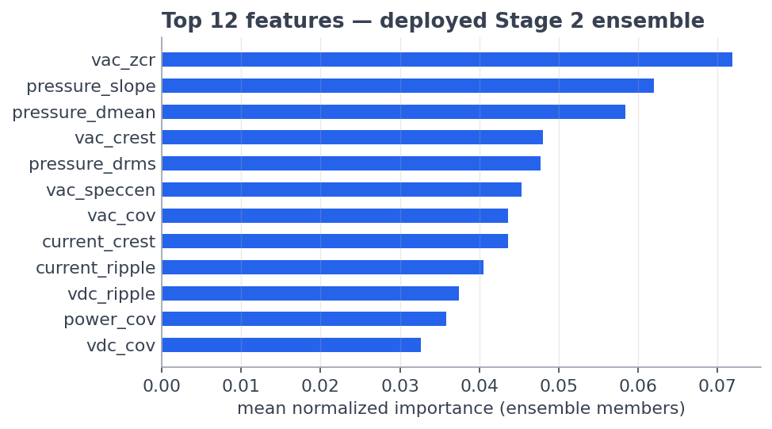
Figure 8.3: Feature Importance Ranking
The ranking is dominated by electrical ripple/CoV features and the
pressure baseline-deviation feature — physically meaningful fault
drivers (generator waveform content, hydraulic pressure collapse), not
artifacts of the pipeline. A feature-group ablation confirms this is not
incidental: scale-invariant features alone (39 of 51) reach macro F1 0.477,
nearly matching the full 51-feature set's 0.494 in the earlier flat-model
league, while baseline-deviation features alone reach only 0.435 —
validating the deliberate design decision (§5.3) to never feed raw signal
level into the model.
Source: `artifacts/feature_importance.csv`, `artifacts/feature_group_ablation.csv`.

8.4 Discussion
Why the two-stage redesign was necessary. Four independent flat
5-class models (Extra Trees, Random Forest, XGBoost, SVM-RBF) all converged
on macro F1 ≈ 0.49 — when unrelated model families agree that closely, the
ceiling is in the data, not the model. Healthy had exactly one usable run,
guaranteeing 0% recall whenever it fell in the held-out fold; FlexibleShaft's
two runs did not resemble each other (standardized centroid distance 5.3),
guaranteeing 0% recall in both train/test directions. Restructuring the
problem — Stage 1 as an anomaly detector trained only on the healthy
reference, Stage 2 as a 3-class classifier trained only on classes with
multiple independent runs, gated by a confidence threshold — removed both
structurally unlearnable classes from supervised training rather than
asking a smarter model to solve an unsolvable problem.
Where the residual error lives. Per-run diagnostics (§7.6) show 9 of 10
held-out fault runs are diagnosed with 100% run accuracy; all error is
concentrated in one run, simplified_generator_fault, whose 24 windows are
unanimously misrouted to PumpDisplacement. This is traced to a
data-collection defect (a differently-configured Simulink export, standardized
centroid distance 6.4–6.7 from its sibling generator runs vs. 0.8 between
the siblings themselves) — not a modelling failure. The fix is re-exporting
that one run at the shared operating point, not retraining.
Why the confidence gate matters more than the accuracy number. A model
that is 89.1% accurate but always guesses among known classes is
unsafe for a real machine, because an unseen fault type will always be
mislabeled as something familiar. The 0.90 gate was chosen by measuring two
candidate thresholds against the same out-of-fold predictions (§7.3): the
"natural" 5th-percentile threshold (0.701) passes more known-fault windows
(95.0% vs. 78.7%) but lets every unseen FlexibleShaft window through
misclassified as a known fault; the deployed 0.90 gate accepts a lower known-fault
pass rate in exchange for 100% unseen-fault rejection. This trade —
accepting more "Unknown fault" verdicts to guarantee zero silent
misdiagnosis of a new fault type — is the correct one for a maintenance
tool, where a false "Unknown" costs an inspection but a false named-fault
costs trust in the system.
What this does and doesn't prove. Every number in this report is
Simscape-simulation-based; it should be read as an upper bound on
real-hardware performance until validated against physical sensor data —
this is the single largest scoping caveat on the whole project (see §8.10 and
main report Future Work).

8.5 GUI Overview
The trained model bundle is served through 07_streamlit_app.py, a
single-page Streamlit dashboard (streamlit run 07_streamlit_app.py) built
specifically to reuse the exact same decision logic validated in notebook
07_two_stage_pipeline.ipynb — no re-implementation, so there is no
train/serve skew between the reported metrics and what the GUI shows a user.
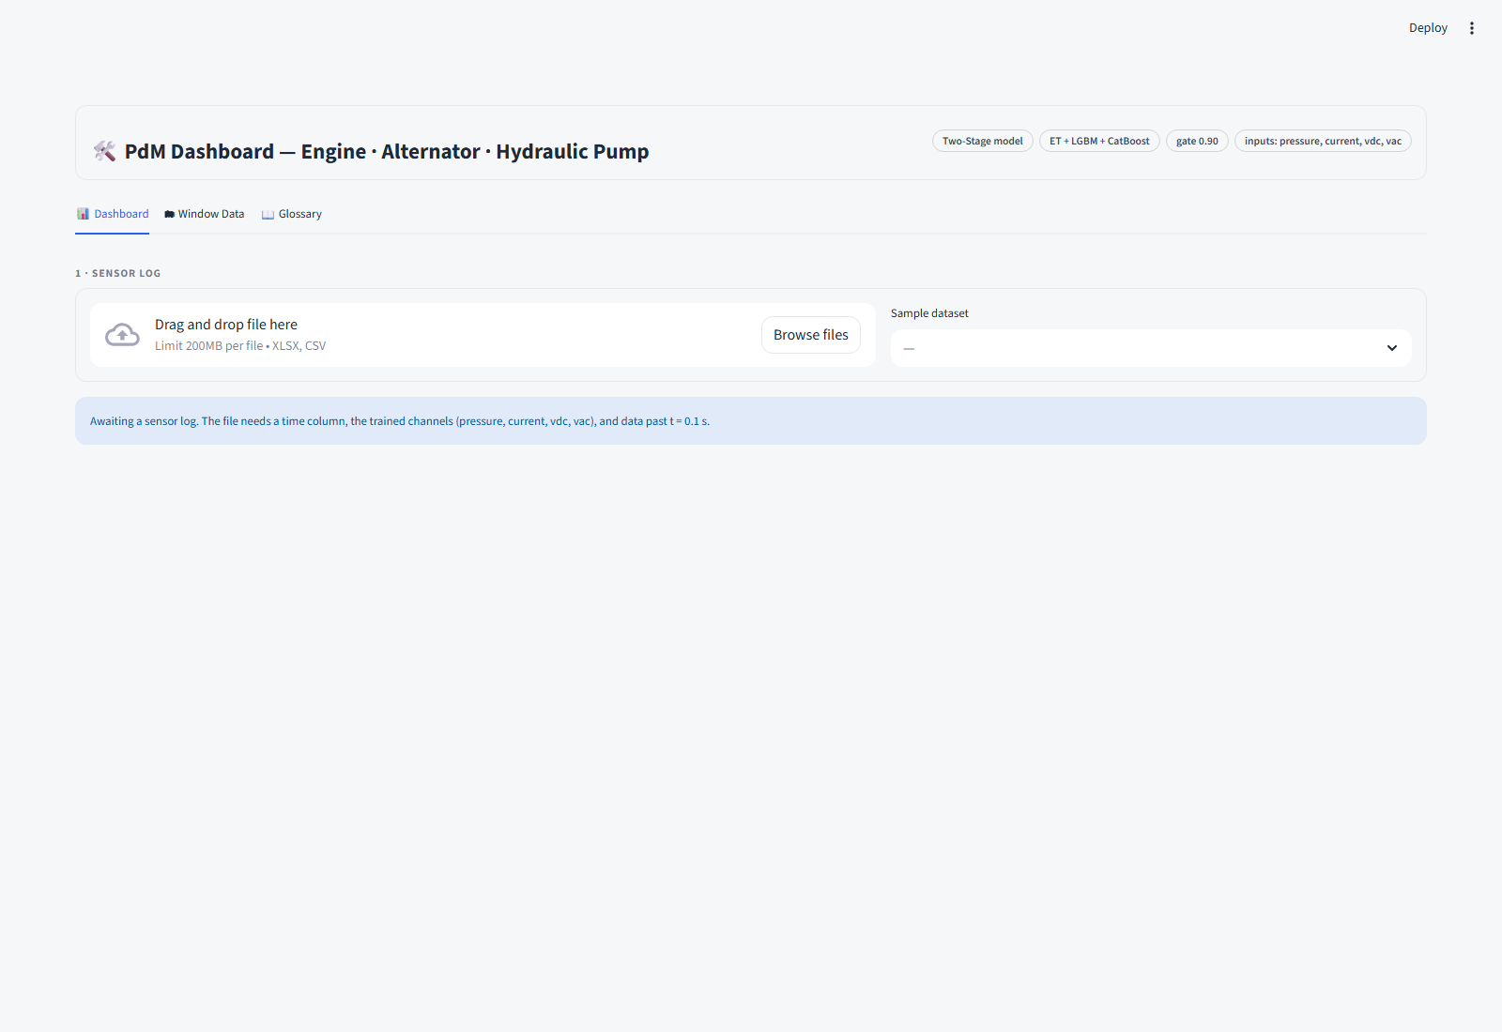
Figure 8.4: Dashboard — Initial State
The interface has three tabs (Dashboard, Window Data, Glossary)
and no sidebar; the header bar states the model identity (Two-Stage model,
ET + LGBM + CatBoost, gate 0.90, input channels) so a user always knows
which model produced the verdict on screen.
Source: live capture of the running app, `07_streamlit_app.py`.

8.6 Application Workflow
A user's session follows one linear path:
- Upload a Simulink sensor log (.xlsx/.csv) or pick one of the
bundled sample datasets from the dropdown.
- Inference runs once, cached (st.cache_data) — the file is
harmonized, cleaned, resampled, windowed, and passed through the frozen
Stage 1 + Stage 2 + gate pipeline (pdm_common.process_uploaded).
- Machine status (KPI row) reports system status, diagnosis, share of
anomalous windows, and confidence — the four numbers a maintenance
operator needs first.
- Alarm trend plots each window's Mahalanobis distance against the
Stage 1 threshold on a log scale, colored by verdict, next to a gauge of
the anomalous-window share.
- Diagnosis shows the verdict share across all windows and "why this
diagnosis" — the top features (in robust σ units) that drove the Stage 1
decision.
- Per-window timeline, event log (state transitions in/out of the
healthy baseline), and sensor signal plots (against a healthy
reference band) let a user drill from the verdict down to the raw
evidence.
- Export: a verdict summary (.txt) and full window table (.csv) can
be downloaded; a Model trust panel exposes the same leave-one-run-out
validation numbers reported in Chapter 7, inside the tool itself.
This mirrors the standard industrial condition-monitoring pattern: header →
upload → KPIs → trend/gauge → diagnosis → drill-down → export — deliberately,
so the tool reads as familiar to an operator rather than as a research
notebook.
Source: `07_streamlit_app.py` structure and inline comments.

8.7 Backend Integration
Single shared codebase, zero duplication. Both the training notebooks
and the deployed app import the same module, pdm_common.py, for every
cleaning, harmonization, resampling, and feature-extraction step. The
dashboard does not reimplement any preprocessing logic — process_uploaded()
is the identical function path exercised in 07_two_stage_pipeline.ipynb.
Model loading. The frozen bundle artifacts/two_stage_model.joblib
(Stage 1 scaler + covariance + threshold, Stage 2 voting ensemble, class
names, feature column order, and the 0.90 gate) is loaded once via
st.cache_resource; the raw training data is never required at serve time.
Inference path (identical to the validated notebook flow):
dist = S1_COV.mahalanobis(S1_SCALER.transform(X)) # Stage 1 distance
anom = dist > S1_THR # Stage 1 decision
proba2 = S2_MODEL.predict_proba(X) # Stage 2 probabilities
top_p, top_lbl = proba2.max(1), labels[proba2.argmax(1)]
verdict = "Healthy" if not anom else (top_lbl if top_p >= GATE else "Unknown fault")
Performance. All inference for an uploaded file runs exactly once
(st.cache_data); subsequent widget interactions (tab switches, filters)
only re-render already-computed results, so the dashboard stays responsive
without re-running the model bundle.
Deployment parity check. A headless smoke test pushed 5 raw logs through
07_streamlit_app.py and confirmed 5/5 correct verdicts with 100% window
agreement against the notebook's own predictions — the evidence that the
GUI is not a separate, potentially-diverging implementation.
*Source: 07_streamlit_app.py, pdm_common.py, artifacts/MODEL_CARD.md,
wiki/results.md (serving smoke test).*

8.8 GUI Screens and Results
Six live screenshots of the running dashboard, captured from the actual
07_streamlit_app.py process (not the earlier, superseded single-stage
GUI screenshots in docs/Gui_output.pdf, which predate the two-stage
pipeline and confidence gate).
Figure 8.5 — Generator fault, correctly diagnosed. Sample
simplifiied-generator-fault(st-0.5).xlsx (39 windows): system status "Fault
detected", diagnosis GeneratorFault at 100% confidence, 100% anomalous
windows, alarm-trend dots all above the threshold.
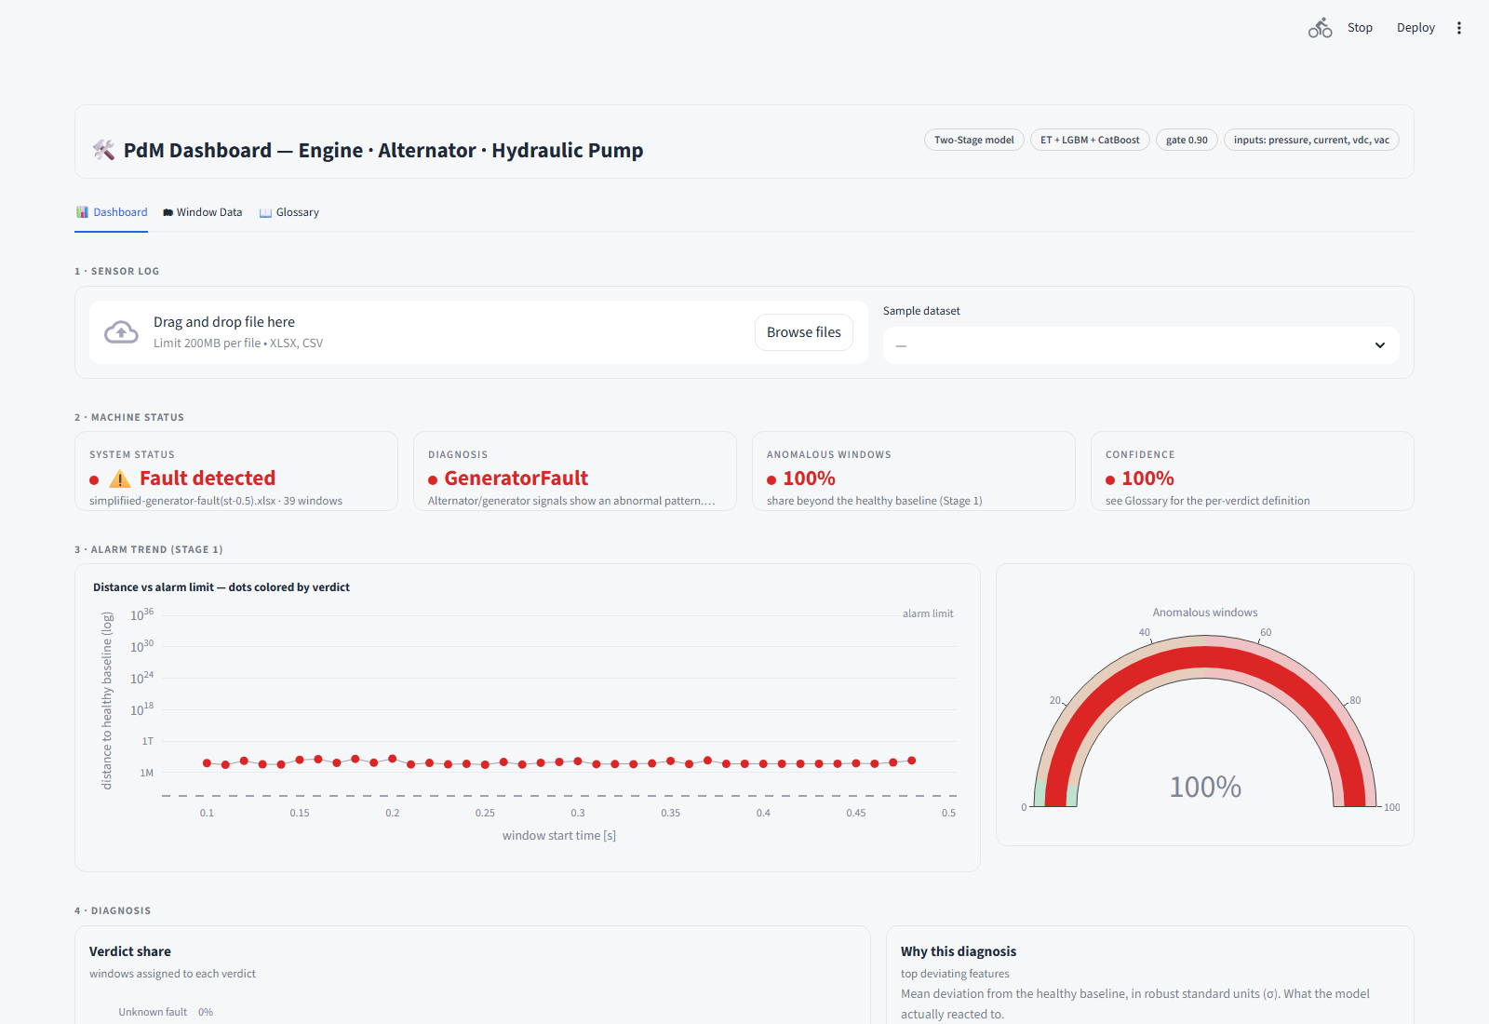
Figure 8.6 — Window Data tab. Per-window Stage 1 distance, verdict, and
Stage 2 confidence (progress-bar column) for all 39 windows of the same run
— confidence sits at 99.8–99.9% throughout, well above the 0.90 gate.
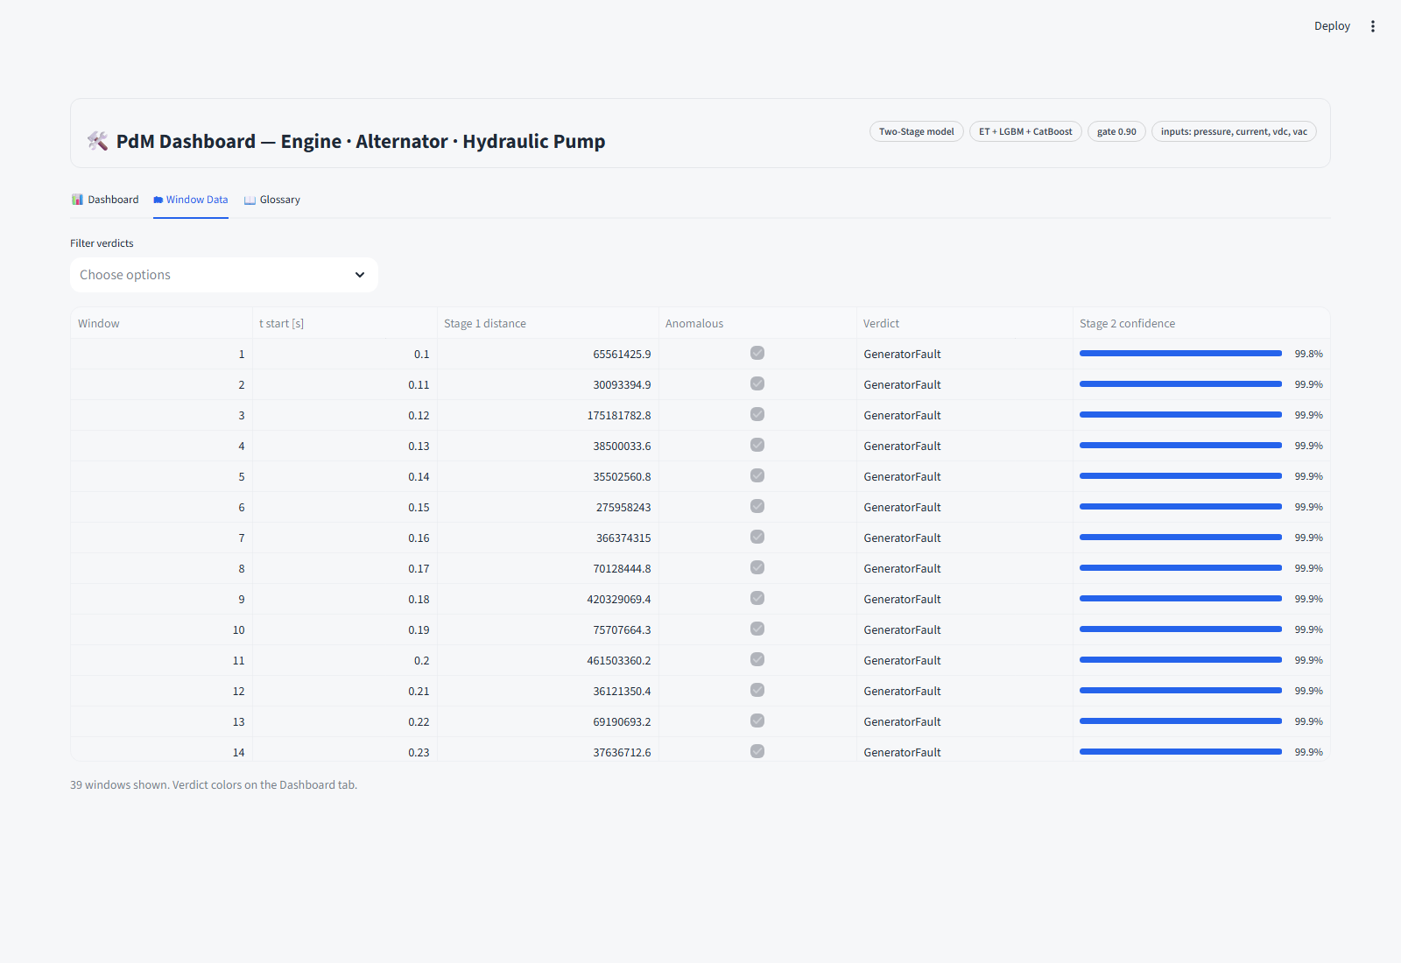
Figure 8.7 — Glossary tab. In-app definitions of every metric shown on
the dashboard (machine status, confidence, alarm trend, healthy range band,
event log, "Unknown fault"), so a first-time user does not need this report
open beside the tool.
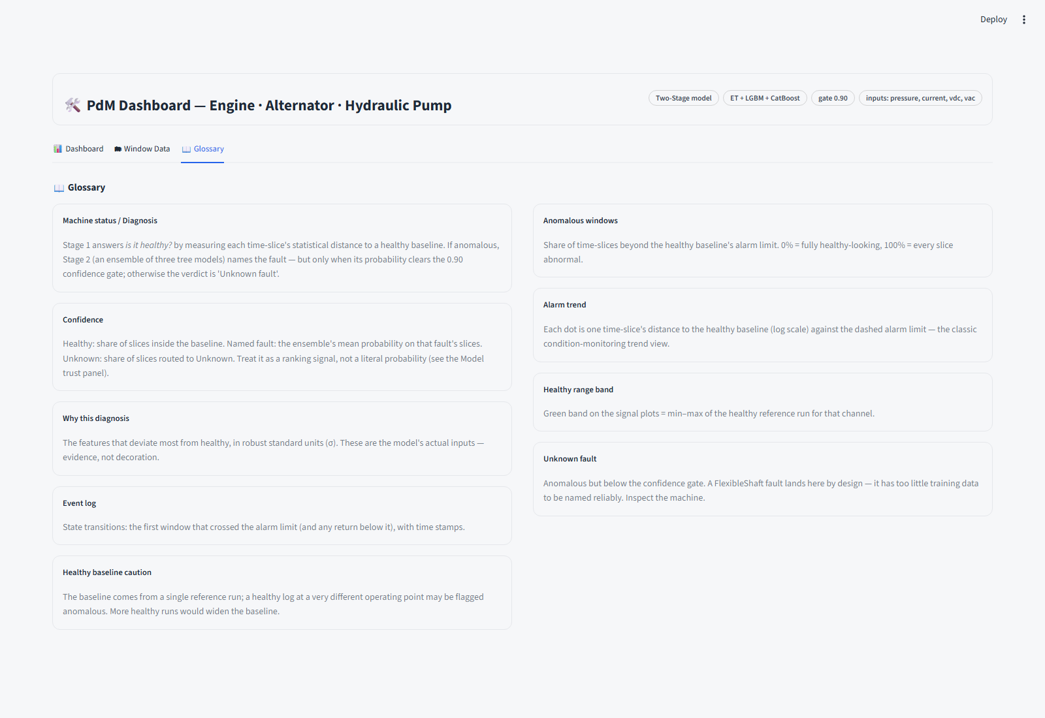
Figure 8.8 — Leakage, correctly diagnosed. Sample Leakage_factor.xlsx
(9 windows): diagnosis Leakage at 100% confidence — confirms the dashboard
correctly separates fault types, not just healthy-vs-fault.
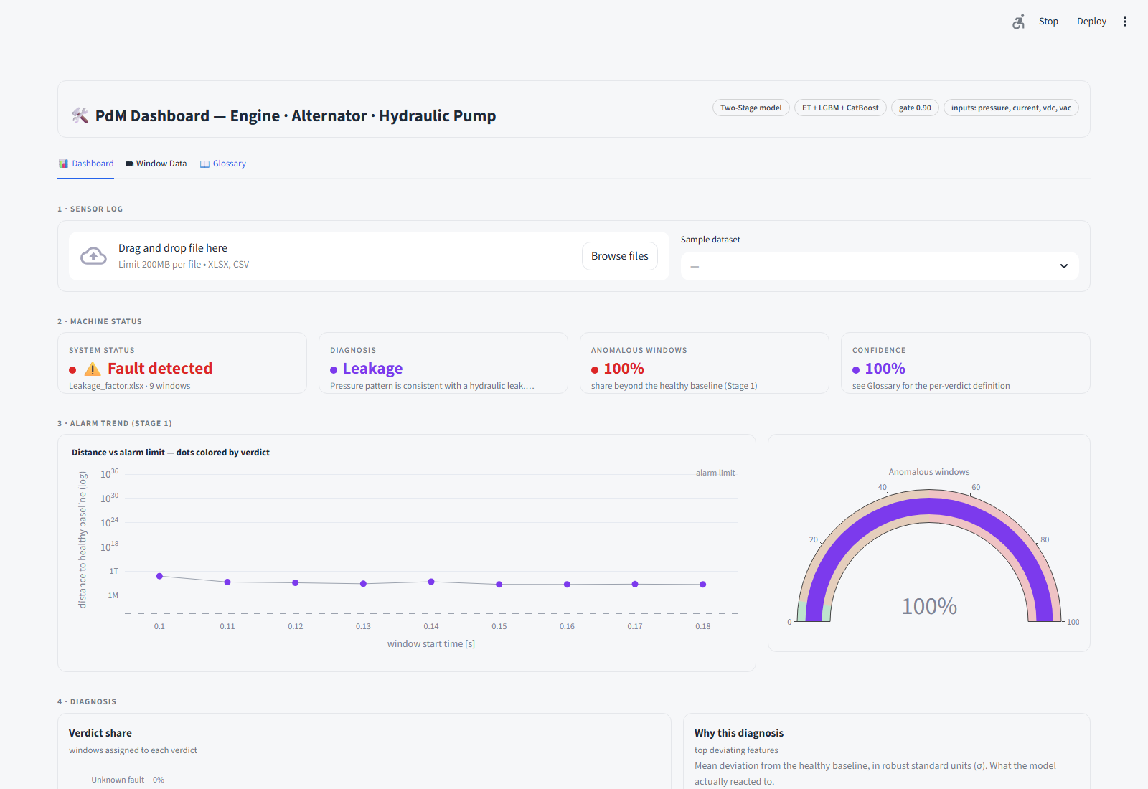
Figure 8.9 — Unseen fault correctly deferred. Sample
MildFlexible_shaft.xlsx (18 windows, never trained as a class): diagnosis
Unknown fault with the on-screen warning "doesn't confidently match a
trained fault — schedule an inspection." This is the confidence gate working
exactly as validated in §7.3/§8.4 — the system refuses to guess rather than
mislabeling an unfamiliar pattern.
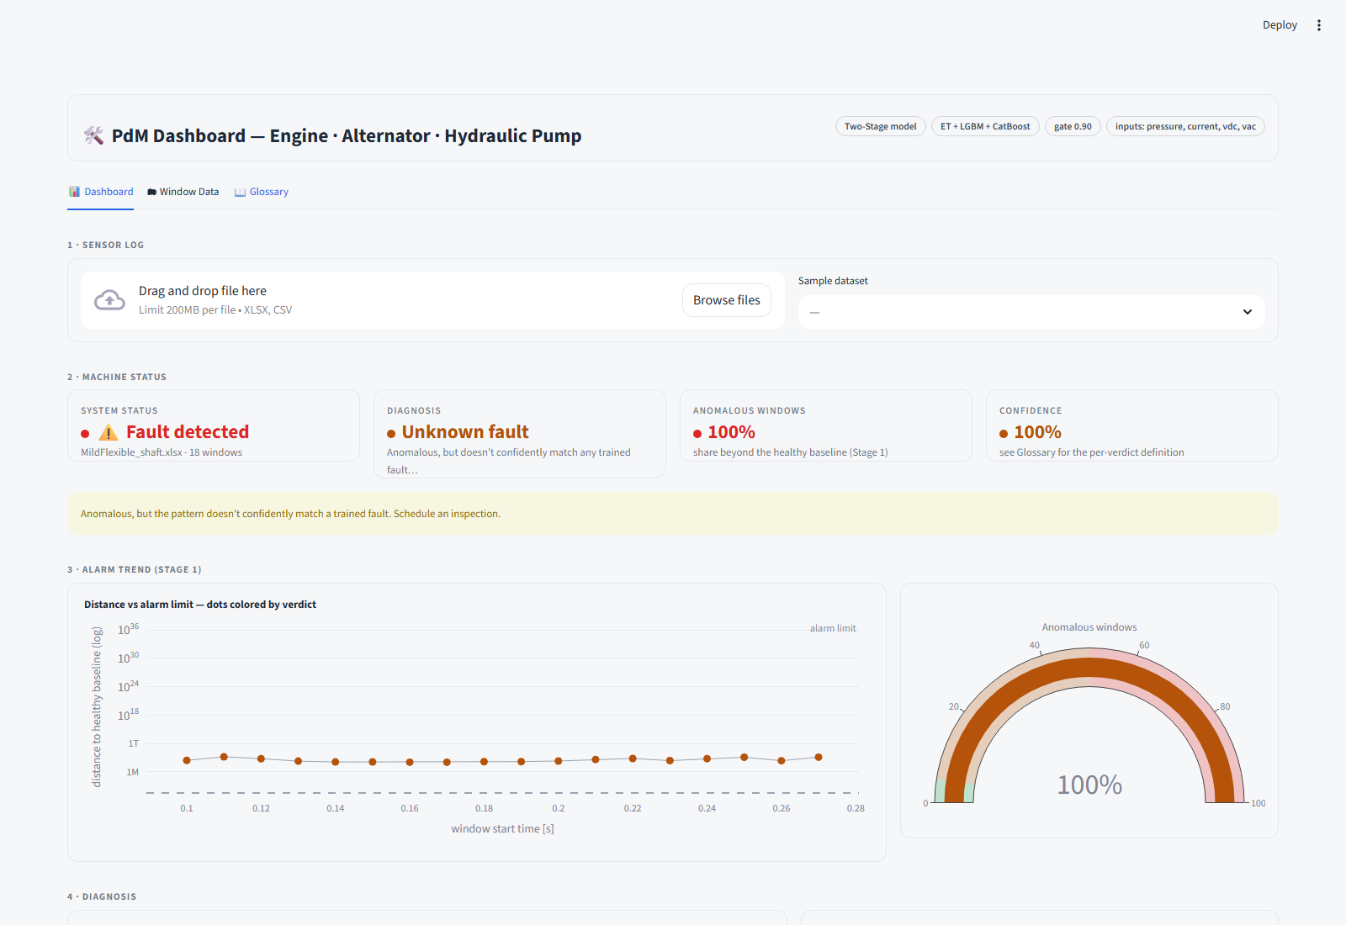
*Source: live Playwright capture of streamlit run 07_streamlit_app.py,
2026-07-10.*

8.9 User Manual
Launching the app
streamlit run 07_streamlit_app.py
Opens at http://localhost:8501.
Step-by-step usage
- On the Dashboard tab, either:
- drag-and-drop / browse to a .xlsx or .csv Simulink log, or
- pick a file from the Sample dataset dropdown.
- Wait for the one-time cached analysis (a spinner reads "Analyzing log —
running the two-stage model …").
- Read the four KPI cards under 2 · Machine status:
- System status — Healthy or Fault detected.
- Diagnosis — the named fault, or Healthy / Unknown fault.
- Anomalous windows — % of time-slices beyond the healthy baseline.
- Confidence — see the Glossary tab for the exact per-verdict definition.
- Check 3 · Alarm trend — each dot is one window's distance to the
healthy baseline; anything above the dashed line is anomalous.
- Check 4 · Diagnosis → "Why this diagnosis" for the specific sensor
features driving the verdict.
- Scroll to Sensor signals to see the raw cleaned channels against the
healthy reference band, and Channel status to confirm all 4 expected
channels (pressure, current, vdc, vac) were found in the upload.
- Use Export report to download a verdict summary or the full
per-window table.
- Open the Model trust panel to see the same leave-one-run-out
validation numbers reported in Chapter 7, without leaving the tool.
- Switch to Window Data for a filterable, sortable per-window table.
- Switch to Glossary for plain-language definitions of every metric.
Input requirements. The uploaded file must contain a time column, the
four trained channels (pressure, current, vdc, vac), and at least 3
complete 0.02 s windows of data at or after t = 0.1 s (the fault-active
region) — the same requirement enforced during training (§5.2).
Reading "Unknown fault." This verdict is not an error — it is the system
correctly refusing to name a pattern it wasn't confidently trained on. It is
the designed (and validated, §7.3) behavior for any fault type resembling
FlexibleShaft. Treat it as "schedule an inspection," not "system failure."
Source: `07_streamlit_app.py` Glossary tab content and inline UI copy.

8.10 Limitations
- Simulation-only validation. Every number in this report — Chapter 7's
validation and this chapter's results — comes from Simscape/Simulink
simulation, not physical sensor data. All metrics should be treated as an
upper bound until validated on real hardware; this is the dominant
real-world risk noted throughout the project (wiki/results.md).
- Single healthy reference run. Stage 1's healthy baseline is fit on 9
windows from one run. Its false-alarm rate is validated only in-run; a
healthy machine at a different but legitimate operating point could be
flagged anomalous simply for being outside that one run's observed range
(surfaced directly in the GUI's "Healthy baseline caution" glossary
entry). More independent healthy runs would widen and de-risk this
baseline.
- One data-collection defect drives all residual Stage-2 error. The
simplified_generator_fault run (24/24 windows misrouted) sits at a
standardized centroid distance of 6.4–6.7 from its sibling generator
runs — a different Simulink export configuration, not sensor noise or a
modelling gap. Until it is re-exported at the shared operating point,
GeneratorFault recall is capped at 70.7%.
- FlexibleShaft is detected, not diagnosed. With only two dissimilar
runs (standardized centroid distance 5.3 apart), FlexibleShaft could not
be trained as a supervised class at all; it is correctly flagged as
"Unknown fault" by the confidence gate, but the system cannot yet name
it. More FlexibleShaft runs at consistent operating points are required
before it can become a named Stage-2 class.
- Overconfident top-bin probabilities. The calibration check (§7.6)
shows the ensemble's ≈0.99 predicted-confidence bin corresponds to only
≈0.85 observed accuracy (gap 0.260, against a 0.15 tolerance), traced to
the same divergent generator run. Displayed confidence values should be
read as a ranking signal, not a literal probability — this is stated
explicitly in the GUI's own Glossary and Model trust panel, not hidden.
- No deep-learning path evaluated. An LSTM sequence-model league was
scoped but never run (TensorFlow unavailable in the execution
environment); given how close Logistic Regression (0.872 macro F1) comes
to the top tree ensembles on the engineered features, the expected
marginal benefit on this dataset size (221 fault windows) is judged
small, but this remains untested.
- No hyperparameter search. All model settings are fixed, conservative
defaults for small tabular data, chosen deliberately to avoid tuning
against the same LOGO folds used for reporting (§6.5) — this trades away
any headroom a validated search might have found.
*Source: §7.6 Error Analysis, artifacts/MODEL_CARD.md "Known caveats",
wiki/results.md "Honesty notes".*
*Sources for this chapter: artifacts/two_stage_metrics.json,
artifacts/two_stage_model_comparison.csv, artifacts/model_comparison.csv,
artifacts/feature_importance.csv, artifacts/feature_group_ablation.csv,
artifacts/MODEL_CARD.md, artifacts/robustness_*, 07_streamlit_app.py,
pdm_common.py, wiki/results.md, wiki/training-and-models.md, and live
captures of the running dashboard (docs/chapter8_gui_screenshots/,
2026-07-10).*

