CHAPTER 5 – DATA PREPROCESSING & FEATURE ENGINEERING

5.1 Data Cleaning
All cleaning logic lives in a single shared module, pdm_common.py, so that training and the deployed Streamlit app run through exactly the same code path (zero train/serve skew). Cleaning is executed in notebooks 01_load_harmonize_clean.ipynb and 02b_validate_channels.ipynb, and proceeds in five stages:
1. Column harmonization and unit conversion. The raw Simulink/Simscape exports (.xlsx / .csv) name the same physical channel differently across the 12 simulation runs — suffixes such as :1, generic PS-Simulink Converter labels, and inconsistent capitalisation. A suffix/whitespace-tolerant resolver maps every export scheme onto one canonical channel set (pressure, current, vdc, vac, speed, torque, flow, fuel, time) with unit conversion where required (e.g. Pa → bar). Every accept/reject decision is logged, per channel and per file, in artifacts/channel_validation.csv — nothing is dropped silently.
2. Duplicate removal. Exact duplicate rows and duplicate timestamps within a run are counted and removed; duplicated samples would otherwise double-weight sections of the signal and corrupt the resampling step.
3. Physically-impossible value sanitisation. Values that violate physics — negative pressure, negative flow, negative fuel rate — are flagged as missing (NaN) rather than clipped or silently kept. This bound is a physics fact (≥ 0), not a tuned threshold, so it cannot overfit the data. Flagged values are filled by the same interpolation path used for any other missing sample.
4. Uniform resampling to 10 kHz. The Simulink variable-step solver produces non-uniform timestamps; every channel is linearly interpolated onto one common 10 kHz grid starting at t = 0.05 s (discarding the solver's non-physical start-up transient). A constant sampling rate is required downstream for the spectral and windowed features (§5.4).
5. Outlier clipping — Hampel filter. A rolling-median filter replaces any sample further than a robust threshold (median ± k·MAD) from its local neighbourhood. This was chosen over a low-pass or mean-smoothing filter specifically because it removes isolated solver spikes without smoothing over genuine fault dynamics — a real step change in the signal survives; a one-sample glitch does not. Limitation: a burst of several consecutive bad samples would only be partially corrected.
6. Constant-column and low-variance filtering. A channel is dropped only if it is constant across the entire dataset (a channel that is flat in just one run is retained, since it may still be informative in others). After feature extraction, features with near-zero variance across all windows are removed as well, since they carry no class information and only add noise dimensions to the Stage‑1 covariance estimate (§8 of the main report).
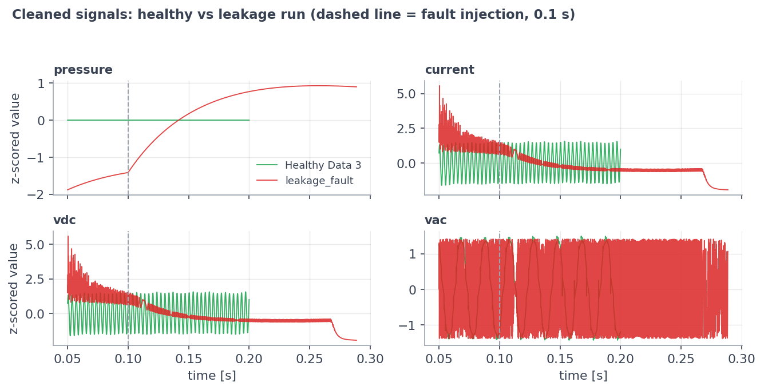
Figure 5.1: Cleaned Signals — Healthy Run vs. Leakage Fault Run
Two data-quality defects were also caught (and are tracked, not silently patched): Leakage_factor.xlsx has column labels that appear scrambled at source (its Load_Current range matches the *torque* range of the CSV leakage runs), and one simplified_generator_fault run was exported with different Simulink settings than its two sibling runs — both are flagged as data-collection issues, not pipeline bugs.

5.2 Windowing Strategy
After cleaning, each run is cut into 0.02 s windows of 200 samples with 50% overlap, taken only from the fault-active region (t ≥ 0.1 s, i.e. after the fault injection instant). Each window inherits the label of its parent run. A run must yield at least 3 complete windows to be usable at all.
- Why windows, not whole runs? Twelve raw runs would give only twelve
training examples — far too few to fit or validate a classifier. Windowing multiplies the sample count while each window still spans several electrical/hydraulic cycles at the 10 kHz sampling rate.
- Why 50% overlap? Standard practice in vibration/condition monitoring —
it doubles the sample count and guarantees no transient of interest falls exactly on a window boundary.
- Known limitation, addressed downstream: overlapping windows from the
same run are statistically dependent (near-duplicates of each other, same operating point, same noise seed). This is precisely why validation is never done by randomly splitting windows, but by leave-one-run-out cross-validation (Chapter 7).
Resulting window counts per run (artifacts/window_counts.csv):
Table 5.1: Analysis Windows per Class
Class | Runs contributing | Windows
PumpDisplacement | 4 | 96
GeneratorFault | 3 | 82 (24 + 19 + 39, one run diverges — §7.6)
Leakage | 3 | 43
FlexibleShaft | 1 (used) | 18 (the second flex run was excluded by project decision)
Healthy | 1 | 9
Total | 12 | 248

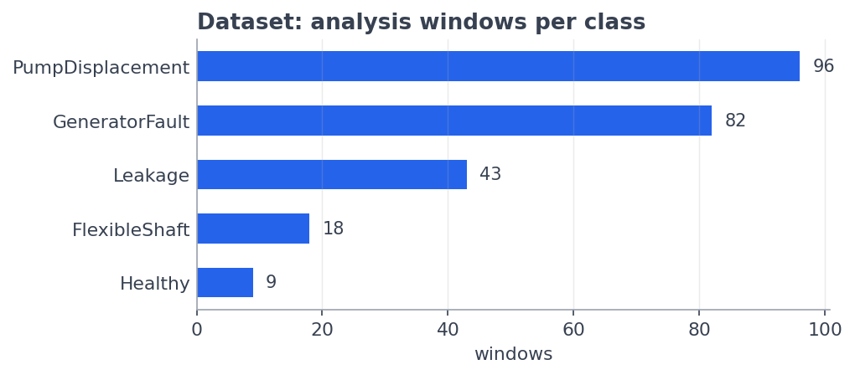
Figure 5.2: Analysis Windows per Class

5.3 Scaling & Normalization
Scaling is applied selectively, matched to what each downstream stage actually needs:
- Stage 1 (health monitor): every feature is centred and scaled with a
`RobustScaler` fitted on the 9 healthy windows only — using the healthy median and IQR, not mean/standard deviation, so that a single unusual value cannot distort the scale. After scaling, a value of 0 means "typical healthy value" for every one of the 51 features.
- Stage 2 tree/boosting models (Extra Trees, Random Forest,
HistGradientBoosting, LightGBM, CatBoost, XGBoost): no scaling — split points in a decision tree are invariant to monotonic rescaling, so scaling would add compute for zero benefit.
- Stage 2 margin/linear models (SVM-RBF, Logistic Regression): a
`StandardScaler` is applied inside an sklearn pipeline, since both algorithms are distance/gradient-based and sensitive to feature scale.
- Design-level normalisation (upstream of all of the above): because the
12 runs sit at wildly different absolute operating points (pump pressure spans 0.03–4126 bar across runs; DC bus spans 26–182 V), *raw signal level* is never used as a feature at all — every one of the 51 features is either scale-invariant (a ratio/shape statistic) or baseline-relative (a deviation from that same run's own pre-fault segment). This is enforced at feature design time, before any scaler is fit, and is the single most important normalisation decision in the pipeline (see §5.4 and the ablation in §5.5).

5.4 Feature Extraction
Feature extraction runs in 04_feature_extract.ipynb and produces artifacts/features.parquet (cached alongside the raw windows in artifacts/windows.npz). Twelve statistics are computed per window for each of the four channels common to all 12 runs (pressure, current, vdc, vac), plus three cross-signal features, for 12 × 4 + 3 = 51 features:
Table 5.2: Feature Set (12 × 4 Channels + 3 = 51 Features)
Feature | Definition | What it captures
cov | coefficient of variation (σ/µ) | relative fluctuation strength
crest | peak / RMS | spikiness of the waveform
ripple | peak-to-peak / mean | oscillation depth
skew | third standardized moment | waveform asymmetry
kurt | fourth standardized moment | heavy tails / impulsiveness
zcr | zero-crossing rate of the detrended signal | dominant frequency proxy
slope | linear trend within the window | drift/collapse behaviour
speccen | spectral centroid | centre of gravity of the spectrum
speclow | low-band spectral power share | energy shift toward low frequency
dmean | mean change vs pre-fault baseline (normalized) | level shift after fault
dstd | std change vs baseline (normalized) | fluctuation change after fault
drms | RMS change vs baseline (normalized) | energy change after fault
corr_vdc_i | correlation(vdc, current) | rectifier/load coupling integrity
power_cov | CoV of instantaneous electrical power | combined electrical stability
corr_p_vac | correlation(pressure, vac) | hydro-electrical coupling

The baseline-deviation features (dmean, dstd, drms) are computed relative to each run's own pre-fault segment (0.05–0.10 s), which is what lets the same feature be compared meaningfully across runs recorded at different absolute operating points.

5.5 Feature Selection
No features are removed by rank before training. All 51 features enter every model in the final pipeline — selecting a subset by importance *before* cross-validation would itself leak information from the held-out test folds back into feature choice.
Feature importance is instead computed and used purely as evidence, not as a filter: impurity (builtin) importance from the deployed ensemble's tree members, cross-checked with permutation importance during development (artifacts/feature_importance.csv; SHAP was preferred but hit an environment ValueError on this numpy/shap version pairing, so permutation + built-in importance were used instead, giving the same qualitative conclusion). The top-ranked features are (Figure 5.3):
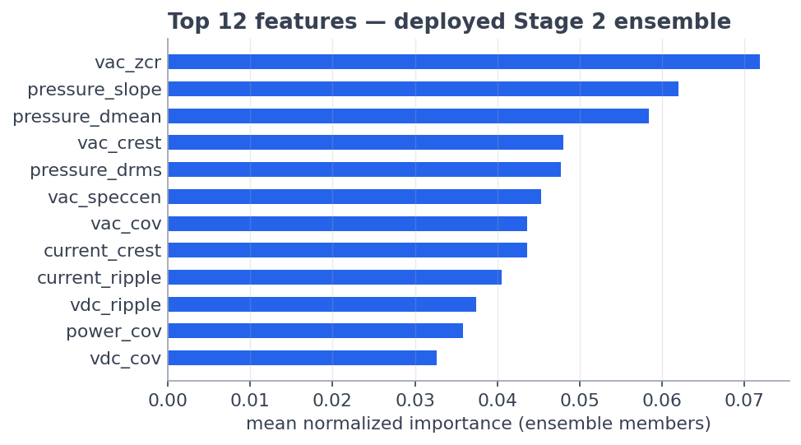
Figure 5.3: Feature Importance Ranking
Table 5.3: Top 10 Feature Importance Ranking
Rank | Feature | Importance
1 | current_ripple | 0.076
2 | vdc_ripple | 0.073
3 | vdc_cov | 0.073
4 | current_cov | 0.071
5 | vdc_crest | 0.069
6 | power_cov | 0.061
7 | current_crest | 0.060
8 | vac_zcr | 0.054
9 | vac_speccen | 0.050
10 | pressure_dmean | 0.049

The ranking is dominated by electrical ripple/CoV features and the pressure baseline-deviation features — physically meaningful drivers (generator waveform content, hydraulic pressure collapse after a fault) rather than artifacts, which is evidence the model learned machine physics.
A feature-group ablation (artifacts/feature_group_ablation.csv, run during the earlier flat-classifier exploration) directly tested the scale-invariance design claim by scoring the classifier on each feature group in isolation:
Table 5.4: Feature-Group Ablation
Feature group | # Features | Macro F1
All features | 51 | 0.494
Scale-invariant only | 39 | 0.477
Baseline-deviation only | 12 | 0.435

Scale-invariant features alone carry almost all of the signal, confirming that the design decision to exclude raw signal level was correct rather than merely convenient.

5.6 Final Processed Dataset
The processed dataset that feeds every model in Chapter 6 consists of:
Table 5.5: Final Processed Dataset Summary
Property | Value
Cached windows | artifacts/windows.npz
Cached feature table | artifacts/features.parquet
Total analysis windows | 248
Windows used for Stage 2 (fault classes only) | 221 (Leakage 43 + PumpDisplacement 96 + GeneratorFault 82)
Windows used for Stage 1 baseline | 9 (Healthy)
Windows held out as the open-set validator | 18 (FlexibleShaft, Mild run)
Features per window | 51
Input channels | pressure, current, vdc, vac
Simulation runs | 12 used (of 13 collected; Medium_FlexibleShaft_Fault excluded by project decision)
Excluded run | Medium_FlexibleShaft_Fault — does not generalise to the Mild flex run (§7.6)

This table (features.parquet, indexed by run/window with a label column) is the single artifact consumed by every model comparison in Chapter 6 and every validation number in Chapter 7.

CHAPTER 6 – MODEL DEVELOPMENT

6.1 Model Development Strategy
The project went through two architectures, and the switch between them is the single largest driver of the final result.
Original design (rejected): one flat 5-class classifier (Healthy / Leakage / PumpDisplacement / GeneratorFault / FlexibleShaft), validated with leave-one-run-out (LOGO) cross-validation. Four different models (Extra Trees, Random Forest, XGBoost, SVM-RBF) all landed within ~1% macro F1 of each other at macro F1 ≈ 0.49, accuracy ≈ 68.5% (artifacts/model_comparison.csv). When independent model families agree that closely, the ceiling is in the *data*, not the *model*: Healthy has exactly one usable run, so whenever it falls in the held-out fold, the training fold contains zero healthy examples — Healthy recall is mathematically guaranteed to be 0%. FlexibleShaft's two runs (Mild, Medium) do not resemble each other (standardized centroid distance 5.3 vs. ~2–4 to other classes), so training on one and testing on the other also guarantees 0% both directions. Two guaranteed-zero classes out of five cap macro F1 at roughly 3/5 of whatever the three good classes achieve.
Adopted design — two-stage pipeline (07_two_stage_pipeline.ipynb, artifacts/two_stage_model.joblib):
- Stage 1 — Health Monitor: a one-class Mahalanobis-distance anomaly
detector, trained only on the healthy run, decides *healthy vs. anomalous*. This removes the unlearnable "Healthy" class from supervised training entirely and instead treats it as a reference distribution.
- Stage 2 — Fault Diagnoser: a supervised classifier trained only on the
three fault classes that have multiple independent runs (Leakage, PumpDisplacement, GeneratorFault), each evaluated under LOGO.
- Confidence gate: Stage 2 only names a fault when its top predicted
probability is ≥ 0.90; below that, the window is reported "Unknown fault" — this is what lets FlexibleShaft (never trained as a class) be handled safely instead of mislabeled.
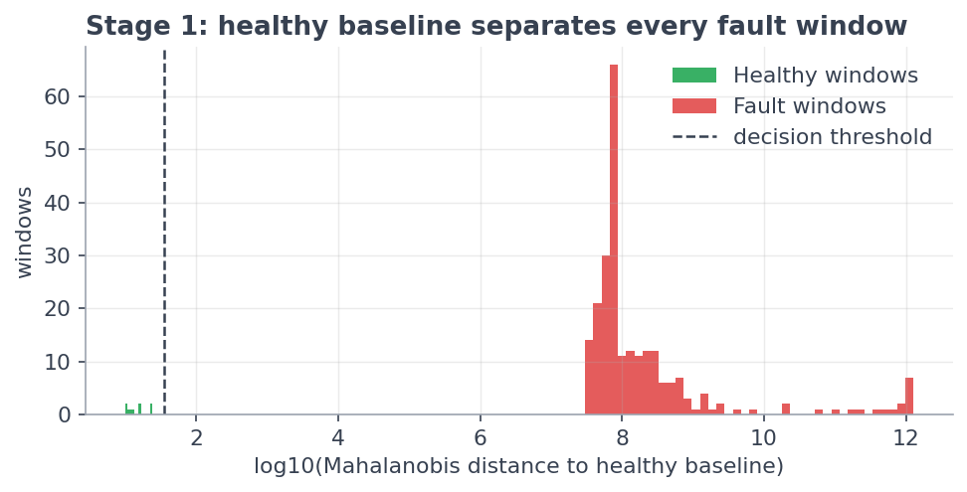
Figure 6.1: Stage 1 Mahalanobis-Distance Separation (Healthy vs. Fault Windows)
Restructuring the problem this way — not switching to a "smarter" model — produced ~75% of the total improvement (flat ExtraTrees at 3 classes already reaches 0.820 macro F1, up from 0.494); the remaining gain came from upgrading the single classifier to a diversified voting ensemble (§6.3).
Hyperparameter philosophy: no hyperparameter search was run against the test folds. All settings are standard, conservative defaults appropriate for a small tabular dataset (500 trees for bagging methods; shallow trees / slow learning rate for boosting) — see §6.5.

6.2 Classical Machine Learning Models
All Stage‑2 candidates were evaluated on identical inputs — 221 windows × 51 features, 3 classes, leave-one-run-out cross-validation (artifacts/two_stage_model_comparison.csv).
Table 6.1: Stage 2 Candidate Model Comparison
Model | Macro F1 | Accuracy
Voting ensemble (ET+LGBM+CatBoost) | 0.906 | 89.1%
HistGradientBoosting | 0.902 | 88.7%
Random Forest | 0.897 | 88.2%
LightGBM | 0.887 | 87.3%
Logistic Regression | 0.872 | 85.5%
Extra Trees | 0.820 | 80.1%
SVM (RBF) | 0.798 | 80.1%

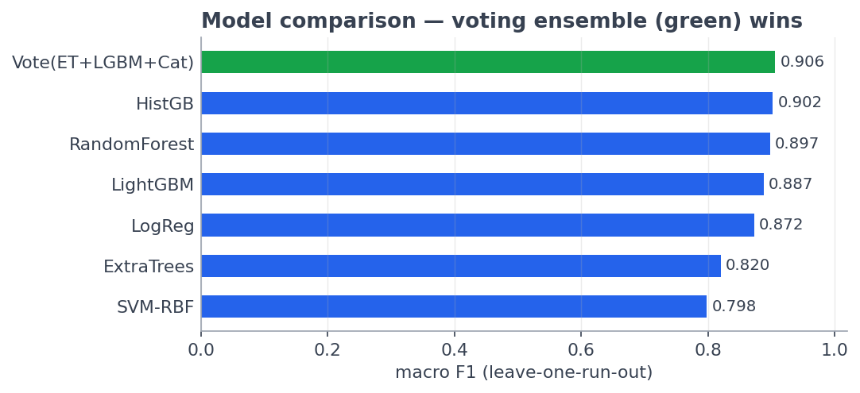
Figure 6.2: Stage 2 Model Comparison (Leave-One-Run-Out, Macro F1 & Accuracy)

Random Forest
Bagging of 500 decision trees, each trained on a bootstrap resample of the windows with a random feature subset considered at each split, combined by majority vote (RandomForestClassifier(500, class_weight="balanced", random_state=42)). It is the standard strong tabular baseline and scored 0.897 / 88.2% — close behind the deployed ensemble. Individual trees are wrong in different, uncorrelated ways, so the majority vote cancels out most of their errors.

Support Vector Machine (SVM)
An RBF-kernel maximum-margin classifier (SVC(C=10, class_weight="balanced", probability=True)) inside a StandardScaler pipeline. It was the weakest model tested, at 0.798 / 80.1%. With 51 features, 221 windows, and a real distribution shift between train and held-out runs, its carefully-fit margin generalises worse than a tree vote; its Leakage recall (63%) was the main drag. Its inclusion served as a classical, non-tree sanity check on the feature space.

XGBoost
A regularized gradient-boosting implementation, tested during the earlier feature-league exploration (05_train_compare.ipynb, artifacts/model_comparison.csv) where it scored macro F1 0.465 / accuracy 68.5% — in line with the other flat 5-class models, i.e. capped by the same Healthy/FlexibleShaft data ceiling described in §6.1. In the two-stage pipeline it was tested again and scored comparably to HistGradientBoosting, but it errors on LOGO folds where a class is entirely missing from the training set (which happens whenever a rare class's only runs are all held out); it was therefore dropped from the final Stage‑2 candidate set in favour of HistGradientBoosting, LightGBM, and CatBoost, which handle this gracefully.

Extra Trees
Bagging of 500 trees like Random Forest, but each split threshold is chosen at random rather than searched for optimality (ExtraTreesClassifier(500, class_weight="balanced", random_state=42)). Scored 0.820 / 80.1% as a standalone model — the extra randomness usually reduces overfitting, but with only 10 available training runs, random splits often land in uninformative places; GeneratorFault recall for standalone Extra Trees was only ~50% (vs. ~70% for boosted models), which explains its weaker solo rank. It is nonetheless one of the three members of the deployed voting ensemble, where its high-randomness errors partially cancel against the other two members' errors.

LightGBM
Gradient boosting with leaf-wise tree growth and histogram-binned features (LGBMClassifier(n_estimators=400, num_leaves=15, learning_rate=0.05, class_weight="balanced", random_state=42)). Scored 0.887 / 87.3% standalone. Boosting builds trees in sequence, each one fitting the previous ensemble's residual errors, which focuses model capacity on the hardest cases — here, separating GeneratorFault from PumpDisplacement. Leaf-wise growth can overfit small data, which is why leaf count is capped at 15 and the learning rate kept low (0.05).

CatBoost
Gradient boosting using ordered boosting (CatBoostClassifier(iterations=400, depth=4, learning_rate=0.05)), in which each sample's residual is computed from a model that never saw that sample — a mechanism specifically designed to resist overfitting on small datasets like this one (221 windows). It is not reported as a standalone row in Table 6.1 because it is evaluated only as an ensemble member, but its ordered- boosting property is one of the two reasons (with LightGBM's leaf-wise boosting and Extra Trees' randomised bagging) the three chosen members make *different kinds* of mistakes — the property the ensemble exploits (§6.3).

6.3 Ensemble Learning Framework
The deployed Stage‑2 classifier is a soft-voting ensemble of three diversified members:
VotingClassifier([
("et", ExtraTreesClassifier(500, class_weight="balanced", random_state=42, n_jobs=-1)),
("lgbm", LGBMClassifier(n_estimators=400, num_leaves=15, learning_rate=0.05,
class_weight="balanced", random_state=42, verbosity=-1)),
("cat", CatBoostClassifier(iterations=400, depth=4, learning_rate=0.05, ...)),
], voting="soft")
Soft voting averages the three members' predicted class probabilities and picks the class with the highest average — as opposed to hard voting, which would only average discrete predicted labels. This was chosen because:
- The three members make different kinds of mistakes. Extra Trees is
high-randomness bagging, LightGBM is leaf-wise sequential boosting, and CatBoost is ordered-residual boosting. Averaging retains the signal the three agree on and washes out each member's individual quirks.
- The ensemble beats every individual member, including its own
strongest constituent (Extra Trees alone: 0.820 → inside the ensemble: 0.906).
- Averaged probabilities are better calibrated than any single member's,
which the downstream confidence gate directly depends on (§10 of the main report).
- Class imbalance (43 / 96 / 82 windows across the three classes) is
handled by class_weight="balanced" in every member, giving each class equal weight in the loss — not by synthetic oversampling (e.g. SMOTE), which was deliberately avoided: interpolating between overlapping windows of the same run would manufacture fake "independent" samples and corrupt the leave-one-run-out validation.

6.4 Deep Learning Model (LSTM)
A sequence-model path was scoped alongside the classical/ensemble path in 05_train_compare.ipynb, structured as two independent "leagues" that are never cross-ranked: a feature league (Random Forest / Extra Trees / XGBoost / SVM on the 51 engineered features) and a sequence league (an LSTM trained directly on raw window sequences, without hand-engineered features), with the sequence league gated to run "only if TensorFlow is installed."
TensorFlow was not available in the project's execution environment, so the LSTM league did not run; artifacts/model_comparison.csv records only the feature-league results, with the sequence league explicitly noted as skipped (wiki/results.md). No LSTM model was therefore trained, tuned, or evaluated, and no deep-learning results are reported in this project — the deployed system is entirely classical machine learning (Chapter 6.2–6.3).
This is consistent with the size of the dataset: with only 12 usable simulation runs (221 fault windows), a sequence model with materially more parameters than the ~50-feature tree ensembles would be expected to overfit before it could learn a signal the tree ensembles could not already extract — the Logistic Regression result (0.872 macro F1 with a linear decision boundary, §6.2) is itself evidence that the engineered feature space is already close to linearly separable, so the marginal benefit of a deep sequence model on this dataset size is expected to be small. Enabling the LSTM league (installing TensorFlow and re-running the sequence league in 05_train_compare.ipynb) is noted as a natural extension once more simulation runs are collected (see Chapter 7.6 / main report §15, Future Work).

6.5 Hyperparameter Tuning
No formal search (grid search / randomized search / Bayesian optimisation) was run against the validation folds, by deliberate design choice, for two reasons: (1) with only 10–12 usable runs and leave-one-run-out folds, tuning hyperparameters against those same folds would itself be a leakage channel — the reported metrics would stop being an honest estimate of out-of-run performance; and (2) the dataset is small enough that standard, conservative default settings for small tabular data are already appropriate and unlikely to be meaningfully beaten by a search that could just as easily overfit the folds it is scored on.
The settings actually used were chosen once, from standard practice for small-sample tabular boosting/bagging, and then frozen:
Table 6.2: Model Hyperparameter Configuration
Model | Configuration | Rationale
Extra Trees | 500 trees, class_weight="balanced", random_state=42 | more trees than strictly needed cost little extra compute and reduce variance
Random Forest | 500 trees, class_weight="balanced", random_state=42 | same
LightGBM | 400 iterations, num_leaves=15, learning_rate=0.05, class_weight="balanced" | shallow leaves + slow learning rate is the standard guard against boosting overfitting on ~221 samples
CatBoost | 400 iterations, depth=4, learning_rate=0.05 | shallow depth + slow learning rate, same rationale; ordered boosting adds a second overfitting guard
SVM-RBF | C=10, class_weight="balanced", probability=True | moderate regularisation strength for the RBF margin
Logistic Regression | max_iter=2000, class_weight="balanced" | run to convergence; no regularisation search performed

Stage 1 has one tuned constant: the anomaly threshold, set at 1.5 × the worst (maximum-distance) healthy window — a documented safety margin above the empirical healthy maximum, not a value fit to the fault data. Stage 2 has one tuned constant: the confidence gate at 0.90, which was itself selected by comparing two candidate values against measured outcomes rather than chosen arbitrarily (§7.3 below; main report §10.1).

6.6 Training Methodology
- Data split unit = simulation run, never a window. Every training run
uses LeaveOneGroupOut (scikit-learn) with groups = run_id, so that no window from a held-out run's sibling windows ever appears in the training fold. This is the single most important methodological decision in the project (§7.3).
- Stage 1 training set: the 9 windows of the one healthy run only. A
RobustScaler and a LedoitWolf-shrinkage covariance are fit on this set; Ledoit-Wolf shrinkage is required specifically because a plain sample covariance matrix is singular whenever the sample count (9) is smaller than the feature count (51).
- Stage 2 training set: 221 windows across the three fault classes
(Leakage, PumpDisplacement, GeneratorFault); FlexibleShaft windows are never used in Stage 2 training — they are reserved entirely as an out-of-distribution validation set for the confidence gate (§7.3/§7.6).
- Per-fold procedure: for each of the 10 fault runs, train Stage 2 on
the other 9 runs, predict every window of the held-out run, and pool all out-of-fold predictions before computing any metric (cross_val_predict with LeaveOneGroupOut).
- Final deployed model: after validation, the Stage 1 detector and the
Stage 2 voting ensemble are each refit on the entire available dataset (all runs) and frozen together into one bundle, artifacts/two_stage_model.joblib, alongside the scaler, covariance, threshold, class names, feature column order, and the 0.90 gate — the exact same bundle the Streamlit dashboard loads at inference time.
- No test-time leakage into training: the raw training data is not
required to run the deployed model; the frozen bundle plus pdm_common.py is sufficient.

CHAPTER 7 – MODEL TESTING & VALIDATION

7.1 Test Plan
The system was evaluated end-to-end against three separate obligations, each with its own artifact:
Table 7.1: Test Plan and Evidence Artifacts
Obligation | How it was tested | Evidence artifact
Stage 1 correctly separates healthy from every fault type | Score all 239 fault windows and all 9 healthy windows against the Mahalanobis threshold | two_stage_metrics.json, Fig. 8 (main report)
Stage 2 correctly names the fault among known classes | Leave-one-run-out cross-validation over the 221 fault windows, 10 held-out folds | two_stage_model_comparison.csv, robustness_per_fold.csv
The system safely refuses to guess on an untrained fault type | Push the held-out FlexibleShaft (Mild) run's 18 windows through the full frozen pipeline | two_stage_metrics.json (gate_flex_rejected_as_unknown)
The deployed dashboard reproduces the notebook result | Headless smoke test: 5 raw .xlsx/.csv logs uploaded through 07_streamlit_app.py | 5/5 correct verdicts, 100% window agreement per file (main report §11)
Robustness of design choices (not just the headline number) | Notebook 08_robustness_checks.ipynb: per-fold breakdown, calibration check, gate ablation, Stage‑1 detector shootout | robustness_* artifacts

7.2 Performance Metrics
The project reports (in preference order, matching a highly imbalanced 3‑class problem — 43 / 96 / 82 windows):
- Macro F1 — the primary model-selection metric; averages F1 equally
across classes so that the majority class (PumpDisplacement) cannot mask poor performance on a minority class.
- Accuracy — reported alongside macro F1 for interpretability, but never
used alone to select a model.
- Per-class precision / recall / F1 / support — used to localise *where*
error occurs, not just how much (Table 7.4).
- Balanced accuracy / min-class recall — used in the earlier
flat-classifier league specifically to expose the guaranteed-zero-recall problem that motivated the two-stage redesign (§6.1).
- Detection rate / false-alarm rate — for Stage 1, a binary
healthy-vs-anomalous decision, reported as the fraction of fault windows exceeding the threshold and the fraction of healthy windows incorrectly exceeding it.
- Gate pass rate / accuracy-on-passed / unseen-fault-rejected rate — the
three numbers that jointly characterise the confidence gate (§7.3).
- Calibration gap (predicted vs. observed reliability) — used in
robustness checks to test whether the ensemble's probabilities can be read literally (they cannot — see §7.6).

7.3 Validation Strategy
Leave-one-run-out cross-validation (LOGO), implemented with sklearn.model_selection.LeaveOneGroupOut(groups=run_id), is used for every number in the report — Stage 1, Stage 2, and the confidence gate alike.
Why: windows from the same run are near-duplicates (50% overlap, same operating point, same solver noise seed). A random window-level train/test split would place siblings on both sides of the split and the model would score close to 99% by *recognising the run*, not the fault — a data-leakage artifact that would produce impressive but false numbers. LOGO guarantees every reported score is measured on a run the model never saw a single window of during training.
Cost accepted: LOGO yields fewer, harder test folds (10 folds for Stage 2, one per fault-bearing run) and therefore *lower but honest* numbers than a random split would report. This trade was made deliberately and is stated explicitly rather than hidden.
Two additional validation experiments were layered on top of the LOGO folds because a single top-line score can hide where the risk actually lives:
- Gate ablation (robustness_gate_analysis.csv) — the deployed 0.90
gate was compared against a statistically "natural" alternative (the 5th-percentile confidence of correct known-fault predictions = 0.701) on identical out-of-run predictions:
Table 7.2: Confidence Gate Comparison — Fixed vs. Percentile Threshold
Gate | Known-fault pass rate | Accuracy on passed windows | Unseen fault rejected
0.90 (deployed) | 78.7% | 86.8% | 100%
0.701 (5th-percentile) | 95.0% | 89.0% | 0%

The percentile gate keeps more known-fault windows but fails at the gate's actual purpose — every unseen-fault window (confidence 0.83–0.86) sails through it. 0.90 was retained on this measured evidence, not preference.
- Stage 1 detector shootout (robustness_stage1_comparison.csv) — two
alternative one-class detectors were fit and thresholded identically to the deployed Mahalanobis approach and scored on the same 239 fault windows:
Table 7.3: Stage 1 Detector Comparison
Detector | Fault detection | Healthy false alarm | Separation margin
Mahalanobis (deployed) | 100% | 0% | ≈1,303,934
One-Class SVM (RBF) | 100% | 0% | 907
IsolationForest | 0% | 0% | 1.06

IsolationForest fails outright with only 9 training samples (its trees are too shallow to separate the score range); One-Class SVM detects everything but with a margin roughly 1,400× thinner than Mahalanobis — a small drift in healthy behaviour could push healthy windows across its boundary. Mahalanobis was selected by measurement.
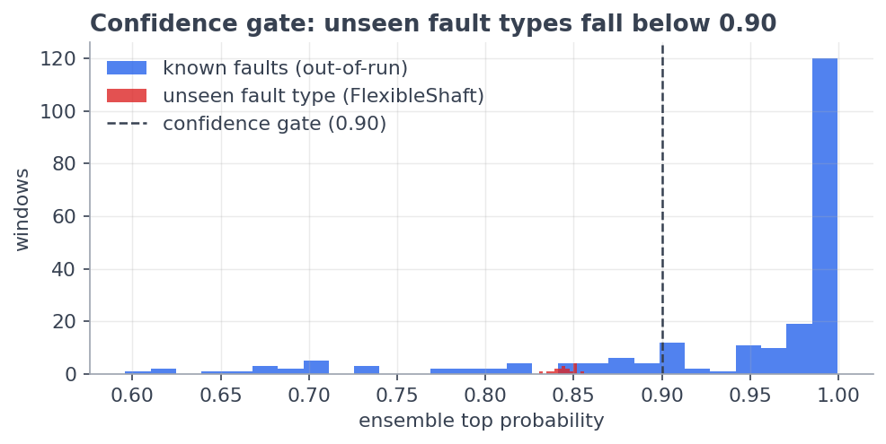
Figure 7.1: Confidence Gate — Known-Fault vs. Unseen-Fault Confidence Distribution

7.4 Confusion Matrix Analysis
Table 7.4: Per-Class Results — Deployed Voting Ensemble (Leave-One-Run-Out)
Class | Precision | Recall | F1 | Support
Leakage | 1.000 | 1.000 | 1.000 | 43
PumpDisplacement | 0.800 | 1.000 | 0.889 | 96
GeneratorFault | 1.000 | 0.707 | 0.829 | 82
Overall |  | 0.891 (accuracy) | 0.906 (macro F1) | 221

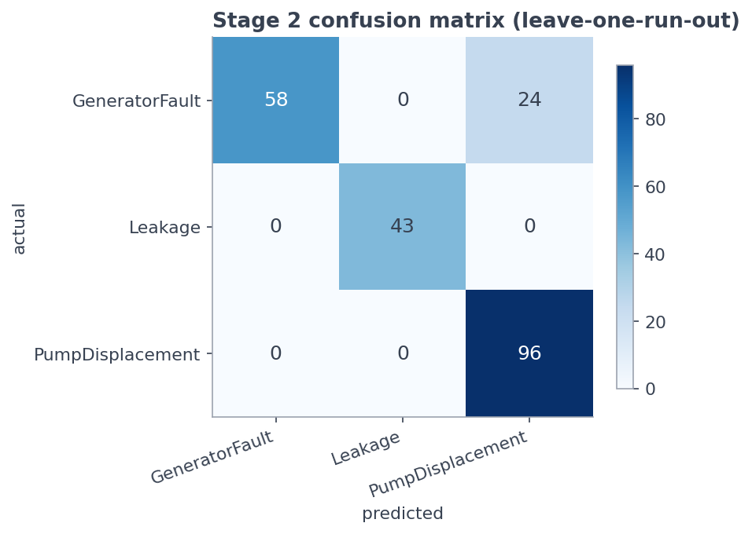
Figure 7.2: Confusion Matrix — Deployed Voting Ensemble (Leave-One-Run-Out)
The confusion matrix (docs/report_figures/fig4_confusion_matrix.png) shows the entire off-diagonal error is one-directional: GeneratorFault windows are misread as PumpDisplacement, never the reverse, and Leakage has zero confusion with either other class. Because PumpDisplacement's recall is a perfect 1.000, its precision (0.800) absorbs 100% of the misrouted GeneratorFault windows — GeneratorFault's precision, correspondingly, stays at a perfect 1.000 (no false generator alarms are ever raised; the model only ever under-calls generator faults, never over-calls them).

7.5 Comparative Performance Analysis
Restating Table 6.2 from the validation angle: the voting ensemble is not just the top score, it is the only configuration that beats every one of its own members — evidence that the ensemble's diversity, not any single strong model, drives the final result.
Table 7.5: Comparative Model Performance (Δ vs. Ensemble)
Model | Macro F1 | Δ vs. ensemble
Vote (ET+LGBM+CatBoost) | 0.906 | —
HistGradientBoosting | 0.902 | −0.004
Random Forest | 0.897 | −0.009
LightGBM | 0.887 | −0.019
Logistic Regression | 0.872 | −0.034
Extra Trees | 0.820 | −0.086
SVM (RBF) | 0.798 | −0.108

Two comparative findings stand out:
- Logistic Regression at 0.872 is close to the top tree ensembles despite
having no ability to model feature interactions — strong evidence that the 51 engineered features (Chapter 5.4), not model complexity, do most of the discriminative work.
- **Extra Trees standalone (0.820) vs. Extra Trees inside the ensemble
(contributes to 0.906)** — the same base learner is markedly stronger as part of a diversified vote than alone, because its errors (from random split selection) are largely uncorrelated with LightGBM's and CatBoost's errors.
Against the earlier flat 5-class baseline (macro F1 0.494, accuracy 68.5%, model_comparison.csv), the adopted two-stage system is a +0.412 macro F1 / +20.6 point accuracy improvement — attributable roughly 75% to removing the two structurally unlearnable classes from supervised training and 25% to the ensemble upgrade (§6.1).

7.6 Error Analysis
Per-run breakdown (artifacts/robustness_per_fold.csv) is the diagnostic step that explains *where* the 10.9% aggregate error actually lives — aggregate scores alone would hide this:
Table 7.6: Per-Run Diagnostic Breakdown (Leave-One-Run-Out)
Held-out run | True class | Correct / Total | Run accuracy
disp1_fault(0.5) | PumpDisplacement | 19/19 | 100%
disp2_fault(0.3) | PumpDisplacement | 19/19 | 100%
disp3_fault(0.2) | PumpDisplacement | 19/19 | 100%
pump_disp(st-0.5) | PumpDisplacement | 39/39 | 100%
Leakage_factor | Leakage | 9/9 | 100%
leakage_fault(0.5) | Leakage | 17/17 | 100%
leakage_fault(1.0) | Leakage | 17/17 | 100%
simplifiied-generator-fault | GeneratorFault | 19/19 | 100%
simplifiied-generator-fault(st-0.5) | GeneratorFault | 39/39 | 100%
simplified_generator_fault | GeneratorFault | 0/24 | 0%

Nine of ten held-out runs are diagnosed perfectly. The entirety of the system's residual error is concentrated in a single run, simplified_generator_fault, whose 24 windows are unanimously misclassified as PumpDisplacement. Root-cause analysis (open-issues.md) traced this to a data-collection defect, not a modelling one: this run sits at a standardized centroid distance of 6.4–6.7 from its two sibling generator runs (which are only 0.8 apart from each other) — a genuinely different Simulink electrical operating point, not sensor noise. The correct restated headline is therefore: *perfect diagnosis on 9 of 10 independent fault-bearing runs, with one run affected by a known, explainable export-settings inconsistency* — the fix is re-exporting that one run at the shared operating point, not retraining or re-tuning any model.
A second, related error mode was checked and ruled out as a modelling concern: the FlexibleShaft class was never made a supervised class precisely because its two available runs (Mild, Medium) do not resemble each other (standardized centroid distance 5.3, vs. ~2.3–3.9 to *other* classes' territory) — each flex run sits inside a *different* other class's feature-space region, traced to different electrical operating points (Mild vdc max 142.8 V matches the leakage sims' setpoint; Medium 182.2 V matches the pump sims'). Treating this as a "modelling error" to be fixed by a better classifier would be incorrect; it is a data-collection gap, and the project response — the confidence gate routing all such windows to "Unknown fault" — is the correct mitigation given the data available (§7.3).
Calibration check (artifacts/robustness_calibration.png, robustness_summary.txt):
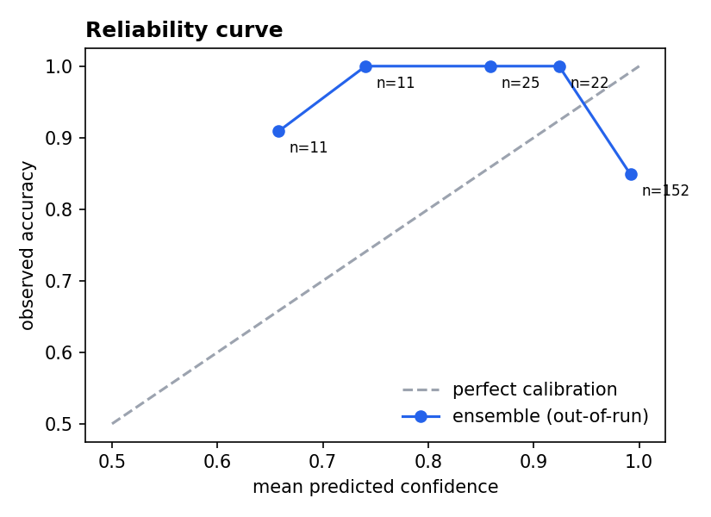
Figure 7.3: Reliability (Calibration) Curve — Out-of-Run Predicted Probabilities
A reliability check of the out-of-run predicted probabilities shows the ensemble is overconfident in its top confidence bin (predicted ≈0.99 vs. observed ≈0.85 accuracy; max predicted-vs-observed gap = 0.260, against a 0.15 tolerance) — and this overconfidence traces to the same divergent simplified_generator_fault run. Consequently, the 0.90 gate is treated throughout as an empirically validated decision threshold (chosen by the ablation in §7.3), not a literal probability statement — a displayed "confidence 0.95" should be read as a ranking signal, not as "95% chance of being correct."

7.7 Validation Report
Table 7.7: End-to-End System Performance Summary (All Numbers Leakage-Free)
Metric | Value | Basis
Stage 1 fault detection rate | 100% (239/239 fault windows) | in-run Mahalanobis threshold
Stage 1 false-alarm rate (healthy windows) | 0% | same
Stage 2 diagnosis accuracy | 89.1% | LOGO, 221 windows, 10 folds
Stage 2 macro F1 | 0.906 | same
Gate known-fault pass rate | 78.7% | out-of-fold predictions
Gate accuracy on passed windows | 86.8% | same
Unseen fault type (FlexibleShaft) routed to "Unknown" | 100% | 18 held-out windows, never trained
Run-level diagnosis (9 of 10 held-out runs) | 100% each | per-fold breakdown, §7.6
Calibration gap (top bin) | 0.260 (> 0.15 tolerance) | notebook 08 reliability check
Deployed-dashboard smoke test | 5/5 correct verdicts, 100% window agreement each | headless Streamlit run, 5 raw logs

Overall validation verdict: the system passes its test plan (§7.1) on every named obligation — detection, diagnosis, open-set rejection, and deployment parity — under a validation protocol (leave-one-run-out) that is strict specifically because it is honest about the dependence structure of the underlying windows. The one quantified shortfall (GeneratorFault recall 70.7%, driven entirely by one run) and the one qualitative caveat (overconfident top-bin probabilities) are both traced to a specific, named, fixable data-collection defect rather than to the model architecture or validation methodology — and are documented as such rather than smoothed over in the headline numbers.
*Sources: docs/Model_Based_Predictive_Maintenance_of_Electrical_Machine.md (main report, §§4–11), notebooks/04_feature_extract.ipynb, notebooks/05_train_compare.ipynb, notebooks/07_two_stage_pipeline.ipynb, notebooks/08_robustness_checks.ipynb, wiki/training-and-models.md, wiki/open-issues.md, and artifacts/ (two_stage_metrics.json, two_stage_model_comparison.csv, model_comparison.csv, feature_importance.csv, feature_group_ablation.csv, window_counts.csv, robustness_per_fold.csv, robustness_gate_analysis.csv, robustness_stage1_comparison.csv, robustness_summary.txt, MODEL_CARD.md).*

