**PROJECT TOPIC :-**

Onilne pizza ordering system.

**PROBLEM STATEMENT :-**

To develop a web page using HTML to provide information about pizza's and its stored websites and to account on all the order details

**COMPONETS USED :-**

🡪HTML

🡪CSS

🡪 BOOTSTRAP

🡪 ANGULAR JSS

**SOURCE CODE**

**HTML CODE**🡪

<!DOCTYPE html>

<html>

<head>

<title>Pittseria.com</title>

<meta name="viewport" content="width=device-width, initial-scale=1, maximum-scale=1, user-scalable=0">

<meta http-equiv="Content-Type" content="text/html; charset=utf-8">

<meta name="msapplication-config" content="none">

<link rel="stylesheet" href="https://stackpath.bootstrapcdn.com/bootstrap/4">

<link rel="stylesheet" type="text/css" href="webpro.css">

<link rel="stylesheet" href="https://stackpath.bootstrapcdn.com/bootstrap/4.3.1/css/bootstrap.min.css" integrity="sha384-ggOyR0iXCbMQv3Xipma34MD+dH/1fQ784/j6cY/iJTQUOhcWr7x9JvoRxT2MZw1T" crossorigin="anonymous">

<link rel="stylesheet" type="text/css"href="https://getbootstrap.com/docs/4.3/components/carousel/#with-controls">

</head>

<body bgcolor="light">

<div class="lol">

<br><br> <br>

<!--<div class="text-top"><!-->

<center><img src="finalogo.png"height="160px" width="170px" align-text="left">PITTSERIA</div></div></center>

<div class="container-fluid">

<div class="fixed-top"><center> <div class="btn-group btn-group-lg" role="group" aria-label="Basic example">

<button type="button" class="btn btn-info"><a href="form.html"><div id="a">Log In</div></a></button>

<button type="button" class="btn btn-info"><a href="pit.html"><div id="a">Sign In</div></a></button>

<button type="button" class="btn btn-dark">Log Out</button>

</div></center>

<div id="container-fluid">

<center><ul><li><a href="#">Home</a></li>

<li><a href="#">Stores</a></li>

<li><a href="#">Order</a></li>

<li><a href="#">About</a></li>

</ul></center></div></div></div>

</div>

</div>

</div><br>

<div class="display-1"><h1><center>What's Your Today's Pick??</center></h1></div>

<br>

<div class="pop">

<div class="container">

<!--<div class="card" style="width: 18rem;">

<img src="pizz.jpg" class="card-img-top" alt="...">

<div class="card-body">

<h5 class="card-title">Card title</h5>

<p class="card-text">Some quick example text to build on the card title and make up the bulk of the card's content.</p>

<a href="#" class="btn btn-primary">Go somewhere</a>

</div>

</div>

<div class="card" style="width: 18rem;">

<div class="card-body">

<h5 class="card-title">Card title</h5>

<h6 class="card-subtitle mb-2 text-muted">Card subtitle</h6>

<p class="card-text">Some quick example text to build on the card title and make up the bulk of the card's content.</p>

<a href="#" class="card-link">Card link</a>

<a href="#" class="card-link">Another link</a>

</div>

</div>

</div>

</div><!-->

<div class="row">

<div class="col-sm-6">

<div class="card" style="width: 18rem;">

<img src="pizz.jpg" class="card-img-top" alt="...">

<div class="card-body">

<h5 class="card-title">Pepperoni</h5>

<p class="card-text"> A whopping 36% of people order pepperoni on their pizzas, according to research by business advisor Brian Romelle...</p>

<a href="#" class="btn btn-primary">Ingredients</a>

</div>

</div>

</div>

<div class="col-sm-6">

<div class="card" style="width:35rem;height: 26rem;">

<div class="card-body">

<h5 class="card-title">Special delivery order !!</h5>

<br><br>

<p class="card-text">Get a freshly taste of exotic flavours blending in richness of spicy and mid-Italian-Indian taste letting you feel the aroma of Mediteranian region.

<br><br><br>

Get your flavors on - </p>

<br>

<a href="https://pizzaonline.dominos.co.in/menu?categoryId=3" class="btn btn-primary">Dominos</a>

<a href="#" class="btn btn-primary">Pizza Hut</a>

</div>

</div>

</div>

</div>

<br>

<hr><br>

<div class="display-1"><h1><center>Popular Pittsies</center></h1></div>

<div class="card-deck">

<div class="card">

<img src="pizzu.jpg" class="card-img-top" alt="...">

<div class="card-body">

<h5 class="card-title">Olive Burst Pizza</h5>

<p class="card-text">Olives go great with all your favorite pizza toppings — try them with sausage, bell peppers, even ham and pineapple! ... Preheat oven to 500°F, ideally with pizza stone. ... Top with pizza sauce, cheese, onion, pepperoni, and olives.</p>

<a href="#" class="btn btn-primary">Dominos</a>

<a href="#" class="btn btn-primary">Pizza Hut</a>

</div>

<div class="card-footer">

<small class="text-muted">Images shown may be different to the actual product.</small>

</div>

</div>

<div class="card">

<img src="pizzz.jpg" class="card-img-top" alt="...">

<div class="card-body">

<h5 class="card-title">Sicilian Pizza</h5>

<p class="card-text">Sicilian pizza has a fluffy, spongy bread base topped with a meatless sauce made from tomatoes, onions, herbs, and anchovies, which is covered with breadcrumbs</p>

<a href="#" class="btn btn-primary">Dominos</a>

<a href="#" class="btn btn-primary">Pizza Hut</a>

</div>

<div class="card-footer">

<small class="text-muted">Images shown may be different to the actual product</small>

</div>

</div>

<div class="card">

<img src="chocoo.jpg" class="card-img-top" alt="...">

<div class="card-body">

<h5 class="card-title">Chocolate Pizza</h5>

<p class="card-text">Our gourmet chocolate pizzas make the perfect gift for every occasion, including birthdays, anniversaries, corporate events, and exam celebrations.</p>

<a href="#" class="btn btn-primary">Dominos</a>

<a href="#" class="btn btn-primary">Pizza Hut</a>

</div>

<div class="card-footer">

<small class="text-muted">Images shown may be different to the actual product.</small>

</div>

</div>

</div><div class="display-1"><h1><center>Have a liking to the sides too..</center></h1></div>

<div class="card-deck">

<div class="card">

<img src="garlic.jpg" class="card-img-top" alt="...">

<div class="card-body">

<h5 class="card-title">Garlic Bread</h5>

<p class="card-text">The best Italian style Cheesy Garlic Bread in our delivery system. Quality bread toasted to perfection with loads of cheese and garlic butter which makes the perfect compliment for any meal</p>

<a href="https://pizzaonline.dominos.co.in/menu?categoryId=4" class="btn btn-primary">Dominos</a>

<a href="#" class="btn btn-primary">Pizza Hut</a>

</div>

<div class="card-footer">

<small class="text-muted">Images shown may be different to the actual product.</small>

</div>

</div>

<div class="card">

<img src="pasta.jpg" class="card-img-top" alt="...">

<div class="card-body">

<h5 class="card-title">White Pasta Italiano Veg</h5>

<p class="card-text">The cheesiest pasta guaranteed! with lots of veggies and white sauce ....</p>

<a href="https://pizzaonline.dominos.co.in/menu?categoryId=4" class="btn btn-primary">Dominos</a>

<a href="#" class="btn btn-primary">Pizza Hut</a>

</div>

<div class="card-footer">

<small class="text-muted">Images shown may be different to the actual product</small>

</div>

</div>

<div class="card">

<img src="choco1.jpg" class="card-img-top" alt="...">

<div class="card-body">

<h5 class="card-title">Choco Lava</h5>

<p class="card-text">A perfect indulgence for every occasion yet very easy for every day dessert! Classic chocolate lava cake!!</p>

<a href="https://pizzaonline.dominos.co.in/menu?categoryId=4" class="btn btn-primary">Dominos</a>

<a href="#" class="btn btn-primary">Pizza Hut</a>

</div>

<div class="card-footer">

<small class="text-muted">Images shown may be different to the actual product.</small>

</div>

</div>

</div>

<div class="dropdown-menu">

<form class="px-4 py-3">

<div class="form-group">

<label for="exampleDropdownFormEmail1">Email address</label>

<input type="email" class="form-control" id="exampleDropdownFormEmail1" placeholder="email@example.com">

</div>

<div class="form-group">

<label for="exampleDropdownFormPassword1">Password</label>

<input type="password" class="form-control" id="exampleDropdownFormPassword1" placeholder="Password">

</div>

<div class="form-group">

<div class="form-check">

<input type="checkbox" class="form-check-input" id="dropdownCheck">

<label class="form-check-label" for="dropdownCheck">

Remember me

</label>

</div>

</div>

<button type="submit" class="btn btn-primary">Sign in</button>

</form>

<div class="dropdown-divider"></div>

<a class="dropdown-item" href="#">New around here? Sign up</a>

<a class="dropdown-item" href="#">Forgot password?</a>

</div>

<br>

<br>

<hr><br><br>

<<!--

div id="carouselExampleControls" class="carousel slide" data-ride="carousel">

<div class="carousel-inner">

<div class="carousel-item active">

<img src="C:\Users\Admin\Desktop\Web Project\pizzu.jpg" class="d-block w-100" alt="...">

</div>

<div class="carousel-item">

<img src="C:\Users\Admin\Desktop\Web Project\pizza1.jpg" class="d-block w-100" alt="...">

</div>

<div class="carousel-item">

<img src="C:\Users\Admin\Desktop\Web Project\pizza3.jpg" class="d-block w-100" alt="...">

</div>

</div>

<a class="carousel-control-prev" href="#carouselExampleControls" role="button" data-slide="prev">

<span class="carousel-control-prev-icon" aria-hidden="true"></span>

<span class="sr-only">Previous</span>

</a>

<a class="carousel-control-next" href="#carouselExampleControls" role="button" data-slide="next">

<span class="carousel-control-next-icon" aria-hidden="true"></span>

<span class="sr-only">Next</span>

</a>

</div><!-->

<!--<div class="edv-img sc-gGBfsJ sqqYN"><div class="img-cntnt"><span class="img-cntnt-rbn">2 Pizzas @ 219 each</span><span>Select any 2 Medium Pizzas</span><span>Worth <span class="img-cntnt-ln-thrg">335</span> @<span class="rupee img-cntnt-prc">219 each</span></span><div class="injectStyles-sc-1jy9bcf-0 kbDNbH"><button class="btn--noStyle"><span>Order now</span></button></div></div></div>

<div class="edv-img sc-gGBfsJ sqqYN"><div class="img-cntnt"><span class="img-cntnt-rbn">2 Pizzas @ 199 each</span><span>Select any 2 Medium Pizzas</span><span>Worth <span class="img-cntnt-ln-thrg">305</span> @<span class="rupee img-cntnt-prc">199 each</span></span><div class="injectStyles-sc-1jy9bcf-0 kbDNbH"><button class="btn--noStyle"><span>Order now</span></button></div></div></div><!-->

</body>

</html>

**Sign In/Log In HTML**🡪

<!DOCTYPE html>

<html>

<head>

<title>Sign In</title>

<link rel="stylesheet" type="text/css" href="form.css">

</head>

<body>

<div class="wrapper">

<form class="form-signin">

<h2 class="form-signin-heading">Please login</h2>

<input type="text" class="form-control" name="username" placeholder="Email Address" required="" autofocus="" />

<br>

</br>

<input type="password" class="form-control" name="password" placeholder="Password" required=""/>

<br>

</br>

<label class="checkbox">

<input type="checkbox" value="remember-me" id="rememberMe" name="rememberMe"> Remember me

<br>

</br>

</label>

<button class="btn btn-lg btn-primary btn-block" type="submit">Login</button>

</form>

</div>

</body>

</html>

**CSS Code**🡪

body{

font-family: $font-family-sans-serif:

// Safari for macOS and iOS (San Francisco)

-apple-system,

// Chrome < 56 for macOS (San Francisco)

BlinkMacSystemFont,

// Windows

"Segoe UI",

// Android

"Roboto",

// Basic web fallback

"Helvetica Neue", Arial, sans-serif,

// Emoji fonts

"Apple Color Emoji", "Segoe UI Emoji", "Segoe UI Symbol" !default;

background-color: #C0C0C0;

}

.lol{

background-image:linear-gradient(rgba(0,0,0,0.63),rgba(0,0,0,0.63),rgba(0,0,0,0.63)), url(piz.jpg);

background-size: cover;

background-repeat: no-repeat;

height: 100vh;

color:white;

font-family:Castellar;

font-size: 60px;

}

button{

text-align: center;

padding-left: 100px;

color:white;

}

#a{

color:white;

}

.container-fluid{

background-color: #fff;

}

#container-fluid{

background-color: #ff8b03;

height: 65px;

padding-top: 10px;

}

#container-fluid ul li{

display:inline-block;

}

#container-fluid ul{

list-style-type: none;

display:inline-block;

float:center;

}

#container-fluid ul li a{

text-decoration: none;

font-size: 30px;

font-family: Montserrat;

margin: 40px;

color:black;

transition:0.1s ease;

border:20px solid transparent;

box-shadow: 30px;

}

#container-fluid ul li a:hover{

color:black;

background-color:#fff;

border-radius: 10px;

text-underline-position: inherit;

}

.li{

color: white;

-webkit-column-count:2; /* Chrome,Safari,Opera*/

-moz-column-count:2;/*Firefox*/

column-count: 2;

-webkit-column-width:40px;/*Chrome,Safari,Opera*/

-moz-column-width:40px;/*Firefox*/

column-width:40px;

-webkit-column-gap:20px;

-moz-column-gap:20px;

column-gap:20px;

-webkit-column-rule-color:#9c9;

-webkit-column-rule-style:solid;

-webkit-column-rule-width:10px;

-moz-column-rule-width:10px;

-moz-column-rule-style:solid;

-moz-column-rule-color:#9c9;

column-rule-color: #9c9;

column-rule-style: solid;

column-rule-width: 10px;

height:120vh;

}

**Sign In/Log In CSS**🡪

@import "bourbon";

body {

background: #eee !important;

}

.wrapper {

margin-top: 80px;

margin-bottom: 80px;

color:rgb(131,154,177);

}

.form-signin {

max-width: 380px;

padding: 15px 35px 45px;

margin: 0 auto;

background-color: #fff;

border: 1px solid rgba(0,0,0,0.1);

.form-signin-heading,

.checkbox {

margin-bottom: 30px;

}

.checkbox {

font-weight: normal;

}

.form-control {

position: relative;

font-size: 16px;

height: auto;

padding: 10px;

@include box-sizing(border-box);

&:focus {

z-index: 2;

}

}

input[type="text"] {

margin-bottom: -1px;

border-bottom-left-radius: 0;

border-bottom-right-radius: 0;

}

input[type="password"] {

margin-bottom: 20px;

border-top-left-radius: 0;

border-top-right-radius: 0;

}

input[type="password"] {

margin-bottom: 20px;

border-top-left-radius: 0;

border-top-right-radius: 0;

}

**OUTPUT**

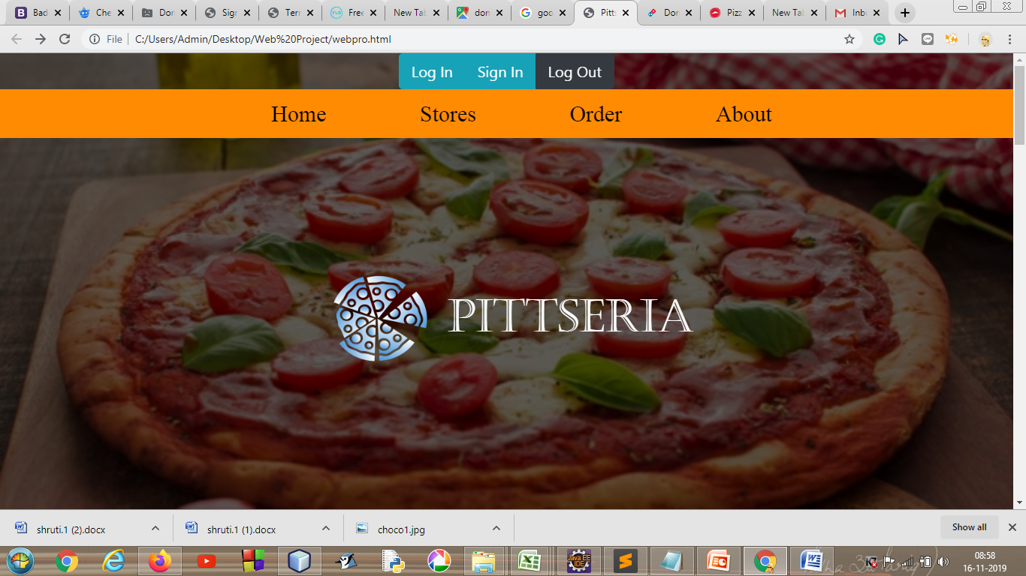

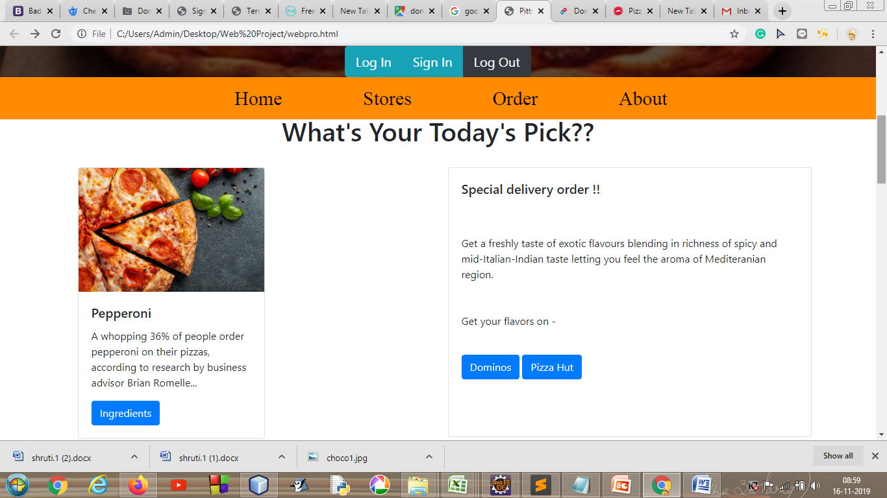

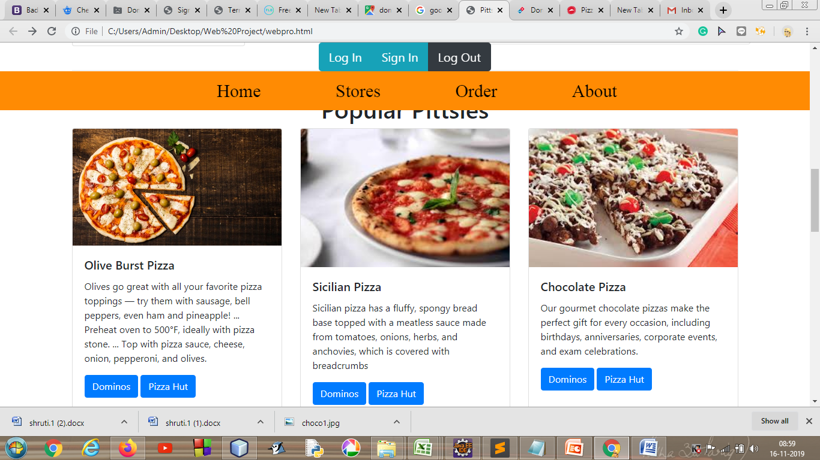

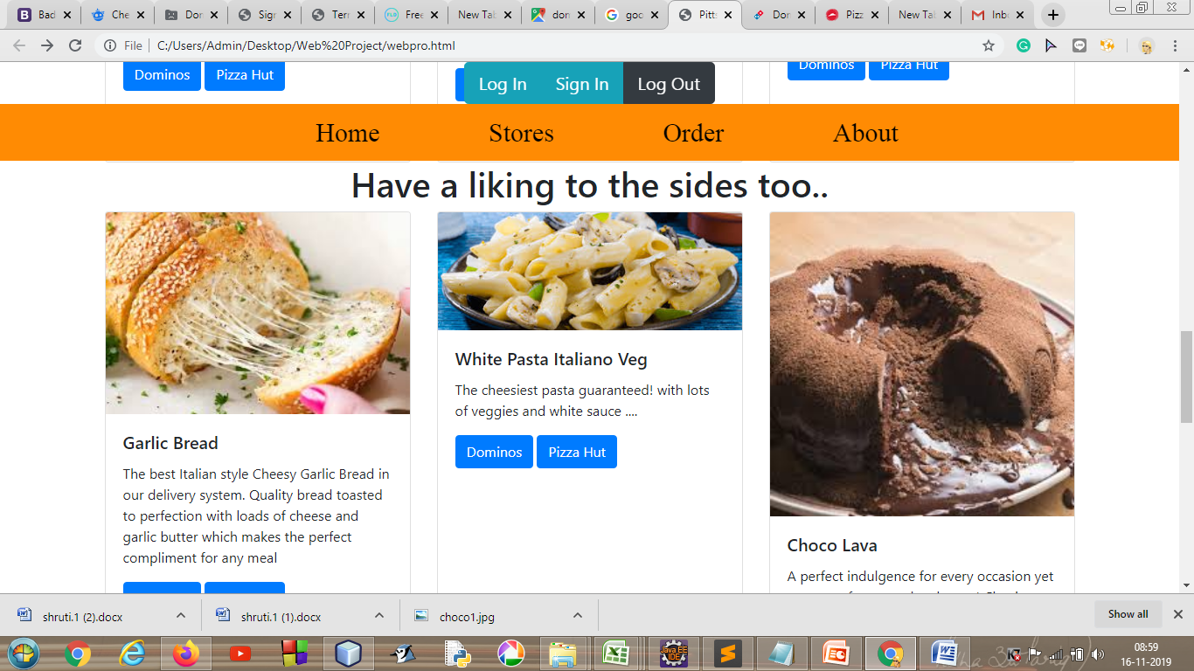

**REFERENCES :-**

🡪 [www.w3schools.com](http://www.w3schools.com)

🡪[www.wikipedia.com](http://www.wikipedia.com)

**CONCLUSION :-**

From the above project we have learnt to develop a web page using HTML CSS and we have even learned to use various function in JavaScript and Angular JS

It was a very help full project.