Question 1
Practice common operations with text (.txt) and Comma Separated Values (.csv) files in Python. Sub-tasks:
Create a new text file named my_notes.txt and write a few lines of text into it.
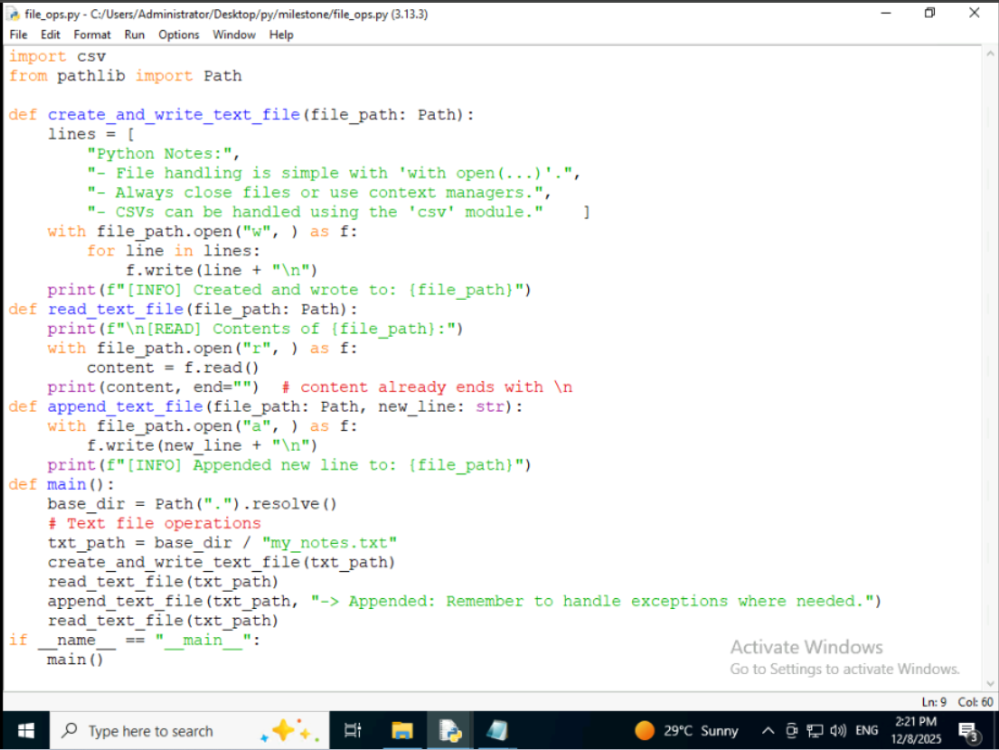

Read the entire content of my_notes.txt and print it to the console.
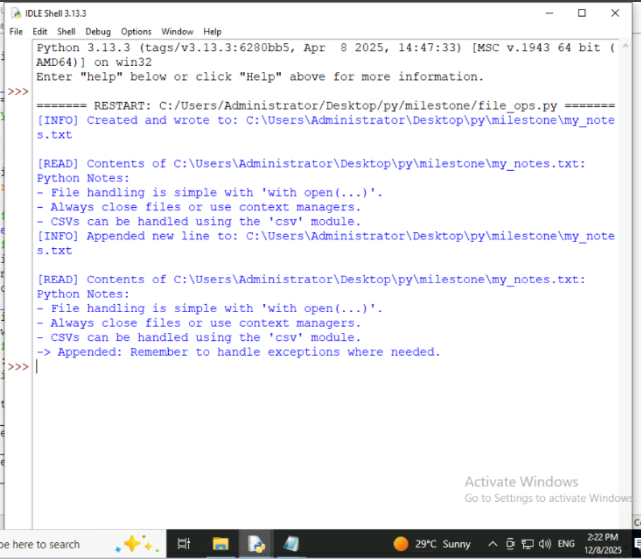

Append a new line of text to the existing my_notes.txt file.
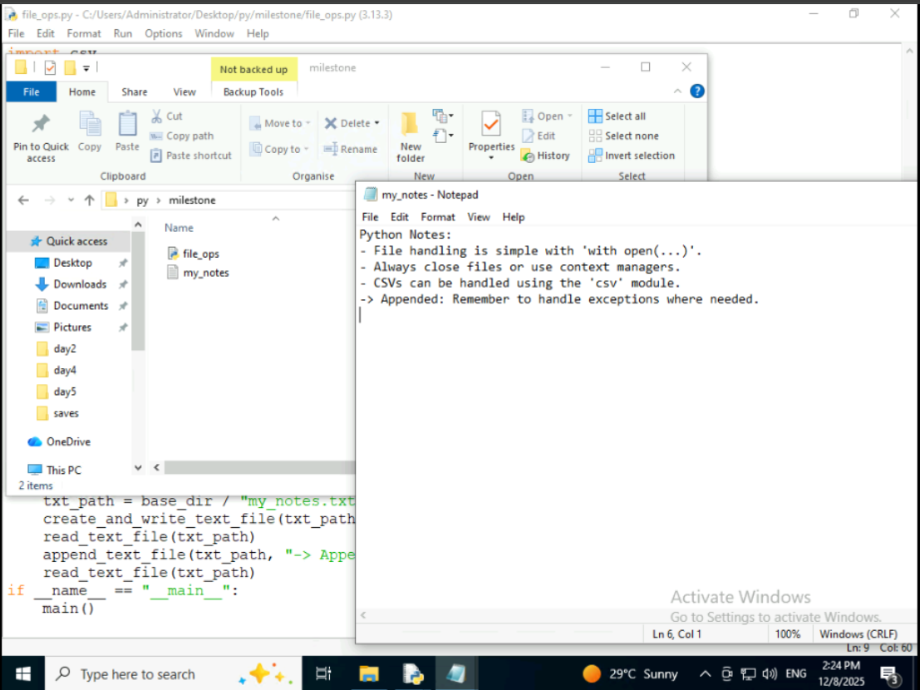

Create a new CSV file named data.csv and write some sample data (e.g., headers like "Name", "Age", "City" and at least two rows of data) into it.
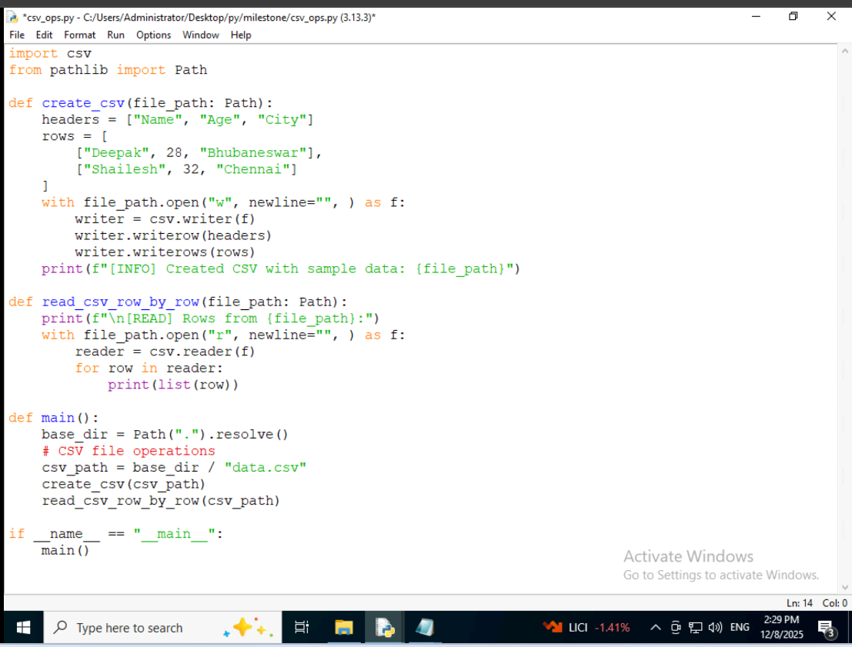
Read data.csv row by row and print each row as a list
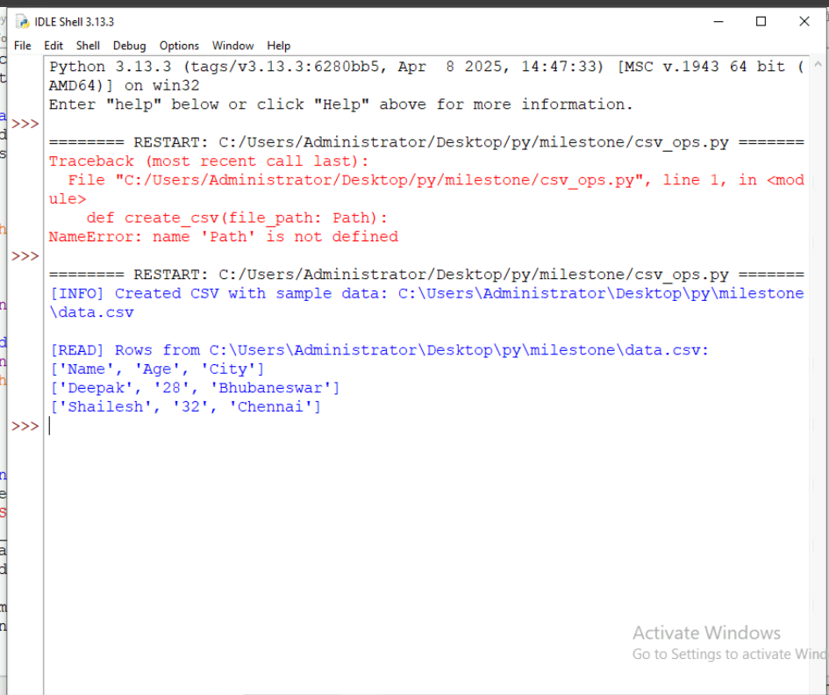
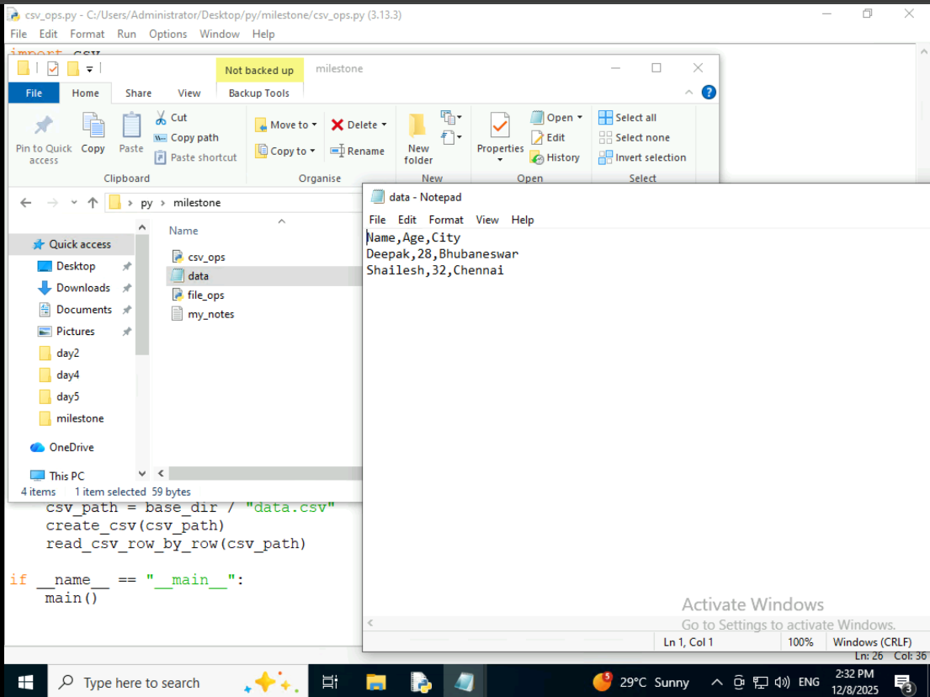
Question 2
Practice extracting specific pieces of information from text using basic regex patterns.
Sub-tasks:
• Extract all numbers (e.g., "123", "45") from the string "Product ID: 123, Quantity: 45 units."
• Find all words that start with the letter 'b' in the sentence "A big blue bird flew by."
• Check if a given string consists only of lowercase letters (a-z).
