Software Engineering
Project Iteration 2

CRIM – Explainable AI-Based Customer Churn Risk Analysis System
Course: Applied Human Computer Interaction
Semester: Spring 2026

Group Members:
Adeela Nasir – 23L-0823
Hajirah - 23L-0929
Sundas Habib – 23L-2580

Instructor: Ms. Ansa Liaqat


National University of Computing and Emerging Sciences, Lahore
Introduction
CRIM (Explainable AI-Based Customer Churn Risk Analysis System) is a web-based application built using FastAPI, React, and scikit-learn. It enables organizations to predict customer churn using a Random Forest model and provides transparent explanations via SHAP (SHapley Additive exPlanations). Sprint 1 established the core prediction pipeline, including CSV upload, data preprocessing, churn probability scoring, risk categorization, and a basic dashboard. Sprint 2 builds upon this foundation by introducing the Explainability and Data Visualization Module. This module focuses on making AI predictions interpretable for non-technical stakeholders through SHAP visualizations, interactive charts, customer drill-down profiles, and result export capabilities. Together, these features fulfill the human-centered design goals of CRIM by ensuring that predictions are not only accurate but also transparent, actionable, and accessible to all user groups.
User Stories
- Story ID US-05
Story Title: SHAP Explainability View
Priority: High
Estimated Hours: 10
User Story:
As a manager, I want to see why a customer is predicted to churn so that I can understand the reasoning behind the AI's decision.
Description:
This story involves integrating SHAP values into the prediction pipeline so that each customer's churn prediction is accompanied by a visual explanation showing which features contributed most to the risk score.
Sub User Stories:
- As a system, I want to compute SHAP values for each customer prediction.
- As a data analyst, I want to view a SHAP bar chart for individual customers.
- As a manager, I want the top contributing factors shown in plain language (e.g., "High monthly charges increased risk").
Acceptance Criteria:
- SHAP values must be computed for every prediction result.
- A feature importance chart must be shown per customer.
- Top 3 contributing factors must be displayed in plain text.
Structured Specification:
US-05.1 Compute SHAP values
Type | Specification
Functional | The system must calculate SHAP values for each customer record after prediction.
Functional | SHAP computation must use the same trained Random Forest model used for prediction.
Performance | SHAP values must be computed within 3 seconds for a standard dataset.
US-05.2 Display SHAP bar chart
Type | Specification
Functional | A horizontal bar chart of feature contributions must be shown on the customer detail view.
UX | Positive contributions (increasing churn risk) must be shown in red; negative in green.
UX | The chart must be labeled clearly with feature names, not raw variable names.
US-05.3 Plain language explanation
Type | Specification
Functional | The system must extract the top 3 SHAP features and convert them to readable sentences.
UX | Explanations must avoid technical jargon and be understandable by non-data-science users.
Functional | Plain text explanation must appear below the SHAP chart on the customer profile.

- Story ID US-06
Story Title: Interactive Data Visualization
Priority: High
Estimated Hours: 8
User Story:
As a marketing analyst, I want to explore churn trends through interactive charts so that I can identify patterns across different customer segments.
Description:
This story focuses on building interactive visualizations on the dashboard including churn rate by contract type, customer tenure distribution, and monthly charges vs churn risk ,enabling deeper data exploration.
Sub User Stories:
- As a user, I want to view a bar chart of churn rate grouped by contract type.
- As a user, I want to view a histogram showing customer tenure distribution.
- As a user, I want to filter all charts by risk category (Low / Medium / High).
Acceptance Criteria:
- At least 3 chart types must be displayed on the dashboard.
- Charts must update dynamically when filters are applied.
- Charts must be responsive and clearly labeled.
Structured Specification:
US-06.1 Churn rate bar chart by contract type
Type | Specification
Functional | The dashboard must display a bar chart showing churn percentage for each contract type.
UX | Each bar must show a tooltip with exact percentage on hover.
Functional | Chart data must be derived from the most recently uploaded prediction dataset.

US-06.2 Tenure distribution histogram
Type | Specification
Functional | The system must display a histogram grouping customers by tenure in months.
UX | Bins must be clearly labeled and color-coded by risk level.
Performance | The chart must render within 2 seconds of page load.
US-06.3 Risk category filter
Type | Specification
Functional | A filter control must allow users to select one or more risk categories to view.
Functional | All charts on the dashboard must re-render based on the selected filter.
UX | The currently active filter must be visually highlighted in the UI.

- Story ID US-07
Story Title: Customer-Level Drill-Down
Priority: Medium
Estimated Hours: 6
User Story:
As a customer success manager, I want to click on any customer in the results table and view their full churn profile so that I can plan a targeted retention action.
Description:
This story involves building a customer detail panel that opens when a row is selected in the prediction table. It displays the customer's risk score, SHAP explanation, key attributes, and a recommended retention action based on risk level.
Sub User Stories:
- As a user, I want to click a customer row in the table so that a detailed profile panel opens.
- As a user, I want to see the customer's churn probability score and risk label on their profile.
- As a manager, I want to see a recommended retention action (e.g., "Offer discount", "Schedule a call") based on their risk level.
Acceptance Criteria:
- Clicking a customer row must open a profile view.
- Profile must show churn score, risk label, top SHAP features, and a recommendation.
- Profile must load without page refresh.
Structured Specification:
US-07.1 Open customer profile panel
Type | Specification
Functional | Clicking any row in the predictions table must open a side panel with that customer's data.
UX | The panel must slide in without reloading the page.
UX | A visible close button must be present to dismiss the panel.
US-07.2 Display churn score and risk label
Type | Specification
Functional | The profile panel must display the customer's churn probability as a percentage.
Functional | The risk label (Low / Medium / High) must be shown with matching color coding.
UX | A visual indicator (e.g., progress bar or gauge) must represent the probability score.
US-07.3 Recommended retention action
Type | Specification
Functional | The system must map each risk level to a predefined recommended action.
Functional | High risk must suggest immediate outreach; Medium risk a discount offer; Low risk routine follow-up.
UX | The recommendation must appear as a highlighted action card at the bottom of the profile panel.
- Story ID US-08
Story Title: Export Results
Priority: Medium
Estimated Hours: 2
User Story:
As a data analyst, I want to export the prediction results to a CSV or PDF file so that I can include them in external reports and share them with stakeholders.
Description:
This story involves adding export functionality that allows users to download the full prediction results as a CSV file or a formatted PDF summary report from the dashboard.
Sub User Stories:
- As a user, I want to click an Export button to download all results as a CSV file.
- As a user, I want to download a PDF summary report showing dashboard statistics and top at-risk customers.
- As a system, I want all relevant columns (Customer ID, churn score, risk label) included in the export.
Acceptance Criteria:
- CSV export must include all prediction columns.
- PDF export must include dashboard summary and top 10 high-risk customers.
- Export must complete within 5 seconds.
Structured Specification:
US-08.1 CSV export
Type | Specification
Functional | The system must provide a button to download prediction results as a .csv file.
Functional | Exported CSV must include Customer ID, churn probability, risk label, and key feature values.
Performance | A CSV file must be generated and downloaded within 5 seconds.

US-08.2 PDF summary report
Type | Specification
Functional | The system must generate a formatted PDF showing total customers, churn rate, and risk distribution.
Functional | The PDF must include a table of the top 10 highest-risk customers.
UX | The PDF must include the CRIM logo, report date, and page numbers.
US-08.3 Export column completeness
Type | Specification
Functional | All exported files must include Customer ID, churn probability score, and risk category label.
Functional | Column headers must use human-readable names, not raw variable names.
UX | A success notification must appear after the export download begins.

Trello Board
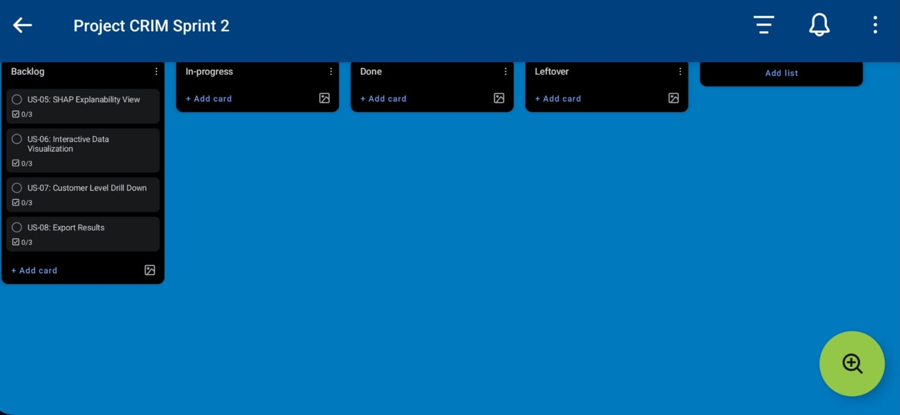
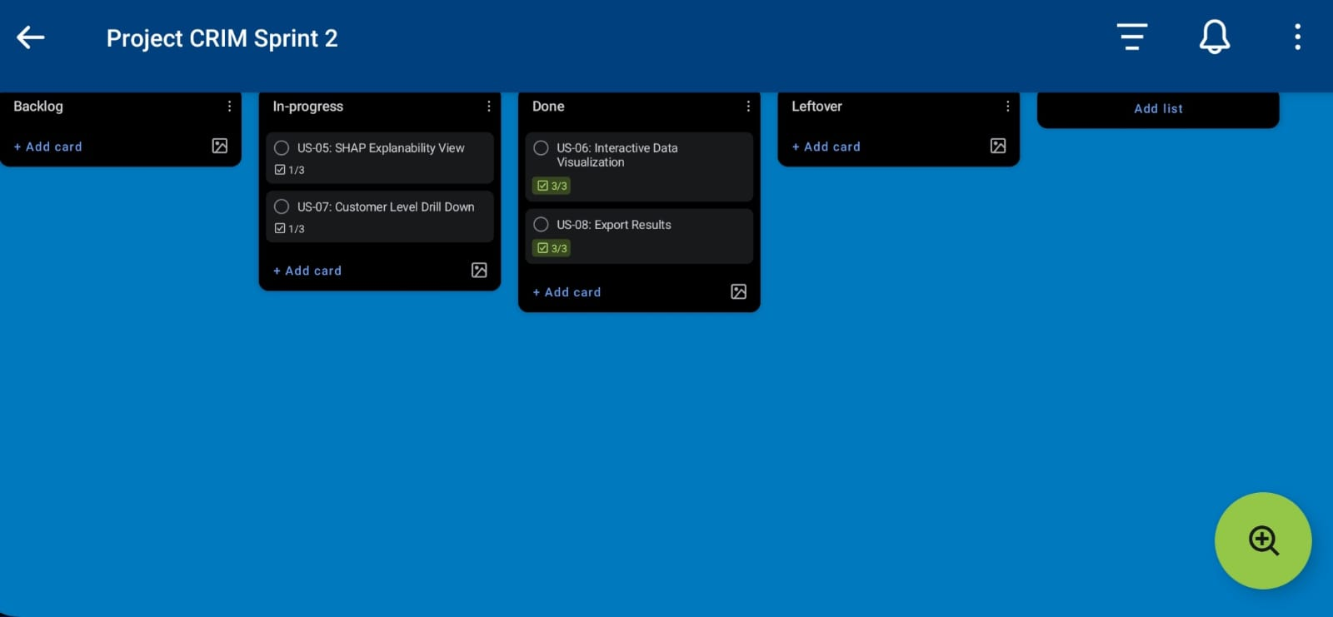
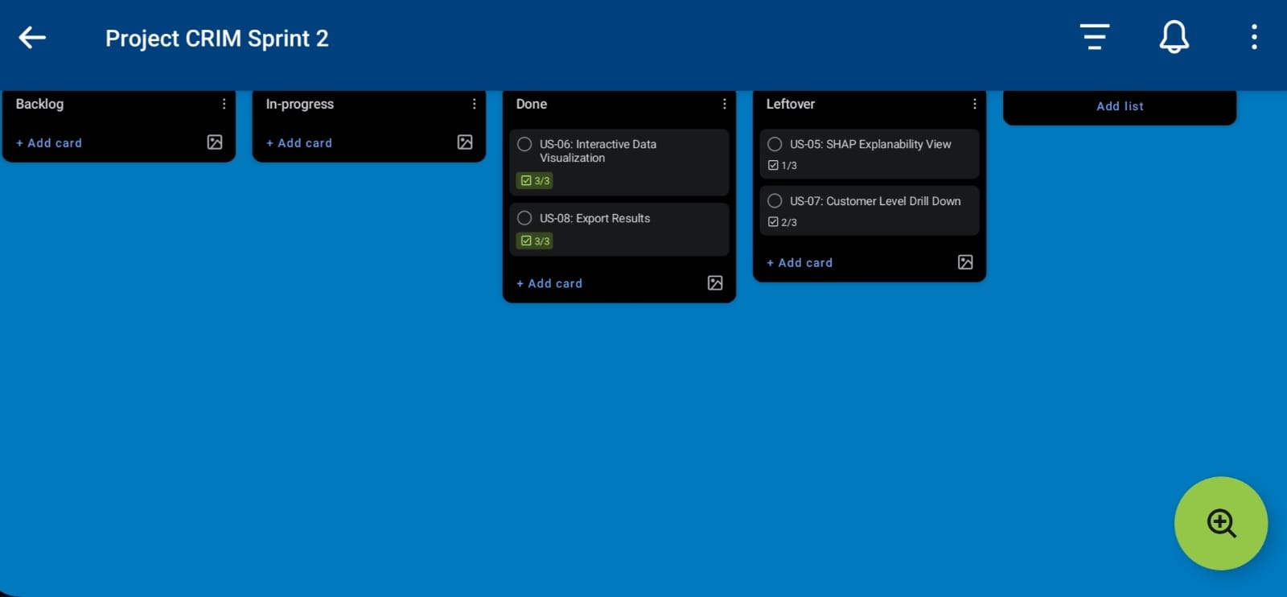
Architecture Diagram
Architecture Styles Used
- Layered (3-Tier): CRIM is divided into three layers: Presentation (React frontend), Application (FastAPI backend), and Data (CSV, ML model, SHAP cache). Each layer only communicates with the one directly below it.
Rationale: Separates UI, business logic, and data so each can be updated independently without breaking the others.
- Client-Server: The React frontend (client) communicates with the FastAPI backend (server) through REST API calls using HTTP and JSON.
Rationale: Keeps the browser lightweight while all heavy ML computation runs on the server side.
- Pipe and Filter: Inside the backend, data flows through four sequential stages: Preprocessor → ML Model → SHAP Engine → Risk Categorizer.
Rationale: Each stage does one job, making the pipeline easy to modify and the predictions easy to trace — which directly supports CRIM's goal of explainability.
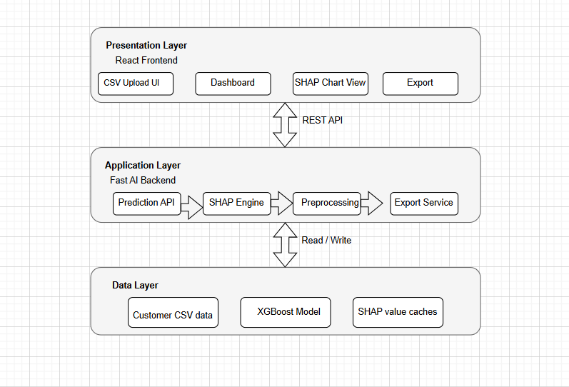
Component Diagram
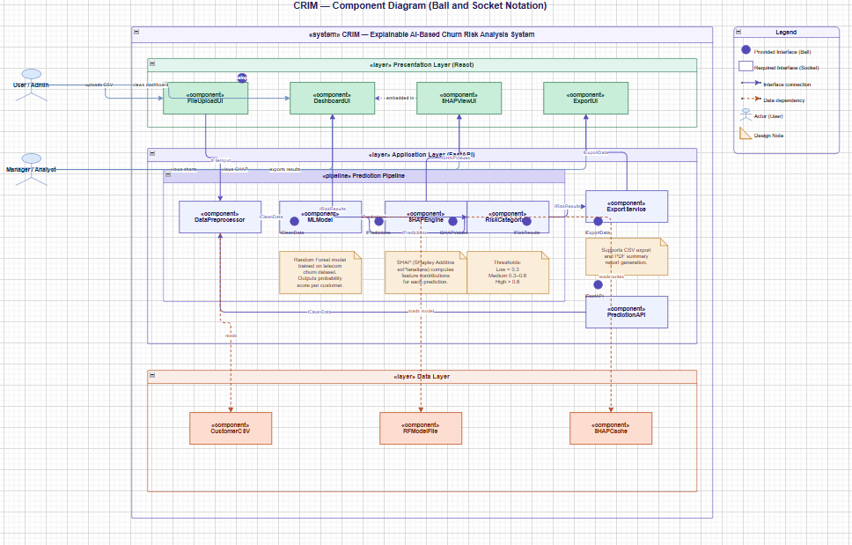
Data Flow Diagrams
Level 0 DFD
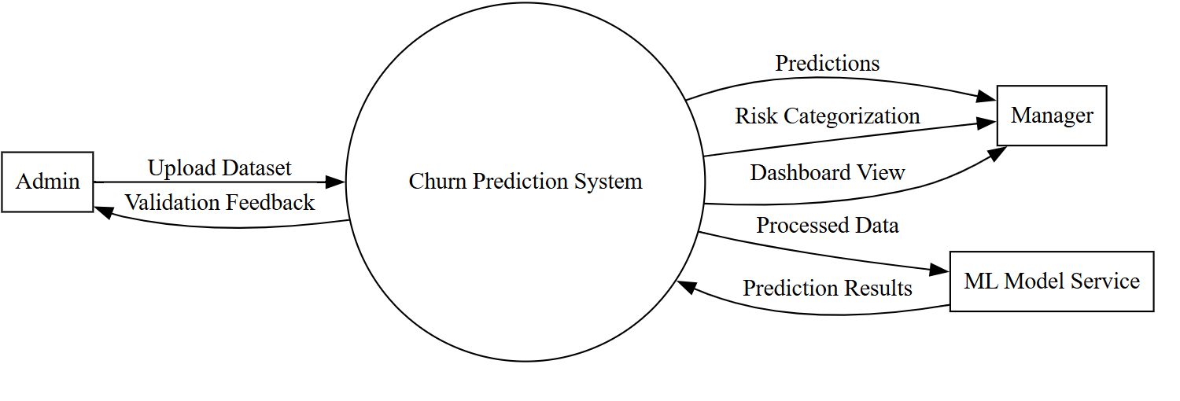

Level 1 DFD (Full System)
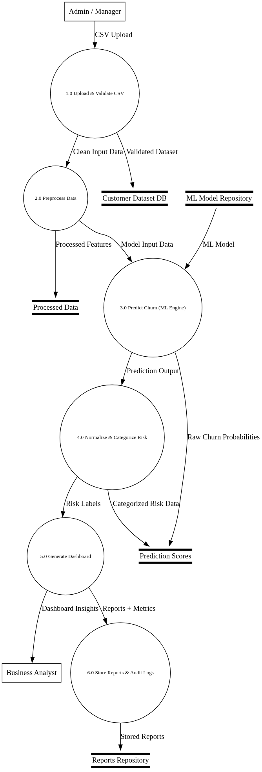

Level 2 DFD (US-01: Customer Data Upload)
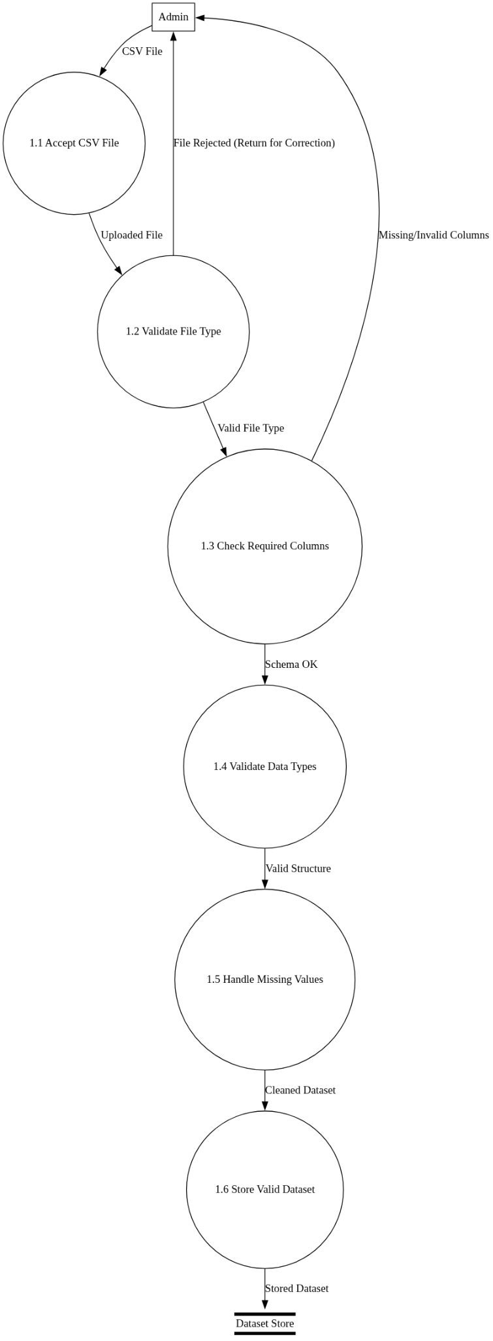

Level 2 DFD (US-03 & US-04: Risk Categorization and Dashboard)
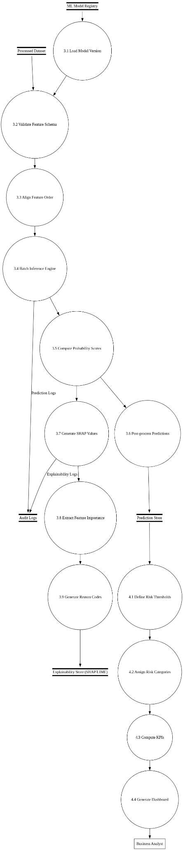

Activity Diagrams
US-01:
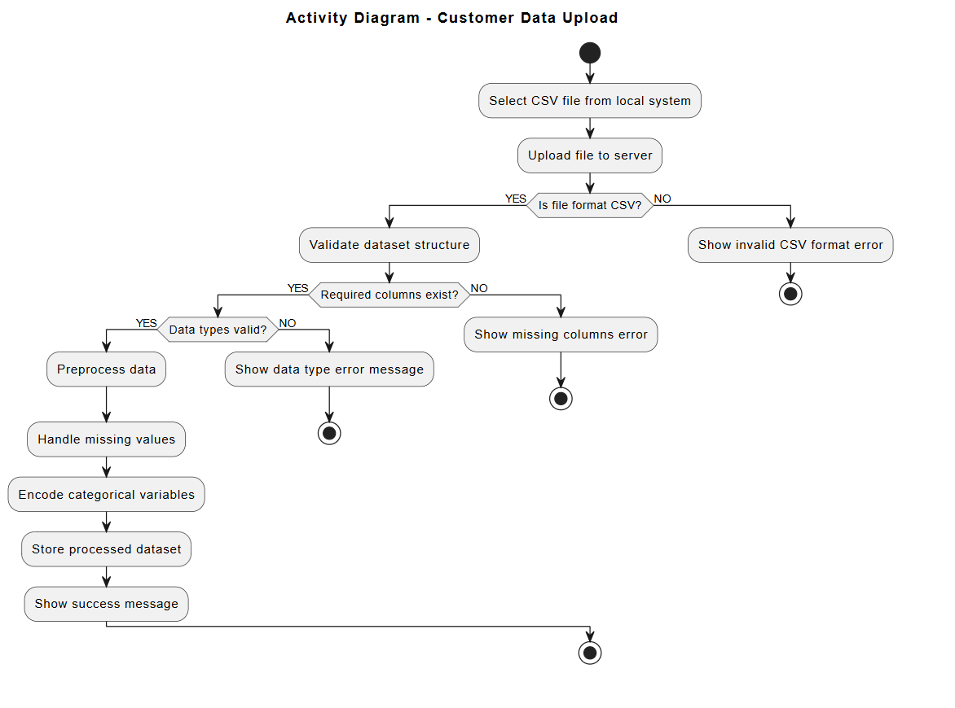

US-02:
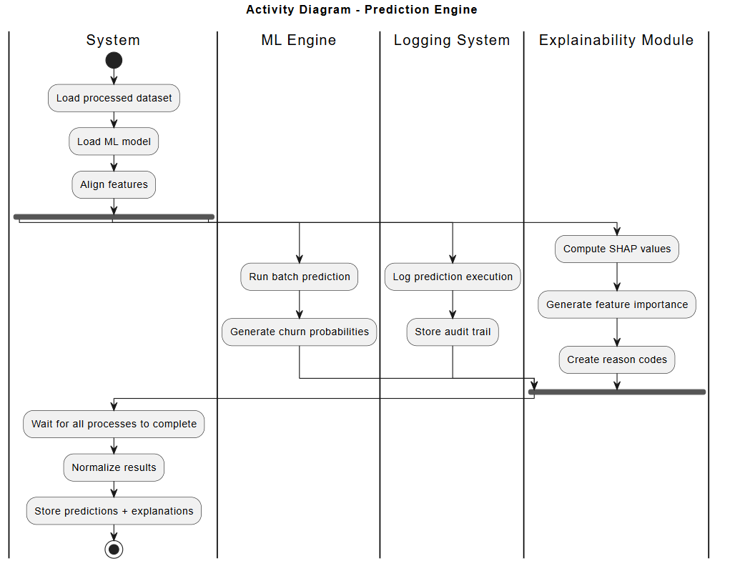

US-03:
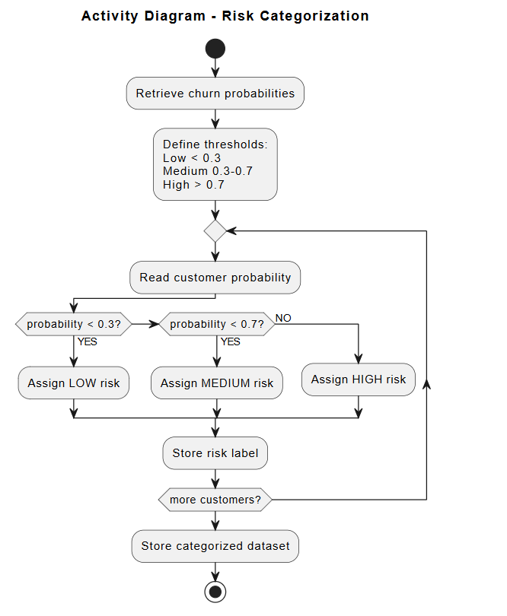

US-04:
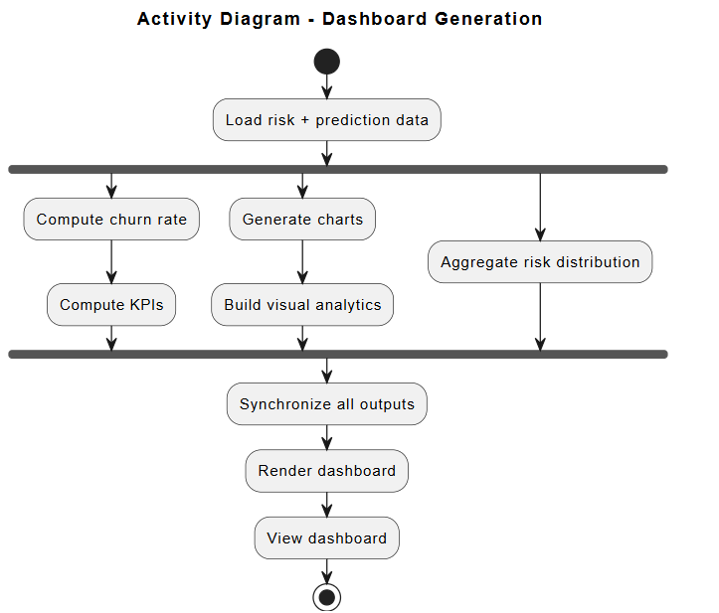

Use case Diagram
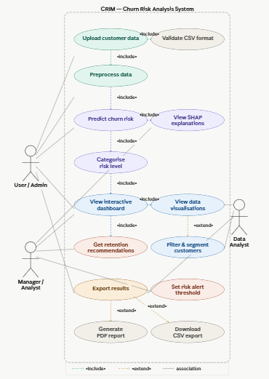

Sequence Diagrams
Diagram 1: Customer Data Upload
(Based on user story US-01)
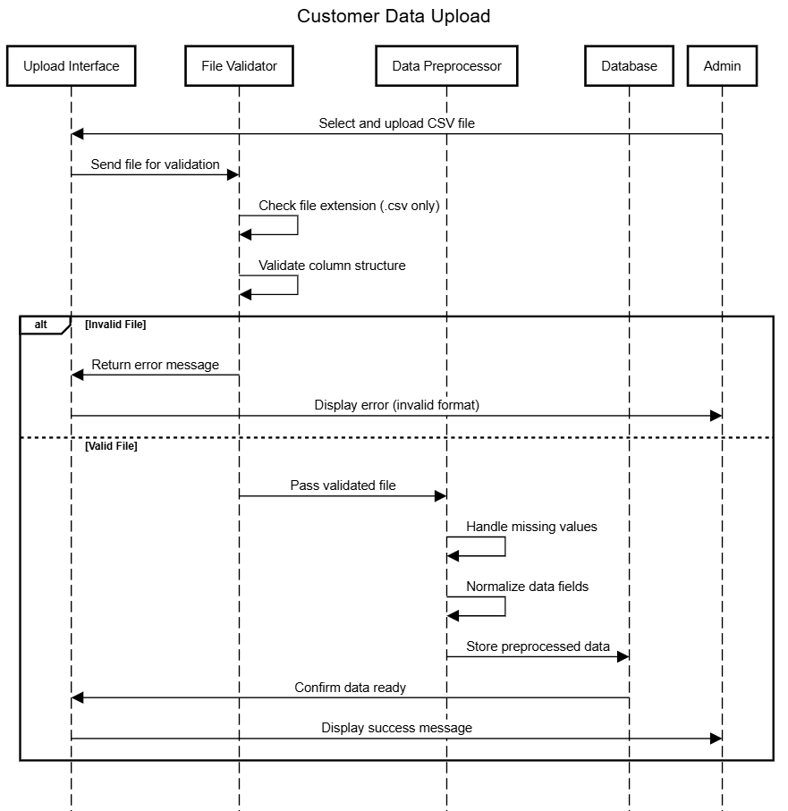

Diagram 2: Churn Prediction & Risk Categorization
(Based on user stories US-02 and US-03)
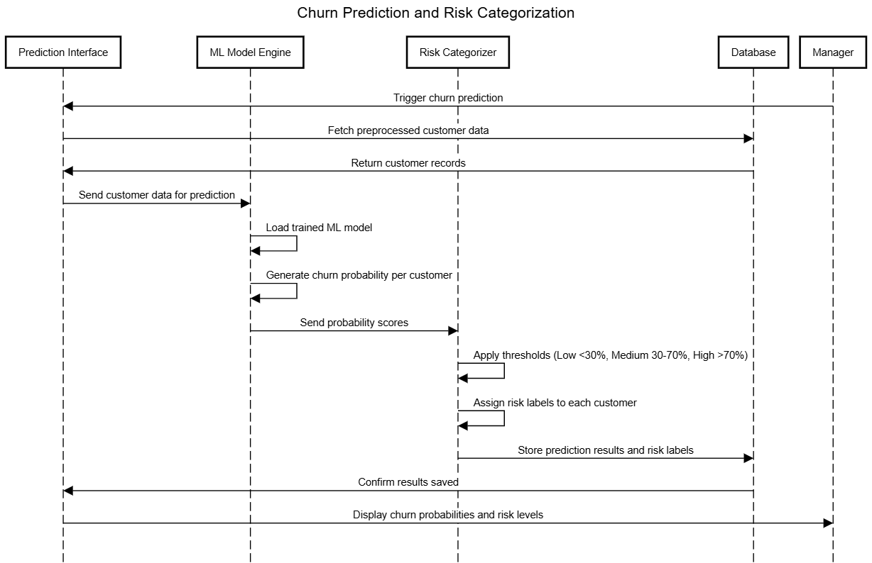

Diagram 3: Dashboard Visualization
(Based on user story US-04)
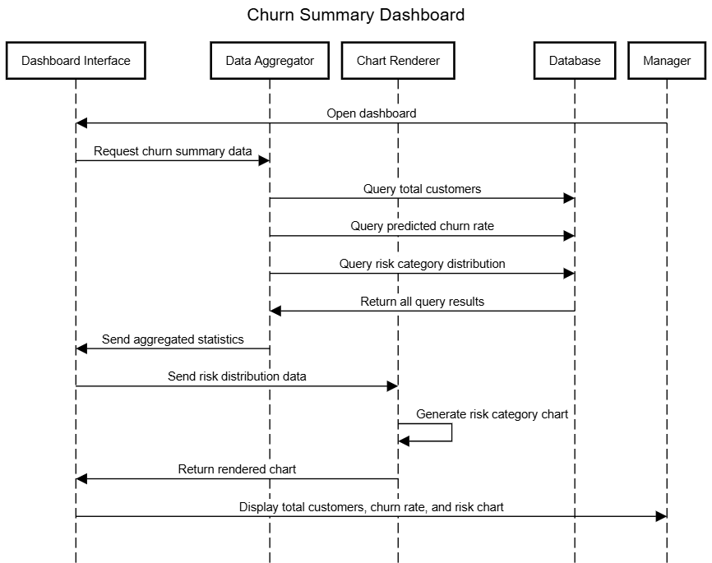
Class Diagram
The CRIM system class diagram consists of fourteen classes. The User base class is extended by Admin and Manager through inheritance, representing the two system roles. The data pipeline flows through CSVUploader, DataValidator, DataPreprocessor, and Customer via association relationships, with UploadSession composing the uploader. The prediction layer shows Customer records feeding into ChurnPredictionEngine, which produces PredictionResult objects, each composed of a RiskLevel assigned by the RiskCategorizer. Finally, Dashboard aggregates these results for the manager to view, while ReportGenerator exports them as reports. The diagram captures all major associations, compositions, aggregations, and dependencies across the system.
