**Task 1: Use Methods OnPost and OnGet**

Open the Asp.Net core application you were working on before. (The one created from the empty project template).

Add a new Razor page with a model to the Pages folder. Call the new page handlerdemo.

Add the following to the razor page ( the .cshtml page)

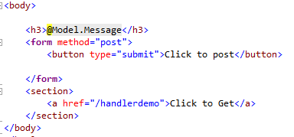

Add the following to the model page (the .cs page).

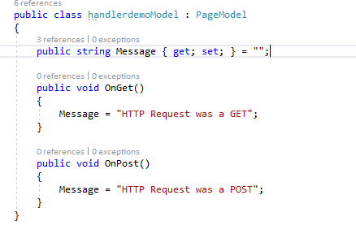

Run the page and see what happens when you click on the link and on the button.

The form submission won’t work unless you add the following line to the razor page. We will discuss what this means in a later lecture.

@addTagHelper *, Microsoft.AspNetCore.Mvc.TagHelpers

**Task 2: Take values from the HTTP Post Request**

Create a new razor page with a model. Call this page namegreeting.

Add a form which has a text box and a submit button. The form should use the method POST.

Give the name attribute of the textbox the value “**firstname**”.

In the OnPost method of the Model add a parameter list to the OnPost method.

public void OnPost (string **firstname**), this will be given the value which is returned to the form.

Edit the method to print out a message: Hello Una (or whatever).

**Task 3: Create a simple adding page.**

Create a new razor page with a model. Call the page adder.



Create a form which takes in two numbers and add code to the OnPost method which uses these numbers. It should add them together and output the result as in the screen shot above.

**Task 4:**