This worksheet is going to look at model binding and tag helpers. The aim of today is to play with the different options available when using tag helpers to try and understand what they can do.

There are a number of questions asked with each of the tasks. Try and answer these on this page.

We will discuss some of the answers.

If you notice anything interesting or unusual please take note of it and we will discuss it and try and understand what is happening.

**Task 1**

Open your existing .Net core web application. Create a new razor page with a page model call it taghelpplay.

Add a property to your model called number1.

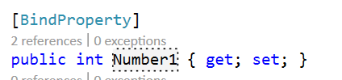

In your cshtml page add the following within a html form with a submit button.

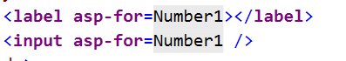

Note: If you don’t get a colour change for the HTML label and input element tags you need to make sure your page is using tag helpers.

What happens when you submit the form?

Note if you the number submitted is replace by a one remember that by default model binding only works with requests using HTTP POST.

Look at the html which is generated can you understand where each of the attributes comes from.

Add some content to the label element “Enter your first number”.

Look at the html which is generated, what is the difference?

Comment out the [BindProperty] decoration of the Number1 property.

What difference does this make?

**Task 2**

Add some more properties to your razor page. Add the [BindProperty] decoration to each of them.

Int?

Double

Double?

Decimal

Decimal?

Float

Float?

Add labels and input elements to your razor page for each of these and see what html is generated when you request the page.

Look at the html which is generated for each of these. What type do they have? Do they have a default value?

**Task 3**

Add a property with type string to the Model and suitable markup to the razor page.

What happens when you run the page?

Why do you think there is no default value generated for the input element when bound to a string?

**Task 4**

Add a property with type **DATETIME** to the Model and suitable markup to the razor page.

What happens when you run the page?

What happens if you use type **DATETIME?** Instead?