1. Create a XAML user interface as shown below. **(5 marks)**

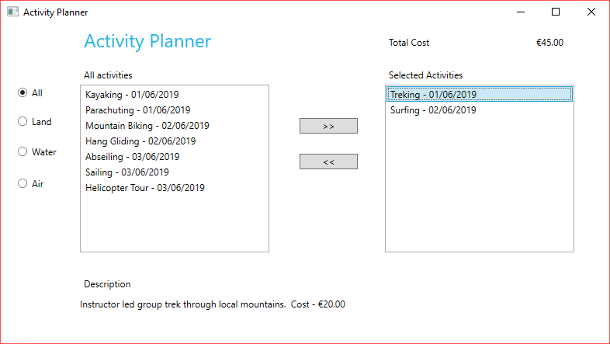

Figure 1 - Sample Interface

1. Create a class called Activity with properties as shown in Table 1 (next page). **(10 marks)**
2. Implement IComparable to sort by date, utilised by both listboxes. **(10 marks)**
3. Utilise the sample code on Moodle to generate a set of sample activities. **(10 marks)**

Display these activities in the Listbox to the left of the screen

1. Display the description when an activity is selected from the listbox. **(5 marks)**
2. Implement add functionality to move an activity to selected activities. **(15 marks)**

This should remove an activity from all activities and display it in the selected activities listbox. If nothing is selected clicking on the add button should display a message that nothing has been selected. If there is a date conflict an appropriate message should be displayed.

1. Implement remove functionality to remove an activity from selected activities. **(5 marks)**
2. Implement filter functionality to filter activities in the All Activities listbox. **(10 marks)**

If nothing has been selected to remove an appropriate message should be displayed.

1. A running total of the cost of selected activities should be displayed. **(10 marks)**
2. Ensure code is clear and well commented. **(10 marks)**
3. Code should compile and run as expected **(10 marks)**

Table 1 - Class properties

|  |
| --- |
| **Name**: string  **ActivityDate**: DateTime  **Cost**: decimal  **Description**: string. This uses a long hand property as it returns cost in addition to description.  **TypeOfActivity**: ActivityType. Use an enum called ActivityType with three properties Air, Water and Land |

**Marking Scheme**

|  |  |
| --- | --- |
| XAML | 5  **Uploading to Moodle**  Zip your project and upload to Moodle. After submission is complete, download your submission, unzip it and start the project to verify that you have properly uploaded your full project.  You also need to submit the Github link to the form on Moodle. |
| Class | 10 |
| Using sample code to generate activities | 10 |
| IComparable | 10 |
| Display Description | 5 |
| Add | 15 |
| Remove | 5 |
| Filter | 10 |
| Cost | 10 |
| Code Compiles and Runs as expected | 10 |
| Comments/Clean Code | 5 |
| Use of Github | 5 |
|  | 100 |