**Project Report**

* Below is my project proposal sketch that I was aiming for when the project began, it was very basic but gave me a rough Idea of the type of website I was aiming for.

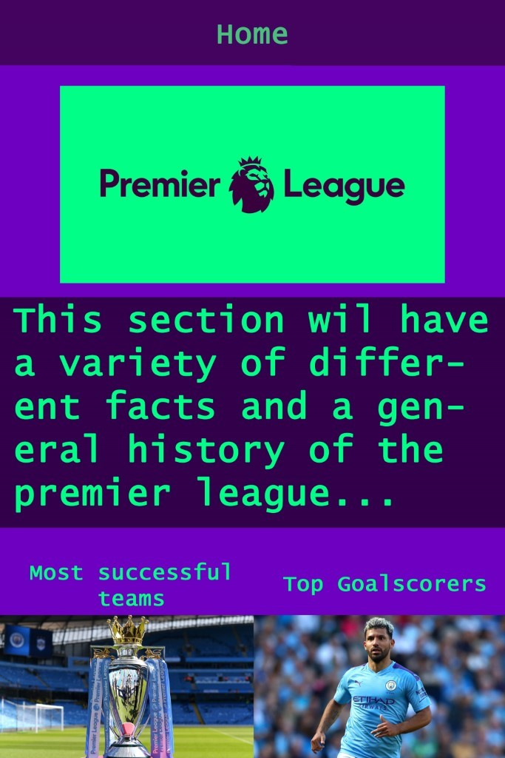

* My Website is centered around the history of the Premier League, a footballing league based in England with 20 teams. It goes in depth into the beginnings of the league and includes other aspects such as top scorers and best ever players to play in the Premier league.
* The first page of the website goes over the history of the league and how it began. The next page shows the current premier league table as of the time this is being written as the league has been postponed. The page that comes after that is Top scorers, which shows the top 10 goal scorers throughout the history of the league along with a video showing the top scorers by age. The final page just shows the top 25 players to ever play in the prem.