HTML and CSS validation

HTML

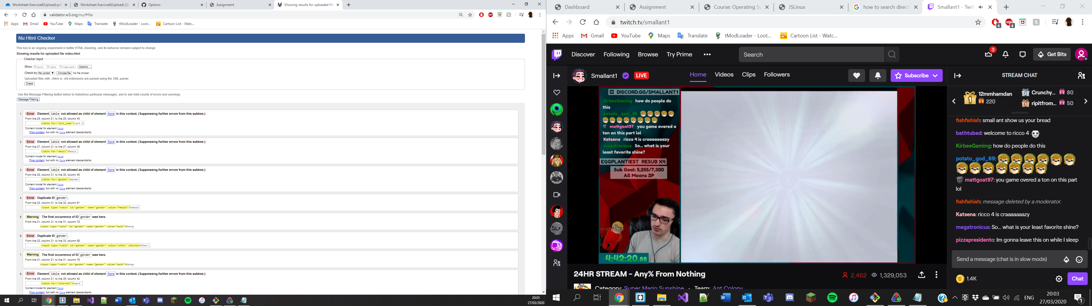

CSS

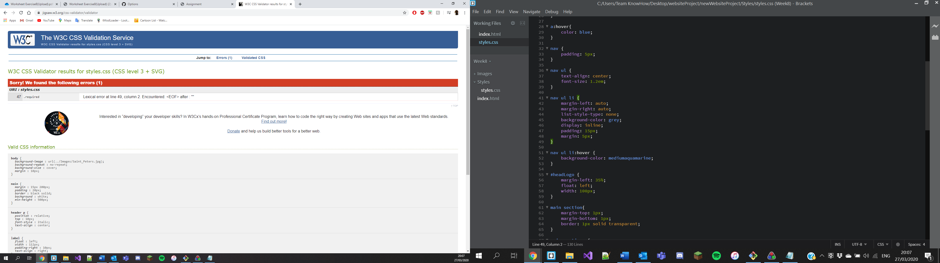

I’m not sure where the error is for the CSS file

GitHub URL:

<https://jackmalone2001.github.io/Week8/>