Web Design Report

This website was made for a plant hire company in the west of Ireland. The company hires out machinery but didn’t have much of an online presence. Due to this lack of online presence, the potential of people knowing this website or who to contact isn’t as big as it could be. The website allows an easier way for people to learn about the company.

The intended audience is people who are looking for plant machinery ranging from small jobs such as cement mixing to help with building houses.

Image Sources

digger.jpg: A photo taken on the Plant Plus Ltd site

dumper.jpg: A photo taken on the Plant Plus Ltd site

facebookLogo.png: A photo taken from Google Images with Labelled for Reuse filter

favicon-32x32.png: A favicon version of oldLogo.jpg

oldLogo.jpg: The logo of the company

plantplusssign.jpg: A modified version of an image by [www.allindesign.com](http://www.allindesign.com) that was made for Plant Plus Ltd

teleporter.jpg: A photo taken on the Plant Plus Ltd site

Web Page Information

index.html

This is the home page. Each of the web pages have the logo, name, background image, footer, navigation and aside. The background image is used to quickly say what kind of business Plant Plus Ltd has. The Opening paragraph goes into a little more detail about what the company does. The video that comes with the home page shows some larger excavators at work. The navigation bar is used to navigate between the different web pages. The aside also has links to the different web pages as well as a link to the companies FaceBook page. The footer has links to the top of the page as well as to the different web pages. Also included is the copyright as well as the company phone number and email.

equipment.html

In this web page, there are pictures of some of the machines that the company lets out on hire. When the user hovers the mouse cursor over one of the images, a drop down will show the different machine types, for example, when a user hovers over the digger image, a drop down will show the different tonnage that the company offers.

about.html

This page is used to have a small summary on what the company is about. The table at the bottom of the page is a table. Due to this being a real company, the data used in the table is not real data.

contact.html

This page is used to make it easier for customers to contact the owner of Plant Plus Ltd. The map allows customers that are collecting the machines to more easily locate the site.

HTML & CSS validation results

index.html

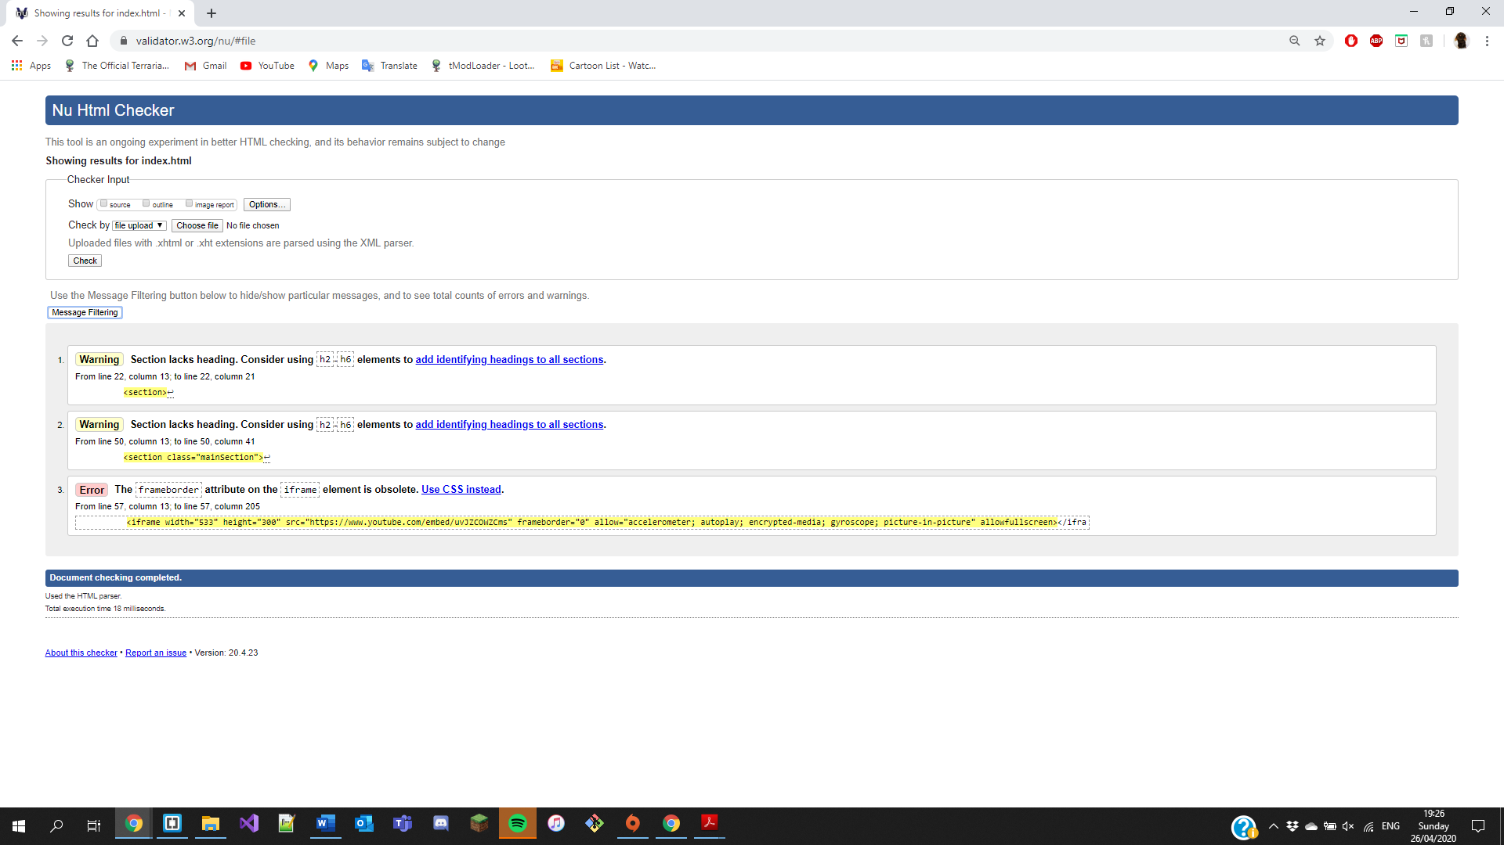

The warnings are asking to put in headings in the sections but this would not work with the website. The error is for the frameborder attribute in the iframe element and asking to use CSS instead.

equipment.html

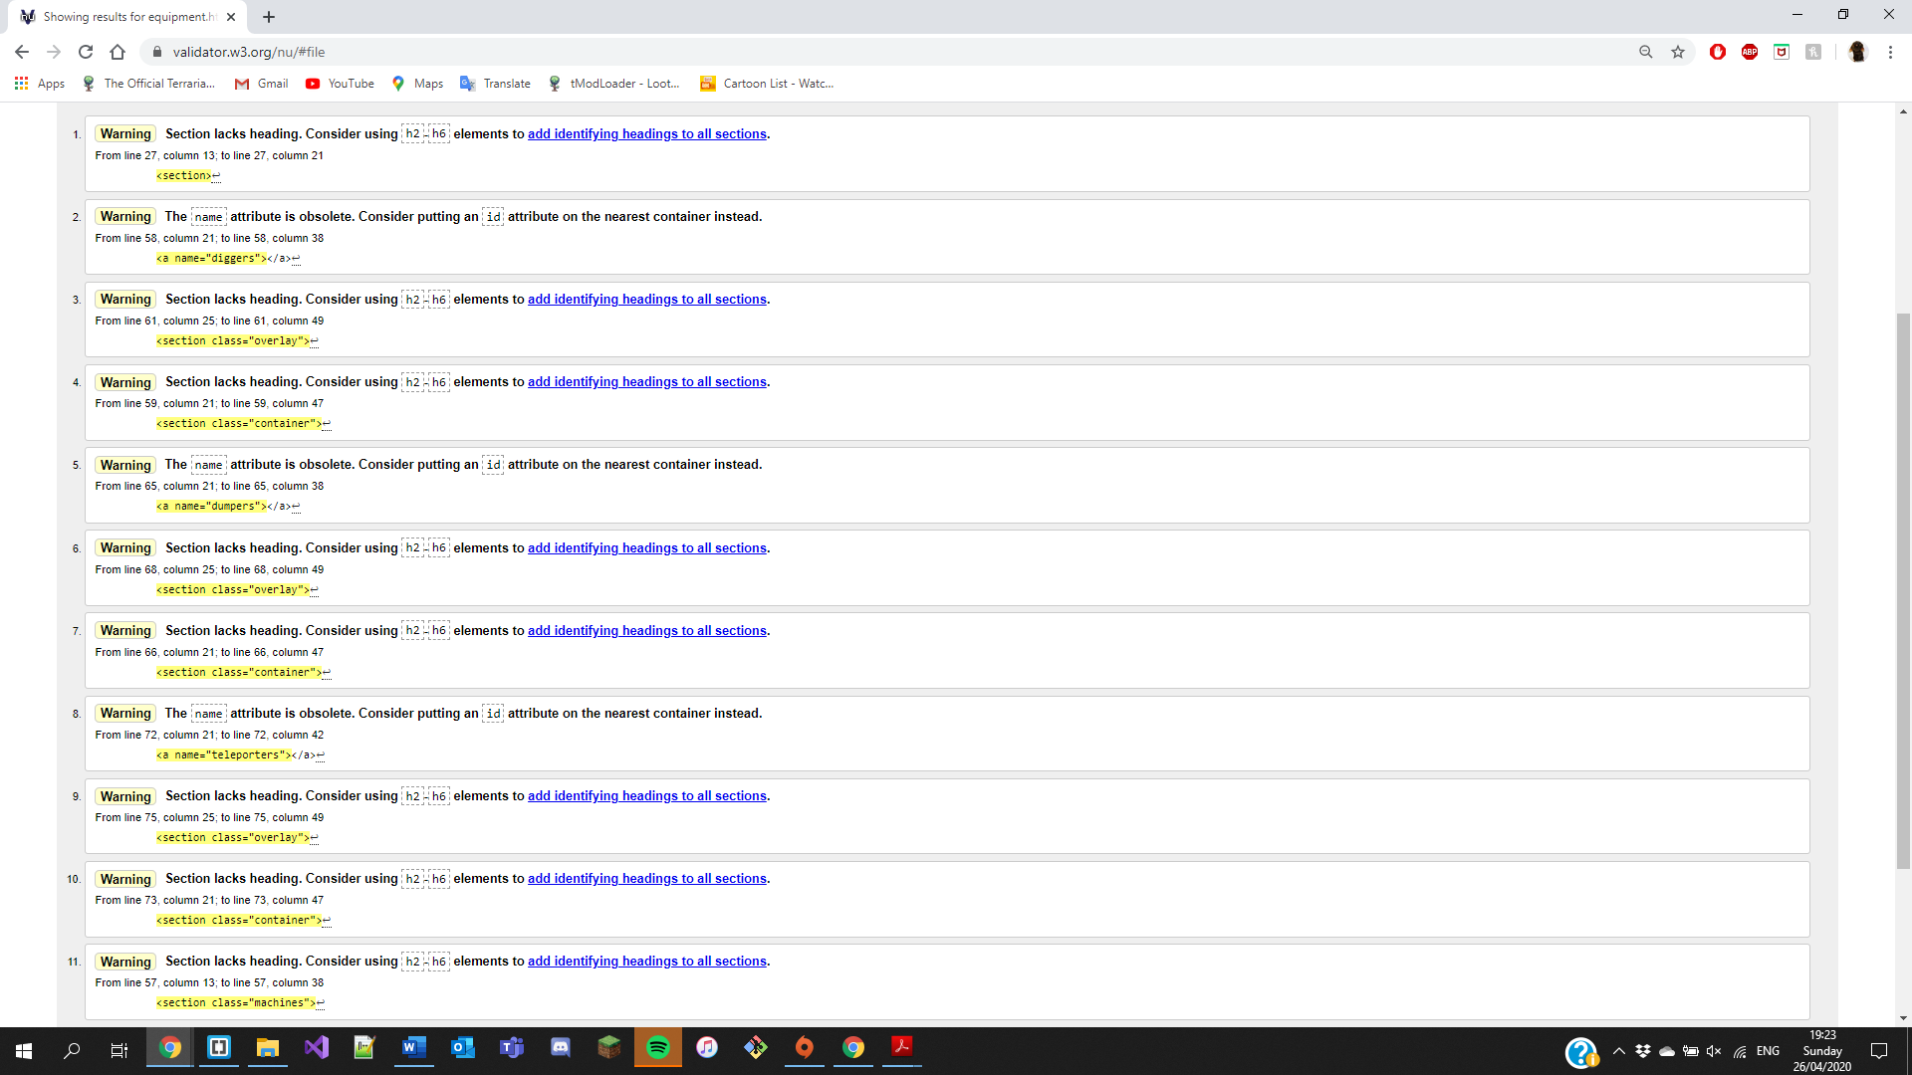

The warnings are all just asking to put in headings but headings in these sections would not work with the website

about.html

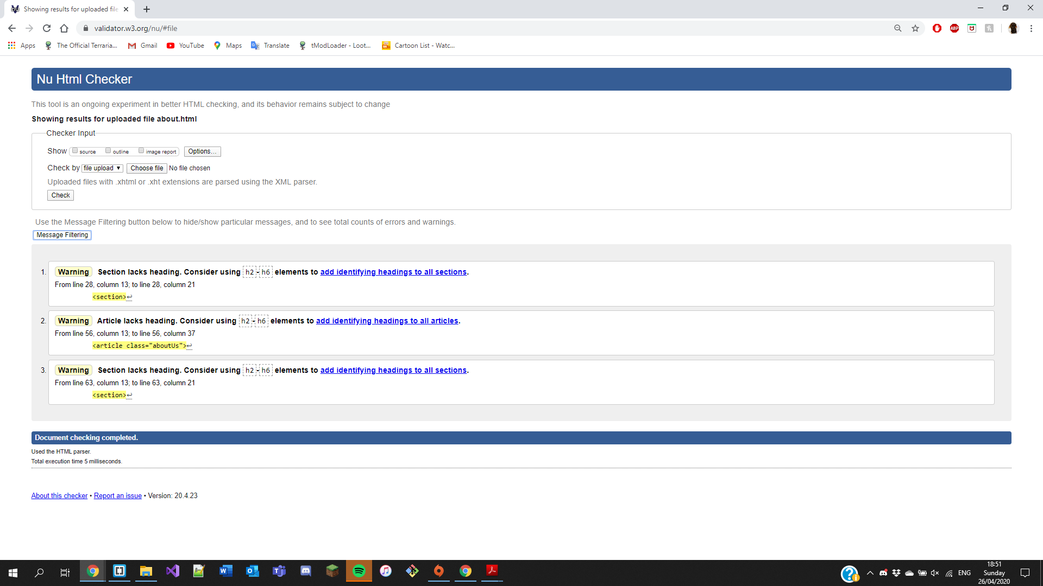

Each of the warnings are asking to put in a heading between h2 – h6 but it wouldn’t fit the style of the website to add headings in those spots

contact.html

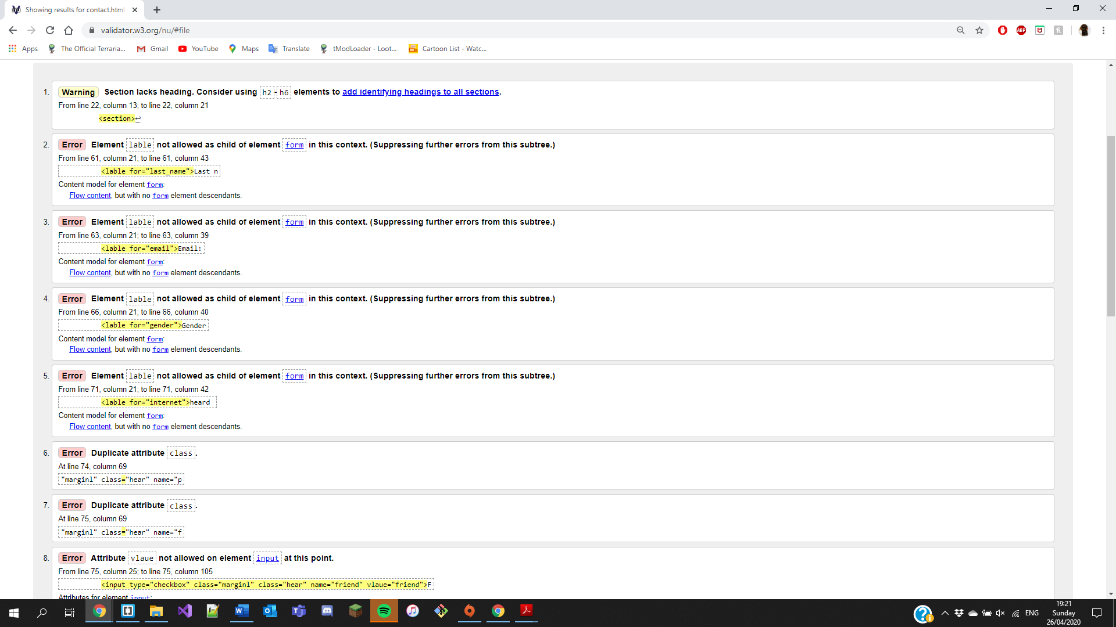

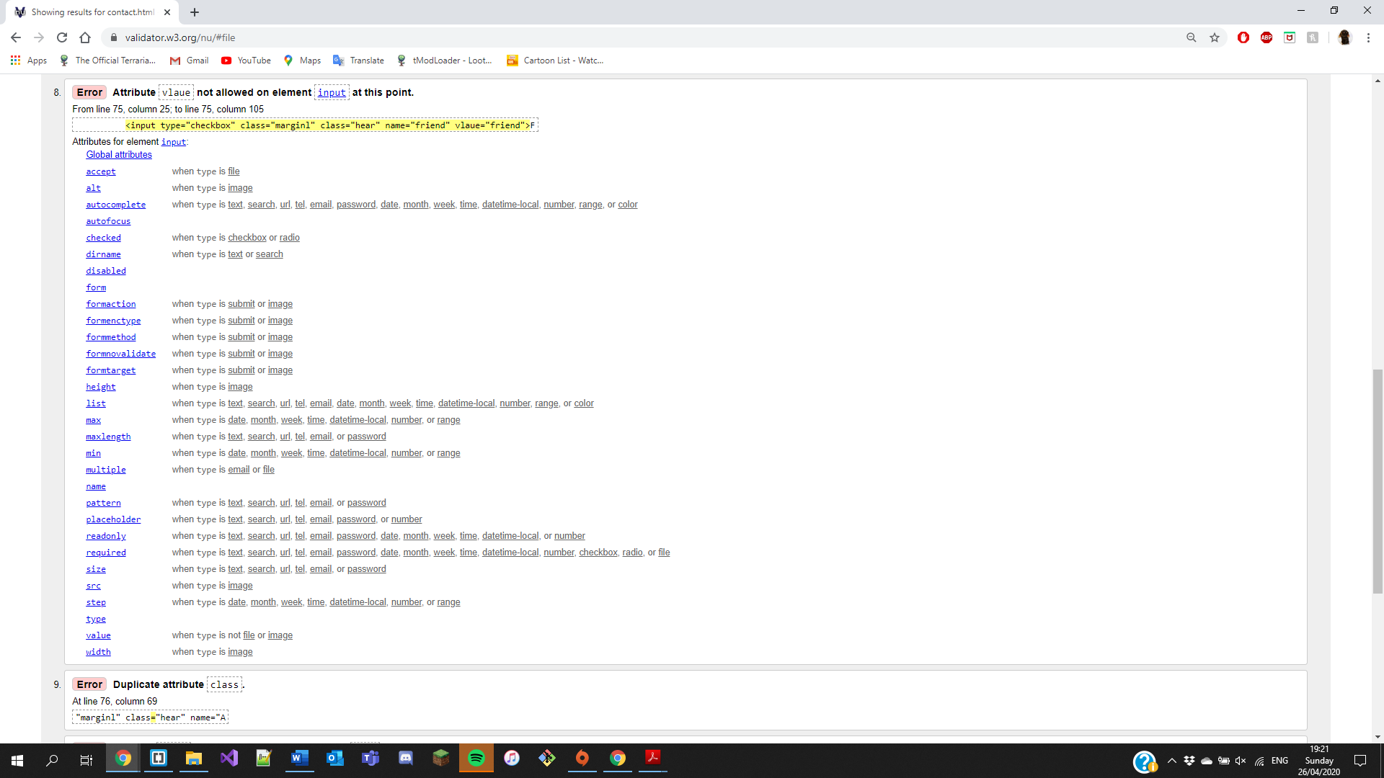

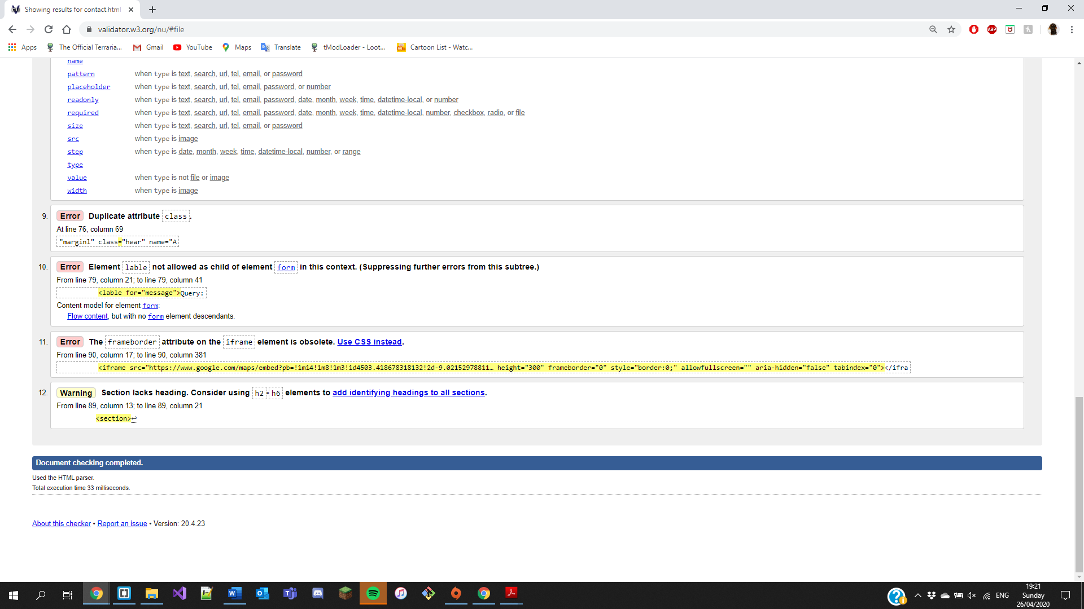

All of the errors are either asking to be done by using CSS or they aren’t going to prevent the webpage from breaking

style.css

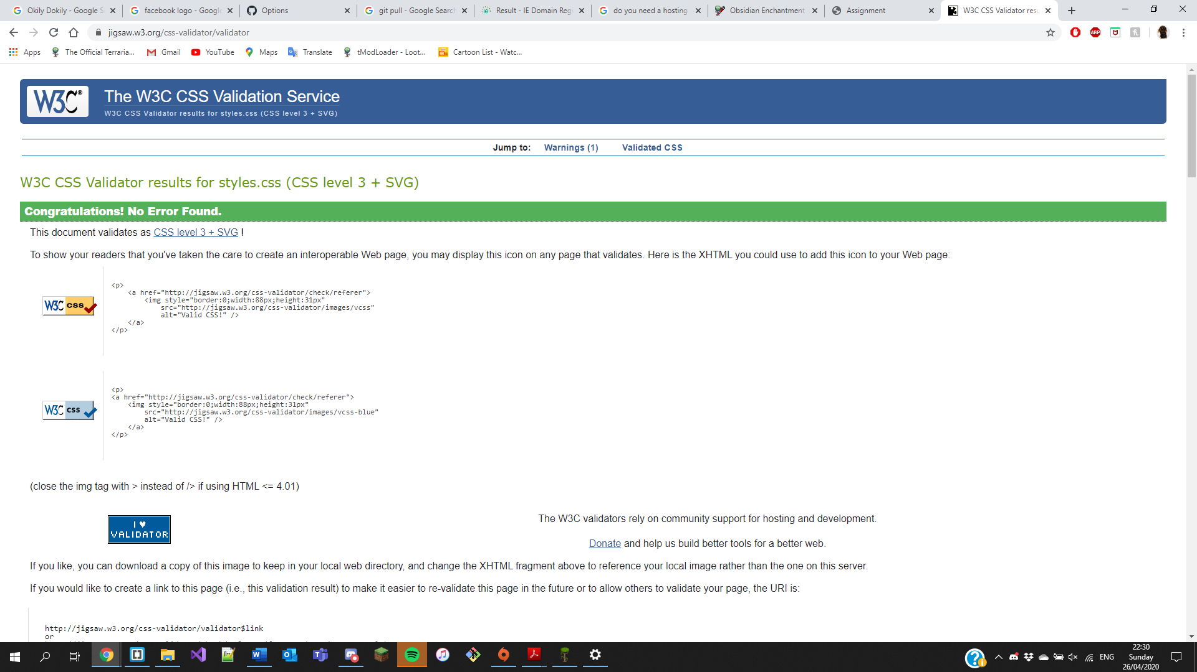

Website URL

<https://jackmalone2001.github.io/newWebsiteProject/>