Team Humidity System Report
Members
Team member 1: Carson Webster (S00292956@atu.ie)
Team member 2: Aneta Mielczarek (S00289919@atu.ie)
Team member 3: Tyler Lines (S00285776@atu.ie)
Team member 4: Irena Schott (S00287115@atu.ie)
Team member 5: Jonathan King (S00286310@atu.ie)

Links
Trello: Team Trello
Github: Team Github

Links to Data Gathered
https://pubs.acs.org/doi/10.1021/acsaelm.2c00721
Humidity Sensors Principle, Mechanism, and Fabrication Technologies: A Comprehensive Review | MDPI
Humidity Sensors
https://www.sciencedirect.com/science/article/pii/S2352710222011585

- Cover Page 1
- Problem to be solved page(s) 2
- Summary of project solution page(s) 3 - 4

- Initial Design page(s) 6
- Description of Data – Implementation plan 7
- Implementation plan pages(s) 7 - 11
- Testing approaches 12 – 13
- Security Analysis 14
- Future Improvements 15

Problem to Be Solved
In life it is essential that we can maintain ourselves to live long and happy lives. Whether that be through exercise or eating healthy there is always something we can be doing to keep ourselves healthy and prosperous. One such activity is maintaining the space we live in. One of the most pressing problems that we face is that of mold which is detrimental our well-being as it can cause long term health problems and as such it is best practice to rid ourselves of this malady before it can negatively affect us.
As well as this mold is known for damaging buildings and the materials used to build them especially if they are organic such as wood, paper based dry wall, ceiling tiles and insulation which are the main materials used in the construction of buildings.
After doing some research, we’ve found that the conditions that are particularly prone to support mold growth are that of damp environments at temperatures that range from 15 to 26 degrees Celsius. Mold is at its best between 25 - 30 degrees Celsius and over 70% Humidity (indoors). Below 0 Celsius they enter a stasis until higher temperatures. Above 50 Celsius they undergo stress and die. The best way to prevent Mold is low humidity (25-50 ideal) and cool temperatures because of this research has also shown that humidity sensors can play an important role in environmental monitoring, industrial applications, and building management systems (Farahani et al., 2014).
Humidity sensors are designed to measure the amount of water content in the air. These sensors provide real-time data to allow building management systems to provide perfect environmental conditions. According to research on humidity sensing technologies, humidity sensors operate using various mechanisms, including capacitive, resistive, and optical sensing methods (Chen & Lu, 2022).
Our question is can we make a humidity and temperature sensor all-in-one device to help tackle mold in not only commercial buildings but homes? This device would not only help tackle mold to help stabilize buildings and cut back on resources used to fix these buildings up but will also help those who may be more vulnerable to the effects of mold such as elderly people and children as their immune systems may be suppressed or even those with health problems that can be worsened by being exposed to mold.

Summary of Project Solutions

For this project, we chose to tackle this problem by creating a humidity system that monitors the humidity and temperature levels in the atmosphere of a given room and monitors the potential for mold growth based on the observational data that it collects. To build this device, we needed some form of humidity sensor built into the board. An Arduino doesn’t have that, and the starter kit didn’t come with one either. So, to build this, we needed to improvise a bit. Our group procured a DHT-11 humidity sensor kit for Arduino online and it is this technology that served as the linchpin for our project.

As for the remaining components we were able to use what was available in the starter kit for the rest of the project. We used an LCD screen and the connector to create the rest of the device. The device has the LCD screen plugged into an I2C. In the code, it uses many libraries such as Adafruit sensor, DHT and DHT_U, these are libraries that contain the commands necessary to communicate with the humidity sensor. The DHT and Ardafruit functions are what links communication between the Arduino Uno board and the humidity sensor component. The loop creates two float variables. One that stores the humidity, the other that stores the temperature. The code fetches a command in the DHT library that has the humidity sensor extension detect the humidity and temperature and return them. The returned values are assigned to the floats and used to generate a reading to the user.

In another function, the LCD prints out the humidity and the temperature, giving the user a clear humidity percentage. The code uses the LCD library to link communication to the lcd screen. In the loop, the Arduino will send the floats as data to the LCD, which the LCD will then read and display on screen to give the user a reading. The humidity sensor has 3 connecting wires with the active wire plugged into the 5V slot, the read wire connects to the digital port 2 slot and the ground wire connect to the ground port. This allows the sensor to give clear readings of humidity and temperature on to the LCD screen via a function. Another component that is currently in our set up is a button that allows the user to switch views on the LCD screen allowing them to toggle between a temperature and humidity readout and the mold risk. In the future, we are going to add functionality to send emails to the user detailing the average temperature and humidity for given space every hour. We haven’t had the necessary time to develop any internet connectivity so at this junction we only have the minimal functionality implemented into the system. We have determined that our project should accomplish a few basic requirements, those requirements being that our board should be able to collect humidity and temperature data, determine if the environmental conditions of the given space would be susceptible to mold, it should as a baseline display the humidity and temperature levels to an LCD screen, as an additional option for the user, they should be able to press a button and have a mold risk readout displayed to the LCD screen, the system should be able to send hourly messages to the user’s email with the average temperature and humidity level from the

data collected over the past hour, and finally the system should push through an emergency email if it has determined the risk of mold to be over a given threshold. For the physical system we plan on creating a box like device that can be set up in any room and collect data from the environment while also having a display that can either display a readout of the current humidity level and temperature or a readout of the current mold risk that is being observed.

When we move to implement the messaging system, we have determined that we will plan on focusing on securing credentials and building a regular device Authentication into the system. This way we can secure the user’s personal information so that no one can access their personal account. To this end, we have decided to look into using the Temboo software stack which will allow us to connect the Arduino to the internet so that it can send messages and updates to the user. At this time though we have not yet looked into any APIs for the system as we have been primarily focused on ensuring that the device works at this time as previously stated.

When we are able to set up the internet messaging system, we make it so that the user can configure the system to allow for multifactor authentication as well as sign in alerts as an additional layer of security and we will make it so that the user can easily set this sort of security up when initially setting up this system. To do this, we will be researching setting up a password system in Arduino so that we can accomplish this task. Ultimately there are going to be problems later down the line that we will need to solve and to do that the group remains dedicated to cooperation and troubleshooting any potential problems that we will inevitably encounter. For right now though our current goal is to ensure that we are able to build the device as best we can and researching and implementing the internet connectivity.

List of Project Requirements
We have determined that our project should accomplish a few basic requirements, those requirements being that our board should be able to collect humidity and temperature data, determine if the environmental conditions of the given space would be susceptible to mold, it should as a baseline display the humidity and temperature levels to an LCD screen, as an additional option for the user, they should be able to press a button and have a mold risk readout displayed to the LCD screen, the system should be able to send hourly messages to the user’s email with the average temperature and humidity level from the data collected over the past hour, and finally the system should push through an emergency email if it has determined the risk of mold to be over a given threshold.

Initial Design
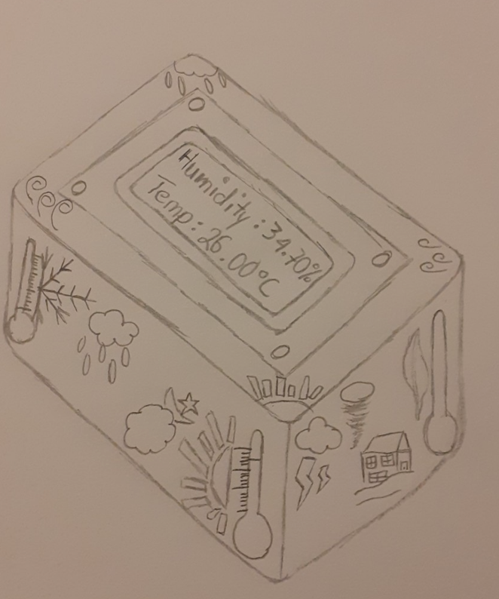
This is our initial design for the humidity sensor. Our idea was to make the humidity sensor into a box shape with patterns, to show what data the machine considers. It also has a lcd screen to show the data collected. We used a lcd screen and the connector to create the device. It has the lcd screen plugged into 12C, which has code used for many libraries such as Adafruit sensor, DHT, and DHT_U. These libraries contain commands that have necessary instruction to communicate with sensor. The loop creates two variables. One for storing humidity, another stores the temperature.
Another function is that the LCD prints out humidity and temperature, giving the user a clear amount of humidity. The sensor attachment attaches to digital pin 2 to give a clear reading of humidity and temperature on to the LCD screen via a function.

Description of Data Generated Datasets or APIs Used
Our data outlined how a humidity sensor functioned. Where we learnt the basic functionality. How a humidity sensor will function as having two plates attached to it. The two plates act as a parallel capacitance sensor. The plates detect humidity through changes in water content and air humidity. We currently do not have any APIs up and running, however we were able to do extensive research into the functionality of a humidity sensor.

How We Plan to Store and Manage Data
By using an excel spreadsheet, we are able to gather data from our tests and record results easily. As well as this, we can easily understand the data we have gathered and compare it to other tests and data found through our research. We would have rows for each test and columns for humidity and temperature to be able to compare both as those are the two main factors as to why mold developments. This will help us understand not only our devices, but what we are trying to achieve is tackling mold.

Implementation Plan
To implement our plan, our project’s physical components consist of an Arduino board, the Arduino starter sensor kit, and a DHT-11 humidity module. We have our system set up so that the Arduino has the humidity sensor plugged into the digital pin 2 slot, the 5Vslot, and the ground slot. Additionally, we have the LCD screen plugged into an I2C slot and a button to change what’s on the LCD screen plugged into the digital port 3 slot.

#include "DHT.h"
#include <LiquidCrystal.h>
#define DHTPIN 2

#define DHTTYPE DHT11 // DHT 11
#include <Wire.h>
#include "rgb_lcd.h"

rgb_lcd lcd;

const int colorR = 0;
const int colorG = 255;
const int colorB = 0;

const int buttonPin = 3;
int buttonState = 0;

DHT dht(DHTPIN, DHTTYPE);

void setup() {
Serial.begin(9600);
Serial.println(F("DHTxx test!"));
lcd.begin(16, 2);
lcd.setRGB(colorR, colorG, colorB);

pinMode(buttonPin, INPUT);

dht.begin();
}

void loop() {
// Wait a few seconds between measurements.
delay(2000);

float h = dht.readHumidity();
// Read temperature as Celsius (the default)
float t = dht.readTemperature();

// Check if any reads failed and exit early (to try again).
if (isnan(h) || isnan(t)) {
Serial.println(F("Failed to read from DHT sensor!"));
lcd.clear();
lcd.setCursor(0, 1);
lcd.print("Failed to read!");
return;
}

Serial.print(F("Humidity: "));
Serial.print(h);
Serial.println("%");
Serial.print(F("Temperature: "));
Serial.print(t);
Serial.println(F("°C "));

// Use button to get Mold Reading when held
buttonState = digitalRead(buttonPin);

if (buttonState == LOW)
{
lcd.clear();
//Display Humidity and Temp
lcd.setCursor(0, 0);
lcd.print("Humidity: ");
lcd.print(h);
lcd.print("%");

lcd.setCursor(0, 1);
lcd.print("Temp: ");
lcd.print(t);
lcd.print((char)223);
lcd.print("C");

}
else
{
//Display Mold
MoldRisk(h,t);
}
delay(100);
}

void MoldRisk(float humidity, float temp){
lcd.clear();
lcd.setCursor(0, 0);
lcd.print("Mold Risk:");
//HIGH RISK
if(humidity >= 60 || (temp >= 30 && temp <= 25))
{
bool h = humidity >= 60;
bool t = (temp <= 30 && temp >= 25);
lcd.print("High");
if(h && t)
{
lcd.setCursor(0, 1);
lcd.print("T and H:");
}
else if(h)
{
lcd.setCursor(0, 1);
lcd.print("H of:");
lcd.print(humidity);
}
else if(t)
{
lcd.setCursor(0, 1);
lcd.print("T of:");
lcd.print(temp);
}
}
//LOW
else if((humidity >= 25 && humidity <=30) && (temp <= 30 && temp >= 25))
{
lcd.print("Low");
lcd.setCursor(0, 1);
lcd.print("Perfect T+H");
}
//NORMAL
else
{
lcd.print("Normal");
}
}

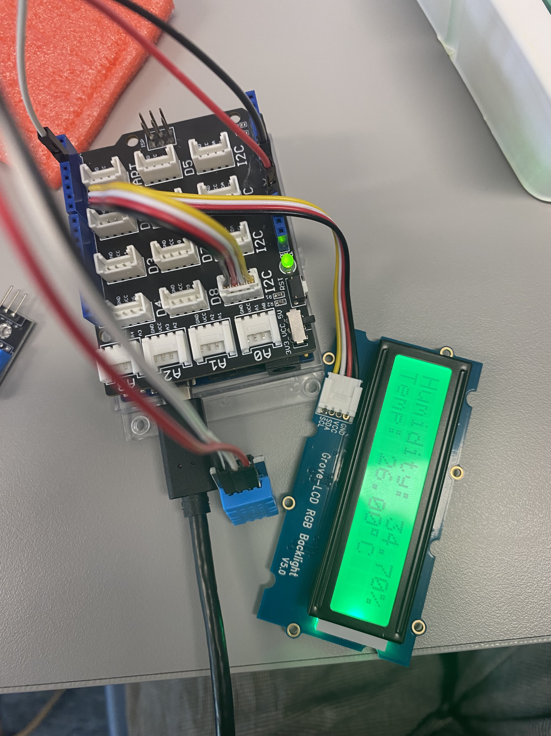

Testing Approach
For our project, we have been testing our system by setting up our hardware in class and testing to see if it works the way we want it to. For the most part, we have been monitoring the systems readings in the serial output and testing the LCD monitor. We used some example libraries to make sure the humidity sensor works.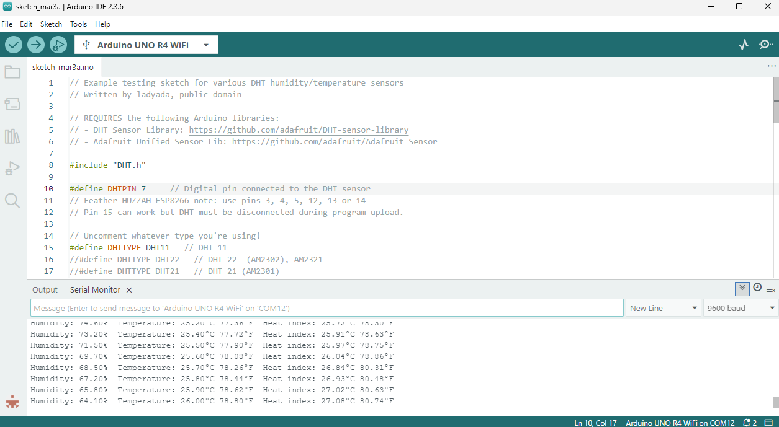

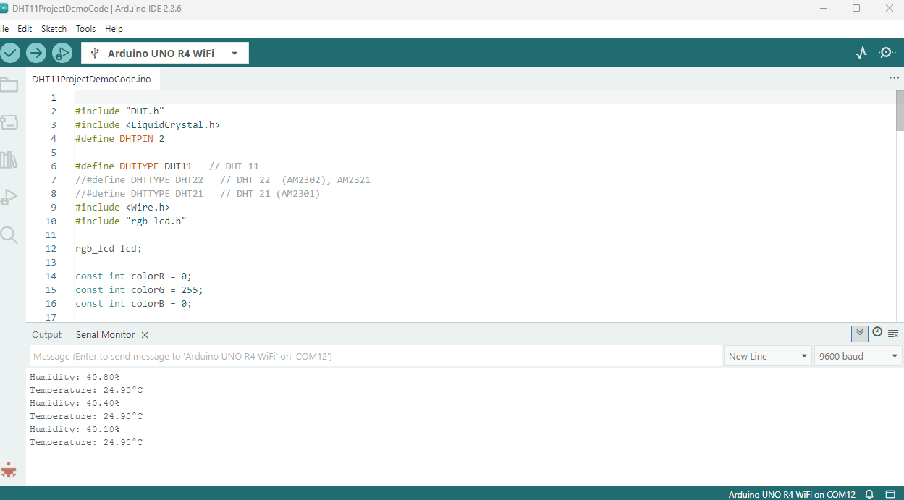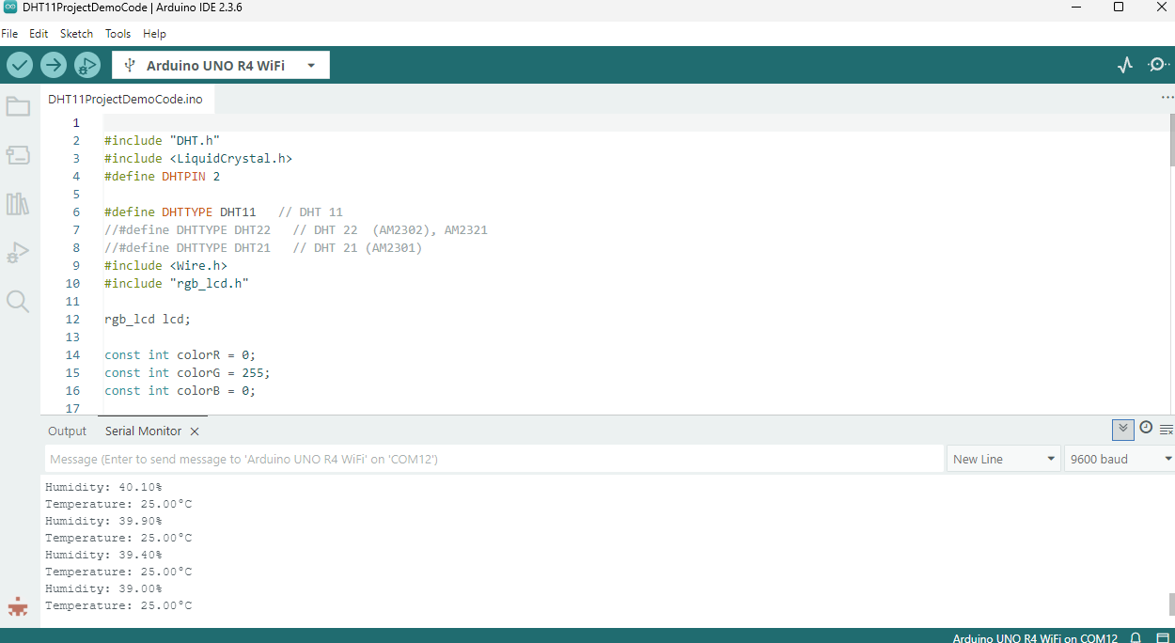

Security Analysis
For our future security system, we plan of focusing on securing credentials, building a regular device Authentication into the system. This may entail the device sending an email to the one registered with the device. This could include a verification code the user will need to put into the device to log in. This adds an extra layer of security to the account, making it so you need access to the email to sign in with could stop a malicious person in their tracks. Restricting access to the device to prevent people from accessing private information such as the user’s email. Accessing sensitive information will require the password and the password will be hidden. We could also use the authentication system on the password reset to give an extra layer of security to the user’s personal details logged into the device. Given the nature of our project, we believe that we will be able to design a system with minimal risk to the user as it is only able to send simple messages. However, we still believe a security system is necessary on the device to protect the user from a data breach as things such as email are sensitive information which the user should not let leak. As the next step in our development process, we plan on implementing this security system alongside our messaging system. We want our system to protect the user’s privacy and as such we will be looking at safeguarding the user's email information so that no one can use our system to steal any information.

Future Improvements
In the future, we plan to implement the messaging system that will send updates to the user regarding the humidity and temperature levels observed and if a given area is at risk of developing mold. To do this, we will most likely be using Temboo for our messaging needs. Once we can connect Arduino to the internet and set up the messaging system, we will devise a demonstration model that will allow us to send a message to the user every time a button is pressed. From here, the goal will be to set up an automatic system that takes the averages of the reading over the previous hour and sends that information to the user in the form of an email. As of this time we will most likely not need to procure any additional physical components as we will be focusing on implementing the messaging system and the only physical piece of hardware that we might need for that is another button from the sensor kit in order to demonstrate and test the email functionality. Additionally, we want to implement a light change system for the LCD screen that causes it to change colors depending upon certain environmental conditions such as the red for high mold risk and loss of connection to the humidity sensor should it ever stop operation. Moreover, we plan on working on building a proper container for the system to fit into as detailed in the initial sketch that houses the Arduino in a secure case with the LCD screen mounted to the top of the box and the toggle LCD screen button next to it. We also plan on mounting the sensor on the side of the box so that it can properly collect data on the environment. When we are able to set up the internet messaging system, we make it so that the user can configure the system to allow for multifactor authentication as well as sign in alerts as an additional layer of security and we will make it so that the user can easily set this sort of security up when initially setting up this system. To do this, we will be researching setting up a password system in Arduino so that we can accomplish this task. From there all we will probably need to do is do further bug testing while also searching for any potential security vulnerabilities that may arise in the future.

