Trevor Myer

Lab 4 – Form Validation

Similar to Lab 3, good instructions. Very detailed instructions. Lots of words. This was coded using NetBeans. The debugging worked well. The changing things form black to red was a little wonky. Any error at all in the java script caused nothing to work. It was very picky.

Results from running the web page.

Right when the web page comes up.

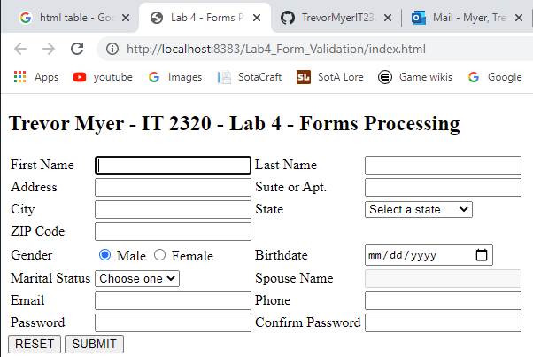

Fully blank… all errored. Spouse Name will not be red if disabled.

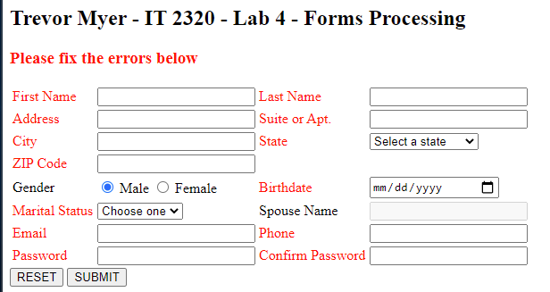

Some filled in

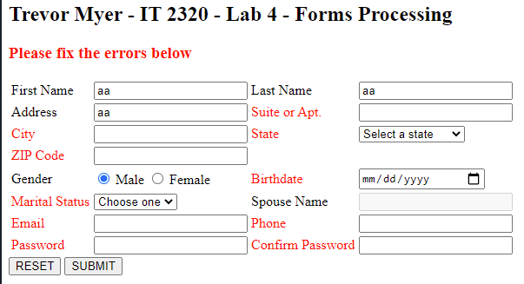

More filled in

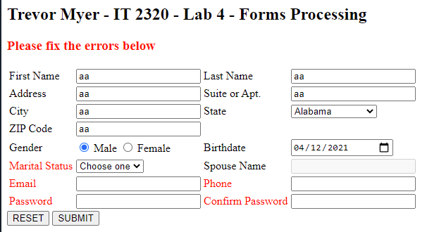

Married and blank spouse… spouse red.

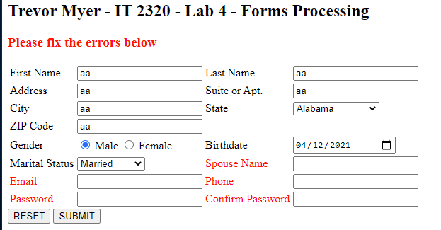

All filled in but passwords do not match

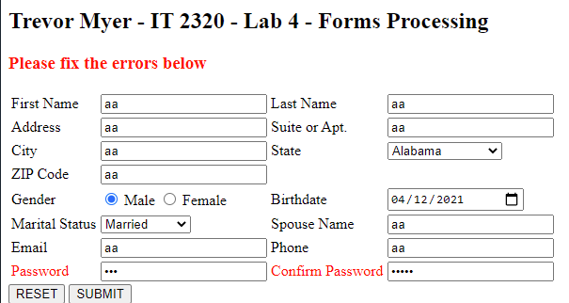

All filled in with matching passwords

