Trevor Myer

Lab 7 – Walking Guy

This was a fun one. It was really neat playing with animations. Hard figuring out the syntax but it was amazing how much you could do with just a couple lines of code.

I subtracted 410 from the width of the screen because when I only did 400 (like your instructions said) there was a bit of a wiggle and a scroll bar popped up in the browser. That may be caused my laptop. I have a surface and it causes a few display issues. The main screen is zoomed 100% and that caused the other monitor issues.

It took forever to figure out the flipping the guy. It was not that hard to find the class that flipped him. The hard part was to get him to flip at the right time. He either never flipped or always flipped. It took getting the syntax just right to flip him in the middle.

**NOTE**: After I thought this was working, I figured out it only worked once. The class flipped to left and stayed left. You had to reload the page to remove the class.

Adding the flipHimRight on the animate caused him to flip before he faded.

I added the flipHimRight to the finial fad. This resets him to right and allows you to hit the start repeatedly.

Initial screen

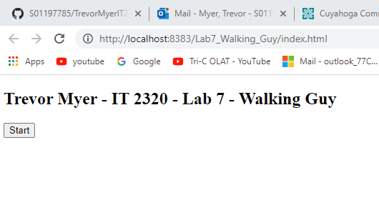

Walking left

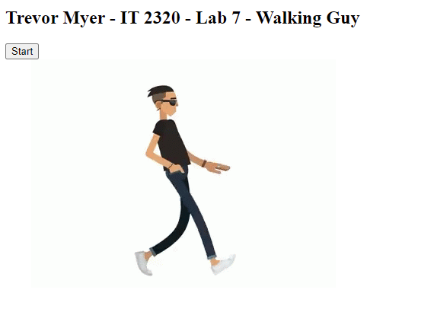

Walking right

