Trevor Myer

Lab 8 – Forms Events

Syntax is horrible. I spent much too much time trying to find the proper syntax. I am coding in NetBeans and running it in Chrome. My syntax seems different from examples in the book and online. They $ and the # does not work the same. I had the $ working on a few Labs by including that function but it did not work here. In Lab9 the weather API, I could not get the ajax call to work until I added jQuery in front of it. None of the examples had that as a requirement. The command syntax is always messing with me.

I could not get the Key press event linked up in jquery. I tried putting it in window onload and in document ready. Nothing I tried worked. The only way I could get the input box to fire the key press was by putting it in the HTML.

This is the final Lab that I had outstanding. I should be all caught up now. Thank you for allowing me to go back and redo the Labs. Sorry that the first pass was incomplete. Combination of incorrect tools, level of effort and motivation cause poor work. I am more motivated now. When my father saw my mid-term grades he was very upset. He threaten to ground me back to the stone age. I am unsure how that would have even worked but it sounded unpleasant. He then threaten to stop funding my college and possible even sell my car to refund himself for failed classes. I shut off the xbox and Netflix and really focused on improving my course work. Thanks for the opportunity.

Initial screen

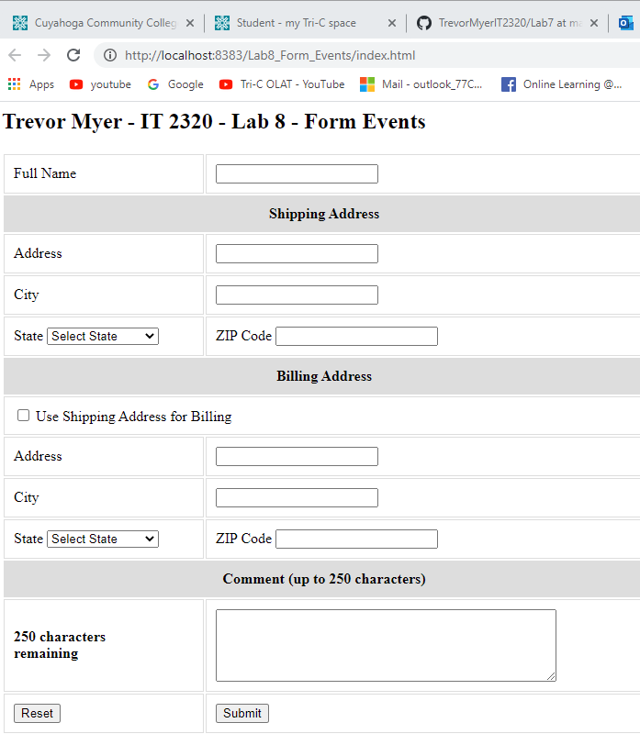

Name shifting to upper

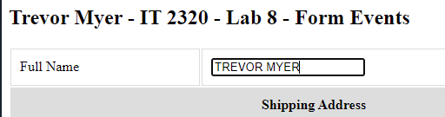

Billing address plug

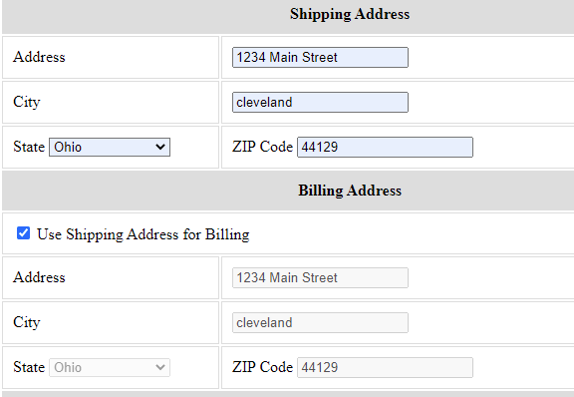

Billing address unplug

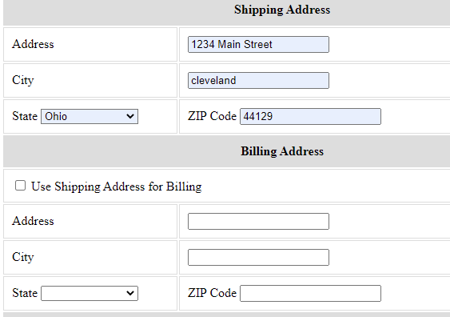

Comment

