Trevor Myer

Lab 9 – Weather API

I started by signing in to the weather web site to get the API code. The web site had a bunch of information. I sort of expected an email confirmation code from signing up. I waited for an hour before I poked around the web site and found the API code under my account.

I found the API documentation and found the keys we needed to call. Web page was pretty easy. jQuery was went together fairly quickly. I kept getting an error on the ajax line about undefined. I could not get it to work until I put jQuery instead of the $. It does not match your example but that is the syntax that my page required.

The weather description kept coming up as undefined. Nothing on the API documentation stated that the weather object was an array. I found a post on stackoverflow that gave me that hint.

<https://stackoverflow.com/questions/61301790/how-to-get-the-weather-description-from-openweathermap-api>

The rest of it was pretty easy so I took a few extra minutes and made the icon display.

Results from running the web page.

Initial screen

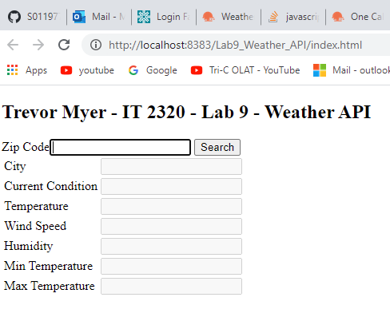

Cleveland – 44129

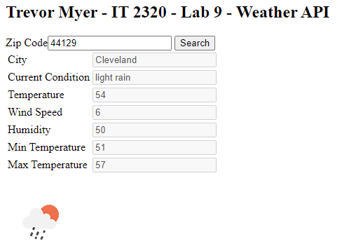

Newton Falls – 44444

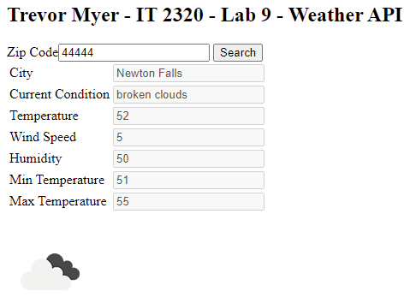

Dallas Tx - 75001

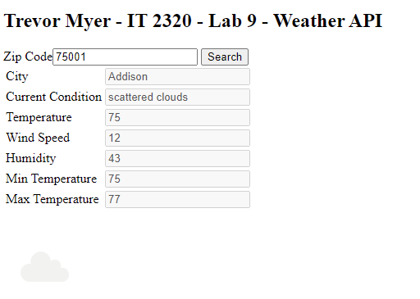

Alaska - 99501

