// Document : Lab2FibonacciSeq

// Created on: Mar 31, 2021, 5: 49: 59 PM

// Author: trevor myer

Prompt window

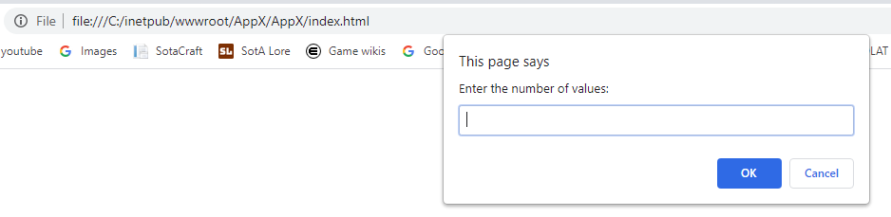

Value 1

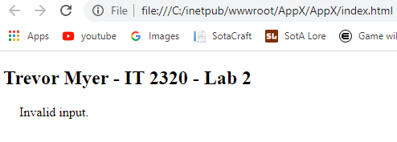

Value 2



Value 4

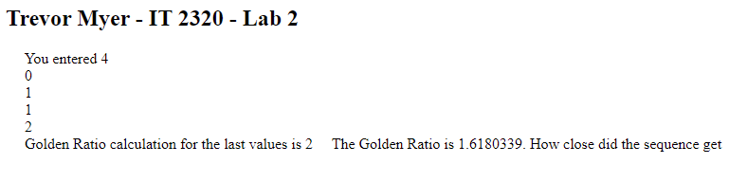

Value 8

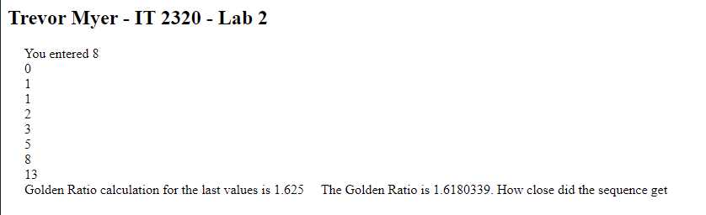

Value 10

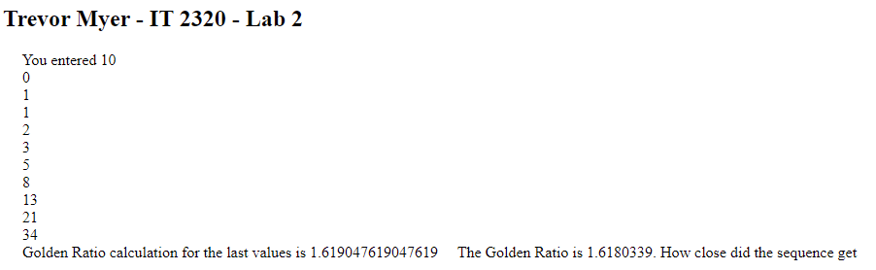

Value 20

