Trevor Myer

Lab 5 – Slide Show

Much less typing this Lab. Shorter code. Again, we coded using NetBeans. The only issue I really had was the preloading the images. I tried a few things before pulling code from the book (page 215). I did not like the set interval logic so I wrote my own.

Results from running the web page.

Initial screen

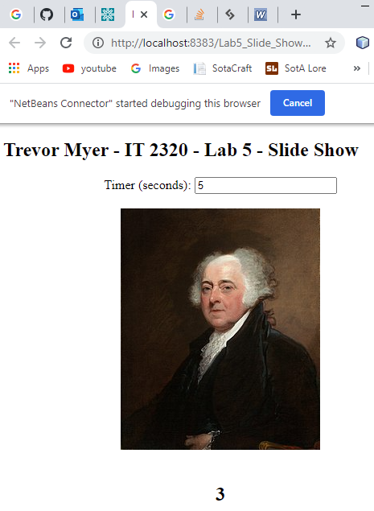

Changing the text box changes the counter

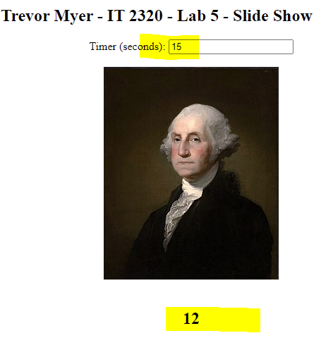

Count down cycles through the pictures

