Trevor Myer

Lab 6 – jQuery Calculator

Reading the chapter was a bit overweilming. It was a bit detailed. It seems these commands are very powerful. Some seem to be just a different way to do things that we can do in Java script with thust a different syntax. Your documentation and example code made this an easy lab. It was interesting how the table formatted to make a calculator.

Results from running the web page.

Initial screen

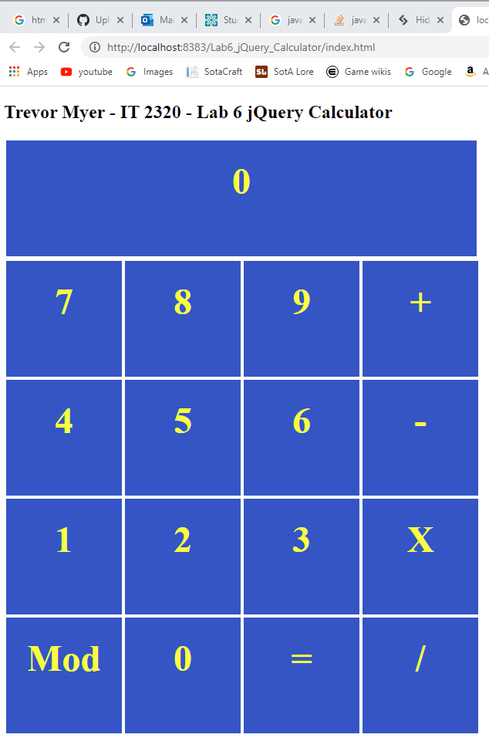

Adding numbers

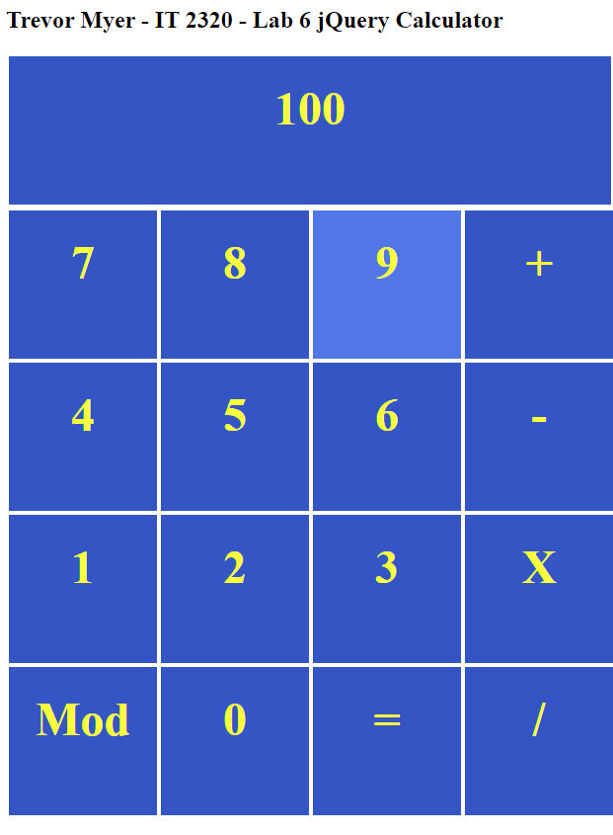

Grey out the action keys

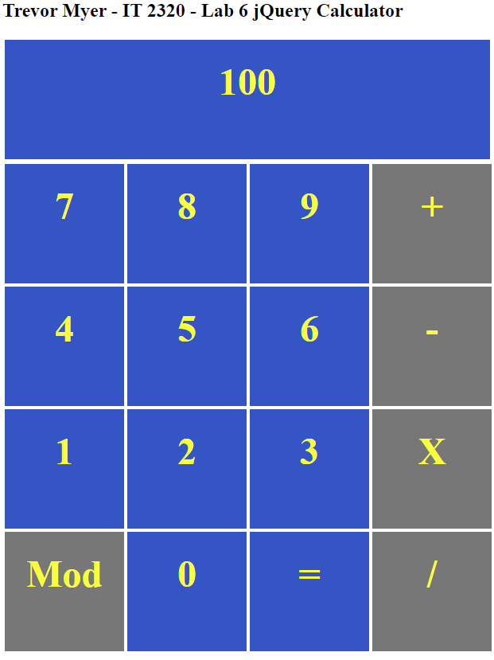

Equals resets the action keys

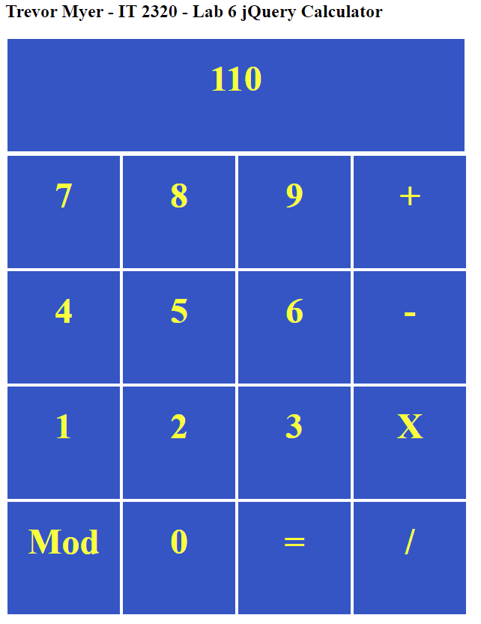

Testing modulo 12 mod 10 = 2

