Exploratory Data Analysis Report

Hansen

## Placing Colorbars

Colorbars indicate the quantitative extent of image data. Placing in a figure is non-trivial because room needs to be made for them. The simplest case is just attaching a colorbar to each axes:[1].

import matplotlib.pyplot as plt  
import numpy as np  
  
fig, axs = plt.subplots(2, 2)  
fig.set_size_inches(20, 8)  
cmaps = ['RdBu_r', 'viridis']  
for col in range(2):  
 for row in range(2):  
 ax = axs[row, col]  
 pcm = ax.pcolormesh(  
 np.random.random((20, 20)) * (col + 1),  
 cmap=cmaps[col]  
 )  
 fig.colorbar(pcm, ax=ax)  
plt.show()

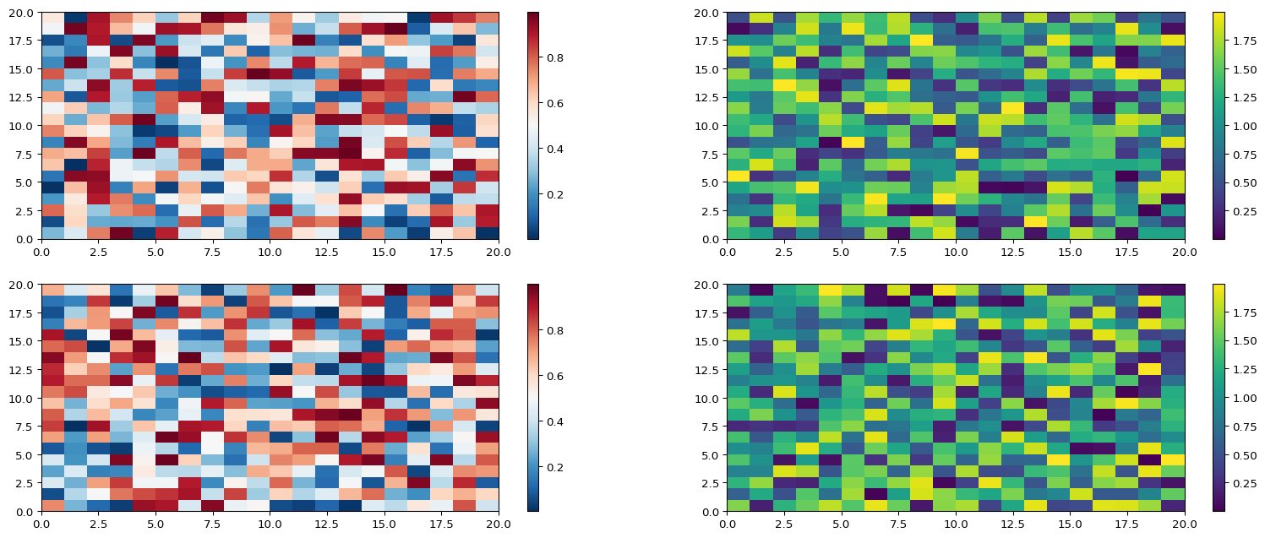

1. See the [Matplotlib Gallery](https://matplotlib.org/stable/gallery/subplots_axes_and_figures/colorbar_placement.html) to explore colorbars further