Android App

I developed an Android app with the login page having username and password and after successfully login it moves to the next Page called as User Page. I have used the data like API KEY and API URL from the website [WWW.Tech.Yandex](http://WWW.Tech.Yandex) .

API KEY used is

trnsl.1.1.20160203T183825Z.a10856e824b2d555.c9ac4043a0a57c5846b3d89559756b82269a9170

The format for the KEY is mentioned in the website

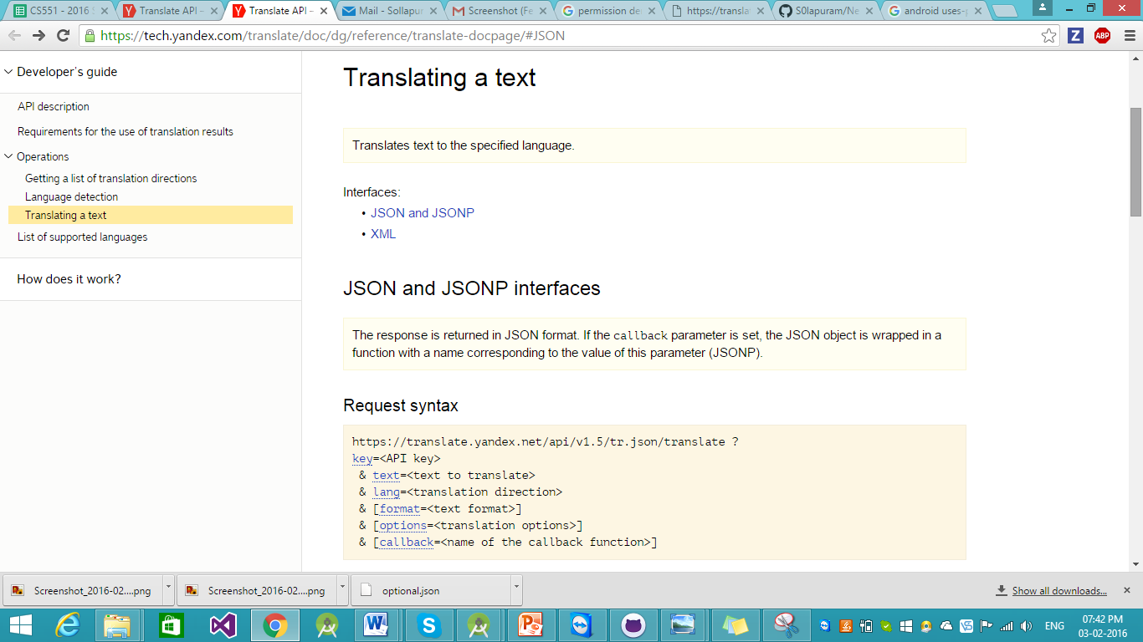

<https://tech.yandex.com/translate/doc/dg/reference/translate-docpage/#JSON> . By using this App we can convert the word from english language to hindi.

I have created two activaties named as Login Page and User.

In the first page I designed it for Login and getting the pop up after successful login as Username and Password is correct otherwise as Username and Password are not correct. After successful login I redirected it to the next activity named User and there I have used API URL and API Key from the above mentioned website.

