**Assignment1**

**Git Hub**

Create the New Repository from the Git hub website ([www.github.com](http://www.github.com))

Clone it to our local desktop and create the specific folder for our files to be created

Open the git shell and write the commands for creating the file and commit it and Push it to the repository.

Create the branches in order to work by multiple members and merge it after the completion.

**My Repository for Chat Application**

Created the repository named as ChatApp and created 3 iterations (Milestones) and 5 tasks (Issues) for each iteration. Created the Source and Documentation Folders.

Analytical Graphs

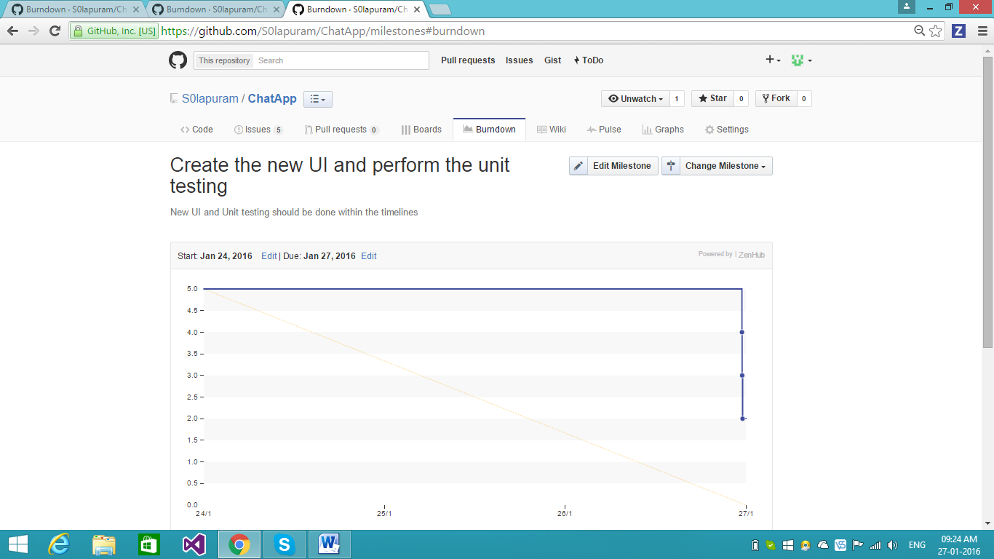

Analytical graph for second milestone with 5 issues. 3 issues are closed and 2 issues are in open and hence the graph is displayed as completed for 3 issues which are in closed and 2 are in pending are not displayed.

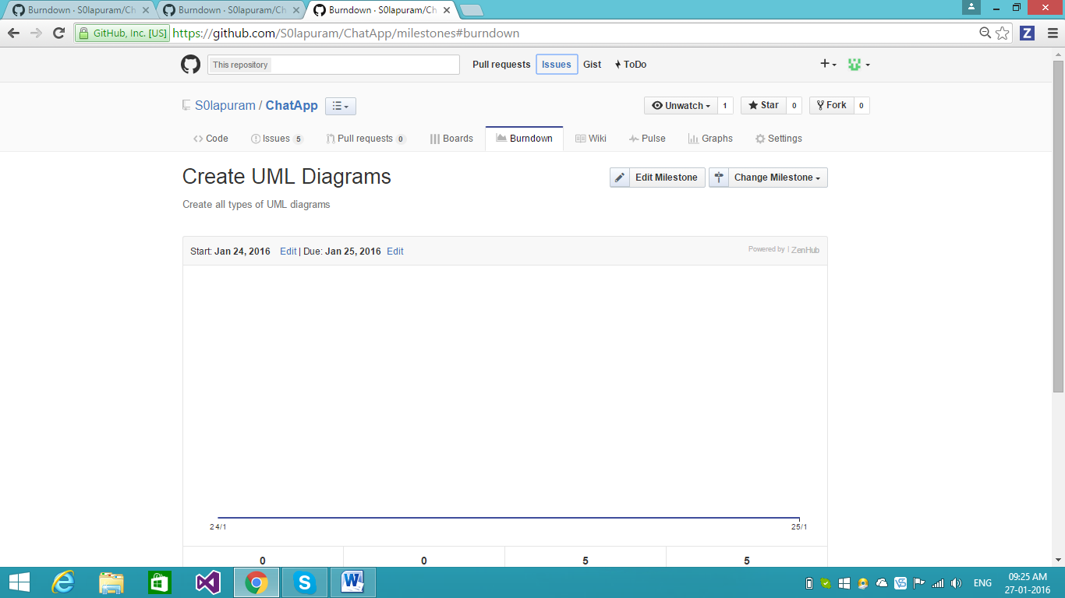

Analytical graph for first milestone with 5 issues. 5 issues are in closed state but the due date is mentioned as 25/01/2016 and estimated hours are not mentioned and hence the graph

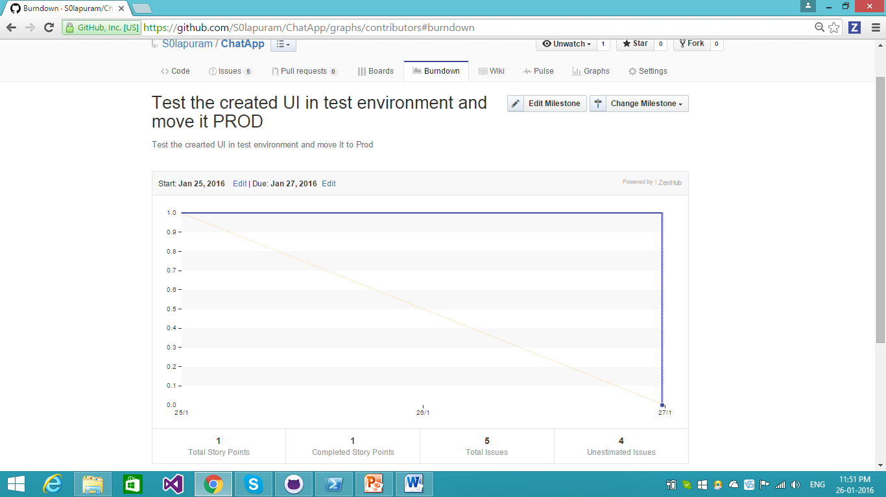

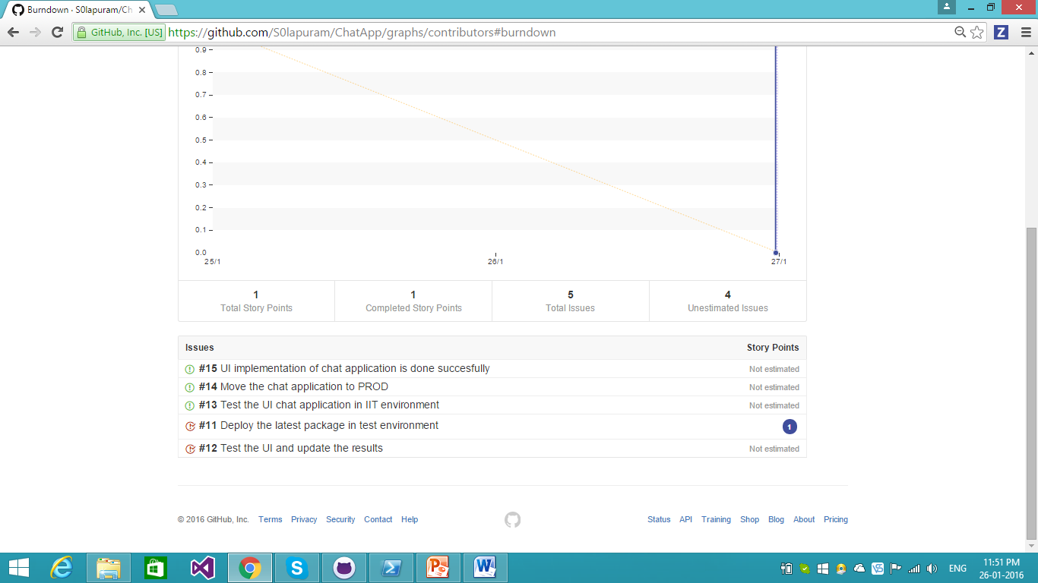

Analytical Graph for third milestone having 5 issues. 2 issues are in closed and 3 issues are in open and only 1 estimated hour is mentioned and hence the graph is shown like that.

I have created 1 branch as well

Please find the link for it <https://github.com/S0lapuram/ChatApp/tree/BranchNagi>

**2) Two folders are created document and Source**

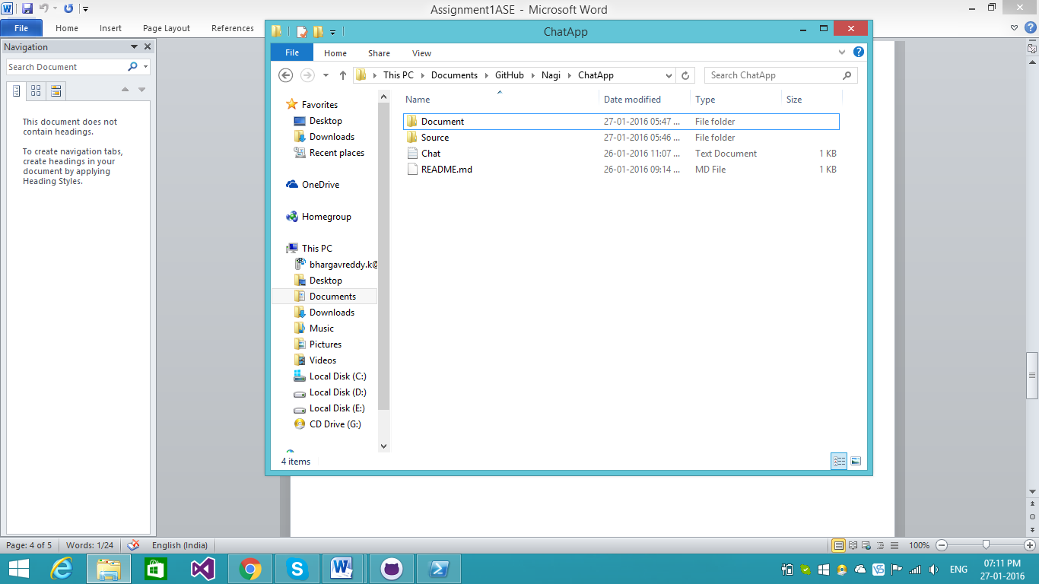

3) UML Class Diagram

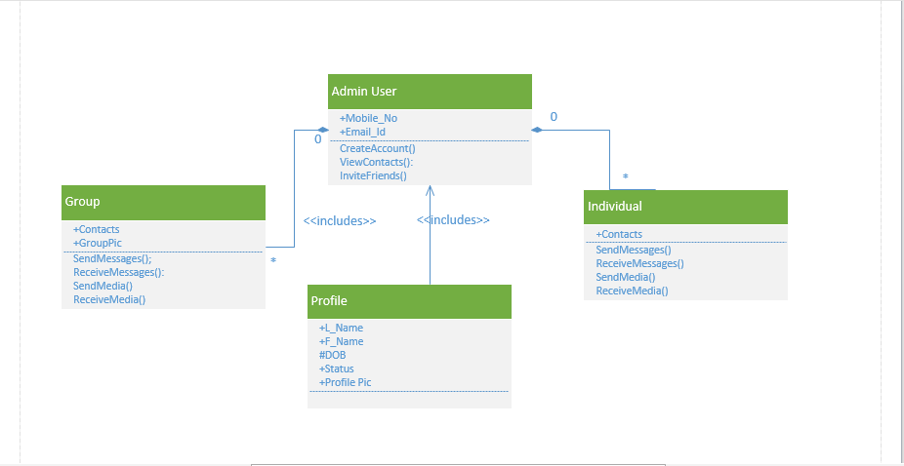

Admin User is considered as the main class and Individual, Group classes are composition related as they can’t exist without the Admin and vice versa. Profile is directly associated and it can exist independently and hence association relation between them