Contribution Title
First Author¹[0000-1111-2222-3333] and Second Author²[1111-2222-3333-4444]
¹ Princeton University, Princeton NJ 08544, USA
² Springer Heidelberg, Tiergartenstr. 17, 69121 Heidelberg, Germany
lncs@springer.com
Abstract. This work presents a new method for the euclidean Traveling Salesman Problem (TSP), based on some geometrical properties of said problem. We will use the cartesian coordinates of the points that compose the instance instead of the usual graph representation, to preserve the structural context of the instance and to allow automatic deduction of the general layout of the points in the solution. To test the results we will use some of the well known datasets such as TSPLib.
Keywords: Combinatorial optimization, Travelling Salesman Problem.
- First Section
  - A Subsection Sample
Please note that the first paragraph of a section or subsection is not indented. The first paragraphs that follows a table, figure, equation etc. does not have an indent, either.
Subsequent paragraphs, however, are indented.

Sample Heading (Third Level). Only two levels of headings should be numbered. Lower level headings remain unnumbered; they are formatted as run-in headings.

Sample Heading (Forth Level). The contribution should contain no more than four levels of headings. The following Table 1 gives a summary of all heading levels.
Table 1. Table captions should be placed above the tables.
Heading level | Example | Font size and style
Title (centered) | Lecture Notes | 14 point, bold
1st-level heading | 1 Introduction | 12 point, bold
2nd-level heading | 2.1 Printing Area | 10 point, bold
3rd-level heading | Run-in Heading in Bold. Text follows | 10 point, bold
4th-level heading | Lowest Level Heading. Text follows | 10 point, italic
Displayed equations are centered and set on a separate line.
x + y = z (1)
Please try to avoid rasterized images for line-art diagrams and schemas. Whenever possible, use vector graphics instead (see Fig. 1).

Fig. 1. A figure caption is always placed below the illustration. Short captions are centered, while long ones are justified. The macro button chooses the correct format automatically.
For citations of references, we prefer the use of square brackets and consecutive numbers. Citations using labels or the author/year convention are also acceptable. The following bibliography provides a sample reference list with entries for journal articles [1], an LNCS chapter [2], a book [3], proceedings without editors [4], as well as a URL [5].

- Introduction

- Preliminaries
In this section, key concepts in regards to TSP and geometry properties relevant for the development of the algorithm are reviewed.

  - Travelling Salesman Problem

  - Convex Hull
In mathematics, the convex hull or convex envelope for a set of N points in euclidean space is the minimal convex set containing these N points (https://ti.inf.ethz.ch/ew/courses/CG13/lecture/Chapter%203.pdf).
This concept will be use in repeated occasions during the algorithm development since convex polygons are simpler to analyze and will allow to transform the problem itself, as it is explained below.

- Literature Review
TSP Solvers, Instance Generators and libraries…

- Data Collection
Why is it important

  - TSPLib
TSPLib is one of the most referenced sources for this problem. It offers instances of a variety of sizes, which is helpful to perform time measurements. Most researchers use these instances to test their algorithms - being exact or not, and to allow us to establish some comparisons, we will choose some of these instances for this purpose.

Relevant considerations
Even though there are some proposed solutions, these may not be optimal. Presumably, the source of these variations is the process of rounding up the distances between each pair of points of the instance, to lighten calculations and reduce computational costs.

In order to avoid imprecise comparisons, we will only use those instances for which a tour is provided, so their real cost can be calculated without rounding to units.

- Theoretical basis of the algorithm
  - TSP as a geometrical problem
As it was previously stated, the TSP problem's goal is to calculate the shortest path which travels through all points of a set, finishing where it started. Geometrically, if we consider this set of points as a set of vertices and the path between each pair of consecutive points as edges, the result would be a polygon of minimum perimeter. Therefore, an equivalent statement of the problem is: "Given a set of n vertices, find the set of n edges which forms a polygon of minimum perimeter".

  - Convex Hull and TSP
As the solution to TSP is a minimum perimeter polygon, one characteristic is that said polygon must be simple. In other terms, it cannot be self-intersecting.
Due to this constraint, by using the polygon's convex hull, the general layout of the solution can be deduced.
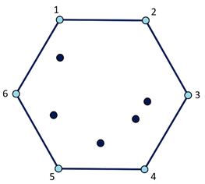
For example in this case, the blue vertices represent the convex hull. When travelling across them in order (1, 2…6 or in opposite direction, 6, 5…1) a simple polygon is obtained. However, if this order is not followed, then it will not be possible to obtain a simple polygon, therefore it would not be of minimum perimeter.
  - Decomposition of an instance
It is possible to decompose the instance by using the convex hull's edges. Each of the inner points of the convex polygon must be joined in these edges so that these two conditions are met:
- Each segment must be a minimum path. This means, if there are any middle points between the 'Start' and 'End' points of each segment, they must be in a specific order so that the distance of the segment is the minimum possible.
- The global distance between all segments must be minimal. Not only the segments need to be minimum paths, but also the inner vertices of the polygon must be joined in the segments that makes the minimal increment in distance.

Applying these rules for the previous example, the solution obtained is as follows:
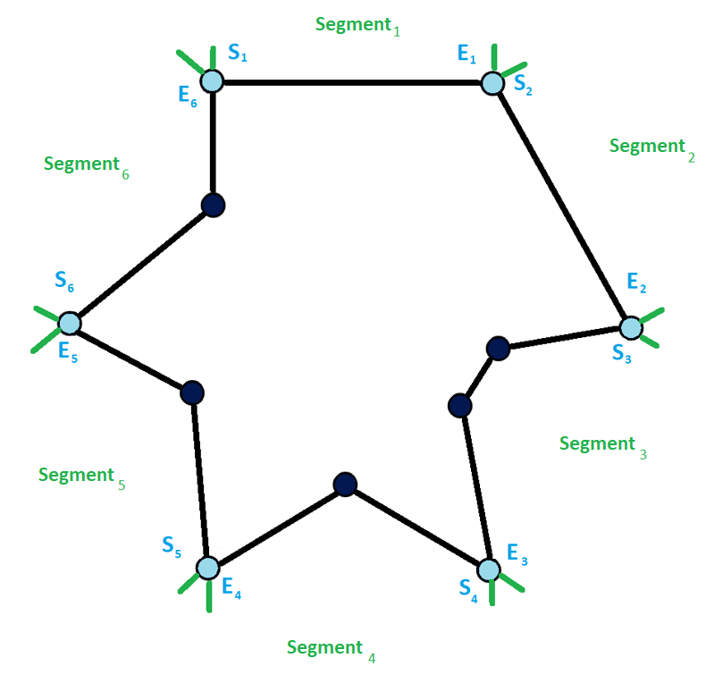
Each of the six segments of the convex hull are minimum paths and the global distance between all segments is minimal as well - therefore reaching the TSP's solution.
  - Equivalence between TSP and a segment
A segment from the TSP may not have any inner points (the case of segments 1 and 2 of the previous example), or may have one or more (being the case of the other segments). In this first case, it is trivial that the minimum path is 'Start-End'.
The second case is not so trivial. In order to deduce the path, it is possible to make an equivalence between TSP and the segment. A segment is defined as "the minimum path which goes across a point 'S' through some inner points to reach an exit point 'E'". Judging by this definition, it is clear that is very simmilar to the one of TSP - and so it is the approach that can be used.
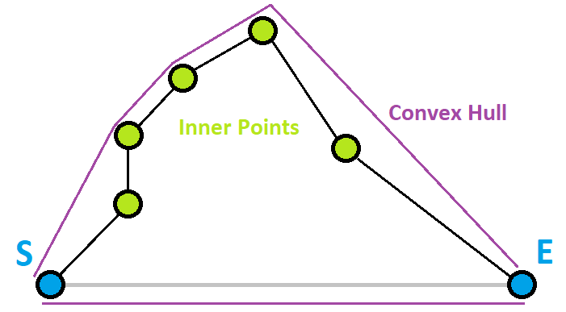
The convex hull of any segment of a TSP will always have a simmilar structure - one side being the direct conexion between E and S and the rest of the sides to link the inner points. The TSP takes into account all sides of its inner convex hull to calculate the path, but as a segment is not circular but linear, the segment from S to E must be ignored (meaning that no inner point must be joined in said sub-segment). Since in both scenarios (TSP and Segment) the goal is to achieve the global minimum, in the Segment problem we must also form minimal paths for each sub-segment and then reduce the global distance to the minimum while also ignoring the segment between E-S. Therefore, both problems are equivalent in these circumstances.

  - Optimization of global distance
Let a 'priori TSP solution' the one obtained by assigning the inner points to their closest segments and have these segments solved with the equivalence between TSP-Segment. Generalizing, a priori solution presents a layout which resembles arches, as it is shown below:
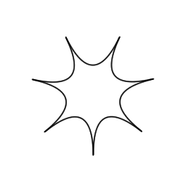
Where the outer points are those that belong to the convex hull, and each arch are those inner points that belong to each of the segments. This case is the most ideal one - all arches are symmetrical to one another so no further optimization is required. Of course, this is not always the case, in most occasions we may find irregular arches, so the resulting polygon will require certain vertices to be moved from one segment to another in order to decrease the global distance.
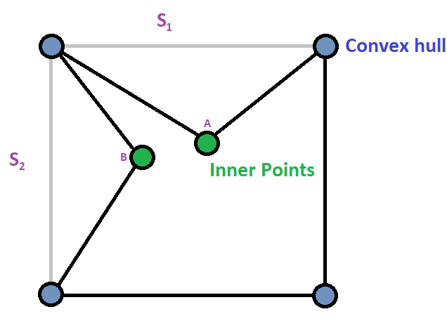
For example, in this case all segments are minimal but the global distance has not been minimized. If A is moved to segment 2 or B moved to segment 1, the perimeter of the polygon is reduced.

As it was aforementioned, this initial solution was obtained from joining these inner points to their closest segments. So, it is trivial that if a segment is left without any inner points, it is because the final solution also has said segment empty. So to optimize this first approach of a solution we will only take into account those segments which already have at least one inner point.

(Naïve approach)

(Theorem of the Irregular Arches - number of steps is polynomial since there are points which wont come back to where they started)

  - Designed algorithm - PolyGenesis
As both the process to obtain each segment and the one to assign each inner vertex to their corresponding segments can be performed in polynomial time, the resulting combination of both - the algorithm to solve the TSP problem - is also of a polinomial time complexity.

References
- Author, F.: Article title. Journal 2(5), 99–110 (2016).
- Author, F., Author, S.: Title of a proceedings paper. In: Editor, F., Editor, S. (eds.) CONFERENCE 2016, LNCS, vol. 9999, pp. 1–13. Springer, Heidelberg (2016).
- Author, F., Author, S., Author, T.: Book title. 2nd edn. Publisher, Location (1999).
- Author, F.: Contribution title. In: 9th International Proceedings on Proceedings, pp. 1–2. Publisher, Location (2010).
- LNCS Homepage, http://www.springer.com/lncs, last accessed 2016/11/21.

