A convex-hull based approach to solve the TSP problem
González Parrado, Carlos[0009-0009-5218-9187] and Guerrero, Elisa[0000-0002-8320-0811]
¹ Universidad de Cádiz, SPAIN
carlos.gonzalezparrado@alum.uca.es
elisa.guerrero@uca.es
Abstract. This work presents a new method for the euclidean Traveling Salesman Problem (TSP), based on some geometrical properties of said problem. We will use the cartesian coordinates of the points that compose the instance instead of the usual graph representation, to preserve the structural context of the instance and to allow automatic deduction of the general layout of the points in the solution. To test the results we will use some of the well known datasets such as TSPLib.
Keywords: Combinatorial optimization, Travelling Salesman Problem.
- Introduction
The traveling salesman problem (TSP) is one of the most studied problems in computational intelligence and operations research. Nowadays it enjoys a lot of interest due to its applicability to a wide variety of scenarios ranging from tourism to industrial and logistics tasks.
The TSP looks to answer the question: "Given a list of cities and the distances between each pair of cities, what is the shortest possible route that visits each city exactly once and returns to the origin city?"
Mathematically, the problem can be stated as: Given a set of cities 1, 2, …, 𝑛 and a cost matrix 𝐶 = 𝑐𝑖𝑗, in which 𝑐𝑖𝑗 represents the cost of going from city 𝑖 to city 𝑗, with 𝑖, 𝑗 = (1, 2, …, 𝑛), find a permutation {𝑖₁ , 𝑖₂ , …, 𝑖_{𝑛} } of cities that minimizes the sum 𝑐_{𝑖1 𝑖2} +𝑐_{𝑖2 𝑖3} +𝑐_{𝑖3 𝑖4} + ⋯ +𝑐_{𝑖𝑛−1𝑖𝑛} +𝑐_{𝑖𝑛 𝑖n} ,where 𝑖 _{𝑗} 𝑖 _{𝑗+1} represent the indexes of consecutive cities in the permutation. The properties of the cost matrix can be used to characterize the problem [1]:
- If 𝑐𝑖𝑗 = 𝑐𝑗𝑖 for every 𝑖 and 𝑗, the problem is symmetric , and otherwise is asymmetric.
- If the triangular inequality is satisfied for the intercity distances (𝑐_{𝑖𝑘} ≤ 𝑐𝑖𝑗 + 𝑐𝑗𝑘 for every 𝑖, 𝑗 and 𝑘), then the problem is metric.
- If 𝑐𝑖𝑗 are Euclidean distances between points in the plane, the problem is Euclidean. This problem is both symmetric and metric.
Given its NP-hard nature, it has led the scientific community to propose many different solvers, all of them with the aim of solving the problem in a computationally affordable way. Two are the most studied and well established TSP solver schemes: exact and approximate methods [2]. The exact algorithms guarantee to find the optimal solution for any instance but at the cost of a very high computational time. Cutting-plane and facet-finding algorithms [3, 4, 5] could be considered the most effective ones. Nowadays Concorde is the best [6], which is based on a sophisticated form of branch & cut, but because of its exponential worst case execution time, it is not well suited for large instances.
Approximate algorithms include tabu [7] and simulated annealing [8] as local based search as well as genetic algorithm [9], ant colony algorithm [10], particle swarm optimization algorithm [11] among others, as population-based optimization. With the increase in the number N of cities, the search space growths in a combinatorial explosion. Furthermore, in some approximate algorithms, if the convergence is slow and the risk of falling into local optima is high, it can lead to low optimization efficiency [12].

In this paper we face the resolution of TSP from a geometrical perspective. We will use the cartesian coordinates of the points that compose the instance instead of the usual graph representation, to preserve the structural context of the instance and to allow an automatic deduction of the general layout of the points in the solution.
The main purpose of this report is to fulfill the following question - is there any mathematical property which is related to this problem and which leads to a potential solver or brings an improvement to existing algorithms?
The rest of the paper is structured as follows: in Section 2 the key concepts behind the proposed method based on the convex hull are explained and the proposed algorithm is presented. The experimental setup and results are detailed in Section 3, along with a discussion on the obtained results. Finally, Section 4 concludes the paper and describes future lines of research.
- Theoretical Background
In this section, key concepts in regards to TSP and geometry properties relevant for the development of the algorithm are reviewed.
  - Convex Hull
In mathematics, the convex hull or convex envelope for a set of N points in euclidean space is the minimal convex set containing these N points (see Fig. 1).
This concept will be used on repeated occasions during the algorithm development since convex polygons are simpler to analyze and will allow to transform the problem itself, as it is explained below. [14,15,16,17]

  - TSP as a geometrical problem
As it was previously stated, the TSP problem's goal is to calculate the shortest path which travels through all points of a set, finishing where it started. Geometrically, if we consider this set of points as a set of vertices and the path between each pair of consecutive points as edges, the result would be a polygon of minimum perimeter. Therefore, an equivalent statement of the problem is: "Given a set of n vertices, find the set of n edges which forms a polygon of minimum perimeter".
  - Convex Hull and TSP
As the solution to TSP is a minimum perimeter polygon, one characteristic is that said polygon must be simple. In other terms, it cannot be self-intersecting.
Due to this constraint, by using the polygon's convex hull, the general layout of the solution can be deduced since such points must be travelled in order - otherwise it will not be possible to assemble a simple polygon thus reaching a non-optimal solution. The rest of the inner points will be added in between any pair of consecutive points of the convex hull.
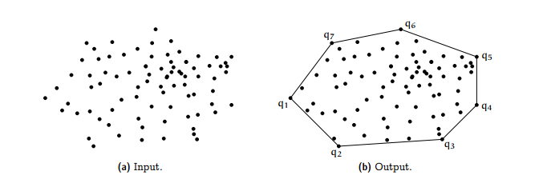
Figure 1. Example of the convex hull of a set of points
  - Basis of a voracious algorithm
We now have fragmented the TSP into several segments. Each of the inner points are likely to be joined to the closest segment, or to the two new edges that are created after another point is linked in a segment.
It is possible to design a voracious algorithm which will join the point which is closest to any of the edges of the convex hull, and will update to the rest of the inner points to check if any of these give better results when joined in the new segments in terms of minimizing the overall Euclidean distance.
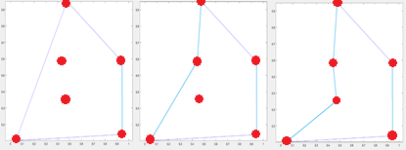
Figure 2. Example of the algorithm's execution.
As it can be seen in figure 2, the first step consists on calculating the convex hull. Then, the inner points are joined to the closest edge, updating everytime a new pair of edges is created. The resulting algorithm is as follows:
EC = convexHull(Coordinates);
for i = 1:length(Coordinates)
[Dist(i), Seg(i)] = MinDistInc(Coordinates(i), EC); //returns the nearest segment of the convex hull to the i-th point and the increment in distance it creates when joined.
end
for i = 1:length(Coordinates)
point_to_join = min(Dist); //index of the point to join
[EC, new_S] = Join(EC, point_to_join, Seg(point_to_join)); //Joins the selected point into the tour. Also returns the two new segments which were created in the process.
Dist(point_to_join) = [];
Seg(point_to_join) = [];
[Dist, Seg] = Update(Dist, Seg, new_S); // checks if other inner points offer better results when added to these new segments.
end
- Results
This algorithm was implemented using Matlab [18] since its compiled file version (MEX files) is of great efficiency and uses advanced techniques such as multithreading to achieve faster calculations. More specifically, it is in the 2021 version of the MEX compiler.
We tested our proposal using all available datasets from TSPLib with sizes ranging from 10 to 8000 points, being 87 instances in total.
All experiments were conducted on a 3.3-GHz core i7 laptop with 16 GB of RAM under the Matlab environment.
When comparing the obtained solutions' costs to those published in TSPLib [19], we obtained the results shown in figure 3.a, where the ratio optimal solution cost reported in the literature, and the solution found by our proposal is compared against the size of the dataset instance, and figure 3.b where we show the time in seconds that our strategy took for solving the problem against the size of the dataset instance. Clearly, bigger size implies longer time and worse solution quality.

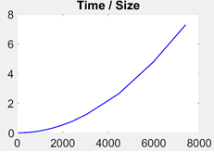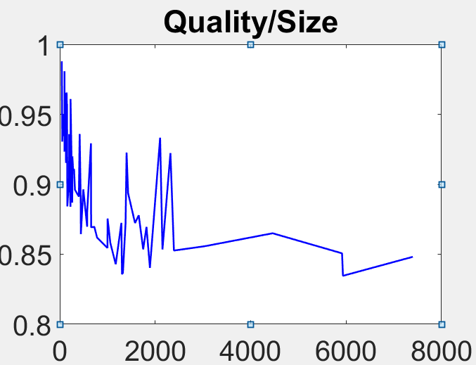
Figure 3.a (left) Comparison between the quality of the solution (optimal solution cost/found solution cost) and the size of the dataset instance (x axis).
Figure 3.b (right) Comparison between the time in seconds (y axis) and the size of the dataset instance (x axis).

However, as we can observe from Fig. 3a the quality of the solution is never below 84%. For datasets of small sizes the ratio optimal/found costs is close to 1, in some cases we found a better solution than the one in the literature. As the size increases, this ratio decreases, but in general the algorithm performance can be considered competitive enough with respect to the optimal solution reported.
In regards to the time costs (Fig. 3b) of our algorithm, for very small datasets it only needs 0.005 seconds to get a very good solution. For the biggest instances of almost 8000 points, it only takes 8s to give a solution. The time complexity of this algorithm is n^2.
- Conclusions and future work
From the above results, we can argue that the feasibility of transforming TSP into a geometric problem has been successfully tested empirically. At the present moment, this proposal cannot be used to prove that there exists an algorithm which belongs to P and that is able to calculate the exact solution to the problem. However we have demonstrated that it is possible to use the properties of the convex hull to pose an alternative geometrical-based formulation to the TSP problem. Most algorithms are non deterministic, which means that this greedy algorithm is relatively uncommon. This has some advantages, when a certain application requires multiple recalculations of similar instances (vehicles recalculating their status because waypoints have been moved for example) and needs to keep a similar structure to that of the previous solutions, this method is the most viable. Not only can it be used as an alternative to approximate methods, but also it is possible to combine both techniques. As this algorithm is not computationally expensive, it can provide an initial state for other techniques such as Annealing, Tabu, or Genetic Algorithms to find a more efficient solution, since this first initial state is already close to the optimal solution.
There are multiple possibilities with this new technique, ranging from the most theoretical (attempt to research further to prove whether it is possible to solve this problem in a polynomial time complexity) to the most practical scenarios, as in designing a new technique which combines this greedy algorithm with other well known ones to achieve good quality results faster, in order to design tours for travel companies or to improve machine’s efficiency.

References
- Huerta I.I. , Neira D.A. , Ortega D.A., Varas V., Godoy J., Asín-Achá R. Improving the state-of-the-art in the Traveling Salesman Problem: An Anytime Automatic Algorithm Selection. Expert Systems with Applications, 187 (115948), January (2022).
- Laporte, G.: The traveling salesman problem: An overview of exact and approximate algo- rithms. European Journal of Operational Research 59(2) 231–247 (1992).
- Grötschel, M., &amp; Holland, O. Solution of large-scale symmetric travelling salesman problems. Mathematical Programming, 51, 141–202, (1991).
- Padberg, M., &amp; Rinaldi, G. A branch-and-cut algorithm for the resolution of large-scale symmetric traveling salesman problems. SIAM Review, 33, 60–100, (1991).
- Applegate, D. L., Bixby, R. E., Chvatal, V., & Cook, W. J. The traveling salesman problem: A computational study. Princeton University Press, (2006).
- Concorde tsp solver. https://www.math.uwaterloo.ca/tsp/concorde.html, last accessed 2023/04/30.
- Glover, F.: Tabu search, part i. ORSA Journal on computing 1(3) 190–206 (1989).
- Kirkpatrick, S., Gellat, C., Vecchi, M. Optimization by simulated annealing. Science 220(4598) 671–680 (1983).
- Goldberg, D.: Genetic algorithms in search, optimization, and machine learning. Addison- Wesley Professional (1989).
- Yu, B., Yang, Z.Z., Yao, B. An improved ant colony optimization for vehicle routing problem. European journal of operational research 196(1) 171–176 (2009).
- Kennedy, J., Eberhart, R. Particle swarm optimization. In: Proceedings of IEEE international conference on neural networks. Volume 4., Perth, Australia 1942–1948 (1995).
- Yang, X.S.: A new metaheuristic bat-inspired algorithm. In: Nature inspired cooperative strategies for optimization (NICSO 2010). Springer 65–74 (2010).
- Osaba E., Yang X-S, del Ser J. Traveling salesman problem: a perspective review of recent research and new results with bio-inspired metaheuristics, Editor(s): Xin-She Yang, Nature-Inspired Computation and Swarm Intelligence, Academic Press, Chapter 9 - Pages 135-164 (2020).
- Welzl Emo, Gärtner Bernd. Chapter 3. Convex Hull.
https://ti.inf.ethz.ch/ew/courses/CG13/lecture/Chapter%203.pdf, last accessed 26/04/2023.
- T. Bonnesen and W. Fenchel, Theory of convex bodies, BCS Associates, Moscow, ID, 1987, Transla- ted from the German and edited by L. Boron, C. Christenson and B. Smith.
- H. G. Eggleston, Convexity, Cambridge Tracts in Mathematics and Mathematical Physics, No. 47, Cambridge University Press, New York, 1958.
- Rolf Schneider, Convex bodies: the Brunn-Minkowski theory, Encyclopedia of Mathematics and its Applications, vol. 44, Cambridge University Press, Cambridge, 1993.
- MATLAB, https://es.mathworks.com/, last accessed 28/04/2023
- TSPLib, http://comopt.ifi.uni-heidelberg.de/software/TSPLIB95/, last accessed 28/04/2023

