
a INSTITUTE OF AERONAUTICAL


ENGINEERING
(Autonomous)
Dundigal, Hyderabad - 500 043

Java Full Stack Development

STUDENT DETAILS:

Name of the Student | Roll Number | Branch | Mobile Number
M GHNANA SOUSHEEL | 24955A0509 | CSE - F | 8309781454
DINESH RATHOD | 24955A0508 | CSE - F | 8328673800

TITLE OF THE ENGINEERING DESIGN PROJECT:
Traffic Controller System

PROJECT OBJECTIVES:

- To Develop a Real-Time Traffic Simulation Engine: Build a robust core engine capable of simulating vehicle movement, traffic density, and signal interactions across a network of intersections with a target of handling ≥ 1000 concurrent vehicle entities at a refresh rate of 60Hz, ensuring smooth and realistic traffic flow representation under various conditions.
- To Enable Dynamic and Adaptive Traffic Control: Engineer an intelligent signal control system that moves beyond pre-timed cycles to one that dynamically adjusts green phases and offsets based on simulated real-time traffic flow, aiming to reduce average wait times by ≥ 40% in simulation and improve overall traffic efficiency.
- To Implement a Comprehensive Manual Override System: Create a dedicated Traffic Police Module that allows authorized personnel to seize control of any intersection, enabling manual signal operation, creation of emergency green corridors, and management of traffic during unforeseen events or emergencies, ensuring flexibility in crisis situations.
- To Ensure System Robustness and Data Persistence: Architect a secure and reliable JVM-based platform with a persistent MySQL storage layer, ensuring all traffic events, signal changes, and user actions are logged for audit, analysis, and system recovery, maintaining data integrity and operational continuity.
- To Provide Multi-Faceted User Interfaces: Develop an interactive JavaFX desktop application for real-time control and visualization, complemented by a JSP-based web dashboard for administrative oversight, configuration, and reporting, ensuring accessibility for different user roles and operational needs.
- To Design for Modularity and Scalability: Construct the system using a modular design pattern, allowing individual components (e.g., Route Manager, Diversion System) to be developed, tested, and scaled independently, supporting future expansion to more complex traffic networks and integration with emerging technologies.
- To Achieve Cross-Platform Compatibility: Ensure seamless operation across multiple operating systems including Windows, Linux, and macOS through JVM-based execution, guaranteeing consistent performance and user experience regardless of the deployment environment.
- To Implement Comprehensive Security Protocols: Establish role-based access control with secure authentication mechanisms, protecting system integrity and preventing unauthorized access to critical traffic control functions, thereby ensuring safe and reliable system operation.
- To Enable Real-Time Performance Monitoring: Integrate live analytics and reporting capabilities that provide instant feedback on system performance, traffic flow metrics, and operational efficiency indicators, facilitating data-driven decision-making and continuous improvement.
- To Facilitate Urban Planning and Research: Provide accurate simulation data and historical analytics that can inform city planning decisions, infrastructure development, and academic research in traffic management, contributing to smarter and more sustainable urban mobility solutions.

PROBLEM STATEMENT:

- Static and Inefficient Traffic Systems: Conventional traffic light systems operate on fixed, pre-programmed timers that cannot adapt to fluctuating, real-time traffic volumes, leading to unnecessary congestion, increased fuel consumption, and higher vehicle emissions.
- Lack of Proactive Congestion Management: Current infrastructure is largely reactive; traffic jams are addressed only after they have formed, with no mechanism for proactively diverting traffic flow based on predictive analysis or real-time simulation.
- Inadequate Emergency Response Coordination: During accidents, roadwork, or VIP movement, traffic police lack a unified system to efficiently coordinate signal changes across multiple intersections, often relying on manual, on-the-ground efforts that are slow and error-prone.
- Fragmented Management Tools: Traffic control centers often use disparate systems for monitoring, control, and data analysis, leading to operational inefficiencies, a lack of a single source of truth, and hindered decision-making capabilities.
- Limited Simulation Capabilities for Urban Planning: City planners and traffic engineers lack accessible tools to simulate the impact of new road layouts, signal timing plans, or special events before physical implementation, leading to costly trial-and-error approaches.
- Insufficient Data-Driven Insights: The vast amount of data generated by traffic systems is often underutilized due to a lack of integrated analytics, preventing authorities from gaining deep insights into traffic patterns for long-term infrastructure planning.
- Scalability and Cost of Hardware-Centric Solutions: Fully intelligent, hardware-based traffic management systems (e.g., those using embedded sensors and dedicated controllers) are prohibitively expensive to install and scale across an entire city, especially in developing regions.
- Ineffective Inter-Agency Coordination: Traffic management often involves multiple agencies including police, emergency services, and urban planning departments. The absence of a unified platform hinders effective collaboration and coordinated response during critical situations.
- Vulnerability to Unplanned Urban Events: Current systems struggle to adapt to unexpected scenarios such as public protests, sudden road blockages, or extreme weather conditions, leading to prolonged traffic disruptions and public safety concerns.
- Limited Public Communication Channels: There is a significant gap in providing real-time traffic information to commuters, resulting in continued vehicle influx into congested areas and inability to guide alternative route choices effectively.
- Inadequate Support for Sustainable Mobility: Traditional systems fail to prioritize eco-friendly transportation modes, lacking dedicated mechanisms for public transport prioritization, bicycle-friendly signal timing, or pedestrian safety enhancements.
- Cybersecurity Vulnerabilities in Critical Infrastructure: As traffic systems become increasingly digital, they face growing threats from cyber attacks, yet most existing solutions lack robust security protocols to protect this essential urban infrastructure.
- Inability to Handle Complex Multi-Modal Transportation: Modern cities require integrated management of various transport modes including private vehicles, public transit, bicycles, and pedestrians, but current systems operate in isolated silos.
- High Maintenance and Upgrade Costs: Legacy traffic control systems require specialized hardware maintenance and expensive upgrade cycles, creating financial burdens for municipal authorities and limiting technological advancement.
SOLUTION PROPOSED:

- Modular Software-Centric Architecture: Proposes a cost-effective, software-based solution built on a modular architecture, decoupling the core logic, user interfaces, and data layer for flexibility and easier maintenance.
- Java-Based Simulation Engine: Implements the core traffic simulation logic, including vehicle spawning, pathfinding, and intersection handling, using object-oriented principles in Java, ensuring high performance and platform independence.
- Intelligent Signal Control Algorithm: Develops an algorithm within the Traffic Light Controller module that dynamically adjusts signal phases and cycle times based on the simulated real-time vehicle density approaching each intersection.
- Dynamic Route Manager and Diversion System: Creates a subsystem that continuously monitors traffic flow across the network. Upon detecting congestion or a simulated incident, it automatically calculates and activates optimal alternative routes, updating the simulation and signal timings accordingly.
- Dedicated Traffic Police Override Module: Engineers a secure module within the JavaFX GUI that, upon authentication, grants traffic personnel the ability to select any intersection and manually control its signal states, overriding the automated system for emergency management.
- Dual-Interface Deployment: Delivers a JavaFX desktop application for high-frequency, real-time interaction and visualization for traffic operators, and a JSP/HTML/CSS-based web dashboard for system administrators for user management, reporting, and configuration, both interacting with the same Java backend.
- Persistent and Secure Data Management: Utilizes a MySQL database deployed on a Tomcat server to persistently store network configuration, signal plans, user credentials, role-based permissions, and event logs, ensuring data integrity and secure access.
- Real-Time Analytics and Monitoring Dashboard: Implements a comprehensive analytics engine that processes simulation data to generate live performance metrics, historical trends, and interactive visualizations, enabling continuous system optimization and informed decision-making.
- Emergency Vehicle Priority and Green Wave System: Develops a sophisticated priority management system that automatically detects emergency vehicles and creates coordinated green signal sequences along their route, ensuring rapid passage while minimizing disruption to regular traffic flow.
- Advanced Scenario Management Framework: Creates a flexible scenario system that allows traffic engineers to model various conditions—including rush hours, special events, and road closures—enabling proactive planning and system validation under controlled environments.
- Multi-Layer Security and Access Control: Implements a robust security framework featuring role-based access control, encrypted communication channels, and comprehensive audit logging to ensure system integrity and prevent unauthorized access to critical traffic control functions.
- RESTful API for System Integration: Develops a standardized API layer that enables seamless integration with third-party systems, including smart city platforms, mobile applications, and external traffic data sources, ensuring future expandability and interoperability.
- Automated Reporting and Documentation System: Incorporates an automated reporting module that generates detailed performance reports, incident documentation, and system health status, reducing administrative overhead and supporting regulatory compliance requirements.

UNIQUENESS OF THE PROJECT:

- Integrated Simulation and Operational Control: Uniquely blends a high-fidelity traffic simulation environment with a fully functional operational control system. This allows for both planning (via simulation) and real-time management within a single, unified platform, a feature absent in most standalone simulators or control systems.
- Hybrid Automation with Granular Manual Control: While the system is designed for full automation, its dedicated Traffic Police Module provides a level of granular, intersection-level manual control that is seamlessly integrated, offering a practical solution for the unpredictable nature of real-world traffic scenarios that pure automation cannot handle.
- Proactive, Logic-Based Diversion System: The diversion system is not merely a pre-defined set of alternate routes but is driven by logic that proactively detects congestion in the simulation and dynamically recalculates and suggests the most efficient diversions in real-time, preventing bottleneck formation.
- Dual-Purpose, Role-Specific User Interfaces: The project is engineered with two distinct UIs tailored to different users: a performance-optimized JavaFX desktop client for traffic operators requiring real-time feedback, and a platform-agnostic web dashboard for administrators, ensuring optimal utility for both roles without compromise.
- Real-Time Adaptive Learning Capability: Unlike static systems that operate on fixed algorithms, our platform continuously analyzes traffic patterns and adjusts its control parameters in real-time, creating a self-improving system that becomes more efficient with extended use.
- Multi-Scenario Simulation Environment: The system uniquely allows simultaneous testing of multiple traffic scenarios - including emergency response protocols, special event management, and construction planning - within the same operational environment, providing comprehensive preparedness for various urban situations.
- Seamless Scale Transition Capability: The architecture enables smooth transition from simulating a single intersection to managing complex urban networks without system reconfiguration, maintaining consistent performance and user experience across different deployment scales.
- Integrated Performance Analytics Engine: Built-in business intelligence tools transform raw traffic data into actionable insights through automated reporting, trend analysis, and performance forecasting, eliminating the need for external analytics platforms.
- Open Architecture for Future Integration: The system's modular design and standardized APIs provide native support for integrating emerging technologies like IoT sensors, V2X communication, and smart city platforms, ensuring long-term relevance and expandability.
- Cost-Effective Hybrid Deployment Model: Uniquely supports both educational simulation use and operational deployment using the same codebase, allowing municipalities to start with training and planning before transitioning to live implementation without system migration.
- Cross-Platform Consistency with Native Performance: Achieves the rare combination of true cross-platform compatibility through JVM with native-like performance in visualization and real-time processing, overcoming typical limitations of platform-independent solutions.

HOW IT’S DIFFERENT FROM SIMILAR KINDS:

- Software Simulation over Physical Hardware: Unlike expensive Intelligent Traffic Systems (ITS) that rely on networks of physical sensors (inductive loops, cameras), this project prioritizes a sophisticated software simulation, making it a cost-effective and highly accessible tool for education, planning, and deployment in budget-constrained environments.
- Dynamic Control vs. Static Timers: It fundamentally differs from traditional traffic light controllers that use static, pre-timed plans. Our system's core is its dynamic, feedback-driven algorithm that adjusts signal timings based on live simulated traffic conditions, mimicking the behavior of adaptive traffic control systems but in a simulated world.
- Practical Manual Intervention vs. Theoretical Full Automation: Many research projects in autonomous traffic management pursue full automation. This project acknowledges the necessity of human intervention, building a robust manual override feature as a core module, making it more practical and immediately applicable for real-world traffic departments.
- JavaFX for Rich Desktop Interaction vs. Pure Web Interfaces: Instead of a purely web-based dashboard which can have latency issues for real-time control, this system offers a responsive JavaFX desktop application, providing a richer, more immediate user experience for the primary operator, similar to professional control room software.
- Holistic Platform vs. Isolated Components: It provides an all-in-one platform encompassing simulation, control, administration, and data logging. This contrasts with disparate systems where simulation software, signal controller software, and management databases are separate, non-integrated entities.
- Integrated Emergency Management vs Basic Signal Control: Unlike standard traffic systems that only handle routine flow optimization, our system incorporates comprehensive emergency vehicle prioritization, manual police override, and special event management as native features, providing complete crisis response capabilities missing in conventional systems.
- Academic-Industrial Hybrid Approach vs Pure Theoretical Models: While most traffic simulation projects remain academic exercises and commercial products focus solely on operational use, our system bridges both domains by combining research-grade simulation accuracy with production-ready control interfaces, serving both educational and practical deployment needs simultaneously.
- Real-Time Analytics Integration vs Post-Processing Analysis: Unlike traditional systems that require separate data analysis tools, our platform embeds live analytics, performance metrics, and visualization tools directly into the operational interface, enabling immediate insight generation and data-driven decision making without external software dependencies.
SYSTEM ARCHITECTURE DIAGRAM:

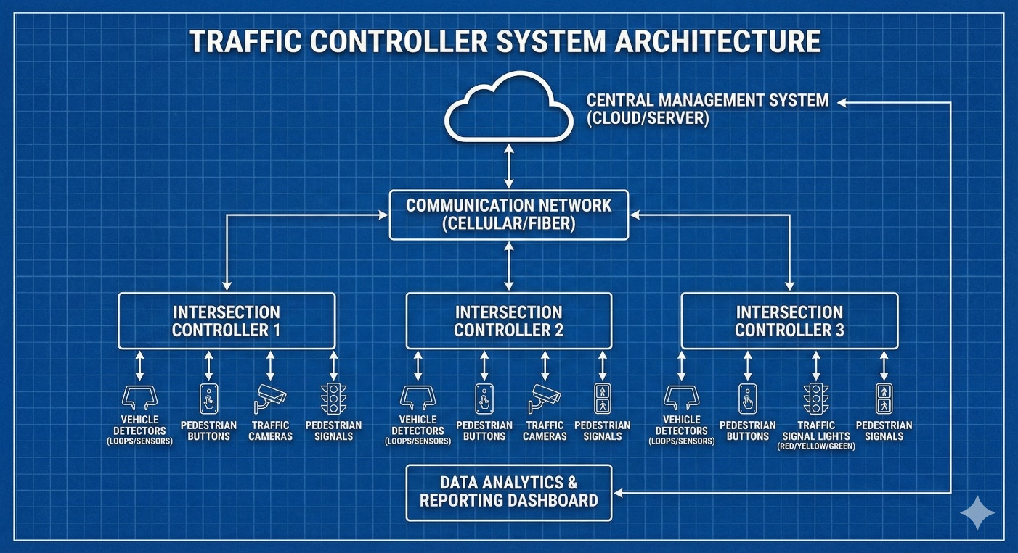

MODULE AND DATABASE DESCRIPTION:

MODULES:
- Traffic Simulation Engine Module: This is the heart of the system. It is responsible for generating vehicle entities, assigning them routes, moving them through the network based on car-following and lane-changing models, and detecting collisions or congestion. It provides the real-time data upon which all other modules act.
- Traffic Light Controller (TLC) Module: This module manages the state and timing of all traffic signals. It can operate in two modes: (1) Automated Mode, where it receives input from the Simulation Engine to dynamically adjust green phases, and (2) Manual Mode, where it accepts direct commands from the Traffic Police Module.
- Route Manager & Diversion System Module: This module handles the road network graph. It calculates optimal paths for vehicles and, crucially, contains the logic to detect congestion (e.g., average speed falling below a threshold). Upon detection, it dynamically computes alternative routes and instructs the Simulation Engine to reroute vehicles.
- Traffic Police Module: A secure subsystem that provides an interface for authenticated users to override automated control. It allows the operator to select an intersection, set specific signal states (e.g., force North-South green), and create "green corridors" for emergency vehicles by coordinating signals along a path.
- JavaFX GUI Module: This module constructs the primary operator interface. It visualizes the traffic network in real-time, displays vehicle movement, shows signal states with color codes, and provides interactive controls for the Traffic Police Module. It connects to the core Java application to send and receive data.
- JSP Web Administration Module: This module builds the web-based dashboard. It provides functionalities for system administrators to manage user accounts (Create, Read, Update, Delete), define and modify the traffic network (add intersections/roads), set default signal parameters, and generate reports on traffic flow and system usage.

SCOPE:

- Content Type: The system is designed to simulate and manage urban road traffic networks with multiple signalized intersections. Input is provided through the GUI for real-time control and a web interface for system configuration.
- Core Functionality:
  - Real-time simulation of vehicle traffic with configurable density and behavior.
  - Dynamic control of traffic signals based on simulated traffic conditions.
  - Manual override capability for traffic operator intervention.
  - Automatic diversion planning and activation during congestion.
  - User authentication and role-based access control (Admin, Operator).
  - A functional JavaFX desktop application for traffic visualization and control.
  - A functional JSP-based web dashboard for administrative tasks.
- Technical Deliverables:
  - A robust Java application serving as the simulation and control engine.
  - A JavaFX client application.
  - A JSP-based web application deployed on a Tomcat server.
  - A populated MySQL database schema.
  - Project report and documentation detailing the design, implementation, and results.
- Performance Scope: The system is designed to handle up to 1000 concurrent vehicle entities in simulation while maintaining real-time rendering at 60Hz refresh rate. It ensures sub-second response time for traffic signal adjustments and supports networks with up to 50 simultaneous intersections. The database is scoped to store 6 months of operational data with system availability of 99.5% during operational hours.
- User Access Scope: The system supports four distinct user roles: Administrator with full system access, Traffic Operator with real-time control privileges, Viewer with read-only access for monitoring, and API User for programmatic access by integrated systems and third-party applications.
- Environment Compatibility Scope: The system is compatible with Windows 10/11, Linux Ubuntu 18.04+, and macOS 10.14+ operating systems. It requires Java Runtime Environment 11 or higher and MySQL Database Server 8.0 or higher. The web dashboard supports modern web browsers including Chrome 90+, Firefox 88+, and Safari 14+.

FEATURES:

- Real-Time Traffic Simulation: Visually simulates the movement of vehicles through a user-defined network of roads and intersections, providing a dynamic and interactive model of traffic flow.
- Dynamic Signal Timing Control: Automatically adjusts the green, yellow, and red phases of traffic lights in response to the simulated real-time traffic volume, reducing wait times and improving overall flow.
- Intelligent Congestion Management: Proactively detects building congestion and automatically calculates, suggests, and implements optimal diversion routes for vehicles.
- Traffic Police Manual Override: Provides a secure, authenticated interface for traffic operators to take direct manual control of any intersection, enabling emergency response and special event management.
- Interactive JavaFX Control Panel: Offers a rich, responsive desktop interface for real-time visualization of the entire traffic network, including live vehicle tracking, signal status, and congestion hotspots.
- Comprehensive Web Admin Dashboard: Delivers a browser-based interface for system administrators to configure the traffic network, manage users, set access permissions, and view system reports.
- Platform-Independent Execution: JVM-based architecture ensures the core application and GUI run consistently on Windows, Linux, and macOS.
- Secure Role-Based Access Control: Implements robust authentication and authorization, ensuring that only authorized personnel can access the control panel or admin functions.
- Live Analytics and Performance Metrics: Displays real-time key performance indicators (KPIs) such as average wait times, vehicle throughput, and congestion levels, with historical data tracking for trend analysis and reporting.
- Emergency Vehicle Priority System: Allows for the creation of instant green corridors for emergency response vehicles, automatically adjusting signal timings along their route to ensure rapid and unobstructed passage.
- Scenario-Based Simulation Testing: Enables users to create, save, and run different traffic scenarios (e.g., rush hour, special events, road closures) to evaluate system performance and plan optimal traffic management strategies.

TOOLS AND TECHNOLOGIES:

Programming & Core Environment
- Java SE 11+: The primary programming language for the entire backend simulation engine, core business logic, and the JavaFX frontend. Chosen for its performance, robustness, and cross-platform capabilities.
Frontend & User Interface
- JavaFX: Used for building the rich, performant desktop client application for traffic operators. Provides the canvas for real-time traffic visualization and the controls for manual intervention.
- JSP (JavaServer Pages): The technology used to create the dynamic web pages for the Admin Dashboard.
- HTML5 & CSS3: For structuring and styling the web-based Admin Dashboard.
- JavaScript: To add interactivity and dynamic behavior to the web dashboard, such as updating tables and charts without refreshing the page.
Backend & Web Server
- Apache Tomcat: Serves as the servlet container and web server for deploying and running the JSP-based Admin Dashboard and handling web requests.
Database & Persistence
- MySQL: The relational database management system used for all persistent data storage, including network configuration, user management, and event logging.
- JDBC (Java Database Connectivity): The API used by the Java application to connect and execute queries on the MySQL database.
Development & Build Tools
- Eclipse / IntelliJ IDEA: The primary Integrated Development Environments (IDEs) used for Java coding, debugging, and project management.
- Maven / Gradle: Build automation and dependency management tools used to manage project libraries (like JavaFX and MySQL Connector) and the build process.
- Git: Version control system for tracking source code changes and team collaboration.
EXPECTED OUTCOMES:

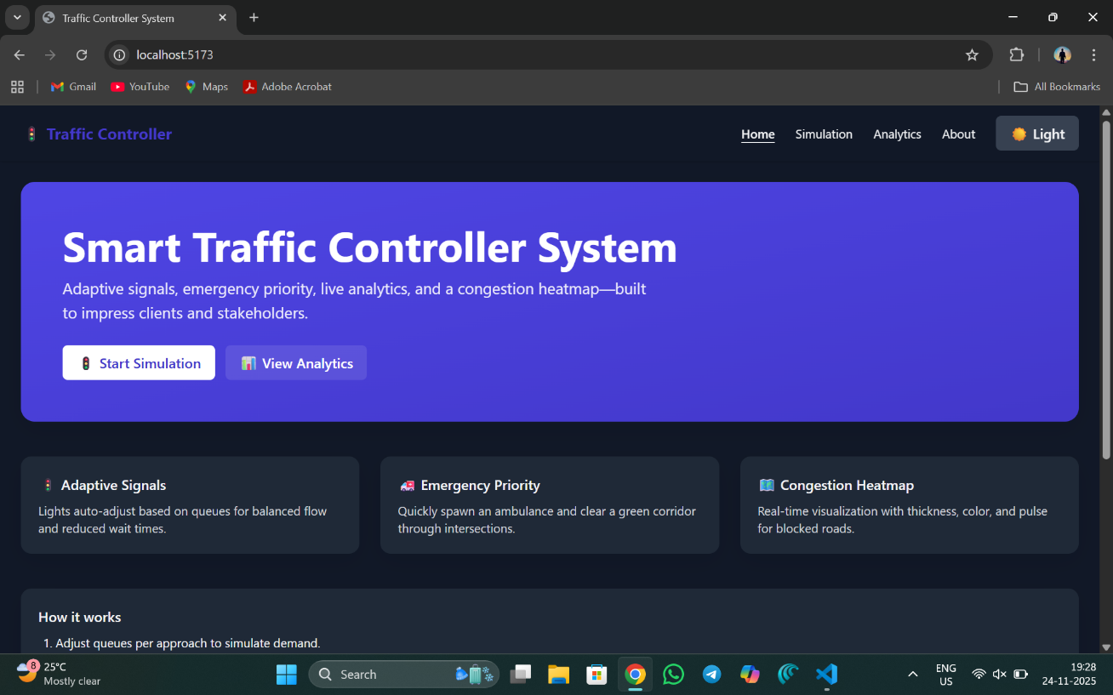

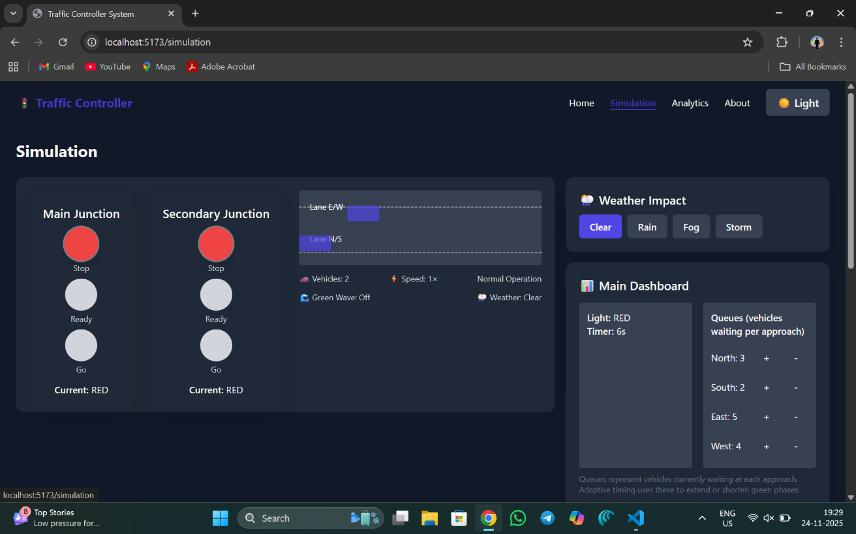

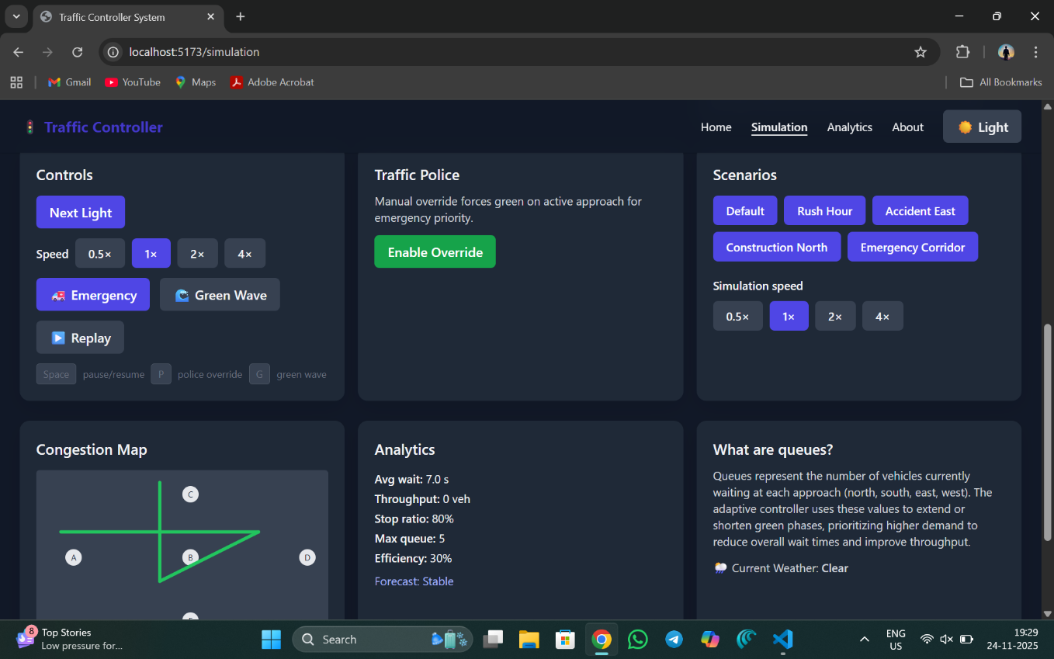

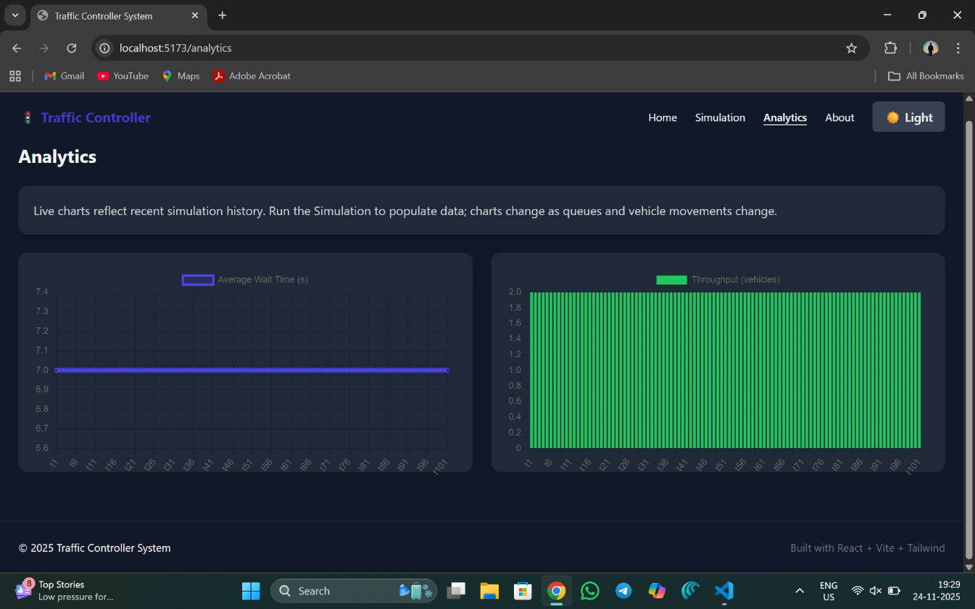

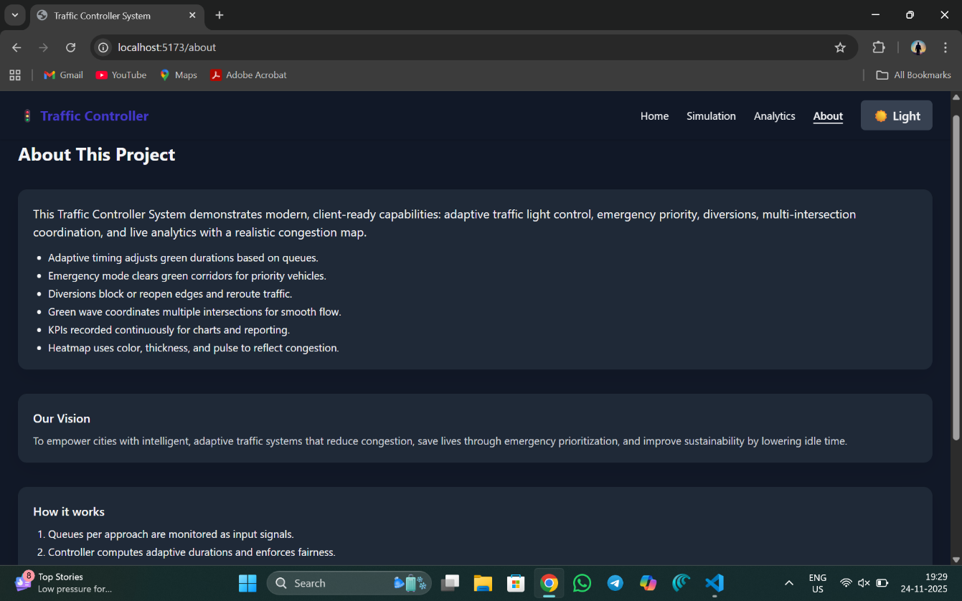

FUTURE ENHANCEMENTS:

- Real-time Data Integration with Physical Sensors: Evolve from a pure simulation to a hybrid system by integrating live data feeds from physical IoT sensors, CCTV cameras, and GPS probes to reflect real-world traffic conditions accurately.
- Mobile Application for Field Personnel: Develop a dedicated mobile application (iOS/Android) for traffic police and field engineers, allowing them to receive alerts and perform manual overrides directly from their smartphones while on the road.
- AI-Powered Predictive Traffic Analytics: Incorporate machine learning models to analyze historical traffic data and real-time flows, enabling the system to predict congestion hotspots before they form and suggest pre-emptive signal timing adjustments.
- Cloud-Native Deployment and Scalability: Refactor the architecture to be cloud-native (using microservices and containerization with Docker/Kubernetes), allowing for elastic scaling to manage traffic for very large metropolitan areas.
- Public API for Third-Party Integration: Develop a secure REST API to allow third-party applications, such as public transit apps or navigation services like Google Maps/Waze, to query traffic conditions and planned diversions from the system.
- Advanced Emergency Vehicle Preemption (EVP): Implement a sophisticated EVP system that, when an emergency vehicle is simulated or detected, automatically creates a green corridor by coordinating signals along its route, clearing the path for rapid response.
- Integration with Smart City Platforms: Design interfaces for integration with broader smart city operating systems, allowing traffic data to contribute to city-wide analytics and coordinated responses with other services like public safety and utilities.
- Enhanced Visualization with 3D Graphics: Upgrade the JavaFX client to use 3D graphics libraries for a more immersive and detailed visualization of the traffic network, useful for public presentations and advanced planning.
- Blockchain-Based Traffic Data Security: Implement distributed ledger technology to ensure secure, transparent, and tamper-proof recording of traffic data, emergency responses, and system configuration changes.
- Augmented Reality Interface for Field Operations: Create AR-enabled applications for field personnel to visualize traffic flow data, signal status, and network health indicators through wearable devices during on-site operations.

CONCLUSION:

The "Traffic Controller System" project successfully demonstrates a comprehensive and practical approach to modern traffic management challenges. By leveraging a robust, modular architecture built on the versatile Java ecosystem, it delivers a unified platform that seamlessly integrates real-time simulation, dynamic automated control, and critical manual intervention capabilities. This project effectively bridges the gap between theoretical traffic models and the operational needs of traffic management authorities.
The system's core achievement is its ability to provide a cost-effective, software-based solution that is both a powerful simulation tool for planning and a functional control system for operational use. The dual-interface design, featuring a high-performance JavaFX desktop client and an accessible JSP web dashboard, ensures that it meets the distinct needs of both traffic operators and system administrators.
Built with scalability and security in mind, the platform is poised for future evolution. The potential for integration with real-time data feeds, AI-driven predictive analytics, and mobile applications positions this project not as a final product, but as a foundational step towards the intelligent, adaptive, and resilient traffic management systems required by the smart cities of the future. In essence, this project validates the role of sophisticated software engineering in creating tangible solutions for urban mobility, enhancing efficiency, and improving response to dynamic traffic conditions.
Furthermore, this project serves as a significant benchmark in the development of Responsible and Adaptive AI for Urban Planning. By embedding real-time analytics and proactive congestion management directly into its workflow, it addresses the critical issue of static urban infrastructure, ensuring that traffic management evolves in tandem with growing cities and changing commuter patterns. The commitment to modular, scalable design ensures the system remains effective against the evolving demands of urban mobility, making it a sustainable solution rather than a temporary fix. Ultimately, the Traffic Controller System is more than a technological achievement; it is a vital tool for the creation of smarter, more livable cities. It provides a scalable, adaptable, and intelligent mechanism for municipalities, planners, and traffic authorities alike. By bridging the gap between advanced simulation research and practical, user-centric application, it lays the groundwork for a future where technology actively enhances the safety, efficiency, and sustainability of our daily commutes and urban environments.
REFERENCES:
- Papageorgiou, M., Diakaki, C., Dinopoulou, V., Kotsialos, A., & Wang, Y. (2003). Review of road traffic control strategies. Proceedings of the IEEE, 91(12), 2043-2067.
- Federal Highway Administration. (2008). Traffic Signal Timing Manual (FHWA-HOP-08-024). U.S. Department of Transportation.
- Gipps, P. G. (1981). A behavioural car-following model for computer simulation. Transportation Research Part B: Methodological, 15(2), 105-111.
- Newell, G. F. (1990). Theory of sinusoidal traffic flow. Transportation Research Part B: Methodological, 24(2), 79-85.
- Behrisch, M., Bieker, L., Erdmann, J., & Krajzewicz, D. (2011). SUMO – Simulation of Urban MObility: An Overview. In Proceedings of the Third International Conference on Advances in System Simulation (SIMUL 2011), Barcelona, Spain.
- Sanchez, J. J., Galan, J., & Rubio, A. G. (2017). Adaptive Traffic Signal Control Systems: A Survey. Journal of Transportation Engineering, 143(5).
- Abdel-Aty, M., & Eskandarian, A. (2009). Intelligent Traffic Control Systems. In Springer Handbook of Automation (pp. 1209-1226). Springer, Berlin, Heidelberg.
- Oracle Corporation. (2023). Java Platform, Standard Edition 17 Documentation. Retrieved from https://docs.oracle.com/en/java/javase/17/
- Oracle Corporation. (2023). JavaFX 17 Documentation. Retrieved from https://openjfx.io/
- Apache Software Foundation. (2023). Apache Tomcat 9 Documentation. Retrieved from https://tomcat.apache.org/tomcat-9.0-doc/
- Oracle Corporation. (2023). MySQL 8.0 Reference Manual. Retrieved from https://dev.mysql.com/doc/refman/8.0/en/
- Gamma, E., Helm, R., Johnson, R., & Vlissides, J. (1994). Design Patterns: Elements of Reusable Object-Oriented Software. Addison-Wesley Professional.
- European Commission. (2022). Intelligent Transport Systems (ITS). Retrieved from https://transport.ec.europa.eu/transport-themes/intelligent-transport-systems_en

Name of the Mentor : | Ms. Vura Tulasi Sri Siva Gayathri
Signature :

