
INSTITUTE OF AERONAUTICAL
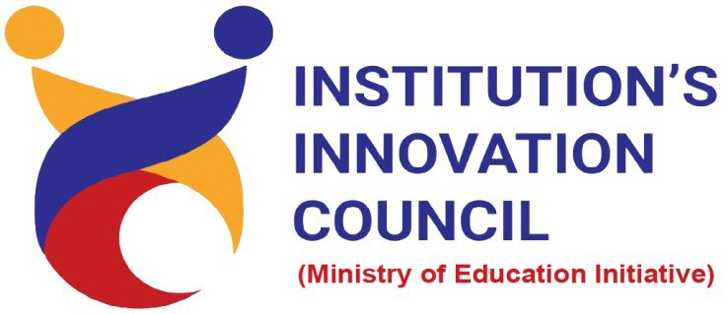

ENGINEERING
(Autonomous)
Dundigal, Hyderabad - 500 043

Engineering Design Project

Batch Number: 4
1. Student Details

Name of the Student | Roll Number | Branch | Mobile Number
M GHNANA SOUSHEEL | 24955A0509 | CSE - F | 8309781454
DINESH RATHOD | 24955A0508 | CSE -F | 8328673800

2. Title of Engineering Design Project
Fake News Detection Using NLP

3. Mentor Details

Name of the Mentor | Mr. Roopesh Kumar Thota

Abstract
This project aims to combat the growing threat of misinformation by developing an AI-powered, real-time fake news detection system that uses advanced Natural Language Processing (NLP) and machine learning techniques to automatically evaluate the authenticity of news articles and social media posts. By analyzing linguistic features and source credibility, the system delivers rapid and highly accurate predictions, supporting over 90% classification accuracy with sub-second response time. The platform is designed for scalability, multi-language support, and seamless integration, empowering users and organizations to efficiently identify and limit the spread of fake news.

