1. Familiarizing Text Editor, IDE, Code Analysis Tools etc // Use any IDE like PyCharm, PyDev…

2. Display future leap years from current year to a final year entered by user.

Program:

import datetime
date=datetime.date.today()
currentyear=int(date.strftime("%Y"))
print("Enter the Last Year:")
endyear=int(input())
print(" List of Leapyear:")
for year in range(currentyear,endyear):
if((year%4==0) and (year%100!=0) or (year%400==0)):
print (year)
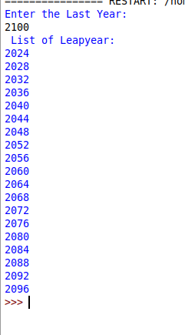
Output
3. List comprehensions: (a) Generate positive list of numbers from a given list of integers (b) Square of N numbers (c) Form a list of vowels selected from a given word (d) List ordinal value of each element of a word (Hint: use ord() to get ordinal values)

Program:

A
numbers =[34.6,-203.4,44.9,68.3,-12.2,44.6,12.7]
newlist =[n for n in numbers if n>0]
print(newlist)

B
print("Enter the limit:")
n=int(input())
squares=[i*i for i in range(n)]
print("Squares of n numbers\n",squares)

C
m=input(" enter the sentence\n")
vowels=['a','e','i','o','u']
vow=[let for let in m if let in vowels]
print(vow)

D
list1=['aravind','aparna']
print("The orginal List:\n"+str(list1))
res=[ord(ele) for sub in list1 for ele in sub]
print ("The ASCII list is :\n"+str(res))

Output:
A

B
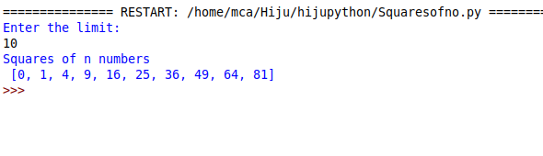
C
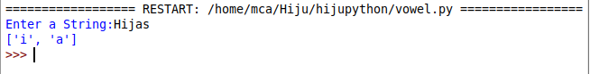

D
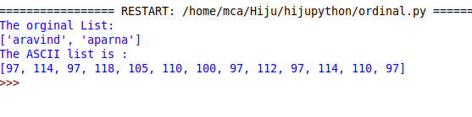

4. Count the occurrences of each word in a line of text.

Program :

line=input("Enter the line:")
counts={}
sentence=line.split()
for word in sentence:
if word in counts:
counts[word]+=1
else:
counts[word]=1
for a,m in counts.items():
print(a,m)

Output:
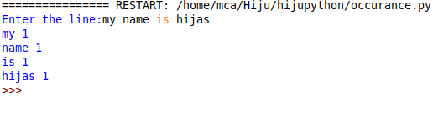

5. Prompt the user for a list of integers. For all values greater than 100, store ‘over’ instead.

Program :

list=[10,20,50,70,140]
result=[]
for i in list:
if i>100:
result.append('over')
else:
result.append(i)
print(result)

Output:

