**Assignment FOR Kudosware**

**FRONTEND**

I have used react library for making front end single page application and used the package below

* + Axios:- To fetch the data from server and post the user credential to server
  + Dotenv:- for Storing sensitive data
  + React router dom for pointing the pages
* The home page shows a basic introduction and about us page for the related HR.
* Home page also include a submit your resume link which redirect to a new page where user can upload the resume and their personal information
* On Signup page where user upload there data
  + User have to input their personal information and password (sign in page is not exist yet) and upload their resume
  + Once submitted the info will be sent to express backend and saved to mongo dB and resume uploaded to CLOUDINARY

**BACKEND**

* I have used Express framework for developing the backend using the below packages
  + EXPRESS RESTFULL API to handle the get post request from the client
  + CORS to allow the origin and headers
  + MONGOOSE to save the user input
  + BCRYPTJS to encrypt the password used have provided
  + MULTER to handle the file from client
  + CLOUDINARY to save the file uploaded by user

**Apart from the assignment, still there are a lot of the thing to be done**

* Developing a user log in page and handle the post API with backend server and use the JWT for saving the tokens in user browser so next time user logged they doesn’t have to input credentials again

Home Page: - <https://hr-page-omega.vercel.app/>

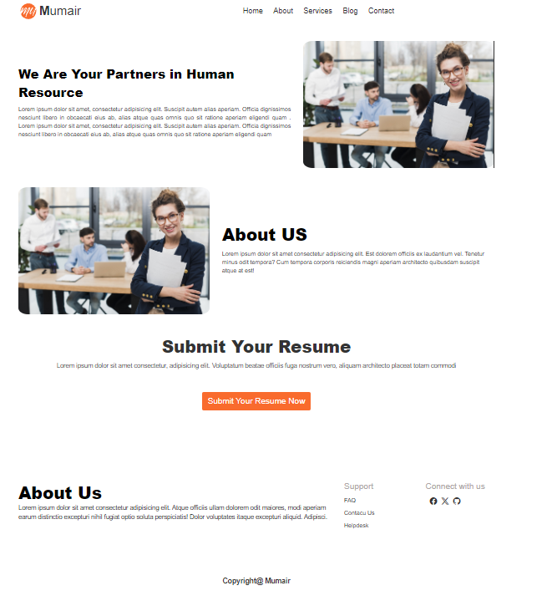

Page for upload of resume: - <https://hr-page-omega.vercel.app/signup>

