## Six Week Group Game Development Project

## Individual Project Proposal

### I. Introduction

As a group we have been tasked to develop a game within six weeks, following a brief given to us. As a group we decided to work with brief two which asks us to develop a two player, hyper-paced, synchronous adversarial game either in digital or non-digital format. The primary outcome for the brief is to make the player feel specific emotions, these emotions include frustration, fiero, schadenfreude and raucous laughter. As a group we decided on a non-digital game, the main reason behind this decision is it gives us more time to design, iterate and balance the game, and secondly, we have had positive outcomes from our previous non-digital projects.

In this individual plan I will discuss my self-management style and my own contribution for the six weeks of development. I will also present my research on the key emotion we are trying to implement into our game, this includes primary research from comparable games I have played and secondary research from journal articles, websites and books.

### II. PROJECT MANAGEMENT PLAN

**A. Expected project results and possible risks**

The overall aim of the project is to create a highly polished non-digital game that creates the emotional reaction from the player that the brief asks for.

Over the development process there is always the chance of risks, below is a risk assessment table for the possible outcomes (Appendix A)

The table shows the possible risk associated with the project. The biggest risk is not having enough play testers, without external players we will be unable to determine whether the players feel the emotions we are trying to design, additionally without external feedback we would be unable to polish the game to a high standard. The lowest risk is the tools used, as it’s a non-digital game very little software besides management tools are used so it’s the lowest risk.

**B. Individual management of project**

To track and plan my personal contribution to the project, I have created a table below to show the hours and days I plan to dedicate purely to the group project (Appendix B), I have added my other module I am currently undertaking to the table. The plan is subject to change depending on the current state of the game and time frame, as well as unforeseen instances like absent group members. I will be using Trello to set and manage task and clocify to accurately time them. I will also be following the group plan proposed by myself and the rest of the group.

I have also completed a work breakdown structure that clearly lays out the structure of the project, and the estimated time split of each aspect of the project (Appendix C)

### III. Project Research

As discussed previously in the plan I have conducted research into the primary emotions required for the brief, these emotions are frustration, fiero, Schadenfreude and raucous laughter.

**A. Frustration Definition**

The feeling of being annoyed or less confident because you cannot achieve what you want. (Dictionary, 2018)

When researching into frustration I explored the triggers that can cause it and how it can shape interaction within games. Frustration is often confused as a negative effect for a game because if it’s too frustrating players will be more likely to quit, however games that are considered to be challenging can get the players motivated to continue because of the sense of satisfaction when he or she overcomes a challenging task” (Jennett et al., 2008; Sweetser and Wyeth, 2005).

The triggers for frustration differ from person to person, a mechanics that frustrates one player may not affect another, so it can be subjective. However typically “We assume that people are frustrated when they get less reward than they expected. They then become hostile towards whomever they blame.” (Battigalli, Dufwenberg and Smith, 2018).

My primary research into frustration led me towards non-digital game called pandemic. In this game the players playing must work together to cure diseases in the game world, the frustration in this game doesn’t come from other players but from the game mechanic themselves. The way in which diseases spread in the game makes it very difficult which results in frustration, in total I played the game 4 times and lost every time.

**B. Fiero Definition**

Feeling pleasure or satisfaction at one’s achievements, possessions, connections etc (Dictionary, 2018).

When researching fiero I explored how the player should react when feeling fiero, and the triggers that that produce it. “it’s usually expressed when a player throws their arms over their head and yells!” (Humphrey, 2012). This usually occurs when a difficult boss is defeated, or a player draws a card they need to win the game.

When researching the triggers that can create fiero there was a fine line between making the player too angry with a mechanic that fiero couldn’t be achieved “It is not that anger is required to attain fiero, so much as there must be a perception of struggle” (Karpouzis and Yannakakis, 2016). With this knowledge we must make sure that the mechanics in our game do not make the player to angry, there is a fine line between making the player frustrated and angry.

A game I played that evoked fiero was the dark souls card game, the normal level monsters in the game are easy to defeat however the boss fights can be very challenging and take a long time to complete. The last boss of the game was Pontiff Sulyvahn, this boss was very difficult and took more than one attempt. Eventually he was down to a single health point and we beat the boss, that boss triggered fiero in all four players.

**C. Schadenfreude Definition**

A feeling of pleasure or satisfaction when something bad happens to someone else (Dictionary, n.d.)

When researching schadenfreude, I discovered that empathy and co-operative games counteracted schadenfreude, as the definition explains schadenfreude requires a player to feel satisfaction when another player get attacked or something negative happens to them. During my research I read an article that discusses an experiment they did on a group of players playing a game, this was their findings “In sum, our main hypotheses received initial support from the data: playing a prosocial (relative to a neutral) video game in-creased interpersonal empathy and decreased reported schadenfreude” (Greitemeyer, Osswald and Brauer, 2010).

For my primary research into schadenfreude I played a non-digital game called Munchkin, it is a single player game in which you battle monster to level up, you win if you get to level ten before your opponents. Within the deck are cards called curse, when you draw one it affects the person who drew it, you feel a sense of satisfaction when an opponent draws one of these cards.

### IV. Appendix

**Appendix A.**

|  |  |  |  |
| --- | --- | --- | --- |
| Likelihood | Impact | Combined | Risk |
| 1 | 1 | 3 | No play testers for game |
| 2 | 3 | 4 | Unable to achieve specific emotion |
| 3 | 5 | 8 | 2 Week prototype goal |
| 4 | 2 | 7 | Over scope |
| 5 | 4 | 9 | Tools used in project |

**Appendix B.**

|  |  |  |
| --- | --- | --- |
| **Day** | **Module** | **Hours Spent on Module** |
| **Monday** | Group project | 6-8 |
| **Tuesday** | Group project | 6-8 |
| **Wednesday** | Group project | 6-8 |
| **Thursday** | Dev Management | 6-8 |
| **Friday** | ILP | 8 |

Total hours on each module in a week (subject to change)

* Group project 18- 24 hours a week
* Dev management 6-8 hours a week
* ILP 8 hours a week

**Appendix C.**

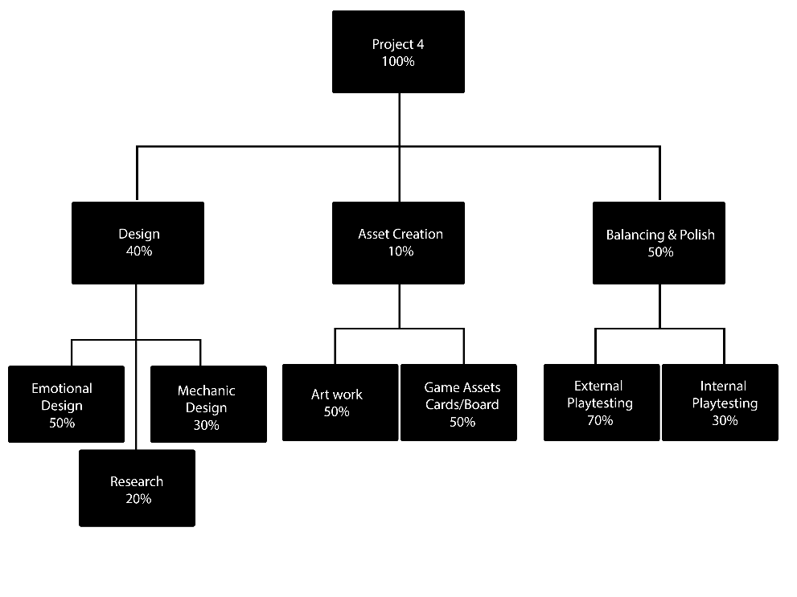

### V. Bibliography

Battigalli, P., Dufwenberg, M. and Smith, A. (2018). *Frustration and Anger in Games*. [online] pp.1-3. Available at: http://www.u.arizona.edu/~martind1/Papers-Documents/faaig.pdf [Accessed 16 Nov. 2018].

Carl, D (2017) *Darks Souls: The Card Game.* [Non-Digital Game] Steamforged Game Ltd.

Dictionary, f. (n.d.). *fiero | definition in the Italian-English Dictionary - Cambridge Dictionary*. [online] Dictionary.cambridge.org. Available at: https://dictionary.cambridge.org/dictionary/italian-english/fiero [Accessed 16 Nov. 2018].

Dictionary, F. (n.d.). *FRUSTRATION | meaning in the Cambridge English Dictionary*. [online] Dictionary.cambridge.org. Available at: https://dictionary.cambridge.org/dictionary/english/frustration [Accessed 16 Nov. 2018].

Dictionary, S. (n.d.). *Schadenfreude | meaning in the Cambridge English Dictionary*. [online] Dictionary.cambridge.org. Available at: https://dictionary.cambridge.org/dictionary/english/schadenfreude [Accessed 16 Nov. 2018].

Greitemeyer, T., Osswald, S. and Brauer, M. (2010). Playing prosocial video games increases empathy and decreases schadenfreude. *Emotion*, [online] 10(6), pp.796-802. Available at: https://pdfs.semanticscholar.org/1edb/1bf45ef616006b7f5de405cd9f02c153cb32.pdf [Accessed 20 Nov. 2018].

Humphrey, E. (2012). Flow vs. Fiero. [Blog] *Gamer Psychology 101:*. Available at: http://blog.perblue.com/2012/02/gamer-psychology-101-flow-vs-fiero.html [Accessed 20 Nov. 2018].

Jackson,S (2008) Munchkin [Non-Digital Game]. Steve Jackson Games.

Jennett, C., Cox, A., Cairns, P., Dhoparee, S., Epps, A., Tijs, T. and Walton, A. (2008). Measuring and defining the experience of immersion in games. *International Journal of Human-Computer Studies*, 66(9), pp.641-661.

Karpouzis, K. and Yannakakis, G. (2016). *Emotion in Games*. 4th ed. Springer International Publishing, pp.9-11.

Leacock, M (2008) *Pandemic* [Non-Digital Game]. Z-Man Games.

Sweetser, P. and Wyeth, P. (2005). GameFlow. *Computers in Entertainment*, [online] 3(3). Available at: http://citeseerx.ist.psu.edu/viewdoc/download?doi=10.1.1.97.480&rep=rep1&type=pdf [Accessed 16 Nov. 2018].