B 2 G P R O P O S A L
Safer Railways for Egypt
A B2G platform for accident prevention and emergency response, built on the first complete open data kit of the Egyptian National Railways
Prepared for: Egyptian National Railways (ENR) - Ministry of Transport
Data basis: Egypt Trains data kit - 903 stations, 798 trains/day, 8,320 km of track, 6,805 level crossings
Author: Railway Data and Product Research Team
Date: November 2026 Companion repo: github.com/S1951711257EG/egypt_train

For discussion - not a tender document November 2026

Table of Contents

1. Executive Summary 1
2. Context: Egypt's Railway Safety Challenge 2
2.1 A national backbone network 2
2.2 The accident record, in numbers 2
2.3 Why now: the funding and modernisation window 3
3. What We Already Hold: The Data Asset 3
3.1 Inventory and safety relevance 3
3.2 Provenance and validation status 4
3.3 Known gaps - stated plainly 4
4. Product Concepts: Six Ways This Data Prevents Accidents 4
4.1 Level-Crossing Risk Prioritization Engine 5
4.2 Timetable Safety Digital Twin 5
4.3 Emergency Response Decision Support 5
4.4 Community and Driver Crossing Alert 6
4.5 Staff Near-Miss and Incident Reporting 6
4.6 Safety Analytics and Oversight Dashboard 6
5. Recommended MVP and Go-to-Market 7
5.1 Scope: bundle Modules A and C 7
5.2 Product shape and commercial model 7
5.3 What we ask of ENR 8
6. Implementation Roadmap: The 90-Day Pilot 8
7. Risks, Data Gaps and Mitigations 9
8. Research Opinion: An Honest Assessment 9
Appendix A: Sources and References 10

Note: This Table of Contents is generated via field codes. To ensure page number accuracy after editing, please right-click the TOC and select Update Field.

1. Executive Summary
This document proposes a business-to-government (B2G) product programme for the Egyptian National Railways (ENR) built on a railway data kit that has already been extracted, decoded and validated: the full station register (4,017 records, of which 903 are physical stations), a complete national timetable (798 trains and 14,694 stop events in a single day), the decoded track geometry of the network (1,790 segments, approximately 8,320 km), and the locations of 6,805 rail-road level crossings, together with live, unauthenticated access to the official ENR ticketing API at obs.enr.gov.eg. The entire kit is committed to a public repository and can be refreshed with the accompanying tooling.
The problem it addresses is one of the most persistent in Egyptian public administration: railway safety. The national statistics agency (CAPMAS) recorded more than 21,000 train accidents between 2002 and 2019, with 1,287 deaths and 2,113 injuries, and the annual count peaked at 2,044 incidents in 2018. The three most recent mass-casualty disasters - a rear-end collision at Khorshid station, Alexandria (2017, 41-43 deaths), a truck-train collision at a level crossing on the Matruh line (2018, 44 deaths), and the Tahta, Sohag rear-end collision (2021, 18-19 deaths and roughly 200 injured) - share two characteristics: they were preventable through better prioritisation and monitoring, and, at Sohag, the first ambulances reportedly needed about half an hour to reach the scene.
We recommend a paid 90-day pilot with two modules built directly on the data kit: (A) a Level-Crossing Risk Prioritization Engine that converts the 6,805-crossing inventory into a ranked, quantified investment queue, and (B) an Emergency Response Decision Support console that answers, within seconds of an incident, which trains are within a given radius, where the nearest stations and road access points are, and what is approaching on the affected line. Both modules work today on public data alone; no proprietary ENR inputs are required for a first version.
The timing is favourable. The World Bank approved the Railway Improvement and Safety for Egypt Project in March 2021, signalling modernisation is under way, a new electrified high-speed network is being built, and the presidency acknowledged in 2018 an EGP 250 billion backlog in railway needs. What is missing is inexpensive, data-driven targeting of the highest-risk locations. Section 8 gives an honest research assessment, including the risks that are institutional rather than technical.

2. Context: Egypt's Railway Safety Challenge

2.1 A national backbone network
Egypt opened the first railway in Africa and the Middle East in 1854, between Alexandria and Kafer Eassa. Today the network is approximately 9,570 km of line according to UNECE data presented in 2014, and the World Bank described it as a 10,000 km network in 2023, with about 60 percent concentrated in the Delta and along the Nile valley, where most of the population lives. ENR is the passenger backbone of the country, operating long-distance, Delta express, suburban and special services; passenger transport historically accounts for the overwhelming majority of its physical activity.
Our own extraction is consistent with this scale: 8,320 km of decoded track geometry, 903 physical stations, and 798 scheduled trains on a single weekday. This correspondence between the app-derived dataset and published figures is an important credibility signal when presenting the data kit to government counterparts.

2.2 The accident record, in numbers
Two independent statistical trails document the scale of the safety problem. The Central Agency for Public Mobilization and Statistics (CAPMAS), as investigated by the ARIJ network, recorded more than 21,000 train accidents between 2002 and 2019, killing 1,287 people and injuring 2,113, with the annual total peaking at 2,044 incidents in 2018. Government records cited around the 2021 Sohag collision indicate nearly 11,000 accidents on rail lines between 2008 and 2017, with a high of 1,793 in 2017. Table 1 summarises three verified mass-casualty events that illustrate the two dominant categories: level-crossing collisions and rear-end collisions involving a stopped or slowing train.
Table 1: Selected verified mass-casualty rail disasters in Egypt (public reports)
Event | Date | Category | Deaths | Injured | Documented cause
Khorshid station, Alexandria | 11 Aug 2017 | Rear-end collision | 41-43 | 120-179 | One train ran into the rear of another near the suburban station
Matruh-Alexandria line | 2018 | Level-crossing collision | 44 | 33 | Truck failed to stop at a crossing and pushed vehicles into a passenger train
Tahta district, Sohag | 26 Mar 2021 | Rear-end collision | 18-19 | approx. 185-200 | Emergency brakes triggered on the leading train; the following train did not stop in time
Both categories are addressable with prioritisation, monitoring and faster response rather than exotic technology. Level-crossing deaths concentrate at a finite, enumerable set of locations - we hold a list of 6,805 of them. Rear-end exposure is computable from the timetable we already hold: for every minute of the day and every segment, the data says which trains follow which. And the response-time problem documented at Sohag is an information problem that a dispatch console can materially reduce.

2.3 Why now: the funding and modernisation window
In 2018 the presidency stated publicly that around EGP 250 billion (about USD 14 billion at the time) would be needed to fix the railway system's accumulated problems. Since then, several large programmes have moved forward: a World Bank-financed Railway Improvement and Safety for Egypt Project was approved in March 2021 with safety and service-quality objectives; the signalling system has been migrating from mechanical and relay interlocking towards electronic interlocking; and a new electrified, high-speed mainline network of roughly 2,000 km is under construction with an international consortium led by Siemens.
The practical implication for a B2G offer is straightforward: budget lines for safety infrastructure and operational modernisation already exist, and their donor-funded components require measurable safety outcomes. A data product that helps spend those budgets where they save the most lives is aligned with both national priorities and donor key performance indicators (KPIs).

3. What We Already Hold: The Data Asset

3.1 Inventory and safety relevance
The companion repository (github.com/S1951711257EG/egypt_train) contains a complete, documented data kit. Table 2 maps each asset to its role in the proposed products.
Table 2: Data kit inventory and its role in the proposed platform
Asset | Content | Scale | Role in the platform
stations_enr (csv + json) | All ENR station records from the official API: IDs, English and Arabic names, legacy codes | 4,017 records; 903 physical stations | Response staging; service and catchment mapping
timetable_2026-11-11 (csv + json) | Full national timetable for one day, stop by stop, with dwell and cumulative distance | 798 trains; 14,694 stop events | Exposure modelling; digital twin; train ETAs
rail_network (geojson) | Track geometry decoded from the app's rail_lines.bin binary | 1,790 segments; 25,188 vertices; 8,320 km | Mapping crossings to segments; network analytics
rail_road_risk + level_crossings (json) | Level-crossing OpenStreetMap way IDs (the consumer app's own crossing-alert list) | 6,805 crossings | The backbone of the risk-prioritization engine
ENR OpenAPI spec (json) | Complete OpenAPI specification of the official ENR ticketing backend | 1,451 endpoints | Automated refresh of stations and timetables
example_ticket_search (json) | Live ticket-search response with fares and seat availability | 35 journeys | Commercial context; API behaviour reference
tools/ (2 scripts) | Fetch and geocoding scripts (Python) | 2 tools | Reproducibility; refresh for any date
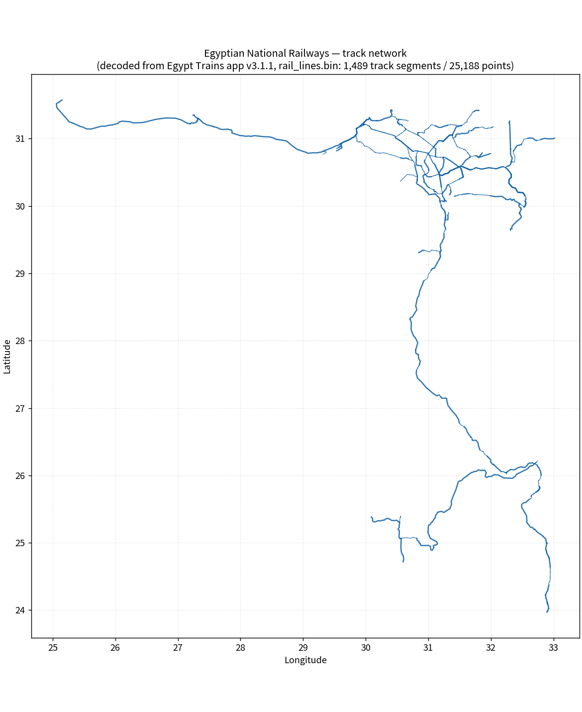
Figure 1: The decoded ENR network - 1,790 segments, approximately 8,320 km (from the data kit)

3.2 Provenance and validation status
The kit comes from two public sources. Station and timetable data were retrieved from the official ENR ticketing API (obs.enr.gov.eg), which is open and requires no authentication; the full OpenAPI specification is archived in the repository. Track geometry and the crossing list were decoded from custom binary assets inside the Egypt Trains Android application (version 3.1.1), the format of which is documented in the repository README.
The timetable's time semantics have been validated against the live system: for each train, departure minutes equal the sum of leg running times plus dwell times from the origin, and the reconstruction of train 163 (Aswan 12:30, Cairo 04:00 next day, Alexandria 07:50) matches the live ticket search exactly. No credentials, personal data or non-public documents are involved anywhere in the kit.

3.3 Known gaps - stated plainly
An honest proposal must state what the kit does not contain. First, the ENR API does not expose station coordinates, so stations need geocoding against OpenStreetMap; the provided tool does this and is designed to run outside restricted networks. Second, the crossing list consists of OpenStreetMap way IDs rather than coordinates; resolving them is a mechanical step planned in week 1 of the pilot. Third, the timetable is the planned schedule, not real-time train positions - actual operations data is not public and would have to come from ENR in a later phase. Fourth, and most importantly, official accident and near-miss records are not public; the platform's scoring is designed to work without them, but they would sharpen it considerably, and obtaining them is one of the pilot's explicit asks.

4. Product Concepts: Six Ways This Data Prevents Accidents
The following concepts were brainstormed against a single constraint: each must be buildable from the data we already hold, or from data that ENR can supply cheaply. They are ordered from most to least ready for a B2G pilot.

4.1 Level-Crossing Risk Prioritization Engine
Concept. Convert the 6,805-crossing inventory into a ranked investment queue. Each crossing is scored from two families of evidence: exposure, computed from the timetable as the number of trains passing that location per day (crossings are mapped to the nearest track segment using the decoded geometry), and context, derived from OpenStreetMap attributes of the crossing road (class, urban setting). The output is a ranked list with an auditable methodology, which ENR can use to sequence gate installations, barriers, cameras, or crossing closures.
Why it matters. Level-crossing collisions are the single deadliest recurring category - the 2018 Matruh-line event killed 44 people at one crossing. A finance ministry or donor asked to fund protection works faces exactly one question: which crossings first? Today that question appears to have no data-backed answer; this module provides one.

4.2 Timetable Safety Digital Twin
Concept. Replay the entire 798-train day deterministically on the 1,790-segment network. The twin computes headways between successive trains per segment and direction, flags minimum-headway violations and tight points, and can simulate scenarios: what happens to following traffic if a train stops here, as happened at Sohag in 2021 when emergency brakes were triggered intentionally. Sections where a stopped train is most dangerous - high-speed differentials, dense following traffic, single-track segments - can be ranked for reinforcement such as improved following-train supervision or revised timetabling.
Why it matters. Two of the three worst recent disasters were rear-end collisions into stopped or slowing trains. A twin that quantifies this exposure supports timetable review before incidents, not after.

4.3 Emergency Response Decision Support
Concept. A dispatch console that, given an incident location (km marker, segment, or nearest station), immediately shows: the nearest stations usable as helicopter or ambulance staging points; the nearest road crossings and bridges for physical access; every train within a chosen radius with its distance and estimated time of arrival, so controllers know what must be stopped; and a printable situation one-pager. The console works from the timetable and geometry alone - it does not require real-time positioning to deliver most of its value.
Why it matters. At Sohag in 2021, witnesses reported the first ambulances arrived roughly half an hour after the collision. Shortening the time from incident to informed dispatch is the cheapest way to convert deaths into injuries and injuries into survivals.

4.4 Community and Driver Crossing Alert
Concept. The consumer app from which the data kit originates already ships a crossing-alert asset (rail_road_risk.bin) used to warn users near registered crossings. Productised for government, this becomes an ENR-branded driver-warning channel or a feature inside a national navigation service, warning road users as they approach the highest-risk crossings identified by Module 4.1.
Why it matters with a caveat. This is a genuine fatality-reduction lever, but alerting the public creates liability and regulatory questions (false negatives, driver distraction, sign-off by traffic authorities). We recommend deferring it until Modules A and C are established and until ENR's legal position is clear.

4.5 Staff Near-Miss and Incident Reporting
Concept. A lightweight, geo-tagged reporting tool for drivers, crossing keepers, track crews and station staff: near-misses, blocked crossings, signalling anomalies. Reports accumulate into the same geospatial backbone, progressively replacing the missing accident-history dataset and sharpening every other module.
Why it matters. The largest analytical gap in Section 3 is the absence of official incident records. A reporting channel that ENR controls creates that dataset organically, with ENR ownership of sensitive data.

4.6 Safety Analytics and Oversight Dashboard
Concept. A KPI dashboard for the Ministry of Transport and donor reviews: accidents and near-misses per train-km by corridor, crossing remediation progress against the ranked list, headway-risk trends from the digital twin. It packages the other modules' outputs for oversight audiences.
Why it matters. Donor-funded safety projects (such as the World Bank project approved in 2021) need objective baselines and outcome measurement. This module makes the platform part of that measurement infrastructure rather than a one-off tool.
Table 3: Concept comparison for pilot selection
Concept | Fatality-impact potential | Data readiness today | Build effort | Primary buyer
A. Crossing risk prioritization | High | High - crossings, timetable and geometry ready | Medium | ENR Safety Sector; Ministry of Transport
B. Timetable digital twin | High | High | Medium-High | ENR Operations
C. Emergency decision support | High | High | Low-Medium | ENR control; civil defence; EMS
D. Driver crossing alert | Medium | Medium - needs alerting infrastructure | Medium | ENR with traffic authorities
E. Near-miss reporting | Medium | Low - needs ENR rollout | Medium | ENR Safety Sector
F. Oversight dashboard | Medium | High | Low | Ministry; donor programmes

5. Recommended MVP and Go-to-Market

5.1 Scope: bundle Modules A and C
We recommend entering with Modules A (crossing prioritization) and C (emergency decision support) as a single paid pilot. The rationale: both are buildable immediately on public data; both attack the fatality categories documented in Section 2 with the strongest evidence; C is the fastest visible win for a demonstration, while A is the most defensible procurement artefact - a concrete ranked list of 6,805 locations that a committee can act on. Module B (digital twin) is the natural phase-two extension once ENR data access is established, and Modules E and F complete the platform later.

5.2 Product shape and commercial model
Delivery is a bilingual (Arabic and English) web console with a weekly data refresh from the open API, deployable as SaaS or on ENR infrastructure. Version 1 requires nothing proprietary from ENR; version 1.1 ingests ENR-supplied accident records and crossing attributes where available. Commercially, the pilot is a fixed-fee 90-day engagement; subsequent modules are licensed annually with support and data-refresh services. Cooperation with an Egyptian university or local consultancy strengthens public-procurement standing and positions the pilot as capacity building: two or three ENR analysts are trained to run the scoring pipeline themselves.

5.3 What we ask of ENR
- A focal point in the Safety Sector with authority to validate pilot outputs.
- Access to two or three years of accident and incident records, under confidentiality agreement, to calibrate the risk model.
- The crossing attribute inventory (protection type, road class) where it exists, to replace OpenStreetMap approximations.
In exchange, ENR receives the pilot results, the full methodology, and a reusable national prioritisation asset - a trade that is easy to accept because the counterpart risk is low.

6. Implementation Roadmap: The 90-Day Pilot
Table 4 sets out the pilot plan with explicit gates. The pilot corridor for demonstration is Cairo-Aswan, the line on which the 2021 Sohag collision occurred and the country's most operationally significant route.
Table 4: 90-day pilot plan
Phase | Weeks | Activities | Deliverable | Gate
0. Preparation | 1-2 | Resolve 6,805 crossings to coordinates; assemble Cairo-Aswan corridor pack; data-quality baseline | Geo-coded crossing layer; corridor dossier | At least 90% of crossings resolved
1. Build | 3-6 | Risk model v1 on the corridor; emergency console prototype; working sessions with ENR safety staff | Live demo on real ENR data | Demo accepted by focal point
2. Operate and evaluate | 7-12 | Corridor-wide scoring; tabletop exercise with dispatch and emergency services; KPI baseline; pilot report | Pilot report and scale-up plan | Signed evaluation; decision to scale
Follow-on | 13+ | National rollout of A and C; digital twin pilot; staff reporting rollout | Framework contract | -
The team is deliberately small: two engineers, one data analyst and a part-time engagement manager. Everything in Phase 0 runs on existing tooling; the geocoder is already written and tested, and the timetable and geometry parsers are the ones that produced the data kit.

7. Risks, Data Gaps and Mitigations
Table 5 lists the material risks with the mitigations we would commit to in a pilot contract.
Table 5: Risk register
Risk | Likelihood | Impact | Mitigation
Crossing coordinates cannot be fully resolved from OpenStreetMap | Medium | High | Cached Overpass mirrors; manual resolution for the top-risk subset; ENR crossing inventory where available
ENR accident records not shared | High | High | Model works on public data alone; published disaster data as calibration seed; near-miss data accumulates via Module E
Planned timetable differs from actual operations (delays) | High | Medium | Label outputs as schedule-based exposure; integrate real-time positioning in later phases if ENR provides it
Open API availability or rate limits | Medium | Medium | Full spec and raw extracts already archived in the repository; weekly refresh script with caching
Public-procurement friction and long cycles | High | Medium | Anchor the pilot in donor-funded safety programmes; keep the pilot contract small; local partner
Risk scores stigmatise locations if published prematurely | Low | Medium | Results co-owned by ENR; no publication without ENR consent
Liability exposure from public alerting (Module D) | Medium | High | Defer public alerting; require regulatory sign-off before any public-facing warning channel
Two risks deserve emphasis. The absence of official accident records caps the precision of any risk model, which is why the pilot asks for them explicitly and why Module E exists. And procurement, not technology, is the most probable cause of delay - which is why the entry point is a small, donor-aligned pilot rather than a large system tender.

8. Research Opinion: An Honest Assessment
Feasibility. This opportunity is unusual because the hardest part - acquiring and validating the data - is already done, in the open, at national scale. Comparable projects typically spend their first year on exactly that. The remaining unknowns are institutional: will ENR engage, share records, and procure? Those are questions a small pilot answers cheaply, and nothing in the technical plan blocks on them.
The most defensible wedge is the crossing prioritization engine. A ranked, auditable list of 6,805 locations is tangible, inexpensive to produce, and matches how donors and ministries actually allocate safety budgets. The emergency response console is the fastest demonstration of value and makes the platform emotionally and politically legible: it visibly answers the question every controller asks after an incident. The weakest near-term plays are public-facing ones - driver alerting and a transparency dashboard - because liability and political sensitivity outweigh their B2G value early on; both make sense later as ENR-branded, ENR-owned tools.
Recommended validation sequence for the coming month:
- Run the crossing geocoder and measure the resolution rate; this de-risks Module A's foundation within days.
- Hold three to five conversations - ENR Safety Sector, staff of the donor-funded safety project, and emergency services - to test the problem framing and the pilot ask.
- Request two to three years of incident records under NDA; the response itself is diagnostic of ENR's appetite for data-driven work.
If all three succeed, commit to the 90-day pilot as scoped in Section 6. The single success metric that matters most: ENR adopts the ranked crossing list as a working input to its protection programme. That outcome, more than any technology, is what would make this platform part of how Egypt's railways get safer.

Appendix A: Sources and References
All external claims in this document are traceable to the sources below. Dataset figures (903 stations, 798 trains, 8,320 km, 6,805 crossings, 1,451 API endpoints) refer to the companion repository, where their extraction and validation are documented.
[1] Egypt Trains data kit repository (stations, timetable, geometry, crossings, tools) - https://github.com/S1951711257EG/egypt_train
[2] ENR official ticketing API - OpenAPI specification (obs.enr.gov.eg) - https://obs.enr.gov.eg/v3/api-docs
[3] ARIJ investigation: Train Accidents Unstoppable in Egypt (CAPMAS statistics) - https://en.arij.net/investigation/train-accidents-unstoppable-in-egypt
[4] Wikipedia: Sohag train collision (26 March 2021) - https://en.wikipedia.org/wiki/Sohag_train_collision
[5] Al Jazeera: Egypt revises death toll from train crash to 19 (27 March 2021) - https://www.aljazeera.com/news/2021/3/27/egypt-buries-train-crash-dead-toll-revised-to-19
[6] Wikipedia: Alexandria train collision (11 August 2017) - https://en.wikipedia.org/wiki/Alexandria_train_collision
[7] BBC News: Egypt trains collide in Alexandria killing dozens (11 August 2017) - https://www.bbc.com/news/world-middle-east-40903723
[8] Wikipedia: List of rail accidents in Egypt (Matruh-Alexandria level-crossing collision, 44 deaths) - https://en.wikipedia.org/wiki/List_of_rail_accidents_in_Egypt
[9] World Bank: In Egypt, Safer and More Efficient Railways Will Bring Wide-Ranging Benefits for Development (14 November 2023) - https://www.worldbank.org/en/news/feature/2023/11/14/in-egypt-safer-and-more-efficient-railways-will-bring-wide-ranging-benefits-for-development
[10] Railway PRO: WB loan for Egypt rail service quality improvement (9 March 2021) - https://www.railwaypro.com/wp/wb-loan-for-egypt-rail-service-quality-improvement
[11] UNECE: Egyptian National Railway at a glance (2014 workshop presentation) - https://unece.org/DAM/trans/doc/2014/sc2/SC2-Workshop-2014-Pres02e.pdf
[12] IDE-JETRO: Egyptian National Railways (ENR) company profile - https://www.ide.go.jp/English/Data/Africa_file/Company/egypt03.html

