REAL XGBOOST TRAINING REPORT
Flood and Landslide XGBoost V1.0 retrained on the real Kerala district-day Master Dataset
12 September 2026 · models/real/ · generated by updated_data/scripts/14_real_xgboost_training_report.py
Item | Result
What changed | ml/flood_xgboost.py and ml/landslide_xgboost.py gained a --dataset {real, synthetic} switch (default real) and --output-dir. Real artifacts go to models/real/. Model, features, split, parameters and metrics are unchanged. District is declared an identifier and forbidden as a feature; a post-training assertion checks the booster's feature list.
Synthetic V1.0 | Still reproducible: --dataset synthetic regenerates all 10 committed ml/ artifacts byte for byte (verified into a scratch folder). The committed synthetic models, the synthetic dataset, backend, frontend, TCDL and SHAP are untouched.
Flood (test) | ROC-AUC 0.866 (95 % CI 0.84–0.90), PR-AUC 0.075 vs base rate 0.0124; recall 0.89, precision 0.037 at 0.50 (123 positives)
Landslide (test) | ROC-AUC 0.954 (95 % CI 0.86–0.98), PR-AUC 0.016 vs base rate 0.0008; 5 of 8 positives found — only 8 test positives on 4 dates: NOT a reliable test estimate
Final validation | 35 checks, 35 PASS, 0 FAIL (models/real/REAL_MODEL_VALIDATION.csv)

1. Dataset used
updated_data/master_dataset/real_master_dataset.csv — 66,080 rows × 23 columns: 14 Kerala districts × 4,720 days (2012-01-30 → 2024-12-31); built by updated_data/scripts/13_build_master_dataset.py (87 checks, 0 FAIL). Documentation: REAL_DATA_DICTIONARY.md, MASTER_DATASET_REPORT.docx.

Synthetic vs real Master Dataset (column by column)
Column | Syn type | Real type | Syn NaN | Real NaN | Syn uniq | Real uniq | Difference that matters
date | date | date | 0 | 0 | 1096 | 4,720 | Split key only. Real: 4,720 days; synthetic: 1,096.
latitude | float | float | 0 | 0 | 9 | 14 | Metadata. Real: 14 district points; synthetic: 9 cells.
longitude | float | float | 0 | 0 | 9 | 14 | Metadata (as latitude).
rainfall_1d_mm | float | float | 0 | 0 | 660 | 41,535
rainfall_3d_mm | float | float | 0 | 0 | 1189 | 49,113
rainfall_7d_mm | float | float | 0 | 0 | 1827 | 52,355
rainfall_14d_mm | float | float | 0 | 0 | 2567 | 54,205
rainfall_30d_mm | float | float | 0 | 0 | 3655 | 55,843
soil_moisture | float | float | 0 | 0 | 3457 | 77 | Same name, different quantity: real = NASA POWER GWETROOT saturation fraction (2 decimals, 77 distinct values); synthetic = volumetric content.
temperature_c | float | float | 0 | 0 | 208 | 1,266
humidity_percent | float | float | 0 | 0 | 583 | 4,998
elevation_m | float | float | 0 | 0 | 9 | 14 | Static per location: 14 distinct values = one per district, so it identifies the district.
river_level_m | float | float | 0 | 25,738 | 2307 | 11,567 | Real: stage relative to the gauge's training median (can be negative) and 38.9 % NaN (no gauge / before 2015 / no reading) -> passed to XGBoost as missing.
distance_to_river_km | float | float | 0 | 0 | 9 | 14 | Static per district (14 values).
drainage_density | float | float | 0 | 0 | 9 | 14 | Static per district (14 values); real range much narrower.
slope_degree | float | float | 0 | 0 | 9 | 14 | Static per district; district means, so the range is narrow (1.2–14.6°).
aspect_degree | float | float | 0 | 0 | 9 | 13 | Static per district (13 distinct).
curvature | float | float | 0 | 0 | 9 | 13 | Static per district; district means are ~0 (|c| < 0.002).
land_cover | str | str | 0 | 0 | 5 | 1 | Real: 'forest' in all 14 districts -> constant; the model cannot use it (gain 0).
lithology | str | str | 0 | 0 | 6 | 2 | Real: 2 of 6 classes (granite_gneiss x13, alluvium x1).
flood | int | int | 0 | 0 | 2 | 2 | Real: 4.73 % positive, falling from 5.97 % (train) to 1.24 % (test). Synthetic: 7.98 %.
landslide | int | int | 0 | 0 | 2 | 2 | Real: 0.17 % positive (114 district-days). Synthetic: 7.34 %.
district | absent | str | – | 0 | – | 14 | Real only. Identifier / mapping column; declared forbidden as a feature; ignored by the model.

Columns in both: all 22 synthetic columns (same names, same order). Only in real: district (after longitude). Only in synthetic: none. Dates are ISO strings in both and parsed by read_csv(parse_dates=['date']). Consequences for the pipeline: (1) the extra district column is ignored because features are selected by explicit lists; (2) river_level_m has NaN — handled natively by XGBoost, no code change needed; (3) land_cover/lithology values stay inside the fixed CATEGORY_SCHEMA; (4) targets are int 0/1 without NaN; (5) the split, computed on unique dates, lands exactly on the agreed boundaries. None required a change to the features or the model.

2. Features and targets
Model | Target | Features (in model order) | Not features
Flood | flood (0/1) | rainfall_1d_mm, rainfall_3d_mm, rainfall_7d_mm, rainfall_14d_mm, rainfall_30d_mm, soil_moisture, temperature_c, humidity_percent, elevation_m, river_level_m, distance_to_river_km, drainage_density | landslide, district, date, latitude, longitude, landslide-specific terrain, categoricals
Landslide | landslide (0/1) | rainfall_1d_mm, rainfall_3d_mm, rainfall_7d_mm, rainfall_14d_mm, rainfall_30d_mm, soil_moisture, temperature_c, humidity_percent, elevation_m, slope_degree, aspect_degree, curvature, land_cover, lithology (land_cover, lithology categorical) | flood, river_level_m, distance_to_river_km, drainage_density, district, date, latitude, longitude

Feature definitions are the V1.0 lists, unchanged. The real data dictionary shows land_cover is constant and lithology near-constant; that makes them useless (gain 0) but not harmful, so no change was necessary. Target definitions: flood = IMD-reported damaging flood/heavy-rain district-day (0 = not reported); landslide = exact-dated GSI / IMD landslide record (presence-only).

3. Preprocessing, split, missing values, configuration
- Preprocessing — none fitted. No scaling (trees are scale-invariant), no imputation, no rows dropped. land_cover/lithology bound to the fixed CATEGORY_SCHEMA (pandas CategoricalDtype, XGBoost native categorical, no one-hot).
- Split — chronological_split(): 70/15/15 on unique dates, no shuffling. train 2012-01-30 → 2021-02-14 (46,256 rows) · validation 2021-02-15 → 2023-01-23 (9,912 rows) · test 2023-01-24 → 2024-12-31 (9,912 rows). Both scripts cut identically (landslide script cross-checks the flood results of the same dataset).
- Missing river_level_m — the V1.0 code already passes NaN to XGBoost (XGBClassifier missing = NaN, tree_method = hist): each split learns a default branch for missing values from the TRAINING rows, so no statistic from validation/test is used and nothing is invented. Imputation was therefore not needed. river_level_m NaN: train 21,110 (45.6 %) · validation 2,480 (25.0 %) · test 2,148 (21.7 %). Landslide features have no NaN.
- Leakage — no feature uses future data: rainfall sums are trailing windows ending on day t; river_level_m subtracts a median computed from training dates only (build validation V078–V080); scale_pos_weight from training labels only; early stopping on validation; the test split is used only for final scoring.
- XGBoost (V1.0, unchanged) — objective binary:logistic, eval_metric aucpr, n_estimators 500 with early stopping 50 on validation, learning_rate 0.05, max_depth 5, min_child_weight 2, subsample 0.85, colsample_bytree 0.85, reg_lambda 1.0, random_state 42; landslide adds enable_categorical, max_cat_to_onehot 1. scale_pos_weight (train neg/pos): flood 15.76, landslide 485.91. Decision threshold fixed at 0.50.

4. Flood XGBoost — real data
Split | Rows | Positives | Precision (95 % CI) | Recall (95 % CI) | F1 | ROC-AUC (95 % CI) | PR-AUC (95 % CI) | Base rate | Confusion matrix @0.50
train | 46,256 | 2,760 (512 dates) | 0.184 (0.18–0.19) | 0.893 (0.88–0.90) | 0.305 | 0.899 | 0.406 | 0.0597 | TN 32,557 FP 10,939 FN 296 TP 2464
validation | 9,912 | 242 (72 dates) | 0.054 (0.05–0.06) | 0.810 (0.76–0.85) | 0.101 | 0.819 (0.78–0.85) | 0.103 (0.06–0.16) | 0.0244 | TN 6,228 FP 3,442 FN 46 TP 196
test | 9,912 | 123 (37 dates) | 0.037 (0.03–0.04) | 0.894 (0.83–0.94) | 0.072 | 0.866 (0.84–0.90) | 0.075 (0.04–0.13) | 0.0124 | TN 6,961 FP 2,828 FN 13 TP 110

Early stopping kept 9 trees. Accuracy is not shown as a headline: with base rates of 1.24 % a model predicting 'no event' everywhere would score 98.8 % on test. PR-AUC should be read against the base rate. CIs: Wilson for precision/recall; date-clustered bootstrap for ROC/PR-AUC.
Ranking used on validation / test | ROC-AUC val | PR-AUC val | ROC-AUC test | PR-AUC test
XGBoost (flood) | 0.819 | 0.103 | 0.866 | 0.075
Reference: training district rate (no model) | 0.544 | 0.031 | 0.563 | 0.017
Reference: training calendar-month rate (no model) | 0.445 | 0.023 | 0.683 | 0.022
Reference: training district x month rate (no model) | 0.486 | 0.025 | 0.696 | 0.023

Feature | Gain | Share | Splits
rainfall_14d_mm | 1087.2 | 33.7 % | 184
rainfall_7d_mm | 400.0 | 12.4 % | 98
rainfall_30d_mm | 297.4 | 9.2 % | 206
river_level_m | 238.6 | 7.4 % | 250
rainfall_3d_mm | 217.1 | 6.7 % | 107
drainage_density | 200.7 | 6.2 % | 148
rainfall_1d_mm | 192.2 | 6.0 % | 68
soil_moisture | 178.1 | 5.5 % | 224
elevation_m | 122.1 | 3.8 % | 102
humidity_percent | 103.4 | 3.2 % | 177
temperature_c | 97.0 | 3.0 % | 129
distance_to_river_km | 91.4 | 2.8 % | 52

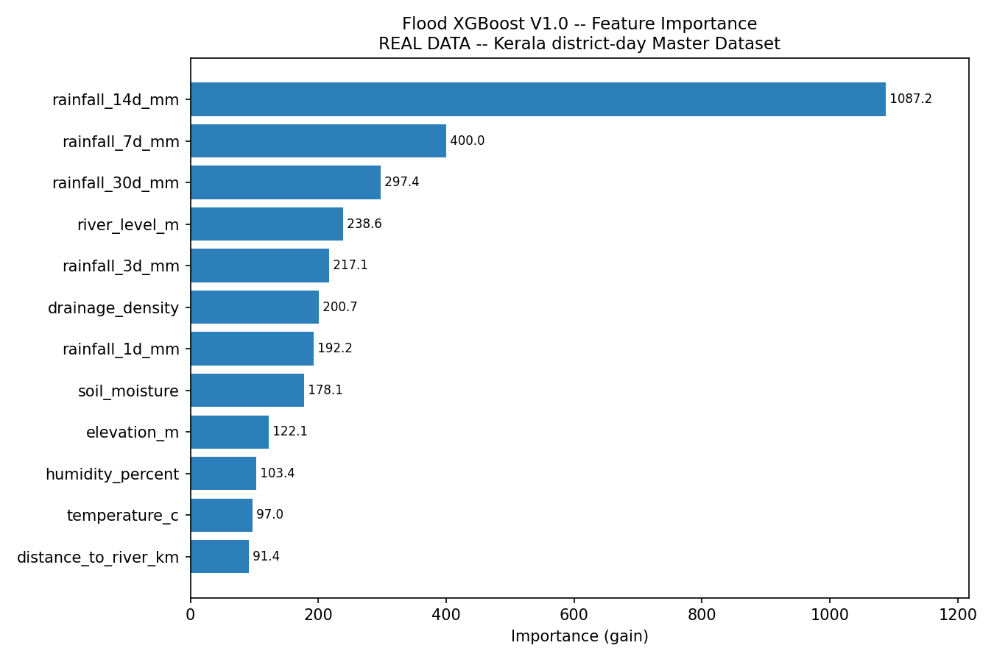
Read with care: (1) the positive rate falls from 5.97 % (train) to 2.44 % and 1.24 %: 1,416 training positives come only from IMD's 2013/2015/2018 multi-week summary periods (e.g. all 14 districts, 29 May–30 Aug 2018), which have no counterpart later. Validation PR-AUC peaked after a handful of trees, so early stopping kept a very small model (9 trees). (2) scale_pos_weight inflates probabilities (mean predicted 0.43 vs observed 0.012 on test), so at the fixed 0.50 threshold the model flags 30 % of test district-days: high recall, precision 3.7 %. (3) Ranking skill above the 'district × month' reference is the part attributable to the weather features; river_level_m is used, but its absence also marks three districts and the pre-2015 years.

5. Landslide XGBoost — real data
Split | Rows | Positives | Precision (95 % CI) | Recall (95 % CI) | F1 | ROC-AUC (95 % CI) | PR-AUC (95 % CI) | Base rate | Confusion matrix @0.50
train | 46,256 | 95 (47 dates) | 0.057 (0.05–0.07) | 1.000 (0.96–1.00) | 0.107 | 0.997 | 0.403 | 0.0021 | TN 44,579 FP 1,582 FN 0 TP 95
validation | 9,912 | 11 (9 dates) | 0.012 (0.01–0.03) | 0.545 (0.28–0.79) | 0.023 | 0.856 (0.67–0.96) | 0.036 (0.00–0.14) | 0.0011 | TN 9,393 FP 508 FN 5 TP 6
test | 9,912 | 8 (4 dates) | 0.016 (0.01–0.04) | 0.625 (0.31–0.86) | 0.031 | 0.954 (0.86–0.98) | 0.016 (0.00–0.04) | 0.0008 | TN 9,597 FP 307 FN 3 TP 5

Early stopping kept 72 trees. Accuracy is not shown as a headline: with base rates of 0.08 % a model predicting 'no event' everywhere would score 99.9 % on test. PR-AUC should be read against the base rate. CIs: Wilson for precision/recall; date-clustered bootstrap for ROC/PR-AUC.
Ranking used on validation / test | ROC-AUC val | PR-AUC val | ROC-AUC test | PR-AUC test
XGBoost (landslide) | 0.856 | 0.036 | 0.954 | 0.016
Reference: training district rate (no model) | 0.659 | 0.003 | 0.773 | 0.002
Reference: training calendar-month rate (no model) | 0.715 | 0.002 | 0.806 | 0.003
Reference: training district x month rate (no model) | 0.732 | 0.005 | 0.659 | 0.002

Feature | Gain | Share | Splits
humidity_percent | 1042.9 | 21.1 % | 349
rainfall_3d_mm | 696.6 | 14.1 % | 257
rainfall_30d_mm | 695.3 | 14.0 % | 284
rainfall_1d_mm | 463.0 | 9.4 % | 232
elevation_m | 351.8 | 7.1 % | 160
curvature | 336.0 | 6.8 % | 45
rainfall_14d_mm | 277.9 | 5.6 % | 182
rainfall_7d_mm | 256.8 | 5.2 % | 164
slope_degree | 238.9 | 4.8 % | 50
temperature_c | 229.9 | 4.6 % | 194
soil_moisture | 214.2 | 4.3 % | 139
aspect_degree | 146.8 | 3.0 % | 49
land_cover | 0.0 | 0.0 % | 0
lithology | 0.0 | 0.0 % | 0

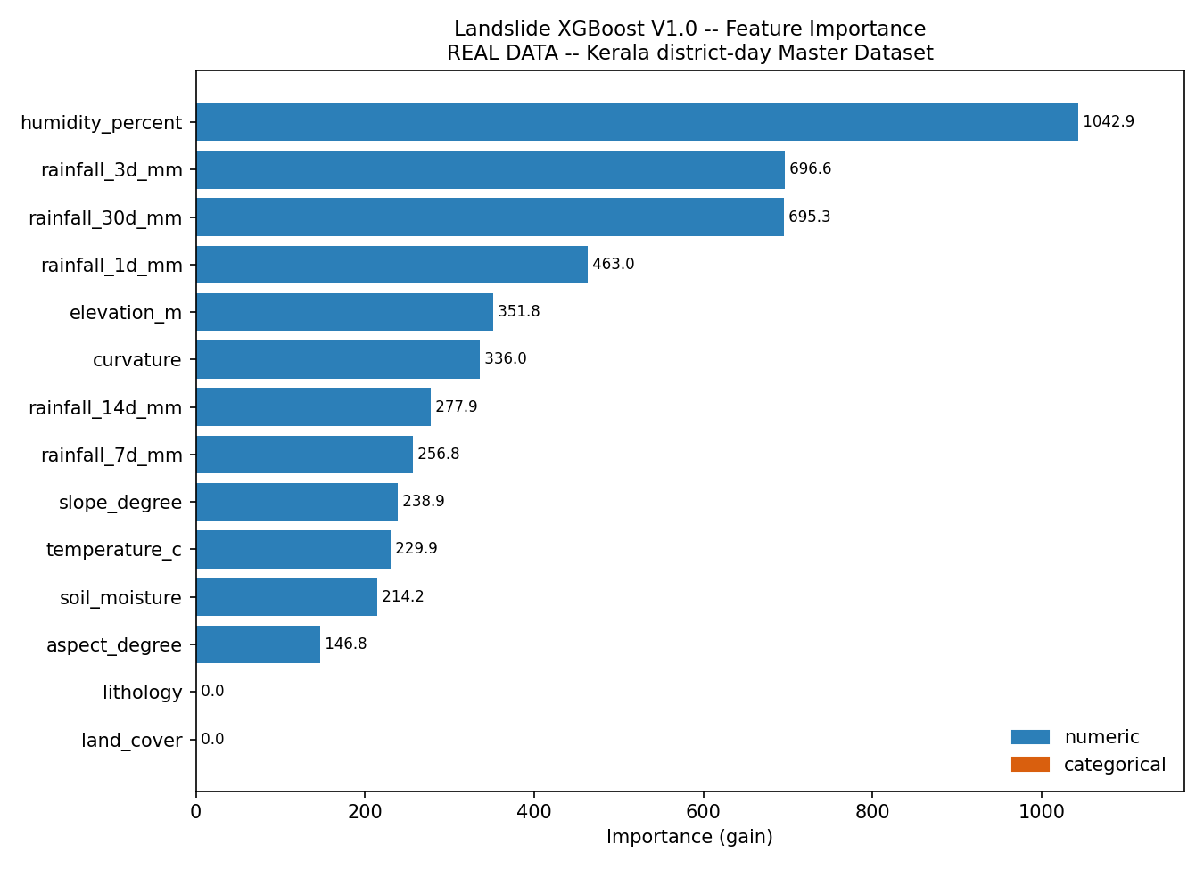
TEST RELIABILITY WARNING — the test split contains only 8 landslide district-days on 4 dates (2024-07-14 Idukki; 2024-07-29 Kozhikode, Palakkad; 2024-07-30 Idukki, Kozhikode, Palakkad, Wayanad; 2024-08-29 Palakkad); 6 of them fall on one storm's two consecutive days. The test metrics therefore describe only a handful of independent events: recall 0.62 is 5 of 8 (95 % CI 0.31–0.86); one event more or less would move ROC-AUC and PR-AUC substantially (bootstrap ROC-AUC CI 0.86–0.98, PR-AUC CI 0.00–0.04). Validation has 11 positives and also drives early stopping. Training fit is near-perfect (ROC-AUC 0.997, recall 1.00) on 95 positives, dominated by the August 2018 and 2019 events — a sign of memorisation. land_cover and lithology received zero gain; the terrain features are one value per district, so their importance mostly encodes which districts (Idukki, Wayanad, …) had recorded landslides. These numbers must not be reported as landslide-prediction skill.

6. Comparison with the synthetic-data models
Model | Dataset | Train | Validation | Test | Important difference
Flood XGBoost | Synthetic | ROC 0.947 · PR 0.750 · F1 0.585 · pos 530 | ROC 0.891 · PR 0.735 · F1 0.546 · pos 129 | ROC 0.874 · PR 0.663 · F1 0.534 · pos 128 | 9 simulated cells, labels drawn from the features (7.98 % positive); no gaps.
Flood XGBoost | Real | ROC 0.899 · PR 0.406 · F1 0.305 · pos 2760 | ROC 0.819 · PR 0.103 · F1 0.101 · pos 242 | ROC 0.866 · PR 0.075 · F1 0.072 · pos 123 | IMD-reported events; base rate falls 5.97 → 1.24 %; river_level_m 39 % NaN; tiny early-stopped model.
Landslide XGBoost | Synthetic | ROC 0.963 · PR 0.762 · F1 0.595 · pos 492 | ROC 0.925 · PR 0.719 · F1 0.557 · pos 121 | ROC 0.909 · PR 0.669 · F1 0.506 · pos 111 | Labels drawn from the features, 111 test positives.
Landslide XGBoost | Real | ROC 0.997 · PR 0.403 · F1 0.107 · pos 95 | ROC 0.856 · PR 0.036 · F1 0.023 · pos 11 | ROC 0.954 · PR 0.016 · F1 0.031 · pos 8 | 8 test positives on 4 dates; static terrain = district identity; train fit ≈ perfect.

The numbers are not comparable as a contest. The synthetic labels are generated from the same features the model sees, so high scores there only show that the pipeline can learn a planted signal. Real labels are reports of damaging events at district level: absence of a report is not absence of an event, the static features cannot separate places within a district, and the flood label changes character over time. Real PR-AUC values are low in absolute terms but must be read against base rates 6–100× lower than in the synthetic file; the real landslide test ROC-AUC is higher than the synthetic one, yet it rests on 8 positives on 4 dates and a strong district/season prior (calendar month alone ranks the test set at ROC-AUC 0.806) and is the least trustworthy number in this report.

7. Limitations
- District-day unit: 14 locations. Every static feature (elevation, slope, aspect, curvature, distance to river, drainage density) is a district identifier in disguise; importances of static features are not process evidence.
- Landslide target: 114 positives in total, 8 in test on 4 dates, 11 in validation; presence-only. Test metrics are anecdotal; validation-based early stopping is noisy.
- Flood target: LONG_PERIOD_SUMMARY periods (1,416 training positives) mark whole seasons, inflating the training positive rate and blurring what a 'flood day' is; 0 = not reported by IMD.
- Probabilities are not calibrated (scale_pos_weight, as in V1.0) and the 0.50 threshold is not tuned — both matter before the TCDL consumes these outputs.
- river_level_m missingness is structured (3 districts, pre-June-2015 for 7 more), so 'missing' is partly a district/period marker; one gauge represents a whole district.
- Same-day features: rainfall, humidity, temperature and soil wetness of day t are used to score day t (as in V1.0) — a nowcast, not a forecast; lead time is not evaluated here.

8. Model files
Path | Content
models/real/flood_xgboost_model.json | flood booster (trees up to best iteration)
models/real/flood_features.json | flood feature order + metadata
models/real/flood_model_results.json | flood metrics, split, parameters, importance
models/real/flood_test_predictions.csv | flood test probabilities (with district)
models/real/flood_feature_importance.png | flood importance plot
models/real/flood_training_log.txt | flood console log
models/real/landslide_xgboost_model.json | landslide booster
models/real/landslide_features.json | landslide feature order + category schema
models/real/landslide_model_results.json | landslide metrics, split, parameters, importance
models/real/landslide_test_predictions.csv | landslide test probabilities (with district)
models/real/landslide_feature_importance.png | landslide importance plot
models/real/landslide_training_log.txt | landslide console log
models/real/REAL_MODEL_VALIDATION.csv | final validation checks (this report, §9)
models/real/real_evaluation_supplement.json | bootstrap CIs, Wilson CIs, reference rankings
ml/*.json, ml/*.csv, ml/*.png | synthetic V1.0 artifacts — unchanged, still used by backend/TCDL/SHAP

Re-train: python ml/flood_xgboost.py && python ml/landslide_xgboost.py (real, default). Synthetic V1.0: add --dataset synthetic. Then python updated_data/scripts/14_real_xgboost_training_report.py.

9. Final validation
ID | Check | Observed | Status
R01 | flood: model trained and saved in models/real/ | 9 trees | PASS
R02 | flood: real artifacts are separate from the synthetic ones | models\real\flood_xgboost_model.json | PASS
R03 | flood: results file records the real dataset | real_master_dataset.csv | PASS
R04 | flood: booster features = features.json feature_order = code list | rainfall_1d_mm|rainfall_3d_mm|rainfall_7d_mm|rainfall_14d_mm|rainfall_30d_mm|soil_moisture|temp… | PASS
R05 | flood: every feature is a column of the real Master Dataset | all present | PASS
R06 | flood: no identifier, date, coordinate or target in the features | none | PASS
R07 | flood: chronological split boundaries | train 2012-01-30..2021-02-14 | validation 2021-02-15..2023-01-23 | test 2023-01-24..2024-12-31 | PASS
R08 | flood: no date in more than one split, train < validation < test | disjoint, ordered | PASS
R09 | flood: scale_pos_weight computed from training labels only | 15.7594 | PASS
R10 | flood: no feature column equals the target | none | PASS
R11 | flood: reloaded model reproduces the reported train ROC-AUC | 0.899390 | PASS
R12 | flood: reloaded model reproduces the reported validation ROC-AUC | 0.819412 | PASS
R13 | flood: reloaded model reproduces the reported test ROC-AUC | 0.865661 | PASS
R14 | flood: saved test predictions carry district (mapping) and match the model | 9912 rows, columns date|latitude|longitude|district|actual_flood|flood_probability|flood_predic… | PASS
R15 | flood: river_level_m NaN passed to XGBoost unchanged (recorded per split = dataset) | train 21110 | validation 2480 | test 2148 | PASS
R16 | flood: trees route missing river_level_m through learned default branches | 51 splits on river_level_m; 2148 test rows with NaN scored | PASS
R17 | landslide: model trained and saved in models/real/ | 72 trees | PASS
R18 | landslide: real artifacts are separate from the synthetic ones | models\real\landslide_xgboost_model.json | PASS
R19 | landslide: results file records the real dataset | real_master_dataset.csv | PASS
R20 | landslide: booster features = features.json feature_order = code list | rainfall_1d_mm|rainfall_3d_mm|rainfall_7d_mm|rainfall_14d_mm|rainfall_30d_mm|soil_moisture|temp… | PASS
R21 | landslide: every feature is a column of the real Master Dataset | all present | PASS
R22 | landslide: no identifier, date, coordinate or target in the features | none | PASS
R23 | landslide: chronological split boundaries | train 2012-01-30..2021-02-14 | validation 2021-02-15..2023-01-23 | test 2023-01-24..2024-12-31 | PASS
R24 | landslide: no date in more than one split, train < validation < test | disjoint, ordered | PASS
R25 | landslide: scale_pos_weight computed from training labels only | 485.9053 | PASS
R26 | landslide: no feature column equals the target | none | PASS
R27 | landslide: reloaded model reproduces the reported train ROC-AUC | 0.996505 | PASS
R28 | landslide: reloaded model reproduces the reported validation ROC-AUC | 0.855937 | PASS
R29 | landslide: reloaded model reproduces the reported test ROC-AUC | 0.954337 | PASS
R30 | landslide: saved test predictions carry district (mapping) and match the model | 9912 rows, columns date|latitude|longitude|district|actual_landslide|landslide_probability|land… | PASS
R31 | landslide: feature set has no missing value | 0 | PASS
R32 | district is in no feature list of either script | none | PASS
R33 | district is declared an identifier (forbidden as a feature) in both scripts | yes | PASS
R34 | synthetic dataset and synthetic model artifacts identical to git HEAD | no change | PASS
R35 | the backend still points at the synthetic artifacts (not integrated yet) | yes | PASS

10. Open issues before TCDL
- Calibrate probabilities (e.g. on validation) and choose thresholds deliberately; V1.0 probabilities are inflated by scale_pos_weight.
- Decide on LONG_PERIOD_SUMMARY flood days (sensitivity run with flood_long_period_only from the keys file).
- Landslide: more exact-dated events are needed (GSI Bhukosh inventory) before any landslide or coupled metric can be reported; consider event-level rather than district-day evaluation.
- TCDL derives event onsets from runs of consecutive label days; 2018 summary periods would become single 64/30-day 'events'. Review before coupling.
- Point TCDL, SHAP and the backend at models/real/ only when integration is intended (their paths still target ml/).

