Screenshot 1 — Dataset Admin

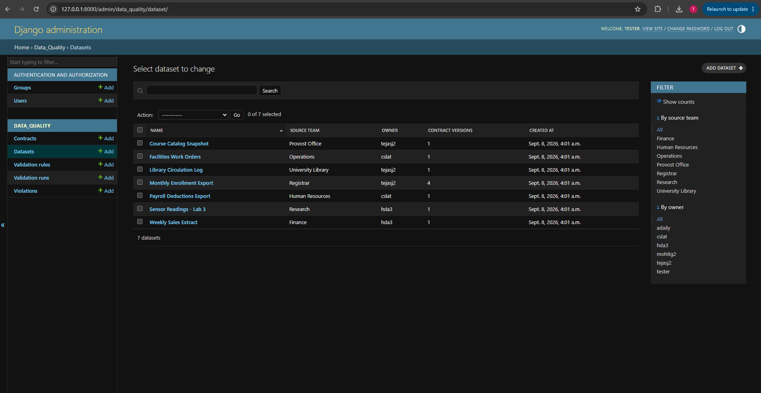

Screenshot 2 — Dataset with inline Contracts

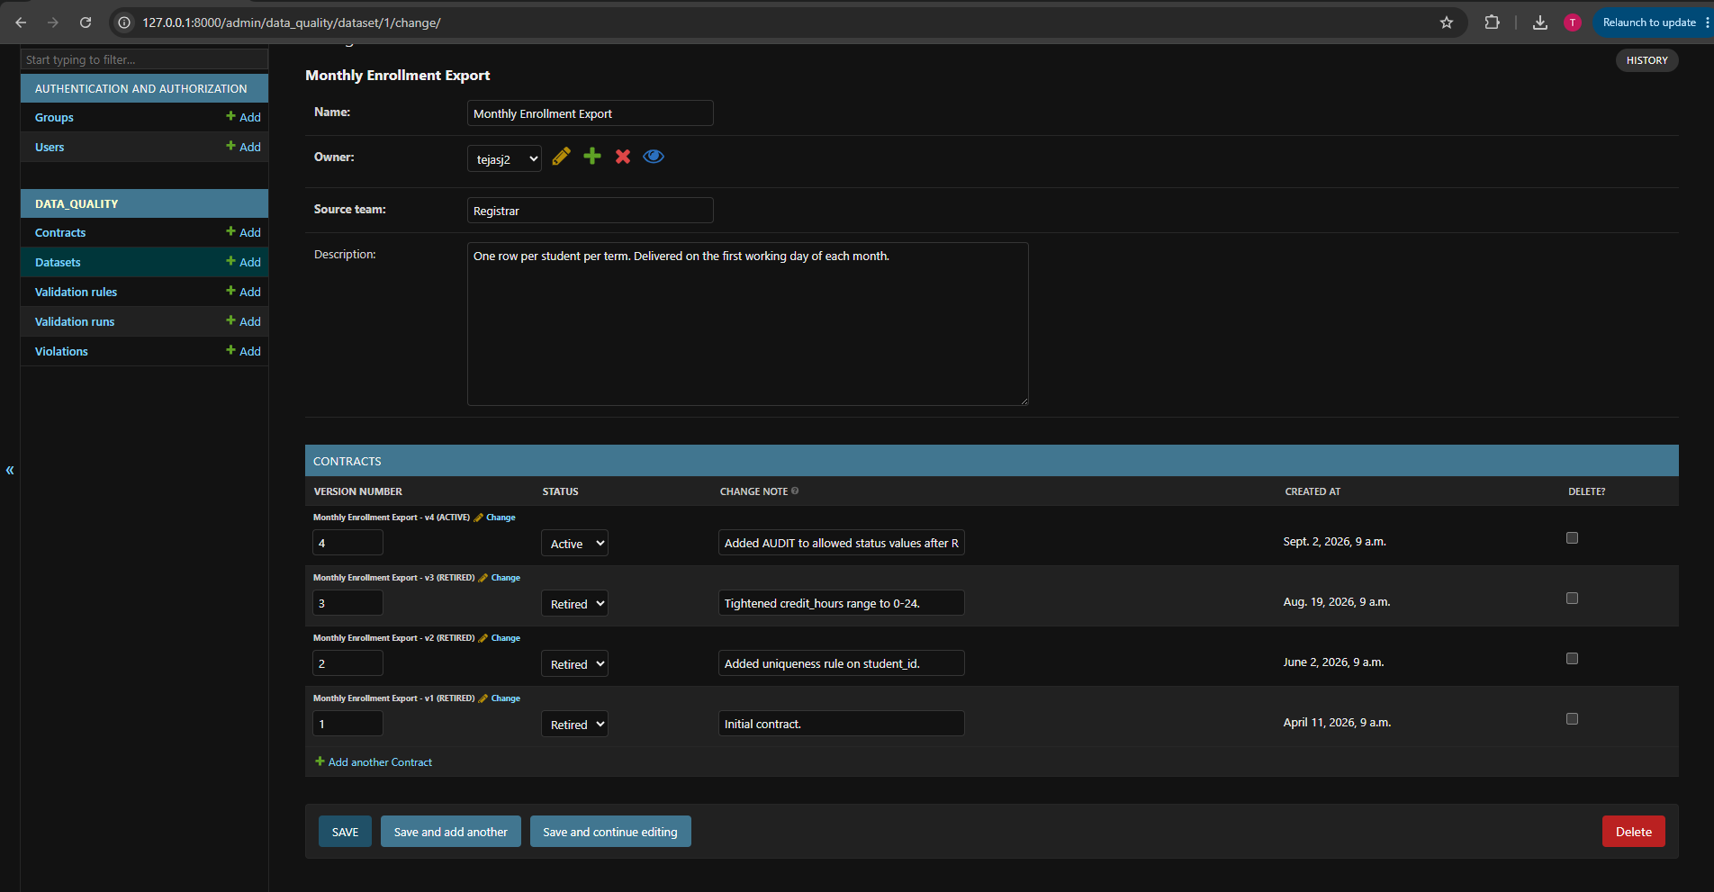
Screenshot 3 — Contract with inline Rules

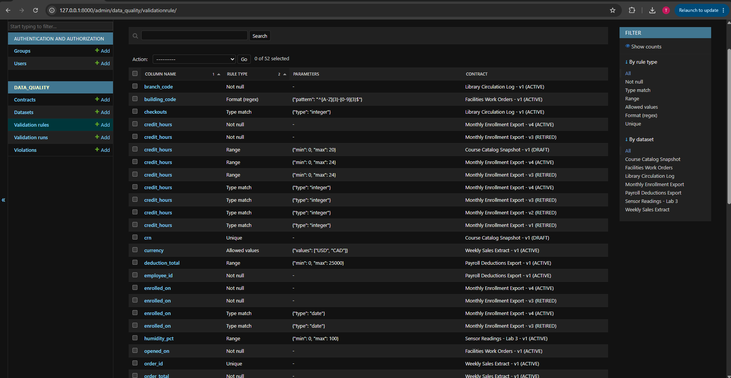

Screenshot 4 — Validation Run with Violations

