**Practical:-2**

**Aim:** **Using table tag create following table structure:**

1)

|  |  |  |  |  |  |
| --- | --- | --- | --- | --- | --- |
| Enrollment No. | StudentName | Subject name |  |  | Total  marks |
|  |  |  |  |  |  |
|  |  | S1 | S2 | S3 |  |
|  |  |  |  |  |  |
|  |  |  |  |  |  |
|  |  |  |  |  |  |
|  |  |  |  |  |  |

**Program code:**

<html>

<head>

<title> **practical2**</title>

</head>

<body>

<table border=**"2"** align=**"center"** cellspacing=**"1"** width=**"95%"**>

<tr>

<th rowspan=**"2"**> **Enrollment**<br> **no**</th>

<th rowspan=**"2"**> **Student**<br> **Name**</th>

<th colspan=**"3"**> **Subject**<br> **Name**</th>

<th rowspan=**"2"**>**Total Marks**</th>

</tr>

<tr>

<th>**s1**</th>

<th>**s2**</th>

<th>**s3**</th>

</tr>

<tr>

<td>&nbsp<**/td>**

<td>&nbsp<**/td>**

<td>&nbsp<**/td>**

<td>&nbsp<**/td>**

<td>&nbsp<**/td>**

<td>&nbsp<**/td>**

</tr>

<tr>

<td>&nbsp<**/td>**

<td>&nbsp<**/td>**

<td>&nbsp<**/td>**

<td>&nbsp<**/td>**

<td>&nbsp<**/td>**

<td>&nbsp<**/td>**

</tr>

<tr>

<td>&nbsp<**/td>**

<td>&nbsp<**/td>**

<td>&nbsp<**/td>**

<td>&nbsp<**/td>**

<td>&nbsp<**/td>**

<td>&nbsp<**/td>**

</tr>

</table>

</body>

</html>

**Output:**

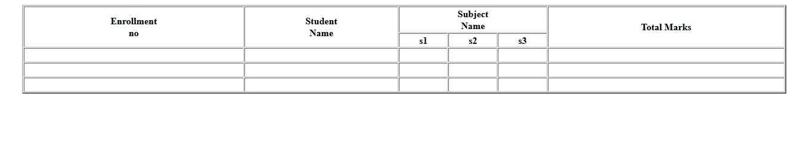

**2)**

|  |  |  |  |  |  |  |  |  |  |  |
| --- | --- | --- | --- | --- | --- | --- | --- | --- | --- | --- |
| A |  | B |  |  |  |  |  |  |  |  |
|  |  |  |  |  |  |  |  |  |  |  |
|  |  | E |  |  | F |  | C |  |  |  |
|  |  | D |  |  |  |  |  |  |  |  |
|  |  |  |  |  |  |  |  |  |  |  |

**Program code:**

<html>

<head>

<title>

**practical2b**

</title>

</head>

<body>

<table border=**"2"** width=**"95%"**>

<tr>

<th rowspan=**"4"**> **A**</th>

<th colspan=**"4"**> **B**</th>

</tr>

<tr>

<th>**E**</th>

<th>**F**</th>

<th rowspan=**"2"**>**C**</th>

<th></th>

</tr>

<tr>

<th colspan=**"2"**>**D**</th>

<th></th>

</tr>

</table>

</body>

</html>

**Output:**

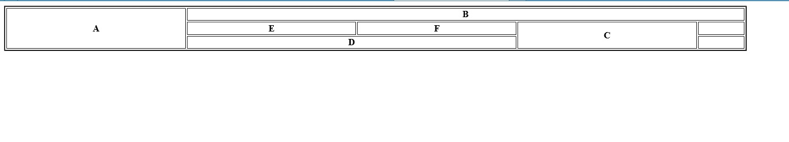

**3)**

|  |  |  |  |  |  |  |  |  |  |  |
| --- | --- | --- | --- | --- | --- | --- | --- | --- | --- | --- |
|  |  |  |  |  |  |  |  |  |  |  |
| Name |  |  |  | Subject name | |  |  |  |  |  |
|  |  |  |  | |  |  |  |  | |  |
|  |  |  | Theory marks | | |  | Practical marks | | |  |
|  | Marks | | Maximum |  | Highest | Marks | | Maximum | |  |
|  | obtain | | marks |  | marks | obtain | | marks | |  |
| Abc | 35 |  | 100 |  | 69 | 40 | | 50 | |  |
|  |  |  |  |  |  |  | |  | |  |
| Xyz | 60 |  | 100 |  | 80 | 30 | | 50 | |  |
|  |  |  |  |  |  |  | |  | |  |
| Pqr | 70 |  | 100 |  | 70 | 38 | | 50 | |  |
|  |  |  |  |  |  |  |  |  |  |  |
|  |  |  |  |  |  |  |  |  |  |  |

**Program code:**

<html>

<head>

<title>

**practical2c**

</title>

</head>

<body>

<table border=**"2"** width=**"95%"**>

<tr>

<th rowspan=**"3"**> **Name**</th>

<th colspan=**"5"**> **Subject Name** </th>

</tr>

<tr>

<th colspan=**"3"**> **Theory Marks**</th>

<th colspan=**"2"**> **Practical Marks**</th>

</tr>

<tr>

<th> **Marks** <br>**Obtain**</th>

<th>**Maximum** <br>**marks**</th>

<th>**Highest** <br> **Marks**</th>

<th>**Marks** <br> **Obtain**</th>

<th> **Maximum** <br>**Marks**</th>

</tr>

<tr>

<td>**ABC**</td>

<td>**35**</td>

<td>**100**</td>

<td>**69**</td>

<td>**40**</td>

<td>**50**</td>

</tr>

<tr>

<td>**XYZ**</td>

<td>**60**</td>

<td>**100**</td>

<td>**80**</td>

<td>**30**</td>

<td>**50**</td>

</tr>

<tr>

<td>**PQR**</td>

<td>**70**</td>

<td>**100**</td>

<td>**70**</td>

<td>**38**</td>

<td>**50**</td>

</tr>

</table>

</body>

</html>

**Output:**

