**Sơ đồ chuyển màn hình**:

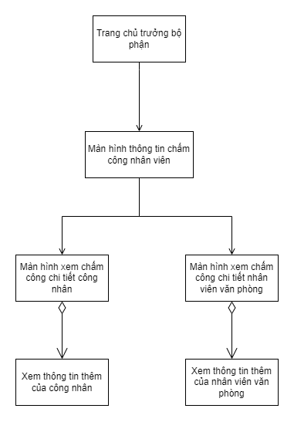

1. **Trang chủ trưởng bộ phận**

|  |  |  |
| --- | --- | --- |
| **Control** | **Operation** | **Function** |
| Main area | Initial | Display data of employee in a table information format |
| Sidebar | Initial | Display button for head of department to choose the function |
| Navbar | Initial | Display common information about system and your account |
| Xử lý yêu cầu chỉnh sửa | Click | Display the table about list of processing requests |
| Xem chi tiết | Click | Display the timekeeping data of employee in a month |
| Reporting | Click | Display the related reports of department timekeeping |

1. **Giao diện thông tin chấm công**

|  |  |  |
| --- | --- | --- |
| **Control** | **Operation** | **Function** |
| Main area | Initial | Displays the calendar and corresponding timekeeping information for the day |
| Export file | Click | Export the timekeeping data of the month |
| Day in calendar | Double Click | Display the view for detail timekeeping information |

1. **Giao diện chi tiết chấm công nhân viên văn phòng**

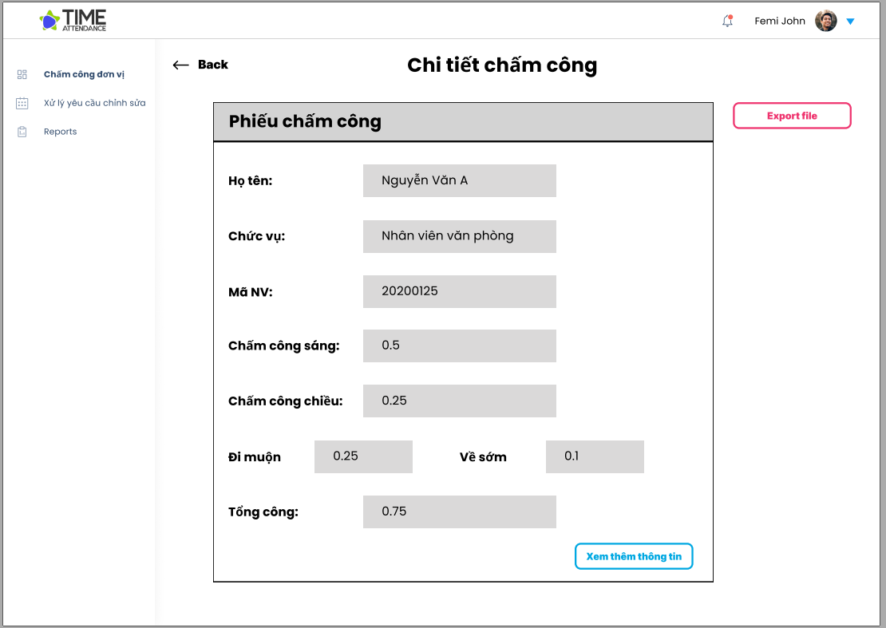

|  |  |  |
| --- | --- | --- |
| **Control** | **Operation** | **Function** |
| Main area | Initial | Display detail Office employee timekeeping card |
| Back | Click | Go back to timekeeping information screen |
| Xem thêm thông tin | Click | Display new screen for more information of the timekeeping card. |
| Export file | Click | Export the timekeeping data of the day |

1. **Giao diện chi tiết chấm công công nhân**

|  |  |  |
| --- | --- | --- |
| **Control** | **Operation** | **Function** |
| Main area | Initial | Display detail worker employee timekeeping card |
| Back | Click | Go back to timekeeping information screen |
| Xem thêm thông tin | Click | Display new screen for more information of the timekeeping card. |
| Export file | Click | Export the timekeeping data of the day |

1. **Hộp thoại thông tin thêm công nhân**

|  |  |  |
| --- | --- | --- |
| **Control** | **Operation** | **Function** |
| Main area | Initial | Display additional information of the timekeeping card of the worker employee in table view. |
| Xác nhận | Click | Close the dialog |

1. **Hộp thoại thông tin thêm nhân viên văn phòng**

|  |  |  |
| --- | --- | --- |
| **Control** | **Operation** | **Function** |
| Main area | Initial | Display additional information of the timekeeping card of the office employee in table view. |
| Xác nhận | Click | Close the dialog |

**Biểu đồ trình tự cho các hành vi trong subsystem**

* Lấy thông tin chấm công

**Biểu đồ lớp cho subsystem**

