XemDS:

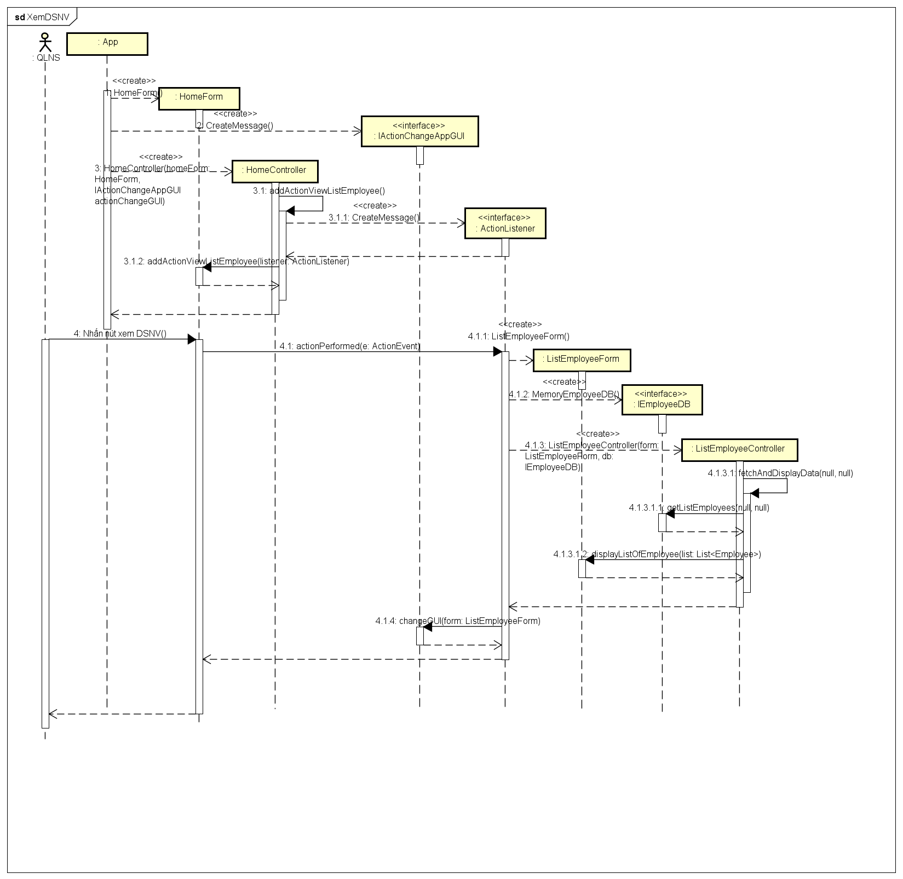

Edit:

Class:

