УО «Белорусский государственный университет информатики и радиоэлектроники»

Кафедра программного обеспечения информационных технологий

Отчет по лабораторной работе №3

по дисциплине

«Программное обеспечение встроенных систем»

Выполнил: Студент гр. 051003

Кукреш А.С.

Проверил: Деменковец Д.В.

Минск 2023

**Настройки STM32CubeMX**:

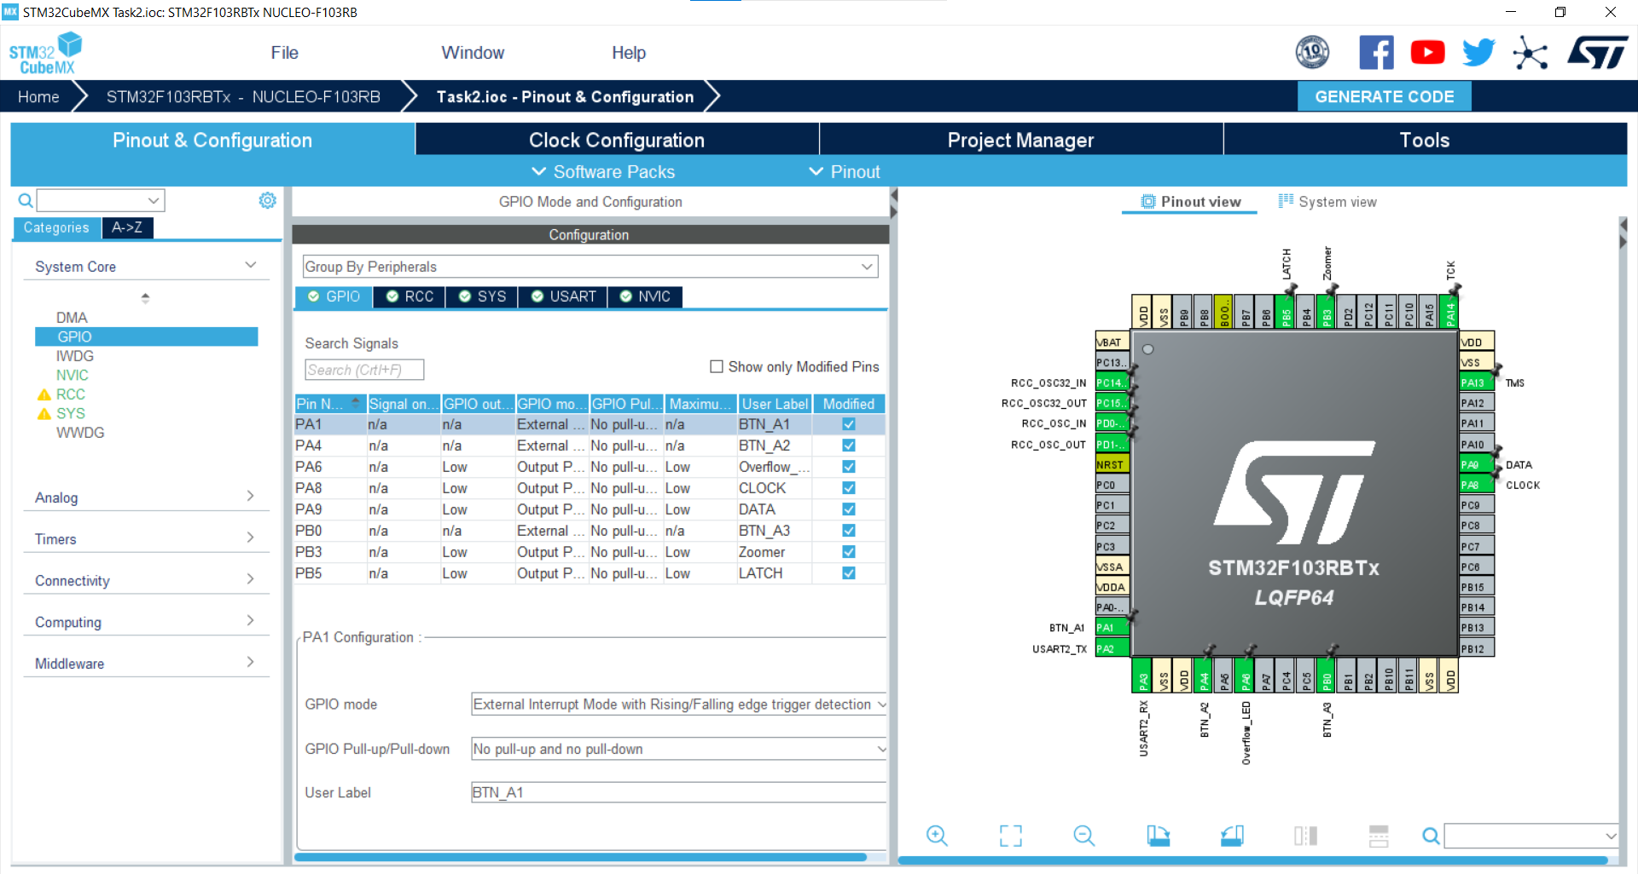

Рисунок – Настройки в CubeMX

***Код main.c****:*

/* USER CODE BEGIN Header */

/**

******************************************************************************

* @file : main.c

* @brief : Main program body

******************************************************************************

* @attention

*

* <h2><center>&copy; Copyright (c) 2023 STMicroelectronics.

* All rights reserved.</center></h2>

*/

/* USER CODE END Header */

/* Includes ------------------------------------------------------------------*/

#include "main.h"

#include "tim.h"

#include "usart.h"

#include "gpio.h"

/* Private includes ----------------------------------------------------------*/

/* USER CODE BEGIN Includes */

#include <stdio.h>

#include <string.h>

/* USER CODE END Includes */

/* Private typedef -----------------------------------------------------------*/

/* USER CODE BEGIN PTD */

/* USER CODE END PTD */

/* Private define ------------------------------------------------------------*/

/* USER CODE BEGIN PD */

/* USER CODE END PD */

/* Private macro -------------------------------------------------------------*/

/* USER CODE BEGIN PM */

/* USER CODE END PM */

/* Private variables ---------------------------------------------------------*/

/* USER CODE BEGIN PV */

/*

a

-----

f| |b

| g |

-----

e| |c

| |

----- .h

d

*/

// a b c d e f g h invert

// 0 1 1 1 1 1 1 0 0 0000 0011

// 1 0 1 1 0 0 0 0 0 1001 1111

// 2 1 1 0 1 1 0 1 0 0010 0101

// 3 1 1 1 1 0 0 1 0 0000 1101

// 4 0 1 1 0 0 1 1 0 1001 1001

// 5 1 0 1 1 0 1 1 0 0100 1001

// 6 1 0 1 1 1 1 1 0 0100 0001

// 7 1 1 1 0 0 0 0 0 0001 1111

// 8 1 1 1 1 1 1 1 0 0000 0001

// 9 1 1 1 1 0 1 1 0 0000 1001

// 0 1 2 3 4 5 6 7 8 9

const uint8_t DIGITS[] = {0x03, 0x9F, 0x25, 0x0D, 0x99, 0x49, 0x41, 0x1F, 0x01, 0x09};

// 0 1 2 3

const uint8_t SEGMENTS[] = {0x10, 0x20, 0x40, 0x80};

/* USER CODE END PV */

/* Private function prototypes -----------------------------------------------*/

void SystemClock_Config(void);

/* USER CODE BEGIN PFP */

void ZoomerInc(void);

void ZoomerDec(void);

void ZoomerReset(void);

void ZoomerPlaySound(int);

void BeginDisplayWrite(void);

void EndDisplayWrite(void);

void WriteDataToRegister(uint8_t dataBits);

void WriteDataToSegment(uint8_t, uint8_t);

void WriteNumberToDisplay(uint32_t);

void setPWM(uint16_t pwmValue);

/* USER CODE END PFP */

/* Private user code ---------------------------------------------------------*/

/* USER CODE BEGIN 0 */

volatile int zoomerValue = 0;

const int zoomerDefaultValue = 0;

const int BUTTON_LONG_CLICK_MILLISEC = 3000;

const int LONG_CLICK_UPDATE_MILLISEC = 1000;

volatile int Btn1Click = 0;

volatile int Btn1ClickTime = 0;

volatile int Btn1LongClick = 0;

volatile int Btn2Click = 0;

volatile int Btn2ClickTime = 0;

volatile int Overflow = 0;

volatile int Btn3Click = 0;

volatile int Btn3ClickTime = 0;

volatile int Btn3LongClick = 0;

/* USER CODE END 0 */

/**

* @brief The application entry point.

* @retval int

*/

int main(void)

{

/* USER CODE BEGIN 1 */

/* USER CODE END 1 */

/* MCU Configuration--------------------------------------------------------*/

/* Reset of all peripherals, Initializes the Flash interface and the Systick. */

HAL_Init();

/* USER CODE BEGIN Init */

/* USER CODE END Init */

/* Configure the system clock */

SystemClock_Config();

/* USER CODE BEGIN SysInit */

/* USER CODE END SysInit */

/* Initialize all configured peripherals */

MX_GPIO_Init();

MX_TIM3_Init();

MX_TIM2_Init();

MX_USART2_UART_Init();

/* USER CODE BEGIN 2 */

int currentTime = 0;

/* USER CODE END 2 */

/* Infinite loop */

/* USER CODE BEGIN WHILE */

int const BUFFER_LEN = 256;

char buffer[BUFFER_LEN];

while (1)

{

/* USER CODE END WHILE */

/* USER CODE BEGIN 3 */

currentTime = HAL_GetTick();

if (Btn1Click && currentTime - Btn1ClickTime > BUTTON_LONG_CLICK_MILLISEC)

{

Btn1LongClick = 1;

Btn1ClickTime += BUTTON_LONG_CLICK_MILLISEC;

ZoomerDec();

}

if (Btn1LongClick && currentTime - Btn1ClickTime > LONG_CLICK_UPDATE_MILLISEC)

{

Btn1ClickTime += LONG_CLICK_UPDATE_MILLISEC;

ZoomerDec();

}

if (Btn3Click && currentTime - Btn3ClickTime > BUTTON_LONG_CLICK_MILLISEC)

{

Btn3LongClick = 1;

Btn3ClickTime += BUTTON_LONG_CLICK_MILLISEC;

ZoomerInc();

}

if (Btn3LongClick && currentTime - Btn3ClickTime > LONG_CLICK_UPDATE_MILLISEC)

{

Btn3ClickTime += LONG_CLICK_UPDATE_MILLISEC;

ZoomerInc();

}

if (Overflow)

{

HAL_GPIO_WritePin(GPIOA, Overflow_LED_Pin, GPIO_PIN_RESET);

}

else

{

HAL_GPIO_WritePin(GPIOA, Overflow_LED_Pin, GPIO_PIN_SET);

}

snprintf(buffer, BUFFER_LEN, "X=%04d\n", (int)zoomerValue);

HAL_UART_Transmit(&huart2, (uint8_t *)buffer, strlen(buffer), HAL_MAX_DELAY);

ZoomerPlaySound(zoomerValue);

}

/* USER CODE END 3 */

}

/**

* @brief System Clock Configuration

* @retval None

*/

void SystemClock_Config(void)

{

RCC_OscInitTypeDef RCC_OscInitStruct = {0};

RCC_ClkInitTypeDef RCC_ClkInitStruct = {0};

/** Initializes the RCC Oscillators according to the specified parameters

* in the RCC_OscInitTypeDef structure.

*/

RCC_OscInitStruct.OscillatorType = RCC_OSCILLATORTYPE_HSI;

RCC_OscInitStruct.HSIState = RCC_HSI_ON;

RCC_OscInitStruct.HSICalibrationValue = RCC_HSICALIBRATION_DEFAULT;

RCC_OscInitStruct.PLL.PLLState = RCC_PLL_ON;

RCC_OscInitStruct.PLL.PLLSource = RCC_PLLSOURCE_HSI_DIV2;

RCC_OscInitStruct.PLL.PLLMUL = RCC_PLL_MUL2;

if (HAL_RCC_OscConfig(&RCC_OscInitStruct) != HAL_OK)

{

Error_Handler();

}

/** Initializes the CPU, AHB and APB buses clocks

*/

RCC_ClkInitStruct.ClockType = RCC_CLOCKTYPE_HCLK|RCC_CLOCKTYPE_SYSCLK

|RCC_CLOCKTYPE_PCLK1|RCC_CLOCKTYPE_PCLK2;

RCC_ClkInitStruct.SYSCLKSource = RCC_SYSCLKSOURCE_PLLCLK;

RCC_ClkInitStruct.AHBCLKDivider = RCC_SYSCLK_DIV1;

RCC_ClkInitStruct.APB1CLKDivider = RCC_HCLK_DIV2;

RCC_ClkInitStruct.APB2CLKDivider = RCC_HCLK_DIV1;

if (HAL_RCC_ClockConfig(&RCC_ClkInitStruct, FLASH_LATENCY_0) != HAL_OK)

{

Error_Handler();

}

}

/* USER CODE BEGIN 4 */

void BeginDisplayWrite()

{

HAL_GPIO_WritePin(LATCH_GPIO_Port, LATCH_Pin, GPIO_PIN_RESET);

}

void EndDisplayWrite()

{

HAL_GPIO_WritePin(LATCH_GPIO_Port, LATCH_Pin, GPIO_PIN_SET);

}

void WriteDataToRegister(uint8_t dataBits)

{

for (int i = 0; i < 8; i++)

{

HAL_GPIO_WritePin(DATA_GPIO_Port, DATA_Pin, dataBits % 2);

dataBits >>= 1;

HAL_GPIO_WritePin(CLOCK_GPIO_Port, CLOCK_Pin, GPIO_PIN_SET);

HAL_GPIO_WritePin(CLOCK_GPIO_Port, CLOCK_Pin, GPIO_PIN_RESET);

}

}

void WriteDataToSegment(uint8_t dataBits, uint8_t segmentBits)

{

BeginDisplayWrite();

WriteDataToRegister(dataBits);

WriteDataToRegister(segmentBits);

EndDisplayWrite();

}

void WriteNumberToDisplay(uint32_t number)

{

for (int i = 0; i < 4; i++)

{

WriteDataToSegment(DIGITS[number % 10], SEGMENTS[i]);

number /= 10;

}

}

const int BUTTON_STEP = 1;

const int BUTTON_DEBOUNCE_MILLISEC = 150;

void HAL_GPIO_EXTI_Callback(uint16_t GPIO_Pin)

{

int currentTime = HAL_GetTick();

switch (GPIO_Pin)

{

case BTN_A1_Pin:

if (HAL_GPIO_ReadPin(GPIOA, BTN_A1_Pin) == 0)

{

if (currentTime - Btn1ClickTime > BUTTON_DEBOUNCE_MILLISEC)

{

Btn1ClickTime = currentTime;

Btn1Click = 1;

Btn1LongClick = 0;

ZoomerDec();

}

}

else

{

Btn1Click = 0;

Btn1LongClick = 0;

}

break;

case BTN_A2_Pin:

if (HAL_GPIO_ReadPin(GPIOA, BTN_A2_Pin) == 0)

{

if (currentTime - Btn2ClickTime > BUTTON_DEBOUNCE_MILLISEC)

{

ZoomerReset();

Overflow = 1;

}

}

else

{

Btn2ClickTime = currentTime;

Btn2Click = 1;

Btn2Click = 0;

Overflow = 0;

}

break;

case BTN_A3_Pin:

if (HAL_GPIO_ReadPin(GPIOB, BTN_A3_Pin) == 0)

{

if (currentTime - Btn3ClickTime > BUTTON_DEBOUNCE_MILLISEC)

{

Btn3ClickTime = currentTime;

Btn3Click = 1;

Btn3LongClick = 0;

ZoomerInc();

}

}

else

{

Btn3Click = 0;

Btn3LongClick = 0;

}

break;

}

}

void ZoomerInc()

{

Overflow = 0;

zoomerValue += BUTTON_STEP;

if (zoomerValue > 254)

{

ZoomerReset();

Overflow = 1;

}

}

void ZoomerDec()

{

Overflow = 0;

zoomerValue -= BUTTON_STEP;

if (zoomerValue < 0) zoomerValue = 0;

}

void ZoomerReset()

{

Overflow = 0;

zoomerValue = zoomerDefaultValue;

}

void ZoomerPlaySound(int zoomerValue)

{

HAL_GPIO_TogglePin(GPIOB, Zoomer_Pin);

WriteNumberToDisplay(zoomerValue);

HAL_Delay(zoomerValue);

WriteNumberToDisplay(zoomerValue);

HAL_GPIO_TogglePin(GPIOB, Zoomer_Pin);

WriteNumberToDisplay(zoomerValue);

HAL_Delay(2);

WriteNumberToDisplay(zoomerValue);

}

/* USER CODE END 4 */

/**

* @brief This function is executed in case of error occurrence.

* @retval None

*/

void Error_Handler(void)

{

/* USER CODE BEGIN Error_Handler_Debug */

/* User can add his own implementation to report the HAL error return state */

__disable_irq();

while (1)

{

}

/* USER CODE END Error_Handler_Debug */

}

#ifdef USE_FULL_ASSERT

/**

* @brief Reports the name of the source file and the source line number

* where the assert_param error has occurred.

* @param file: pointer to the source file name

* @param line: assert_param error line source number

* @retval None

*/

void assert_failed(uint8_t *file, uint32_t line)

{

/* USER CODE BEGIN 6 */

/* User can add his own implementation to report the file name and line number,

ex: printf("Wrong parameters value: file %s on line %d\r\n", file, line) */

/* USER CODE END 6 */

}

#endif /* USE_FULL_ASSERT */

/************************ (C) COPYRIGHT STMicroelectronics *****END OF FILE****/