Decoding Human Activity from Smartphone Sensor Data Using a Hidden Markov Model
Akachi David Nwanze
July 5, 2026

Background and Motivation
Falls and prolonged immobility are among the most serious risks facing elderly individuals living independently, and by the time a caregiver notices a problem, critical time may already have been lost. A low-cost, phone- or wearable-based monitoring system that can continuously infer a person's activity state from accelerometer and gyroscope signals offers a practical way to close this gap, distinguishing ordinary movement (standing, walking) from higher-risk signatures such as a sudden high-impact motion resembling a fall, or an extended period of stillness that may indicate the person is incapacitated. Because activity unfolds as a sequence in which the current state depends on the recent past, a Hidden Markov Model is a natural fit: it explicitly models this temporal structure, treating noisy sensor readings as observations generated by an underlying activity state. This project builds and evaluates such a model using four activities — standing, walking, jumping, and remaining still — as a proof of concept for a fall-risk monitoring system.

Data Collection and Preprocessing
Sensor data was collected with the Sensor Logger app on an iPhone 15 Pro, recording accelerometer and gyroscope simultaneously at a configured 100 Hz. Four activities — standing (held upright at waist height), walking (steady pace), jumping (continuous jumps), and still (phone flat on a surface) — were recorded as short 5–10 second clips: 48 training recordings (12 per activity) and 12 test recordings (3 per activity), each exporting a paired Accelerometer.csv/Gyroscope.csv file with nanosecond timestamps and per-axis (x, y, z) readings. Combined train and test duration exceeded 110 seconds for every activity (standing 115.8s, walking 115.4s, jumping 110.7s, still 113.1s). To ensure a genuinely unseen evaluation, the test session was recorded outdoors with the phone in a pocket rather than indoors, held in hand, with the still clips placed on a different surface.
Sensor Logger warns that the true sampling rate may run slower than configured; measurement confirmed this (approximately 99.9 Hz rather than 100 Hz), and an audit of all 60 recordings found one case, jumping_train_06, where the accelerometer and gyroscope had a mismatched sample count (718 vs. 719 rows) despite sharing a start timestamp. To handle this, and to normalize rate jitter across recordings, both sensors were resampled via linear interpolation onto a shared, uniform 50 Hz grid — a rate well above the frequencies of interest in human motion, since gait and jump cadence both lie under 10 Hz.
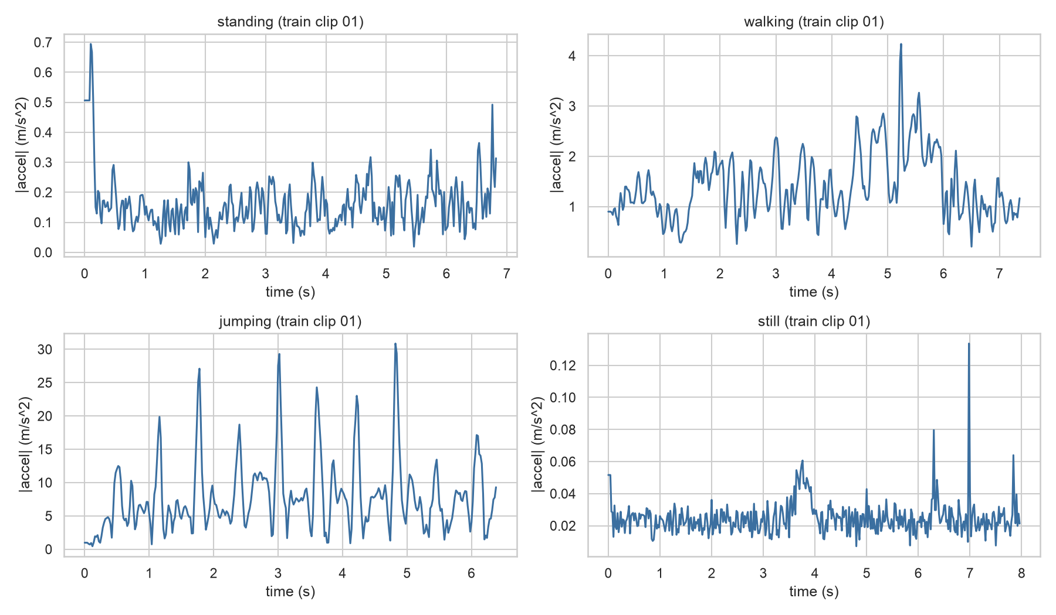
Figure 1. Resampled acceleration magnitude for one training clip of each activity.
Each recording was then split into overlapping 1-second windows (50 samples) with 50% overlap. One second reliably captures one to two full gait or jump cycles at typical cadences (1.5–3 Hz), long enough for the frequency-domain features described below to be meaningful, while still tracking activity changes with reasonable resolution. This produced 631 training windows (standing 161, walking 161, still 156, jumping 153) and 192 test windows (standing 47, walking 48, jumping 46, still 51).

HMM Setup and Implementation Details
The model uses hmmlearn's GaussianHMM with 4 hidden states (Z), one per activity. Observations (X) are the 8-dimensional, Z-score normalized feature vector for each 1-second window. The transition matrix (A), the emission model (B — a Gaussian distribution per state over the 8 features), and the initial state probabilities (π) are all learned via Baum-Welch.
Time-domain features were accel_rms (movement energy, separating jumping from everything else), accel_var (variance of acceleration magnitude, low for still/standing and high for walking/jumping), accel_sma (signal magnitude area across all three axes), accel_corr_xz (correlation between horizontal and vertical acceleration, capturing gait coupling), and gyro_rms / gyro_var (the same energy and variance logic applied to rotation). Frequency-domain features, from the FFT of acceleration magnitude with the DC component excluded, were accel_dom_freq (frequency of the largest peak, targeting rhythm differences) and accel_spectral_energy (total spectral power, near zero for static activities). All features were Z-score normalized using a scaler fit on training data only, since the raw features span very different scales and would otherwise let the largest-magnitude feature dominate the Gaussian emission model's covariance estimates.
A GaussianHMM with diagonal covariance was fit via Baum-Welch (tolerance 1e-4, up to 200 iterations). A plain random initialization — tested with a fixed seed and across 30 restarts — consistently converged to a degenerate solution where two states both settled on “jumping” and none matched “standing.” This traced to jumping's much higher intra-class variance (standardized std ≈0.65–1.5) compared to standing or walking (≈0.0–0.1): EM increases likelihood more by splitting jumping's spread across two states than by allocating a separate, thin state to standing, whose signature sits close to walking's. The fix was informed initialization — seeding each state's mean with its true per-activity training mean, fixing state 0 = standing, 1 = walking, 2 = jumping, 3 = still — after which Baum-Welch's normal updates still ran freely; training labels were used only to choose the starting point. With this fix the model converged after 12 iterations (final training log-likelihood 4883.9), and Viterbi decoding of the training data gave a clean, one-to-one match between states and activities.

Results and Interpretation
Viterbi decoding reached 83.0% accuracy on training data and 67.2% on the held-out, domain-shifted test set. Table 1 reports sensitivity, specificity, and overall accuracy per activity.

Activity | Number of Samples | Sensitivity | Specificity | Overall Accuracy
Standing | 47 | 0.447 | 1.000 | 0.865
Walking | 48 | 0.229 | 0.896 | 0.729
Jumping | 46 | 1.000 | 0.719 | 0.786
Still | 51 | 1.000 | 0.950 | 0.964

Jumping and still were classified almost perfectly (sensitivity 1.000 for both). Standing and walking were far harder: standing was correct in only 21 of 47 test windows, mostly confused with walking, and walking was correct in just 11 of 48, mostly confused with jumping (Figure 2).
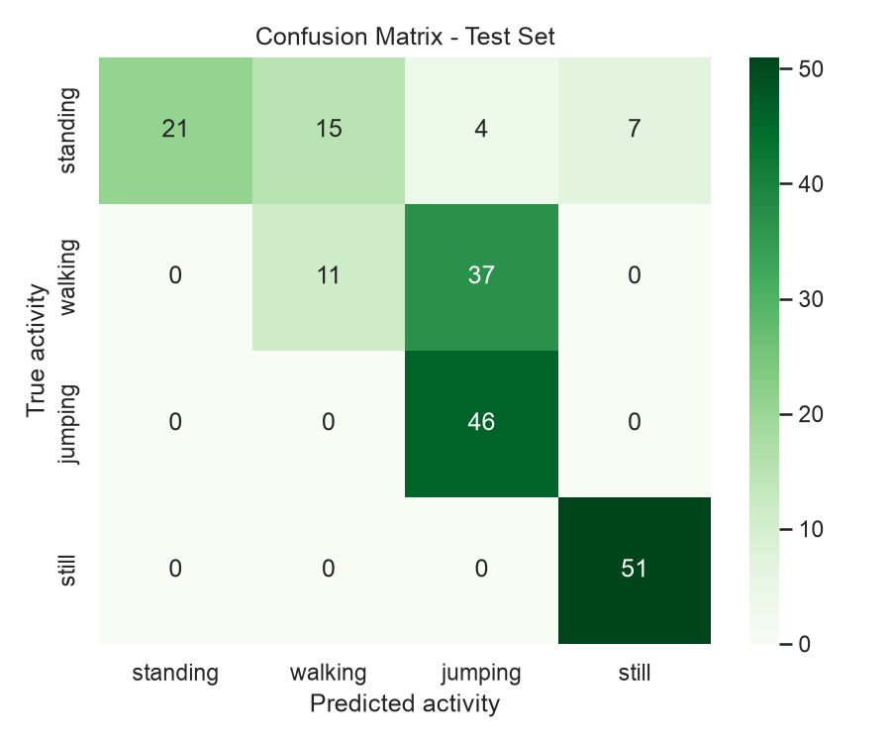
Figure 2. Confusion matrix on the test set.
The learned transition matrix (Figure 3) shows high self-transition probability for every state (0.85–0.98), consistent with training recordings that each contain a single, uninterrupted activity. The emission-means heatmap (Figure 4) shows why standing and walking are confused: their standardized feature means are nearly identical across all 8 dimensions, while jumping is a clear outlier on nearly every feature.
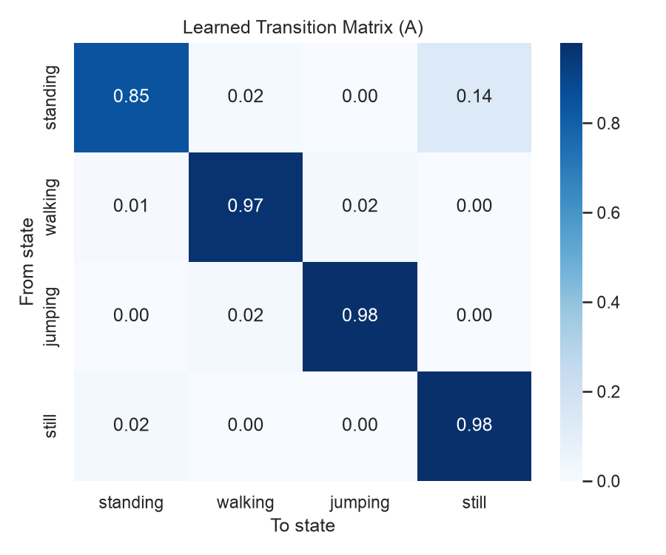
Figure 3. Learned transition matrix (A).
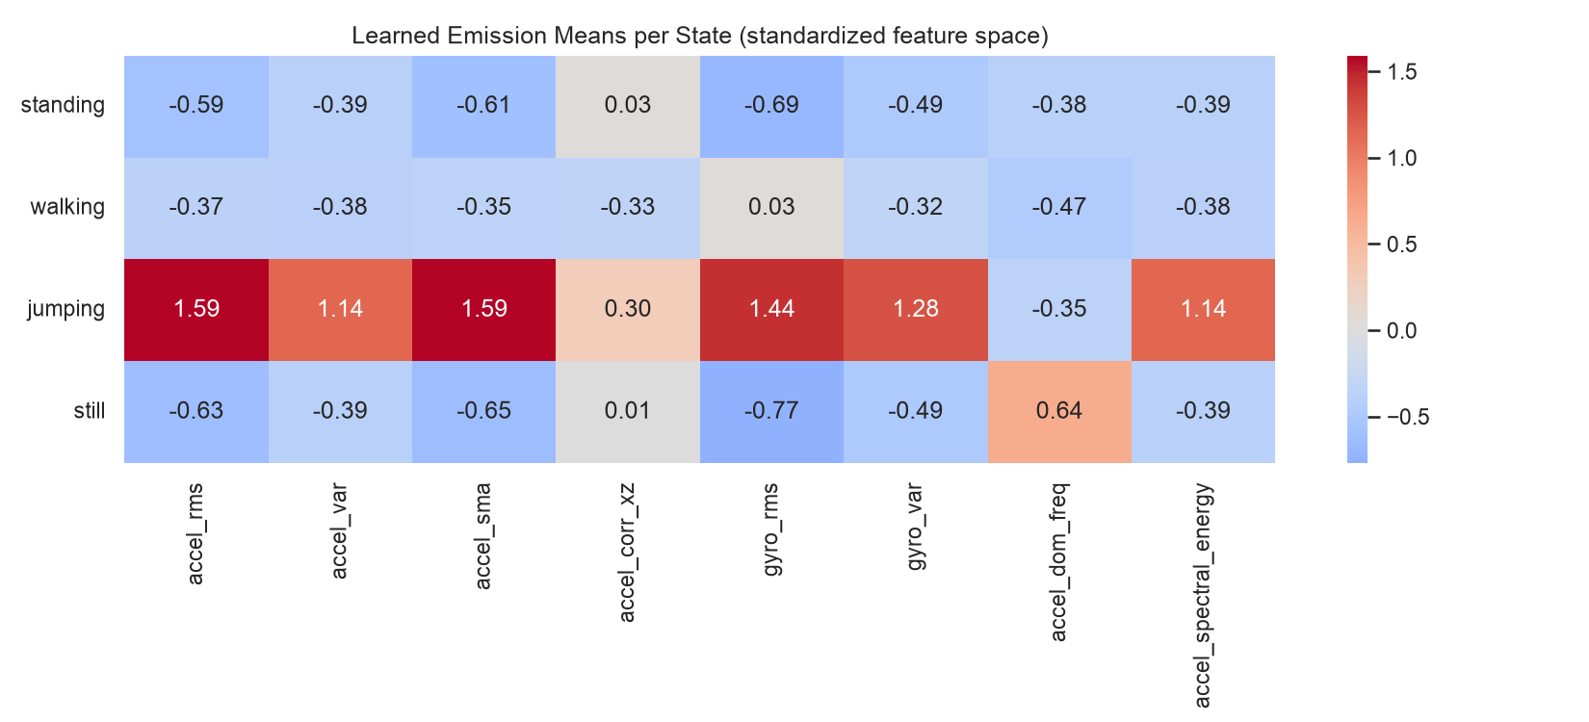
Figure 4. Learned emission means per state (standardized feature space).

Discussion and Conclusion
Jumping and still were easiest to distinguish, sitting at opposite ends of the energy spectrum. Standing and walking were, unexpectedly, hardest to separate — not standing and still, as intuition might suggest — because still was recorded fully motionless on a surface, while standing was held in the hand and carries subtle sway that pushes it close to gentle walking rather than true stillness.
The transition matrix's diagonal dominance reflects the data collection design, not real behaviour: since every recording is a single, uninterrupted activity, no genuine transition was ever observed during training. Learning realistic transition probabilities — for example, that standing → walking is far more common in daily life than jumping → still — would require continuous, multi-activity recordings.
Noise and sampling-rate effects showed up at three levels: the measured rate deviated slightly from the configured 100 Hz and one recording had a genuine accelerometer/gyroscope sample mismatch, both requiring resampling; Baum-Welch's EM was sensitive to initialization because of jumping's higher variance; and the deliberate test-time domain shift (outdoor, phone in pocket) increased walking's signal amplitude enough to be frequently confused with jumping. This is a useful, realistic finding: magnitude-based features are sensitive to phone placement and environment, an important caveat for real deployment.
Future improvements include continuous multi-activity recordings to learn realistic transitions, gait-rhythm-specific features such as narrow-band step-frequency power to better separate standing from walking, training data across more varied phone placements to reduce domain-shift sensitivity, and, with more data, a full-covariance or discriminative sequence model. Overall, this project demonstrates a complete HMM pipeline: robust preprocessing, justified features, Baum-Welch training with a documented and resolved initialization failure, and honest evaluation on domain-shifted test data. It perfectly separates the two most energy-distinct activities, and its standing/walking confusion is a well-understood limitation of the current feature set — directly informing next steps toward a deployable fall-risk monitoring system.

