Gift Voucher Code Cracking
IP address
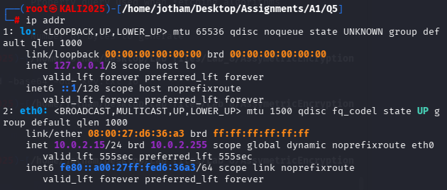
Kali IP: 10.0.2.15/24

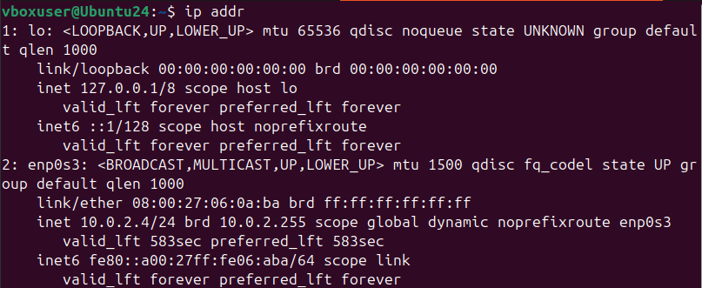
Ubuntu IP: 10.0.2.4/24

Part A
Execute the server on Ubuntu
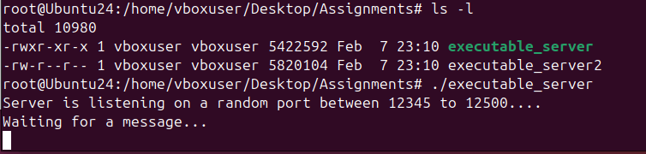

Use NMAP to scan ports 12345 – 12500
nmap -vvvv -sU -p 12345 – 12500 10.0.2.4 -oN taskA.txt
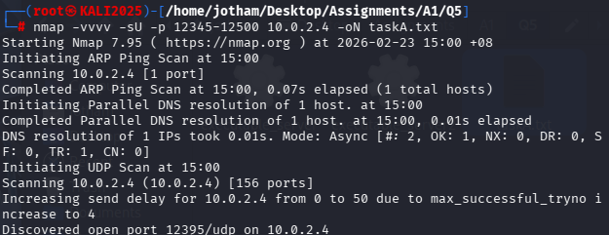

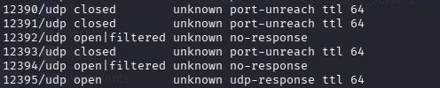
Open port: 12395

Part B
Use Netcat to obtain gift voucher for ClientID
nc -v -u 10.0.2.4 12395
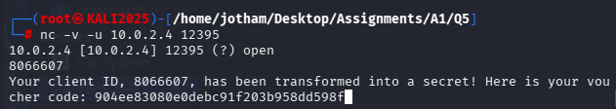
- Send a connection request to the open port 12395 on Ubuntu (10.0.2.4)
- Enter UOW ID

Voucher code: 904ee83080e0debc91f203b958dd598f

Part C
Use crunch to generate a list of potential VoucherCodes
- A is 2 random alphabets
- B is 2 random special chars

VoucherCode format: @@8066607^^
Length: 11

crunch 11 11 -t @@8066607^^ -o wordList.txt
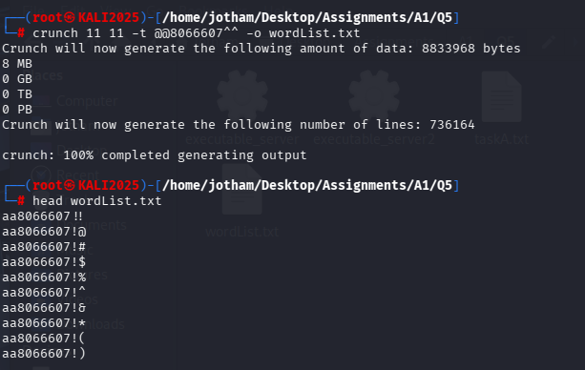
- Generate a wordlist of possible passwords

Store the generated gift voucher in a file hashValue.txt
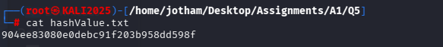

Use Hashcat to crack A and B and store the result in cracked.txt
- Hash the values in wordList.txt using MD5 and match against the generated Gift voucher

hashcat -a 0 -m 0 -o cracked.txt –potfile-disable hashValue.txt wordList.txt
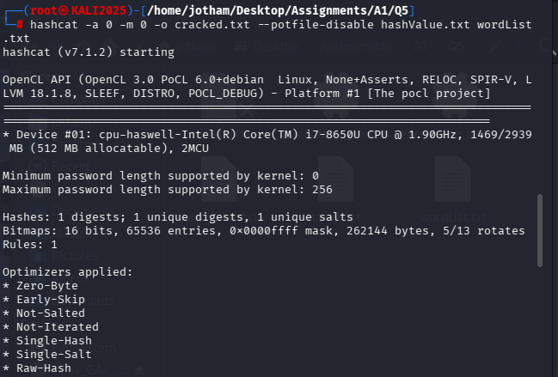

Open cracked.txt
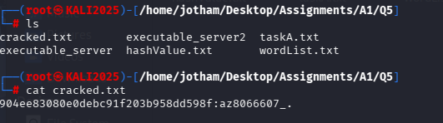
VoucherCode = az8066607_.
A = az
B = _.

