Lab 10
CREATE OR REPLACE PROCEDURE insert_flight(
p_flight_no VARCHAR,
p_scheduled_departure DATE,
p_scheduled_arrival DATE,
p_departure_airport_id INT,
p_arrival_airport_id INT,
p_departing_gate VARCHAR,
p_arriving_gate VARCHAR,
p_airline_id INT,
p_status VARCHAR
)
LANGUAGE plpgsql
AS $$
BEGIN
INSERT INTO flights (
flight_no, scheduled_departure, scheduled_arrival,
departure_airport_id, arrival_airport_id,
departing_gate, arriving_gate,
airline_id, status, created_at, update_at
)
VALUES (
p_flight_no, p_scheduled_departure, p_scheduled_arrival,
p_departure_airport_id, p_arrival_airport_id,
p_departing_gate, p_arriving_gate,
p_airline_id, p_status, NOW(), NOW()
);
END;
$$;
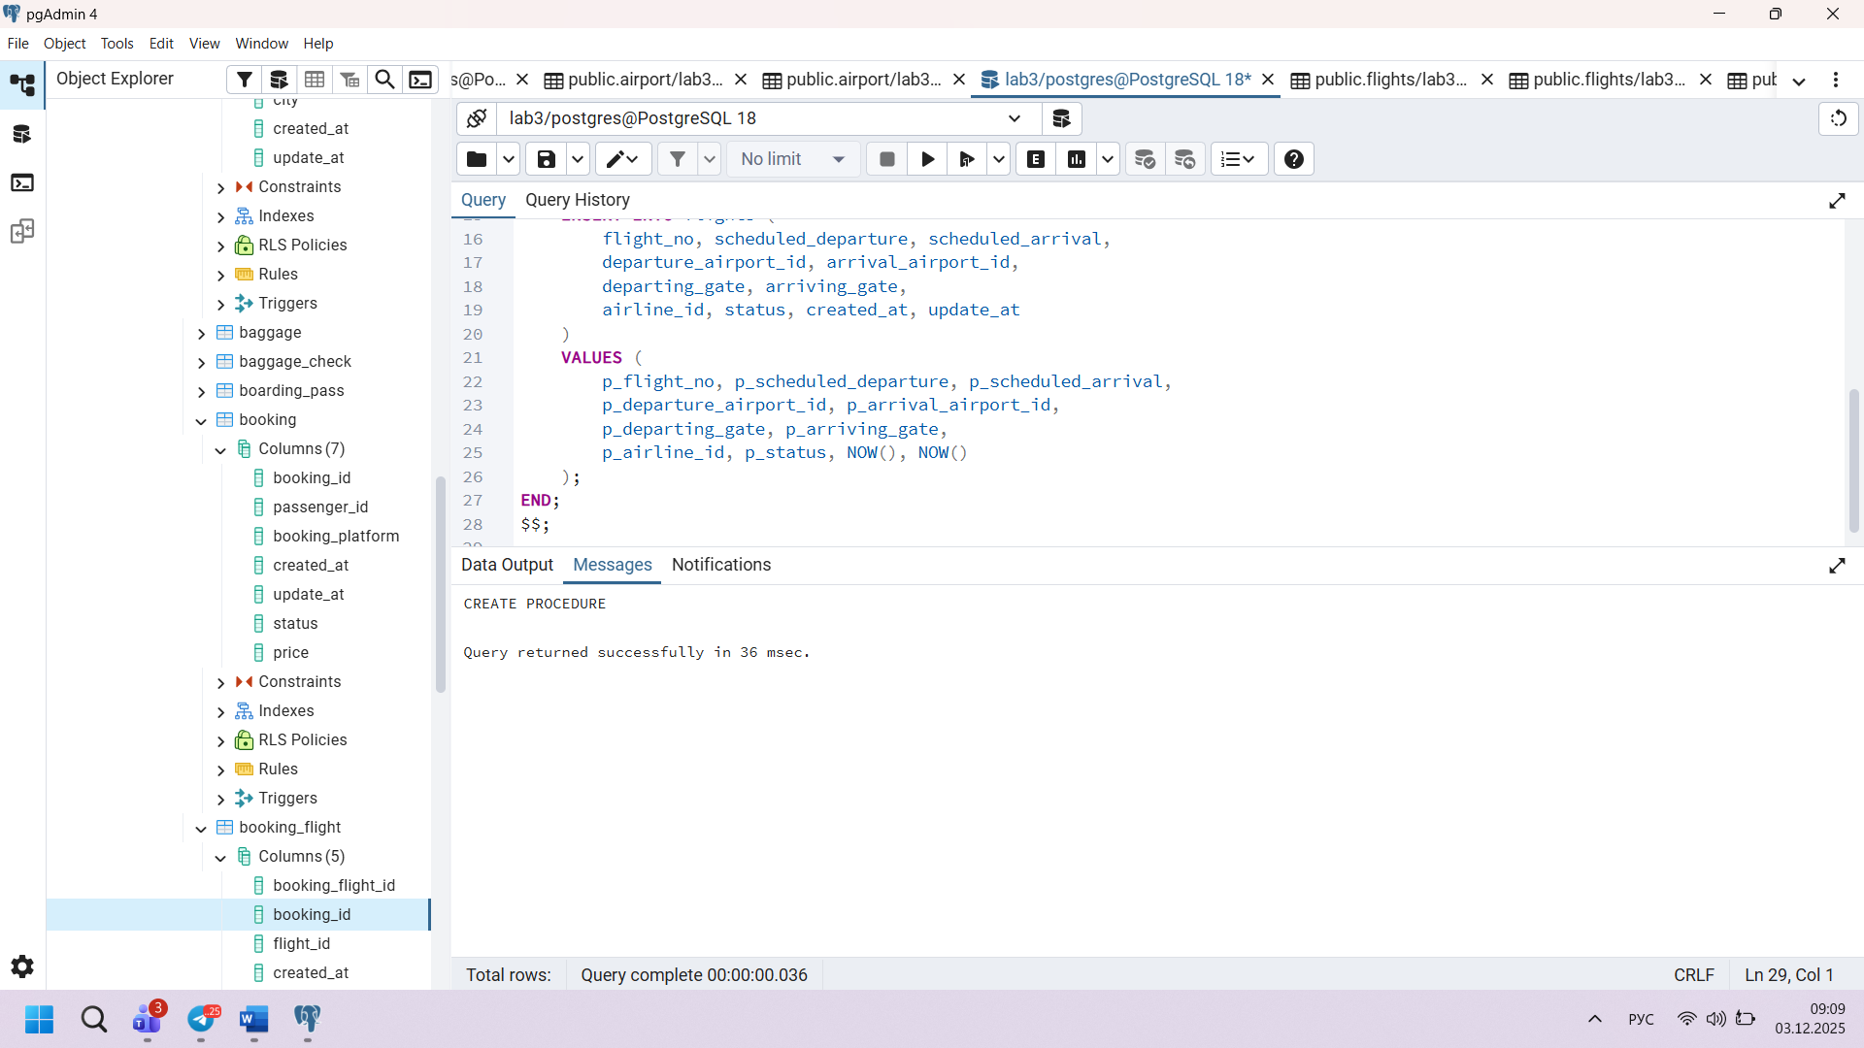
Task 2
CREATE OR REPLACE PROCEDURE update_flight_status(
p_flight_id INT,
p_status VARCHAR
)
LANGUAGE plpgsql
AS $$
BEGIN
UPDATE flights
SET status = p_status,
update_at = NOW()
WHERE flight_id = p_flight_id;
END;
$$;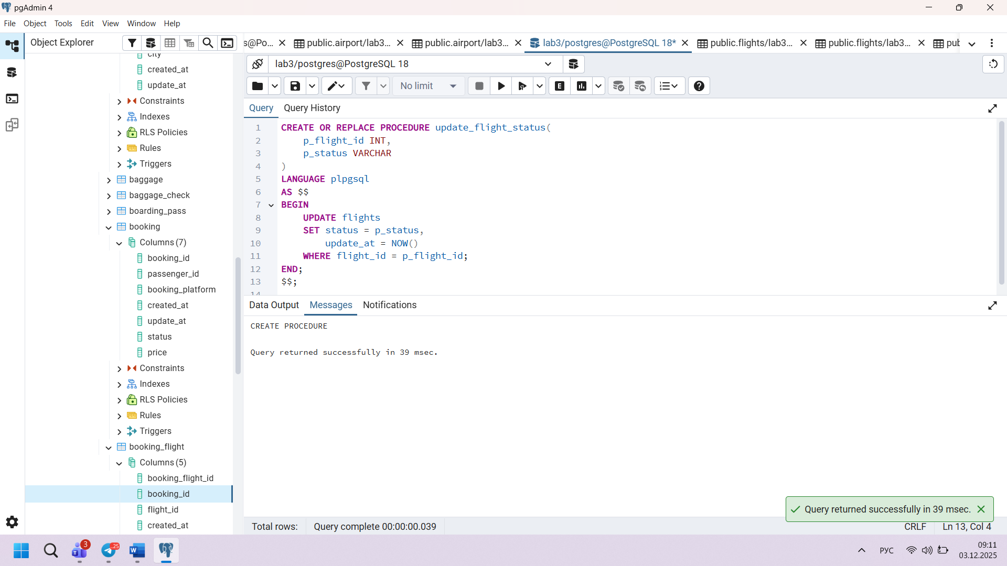
Task 3
CREATE OR REPLACE PROCEDURE flights_from_airport(
p_airport_id INT
)
LANGUAGE plpgsql
AS $$
BEGIN
SELECT * FROM flights
WHERE departure_airport_id = p_airport_id;
END;
$$;
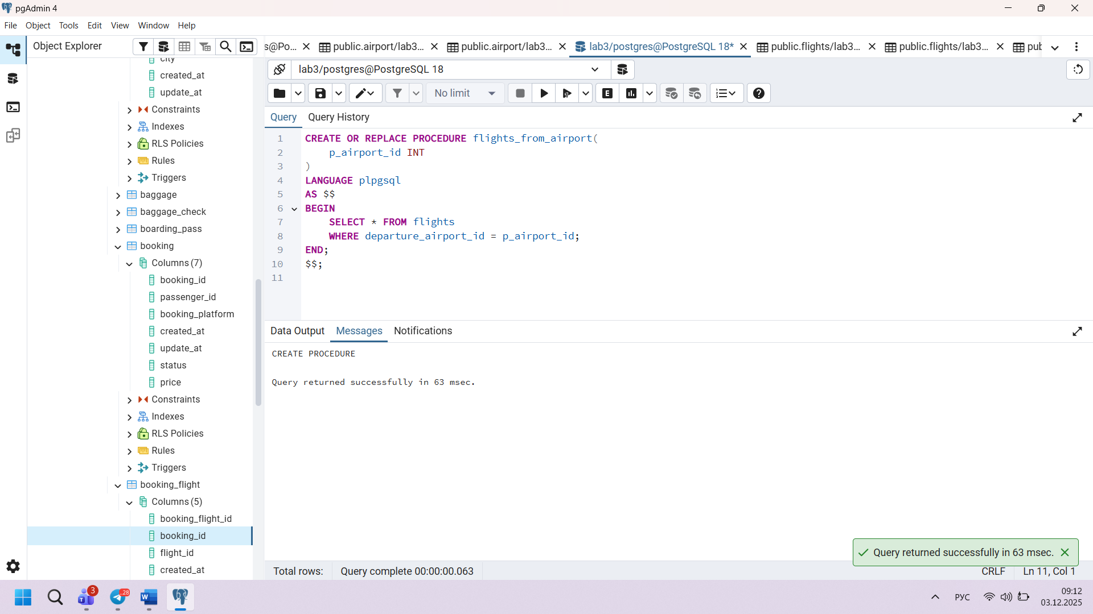
Task 4
CREATE OR REPLACE FUNCTION avg_arrival_delay(
p_airport_id INT
)
RETURNS NUMERIC AS
$$
DECLARE
result NUMERIC;
BEGIN
SELECT AVG(EXTRACT(EPOCH FROM (actual_arrival - scheduled_arrival)) / 60)
INTO result
FROM flights
WHERE arrival_airport_id = p_airport_id
AND actual_arrival IS NOT NULL;

RETURN result;
END;
$$ LANGUAGE plpgsql;
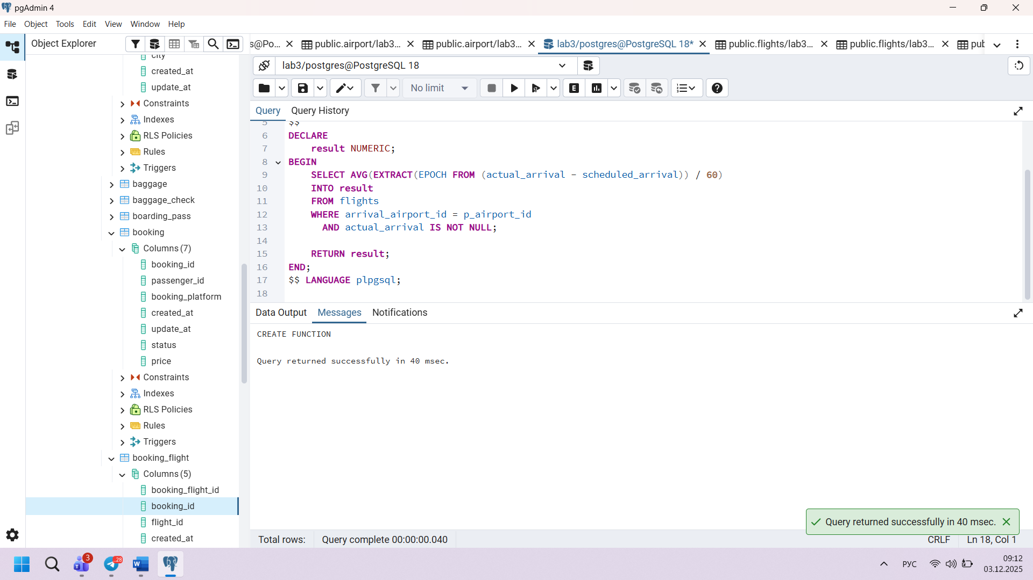
Task 5
CREATE OR REPLACE PROCEDURE list_passengers_for_flight(
p_flight_no VARCHAR
)
LANGUAGE plpgsql
AS $$
BEGIN
SELECT p.*
FROM passengers p
JOIN booking b ON p.passenger_id = b.passenger_id
JOIN booking_flight bf ON b.booking_id = bf.booking_id
JOIN flights f ON bf.flight_id = f.flight_id
WHERE f.flight_no = p_flight_no;
END;
$$;
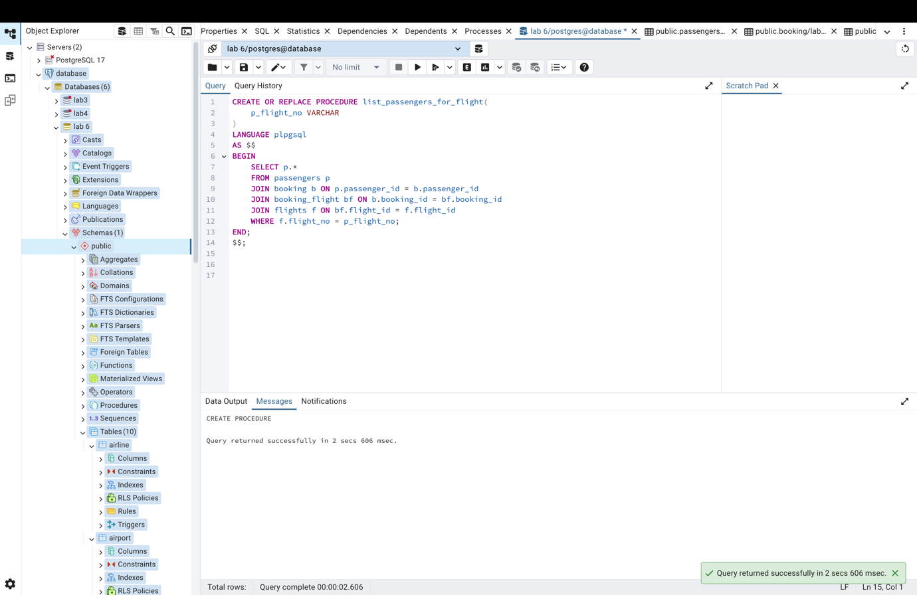
Task 6
CREATE OR REPLACE PROCEDURE top_frequent_passenger()
LANGUAGE plpgsql
AS $$
BEGIN
SELECT p.passenger_id, p.first_name, p.last_name, COUNT(*) AS flights_taken
FROM passengers p
JOIN booking b ON p.passenger_id = b.passenger_id
JOIN booking_flight bf ON b.booking_id = bf.booking_id
GROUP BY p.passenger_id
ORDER BY flights_taken DESC
LIMIT 1;
END;
$$;
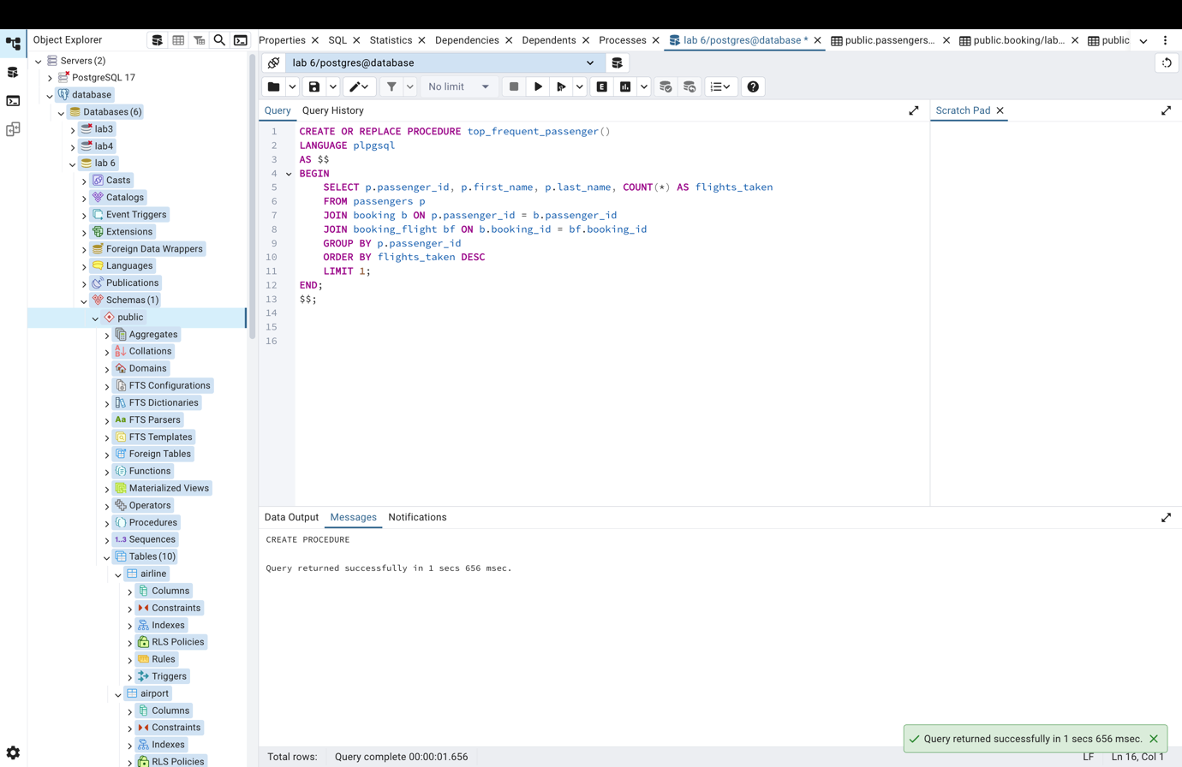
Task 7
CREATE OR REPLACE PROCEDURE flights_delayed_24h()
LANGUAGE plpgsql
AS $$
BEGIN
SELECT *
FROM flights
WHERE actual_departure IS NOT NULL
AND (actual_departure - scheduled_departure) > INTERVAL '24 hours';
END;
$$;
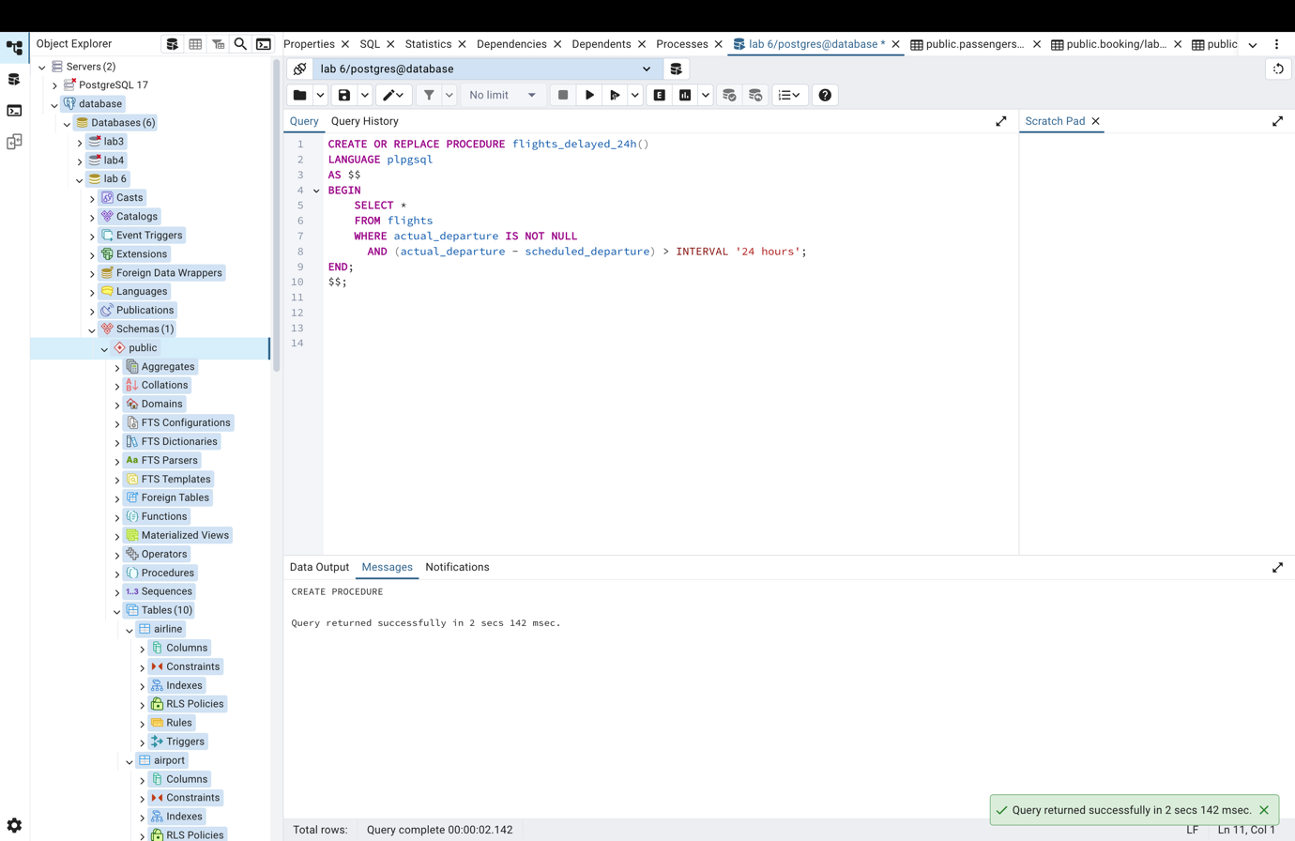
Task 8
CREATE OR REPLACE FUNCTION count_flights_by_airline()
RETURNS TABLE(
airline_id INT,
flight_count BIGINT
)
AS $$
BEGIN
RETURN QUERY
SELECT airline_id, COUNT(*)
FROM flights
GROUP BY airline_id;
END;
$$ LANGUAGE plpgsql;
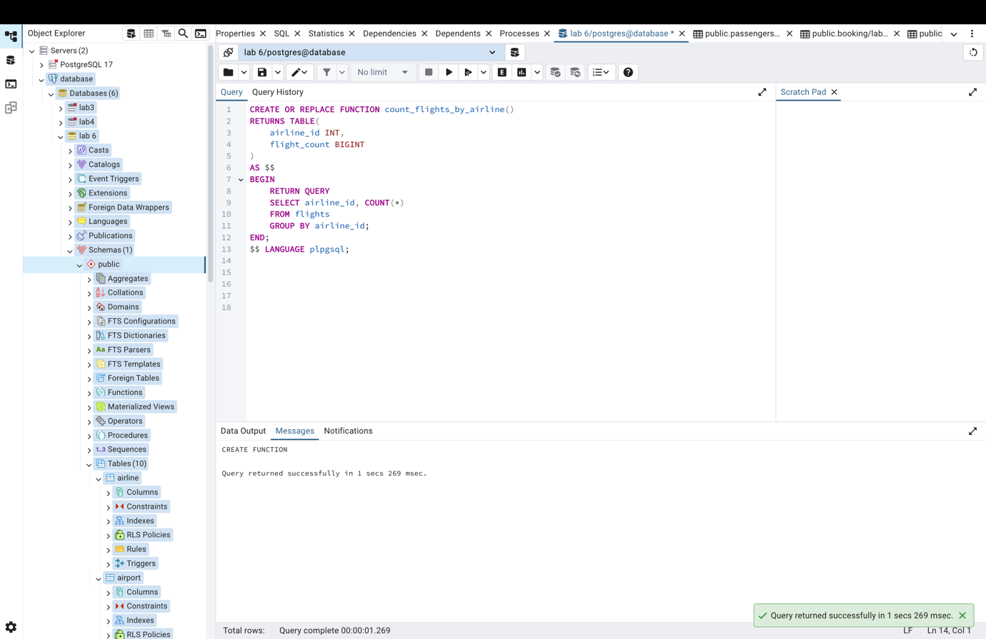
Task 9
CREATE OR REPLACE PROCEDURE avg_ticket_price(
p_flight_id INT
)
LANGUAGE plpgsql
AS $$
BEGIN
SELECT AVG(b.price) AS average_price
FROM booking b
JOIN booking_flight bf ON b.booking_id = bf.booking_id
WHERE bf.flight_id = p_flight_id;
END;
$$;
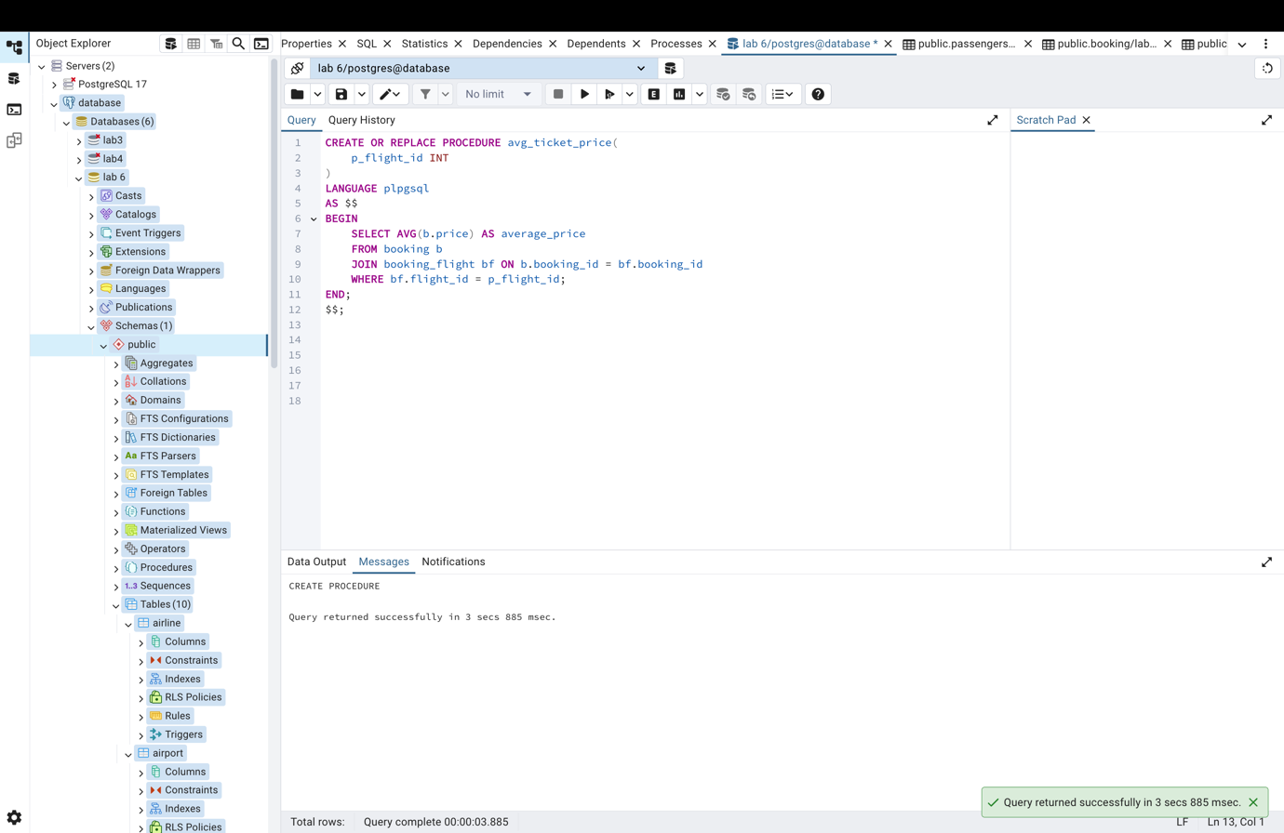
Task 10
CREATE OR REPLACE PROCEDURE highest_ticket_price()
LANGUAGE plpgsql
AS $$
BEGIN
SELECT f.flight_no,
f.departure_airport_id,
f.arrival_airport_id,
MAX(b.price) AS max_price
FROM flights f
JOIN booking_flight bf ON f.flight_id = bf.flight_id
JOIN booking b ON b.booking_id = bf.booking_id
GROUP BY f.flight_no, f.departure_airport_id, f.arrival_airport_id
ORDER BY max_price DESC
LIMIT 1;
END;
$$;

