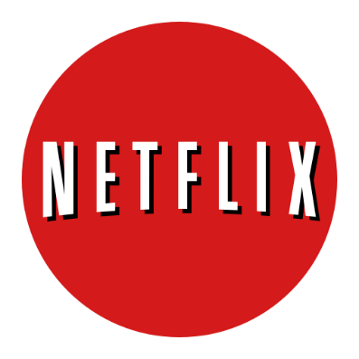

Make Netflix even smarter

IMPROVEMNTS IN 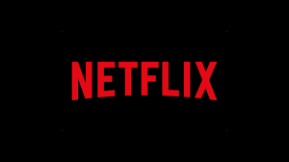
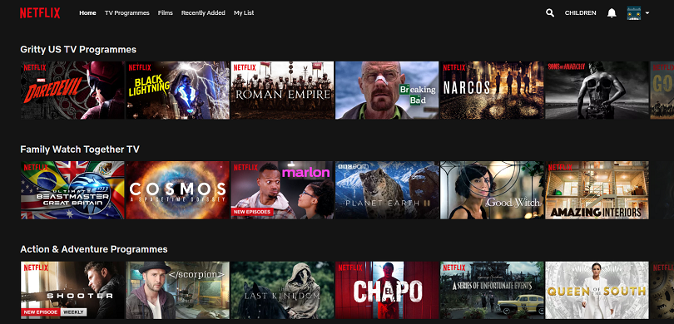
The presence of AI in today’s society is becoming more and more ubiquitous— particularly as large companies like Netflix, Amazon, Facebook, Spotify, and many more continually deploy AI-related solutions that directly interact (often behind the scenes) with consumers everyday.
happy.
By incorporating concepts like data analysis, machine learning, statistics and deep learning, Netflix has utilized its data to good use and growing exponentially. Netflix alone have had such scalable impact that they have forever changed the technology landscape and user experience for millions and more to come. Adoption of these AI-related solutions is only going to get stronger over time.
NETFLIX
Netflix, Inc. is an American media-services provider. Netflix's video on demand streaming service, formerly branded as Watch Now, allows subscribers to stream television series and films via the Netflix website on personal computers, or the Netflix software on a variety of supported platforms, including smartphones and tablets, digital media players, video game consoles and smart TVs.

NETFLIX

NETFLIX FACTS
Netflix is a technology juggernaut which spending is mainly on the AI to make content spending decisions. Netflix has a greater edge over the competitors by following means:
▪ Content is the sole different than other competitors.
▪ Netflix has produced its own series, movies which has been very popular (Netflix Originals e.g. Sacred Games).
▪ The company has taken advantage of being an early start in video streaming space.
▪ Netflix development in Artificial Intelligence and Machine Learning is much greater than most of the competitors as it spends 1.5 billion in 2018 on Technology.
▪ More user-specific content and ease of controls while playing than competitors.
▪ The success rate of Netflix shows is above 80%.
▪ Operates according to the culture and country recommendations and suggestions.

Netflix data analytics shows the company what the customer prefer watching, and it gives u the content accordingly. It basically gives the recommendation of the content for users to watch. It works towards personalization it directly theirs to communicate to the customers from their content and recommendation.
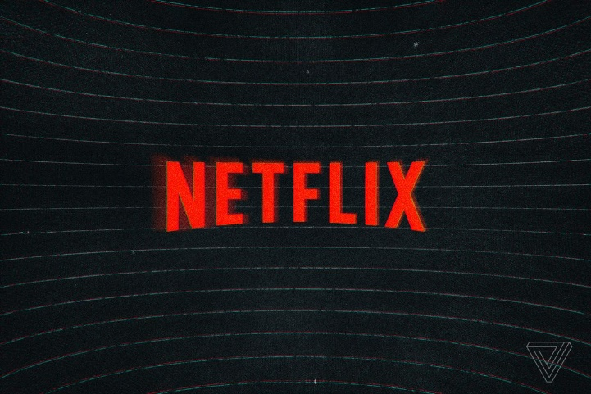
NETFLIX IMPROVEMENTS

DATA COLLECTION
In term of data collection following data can be added:
- The data of the movie ending: sad, happy etc.
- something with you, and Netflix syncs all the screens to your video.
- Classify the movies based on lengths.
USER INTERFACE
In term of user following data can be added:
- Custom theming of Netflix background based on the genre of movie: like thriller, romance etc.
- Adding a lock screen while playing video
ALGORITHM TECHNIQUES
In term of user following data can be added:
- NLP for automated help via chatbot from Netflix.
- Adding and linking Facebook, Instagram account etc. can view most of the movies seen by the friends.
- Netflix can add a feature where you can 'invite' another Netflix user (or several) to watch
- Can become more predictive via reinforcement learning, shows next what user just think off.
- Can add feature to see what is more popular in the region they belong.

THE CONCLUSION

Key competitive differentiators in Netflix's technology stack

Netflix has done a phenomenal job of applying AI, data science, and machine learning the “right way” — using a product-based approach that focuses on business need first, then AI solution next, rather than the other way around.
Netflix uses the collected data for the following improvements in Netflix:
- Personalizing the streaming Experience
- Making content better
- Optimizing the search operation
- Increases popularity and user experience.
- Netflix is a main spilling video supplier on request (SVOD) organization working in 190 nations with 130 million supporters.

Netflix has always focused on constant changing and flexibility of the business from DVD rental business to online video streaming to now owning a TV shows has taken up a speed growth. Their use of data analytics has helped the company to be more customers centric and provide quality experience to the viewers.
NETFLIX AND CHILL
Netflix and chill, as a distinct phrase, means to watch Netflix with a romantic prospect


