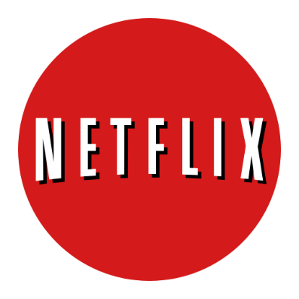

Analyse Netflix's Data Science
and AI Strategy

MACHINE LEARNING AND DATA SCIENCE IN 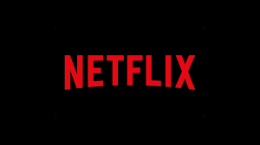
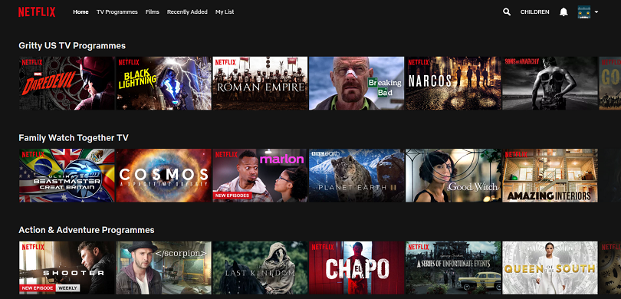
The presence of AI in today’s society is becoming more and more ubiquitous— particularly as large companies like Netflix, Amazon, Facebook, Spotify, and many more continually deploy AI-related solutions that directly interact (often behind the scenes) with consumers everyday.
happy.
By incorporating concepts like data analysis, machine learning, statistics and deep learning, Netflix has utilized its data to good use and growing exponentially. Netflix alone have had such scalable impact that they have forever changed the technology landscape and user experience for millions and more to come. Adoption of these AI-related solutions is only going to get stronger over time.
NETFLIX
Netflix, Inc. is an American media-services provider. Netflix's video on demand streaming service, formerly branded as Watch Now, allows subscribers to stream television series and films via the Netflix website on personal computers, or the Netflix software on a variety of supported platforms, including smartphones and tablets, digital media players, video game consoles and smart TVs.

NETFLIX

DATA COLLECTED AND ALGORITHMS USED
GOOD CLUSTERING OF MOVIES
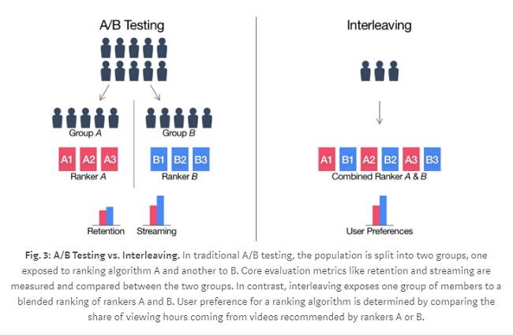
Movies are cluster based on various categorizers, they make good use of data exploration unsupervised learning and classify the movies based on it, say it may be horror, romance or comedy, it uses various key point to classify them, these data are derived from
- The day and time of the content being watched
- Based on ratings, reviews and comments
- Sentiments analysis as per the users behavious
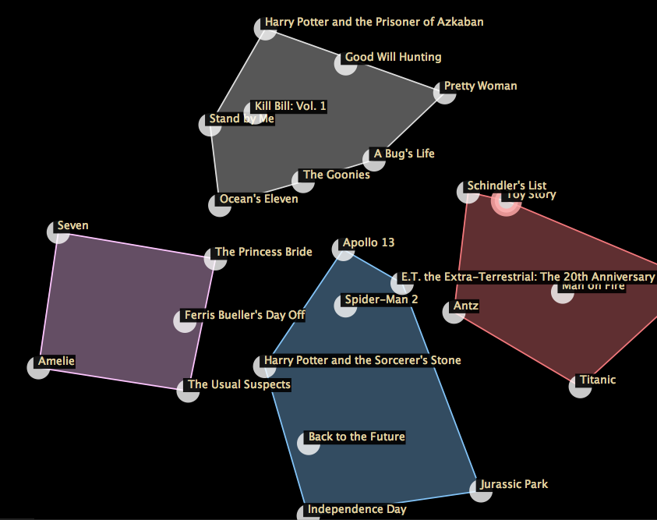
- Number of movies and subscribers.
- Nature of content

GOOD RECOMMENDATION OF MOVIES
Netflix has the best recommendation of movie
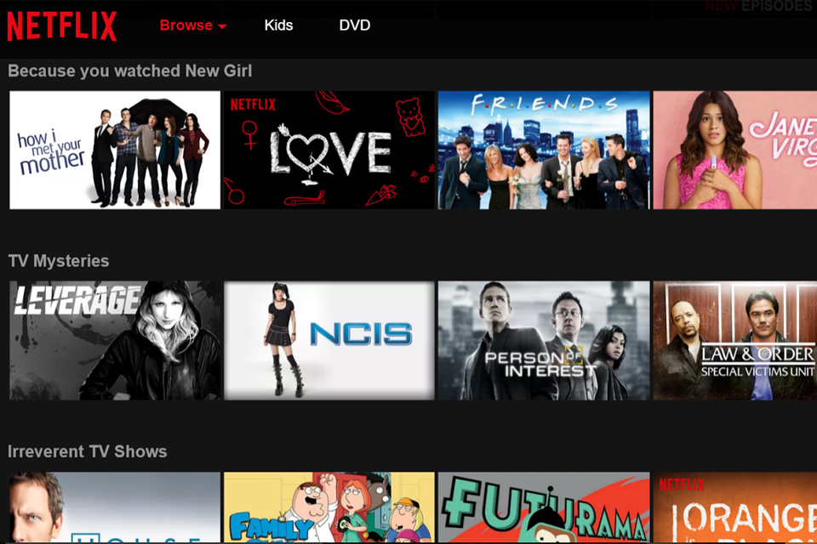
Netflix uses following data collected by various algorithms and user’s behavior over Netflix to create an exception movie recommended system using Predictive analysis:
- The day and time of the content being watched
- The device on which the content has been watched
- Nature of content: Romance, Thriller Horror
- Number of users watched the movie
- Searches on the platform
- User watch history: the type pf movie watched more.
- Way the content was watched: was paused, rewind or fast-forward
- User geographic location data
- Comments and ratings by the users.
- Rewatching of content

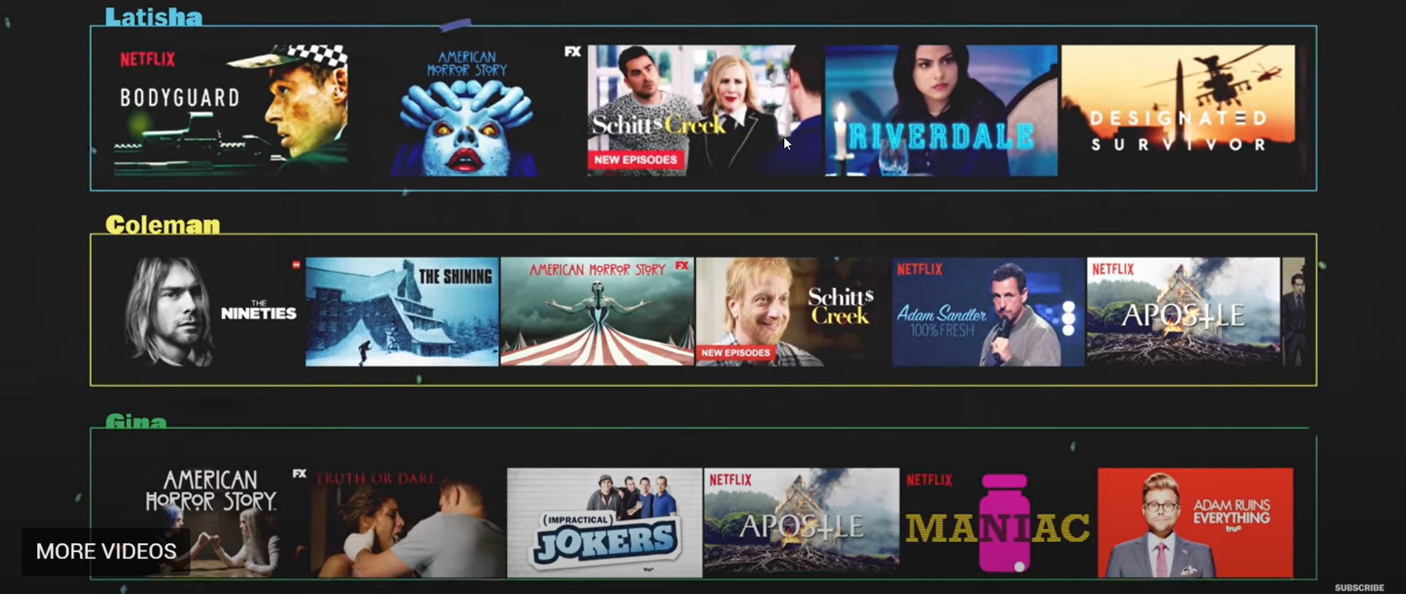
GOOD IMAGE PROCESSING OF MOVIES THUMBNAIL

The above image show Netflix profile of 3 users, see the different thumbnail of same movie for each user.
Netflix has a great Image processing technique customized based on user behavior and the time of accessibility. Netflix uses CV (Computer versioning) for the same. Look how Thumbnail changes as per the mood of user gathered by sentiment analysis of user.
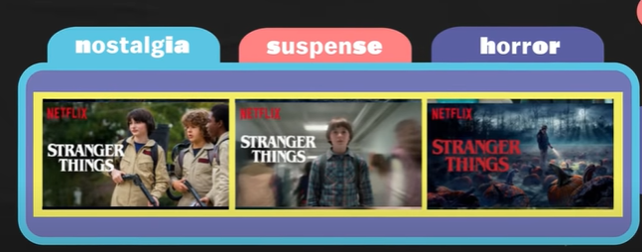

GOOD USER-SPECIFIC CONTENT
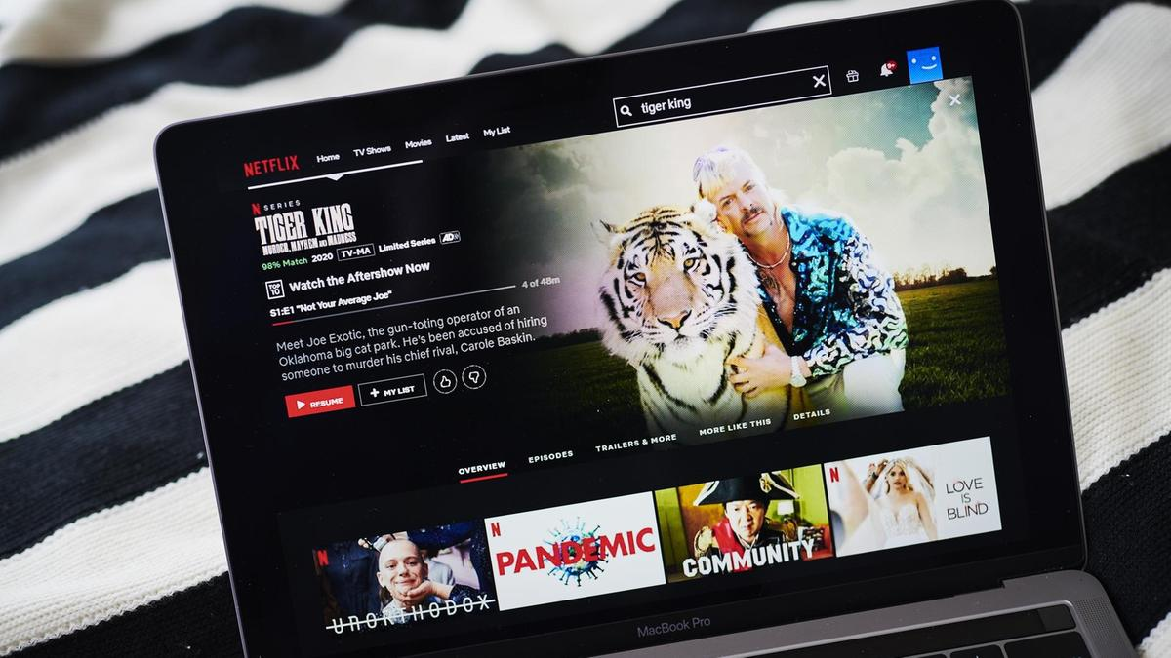
Netflix uses reinforcement learning and sentiment analysis to create a user specific content, suppose, a user loves horror and comedy movies, its contents tends to develop as per the user taste. It uses the following data from the user:
- Nature of content: Romance, Thriller Horror
- Number of users watched the movie
- Searches on the platform
- User watch history: the type pf movie watched more.
- Way the content was watched: was paused, rewind or fast-forward
- User geographic location data
- Comments and ratings by different users.
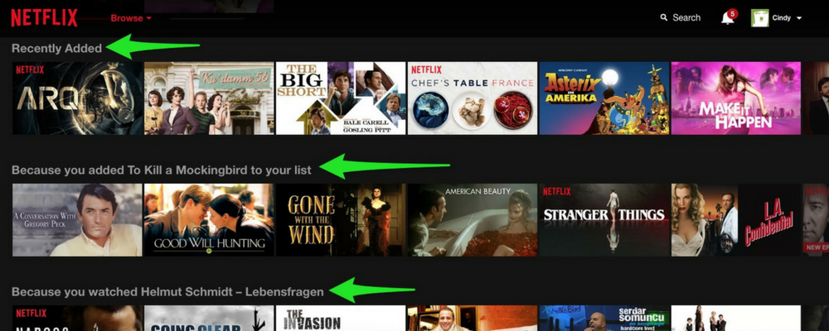
THE CONCLUSION

Key competitive differentiators in Netflix's technology stack

Netflix has done a phenomenal job of applying AI, data science, and machine learning the “right way” — using a product-based approach that focuses on business need first, then AI solution next, rather than the other way around.
Netflix uses the data for the following things:
- Personalizing the streaming Experience
- Making content better
- Optimizing the search operation
- Increases popularity and user experience.
- Netflix is a main spilling video supplier on request (SVOD) organization working in 190 nations with 130 million supporters.

Netflix has a greater edge over the competitors by following means:
- Content is the sole different than other competitors.
- Netflix has produced its own series, movies which has been very popular (Netflix Originals e.g. Sacred Games).
- The company has taken advantage of being an early start in video streaming space.
- Netflix development in Artificial Intelligence and Machine Learning is much greater than most of the competitors as it spends 1.5 billion in 2018 on Technology.
- More user-specific content and ease of controls while playing than competitors.
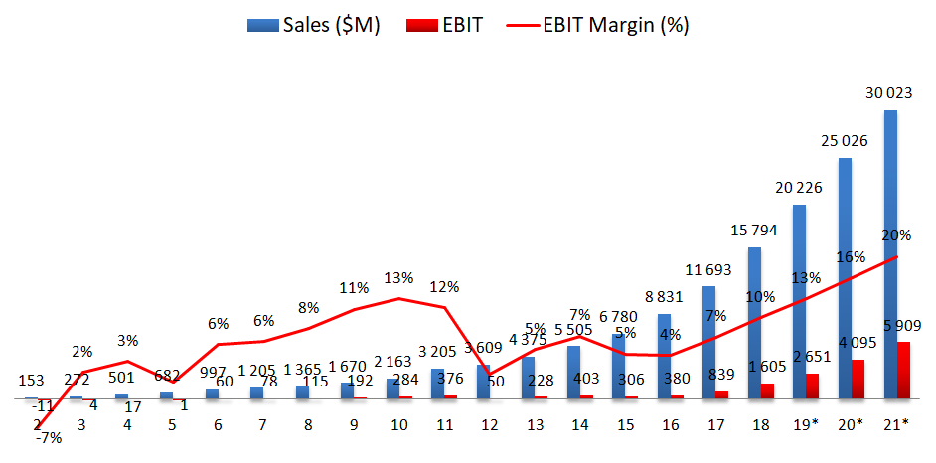
NETFLIX SALES

